Lectio Divina and Praying in silence
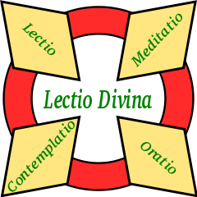
Lectio Divina is the most traditional way to grow in an intimate relationship with God and it is by means of this relationship that we are transformed and rendered capable of living the Gospel in all its fullness.
A monk in the 12th century described the fundamental elements of Lectio Divina:- read the Word of God (lectio); reflect on the Word (meditatio), respond to the Word from the heart (oratio); rest in the Word (contemplatio).
The process of contemplation changes the human ways of thinking, loving and acting into divine ways. Our human ways are very limited and so when we read the Word of God, we are limited by our experience of life and by many other factors. It is said that one can find in the Bible reasons to support any position. It is therefore not sufficient just to read the Bible; our way of looking at things must be purified. When we meditate on the Word of God, we try to understand its meaning and what message it may have for our lives but when we do this, we are still limited. Our little world must be enlarged and our minds reformed according to the mind of Christ. When we pray from the heart, we are still using human words. Our words and thoughts, no matter how beautiful, are still human words and thoughts and it is therefore necessary that they too be purified by the Word of God.
St. John of the Cross wrote that God spoke one word and that word was His Son; this Word God repeats in an eternal silence and in silence must it ever be heard by the soul. Lectio Divina moves towards silence. When our words and our beautiful thoughts are no longer sufficient, only silence can give an adequate response to the Word of God.
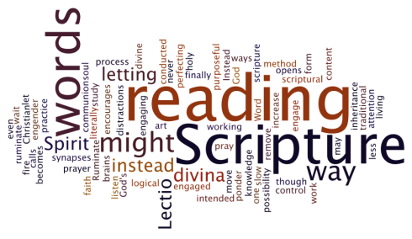
The voice of God is so gentle that we run the risk of suffocating it with the noise within ourselves. Consciously we enter into silence and leaving aside our beautiful words and holy thoughts for a moment, we reserve a space which we hope God will fill. During the period of this prayer, it is not the time to speak to God in words or have holy thoughts. We can do all this at another time. Our silence and our desire are worth much more than many words.
By means of the sacred word which we have chosen, we express our desire and our intention to remain in the presence of God and to consent to God's purifying and transforming action. We return to the sacred word, which is the symbol of our intention and desire, only when we are aware that we are thinking about something. There is no point in getting upset at our distractions but we return very gently to our sacred word as the symbol of our intention to remain in God's presence and to submit to and co-operate with God's action in our lives. The prayer itself consists simply in being in the presence of God without thinking of anything in particular. It is a prayer of relationship with God, Father, Son and Holy Spirit. If we understand how to be with another person in silence without thinking of anything or doing anything, then we can understand this prayer. http://www.carmelite.org/priorgen/prsilence.htm

'Silence and Word: Path of Evangelisation'

Quotes from Pope Benedict’s Statement for World Communications Day

20th May 2012

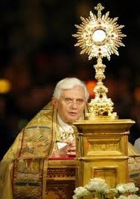
“In silence, we are better able to listen to and understand ourselves; ideas come to birth and acquire depth; we understand with greater clarity what it is we want to say and what we expect from others; and we choose how to express ourselves,”

“we avoid being tied simply to our own words and ideas without them being adequately tested,” and therefore, “space is created for mutual listening and deeper human relationships become possible.”
“When messages and information are plentiful, silence becomes essential if we are to distinguish what is important from what is insignificant or secondary,”

silence is “often more eloquent than a hasty answer,” because it “permits seekers to reach into the depths of their being and open themselves to the path towards knowledge that God has inscribed in human hearts.”
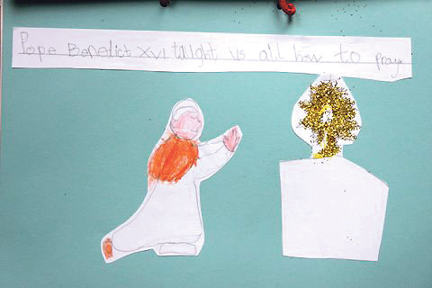
The Pope sees this need for silence as a part of Christian life from the earliest times. He points to the “eloquence of God’s love, lived to the point of the supreme gift,” which is seen “in the silence of the cross,” when, after Christ’s death “there is a great silence over the earth.”

Silent contemplation also “immerses us in the source of that Love, who directs us towards our neighbours so that we may feel their suffering and offer them the light of Christ, his message of life and his saving gift of the fullness of love,”

A reading from the 1st Book of Kings
19:11-13
He said, ‘Go out and stand on the mountain before the Lord, for the Lord is about to pass by.’ Now there was a great wind, so strong that it was splitting mountains and breaking rocks in pieces before the Lord, but the Lord was not in the wind; and after the wind an earthquake; and after the earthquake a fire, but the Lord was not in the fire; and after the fire a sound of sheer silence. When Elijah herd it, he wrapped his face in his mantle and went out and stood at the entrance of the cave. Then there came a voice to him that said, ‘what are you doing here?’
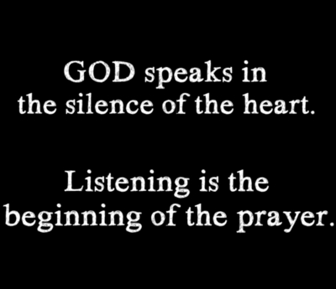

Personal Notes, Comments and Reflections

