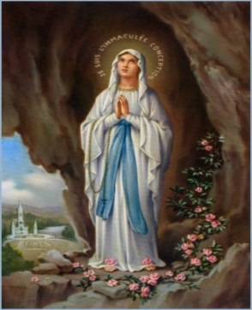
St. Paul’s – Whiteinch
Prayer Service in Honour of Mary

Introduction
Leader
Welcome to our service this afternoon, honouring Mary our Mother. During the month of May we pay special honour to Our Lady as the mother of our Lord Jesus Christ. She is the person who takes our prayers to her Son and helps us when we are in most need.
Let us begin by preparing our altar to show how much we love and admire Mary.
Play quiet music (e.g – Hail mary, gentle woman)
- Altar cloth:
Child – We place a blue cloth on our altar to honour Mary
- Flowers:
Child – We place flowers on our altar to show how much we love Mary
- Candle:
Child – We light our candle to show that God is with us
- Statue:
Child – We place a statue on our altar to show that Mary has a special place in Heaven
Part 1
Leader
Let us now join in singing our opening hymn:
As I kneel before you
Child – Mary our mother is very special. She was chosen by God to be the mother of His Son
Child – Let us listen to how Mary said ‘Yes’ to God
Child/Leader reads the story of the Annunciation

A reading from the Gospel of Luke:

One day an angel , Gabriel visited Mary. -"Mary!" he announced," the Lord is with you.

She was disturbed because she was not sure what these words meant.

The angel told her not to be afraid because he had been sent by God. The angel then told her that God had chosen her to have a very special baby and that his name would be Jesus.

The baby will grow up to be a great man, and his reign will never end. "So the holy child to be born will be called the Son of God."

Mary knelt before the angel Gabriel and said yes.

With this, the angel left her.

The Gospel of the Lord

Part 2

Leader

As Mary said Yes to God she has been honoured by the Church for thousands of years. One of the prayers in honour of Mary is the ‘Litany of Mary’. Let us now pray together:

All sing – Immaculate Mary

Use pictures of the Litany of Mary on ppt.

A child says each litany:

All respond – ‘Pray for us’

Our lady Queen of Angels

Queen of the Rosary

Holy Mary Mother of God

Queen of families

Part 3

Leader

Let us now pray together and ask Mary our Mother to look after us:

Child

Mother Mary, look after our friends and families – Lord hear us

Child

Mother Mary, help all those people who are sick – Lord hear us

Child

Mother Mary, look after everyone in St. Paul’s Primary – Lord Hear Us

Child

Mother Mary, look after Father Smith and all the people in St. Paul’s Parish – Lord Hear Us

Child

Let us now bring all our prayers together by saying

Hail Mary…….

Part 4

Leader

The Rosary is a very special prayer that we say to honour Mary. It is sometimes called a garland of flowers. Before we say a part of the Rosary, let us sing together:

Bring Flowers of the Rarest

All sing and as they are singing the children bring out petals/flowers and place them on the altar.

Child

Let us now say the short Rosary which is:

The Our Father

3 Hail Mary’s

Glory be

Part 5

Child

Thank you for coming to our service. We are happy that you could join in our special prayers.

Child

Let us finish now by singing again:

As I kneel before you

