Focus for School Visits – RERC (Including Other World Religions)
Stage | Strand of Faith | Experience and Outcome | Core Learning | Focus/Visit
P1 | Signs of God  Hours of God | RERC 0‐08a I am aware of being part of a community and I have begun to explore aspects of the local Catholic community.  RERC 0‐16a I can share that Sunday is a special day when the Catholic Christian community meets to celebrate Mass.  RERC 0‐17a I have experienced liturgy as a community event. | I know the name of our parish(es) and priest(s) and I recognise that our priest(s) cares for our parish family.  I know that Sunday is the most important day of the week for Christians.  I am learning that, on Sundays, Catholics have a duty to go to Mass to thank God for His love for us.  I can participate at Mass by being still, listening and praying with others.  I have been given opportunities to celebrate liturgy as part of my class, my school and my parish. | Visit to St. Paul’s  Tour of Church / Meet Priest  September  Participate in school liturgies in Church linked to Liturgical Calendar  Participate in school Liturgies:  October  November  Advent  Lent  May
P2 | Signs of God | RERC 1‐08a I know that through the Community of the Church, people can experience God's love and care and I have reflected on how this community celebrates together. | I can find out about people and groups of people in my parish who care for children e.g. toddlers’ groups, children’s liturgy, our priest(s).  I recognise that we are all members of God’s family and, just as we celebrate special events with our families, we gather to celebrate special occasions with our Parish  family, e.g. Sunday Mass, baptisms, weddings, funerals. | Visit to St. Paul’s:  January  Tour of Church  Talk to Priest about how families celebrate special occasions in Church.  Meet representatives of Children’s Liturgy  See where children’s liturgy takes place.

Stage | Strand of Faith | Experience and Outcome | Core Learning | Focus/Visit
P2 | Hours of God | RERC 1‐16a I know that the Mass is at the heart of Catholic community life and I am developing an understanding of how to participate fully in this celebration.  RERC 1‐17a I have, through liturgical experiences, reflected on an ability to respond to symbols and take part in rituals in order to worship God. | I know that, all over the world, Mass is celebrated by the priest and people on Sunday and, very often, during the week.  I know that Catholics have a duty to attend Sunday Mass each week to show love and respect for Jesus and to help us to follow in his ways.  I know how to process into the Church and genuflect before entering or leaving my seat.  From my own experience I know, on entering a Catholic Church, I use water from the holy water font to bless myself.  I have visited my local Catholic Church and I can identify: the altar, holy water font, the tabernacle, Paschal Candle and the sanctuary lamp.  I have been given opportunities to celebrate liturgy as part of my class, my school and my parish. | As above  January  Children should bless themselves from the font  Genuflect before sitting  Look at the Paschal Candle and Sanctuary Lamp  Participate in school liturgies in Church linked to Liturgical Calendar  Participate in school Liturgies:  October  November  Advent  Lent  May

Stage | Strand of Faith | Experience and Outcome | Core Learning | Focus/Visit
P3 | Signs of God  Hours of God | RERC 1‐09a I am exploring the Sacraments of Initiation and Reconciliation and I have reflected on how the Sacraments help to nurture faith.  RERC 1‐08a I know that through the Community of the Church, people can experience God's love and care and I have reflected on how this community celebrates together.  RERC 1‐17a I have, through liturgical experiences, reflected on an ability to respond to symbols and take part in rituals in order to worship God. | I can recall what I learned about Baptism in Primary 2.  I can explore some other symbols of Baptism:  • water ‐ symbol of new life and cleansing from sin  • holy oils ‐ symbol of healing and strength  • white garment ‐ symbol of Christian dignity, and of Jesus’ Resurrection which gives us new life  I can explain that, in the Sacrament of Reconciliation, I am cleansed from sin, given healing and strength, and given a fresh start in my life.  I can take part in class, school or parish celebrations of everyday and special events.  I have visited my local Catholic church and I can recognise the significance of the altar, holy water font, the tabernacle, Paschal Candle and the sanctuary lamp. | Preparation for the Sacrament of Reconciliation:  Visit to the Church to look at Baptismal Font & Confessional Boxes.  February  Participate in school liturgies in Church linked to Liturgical Calendar  Participate in school Liturgies:  October  November  Advent  Lent  May  This can be focused on during February visit to the Church
P3 – Other World Religion - Judaism
Experience and Outcome  RERC 1-25a I am aware that the Jewish community believe in God.  RERC 1-26a I am aware of family and community values in the Jewish faiths | Core Learning | Focus/Visit
 | I can recall in the Genesis story, God created the earth and everything in it.  I know that the Jewish people today believe in God as the creator of everything. | This could be a focus in September when there is a focus on Creation  Retell the Genesis story, Recall ‘All Things Bright and Beautiful’ (September)  Tell children that Jesus was a Jew and that Jews believe in the same God as us.
 | I can recall that Jesus grew up in a Jewish family  I know that family life is central to Jewish life today | Read the ‘Presentation in the Temple’  Luke 2:22-40  Tell children that Jewish Families have traditions and celebration.  Discuss this Scriptural story and how Mary and Joseph must have felt.  Write/ draw ‘A day in the life of Jesus’  Watch: https://www.bbc.co.uk/education/clips/zd9jxnb  ‘Meet a Jewish Family’  Mezuzah Powerpoint – Make a Mezuzah, place some special prayers in these.
RERC 1-27a I can identify the places of worship of the Jewish faith communities | I can recall from my learning that Jesus went to the Synagogue to pray  I know that the Jewish community today worship in a building called a ‘Synagogue’ | Read Luke 2: 41-52 Jesus in the Temple. Look at the Art, discuss how Mary and Joseph would have felt.  Find images of a Synagogue – discuss the main features  Visit to the Synagogue would be appropriate

Art – The Boy Jesus in the Temple (Synagogue)
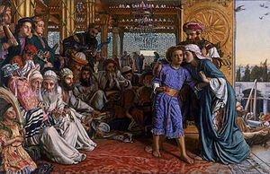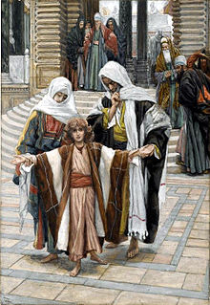

Features of a Synagogue
Every synagogue has 3 special features:
At the front of the synagogue’s main room there will be a special cupboard where the Torah
scrolls are kept. This is called the ark or aron ha-kodesh. There may be curtains in front of
the ark. The ark is always at the eastern end of the synagogue, because that is the direction
towards Jerusalem, where the temple used to be.

Near the ark there will be a lamp that is kept alight all the time. This is called the ner
tamid, which means everlasting light. It is to remind people that God is always there.

The bimah is a raised platform where the Torah scrolls are opened and read out. The bimah
may be in the middle of the synagogue or it may be right next to the Ark.

P3 – Other World Religion - Judaism
Experiences and Outcomes | Core Learning | Focus /Visits
RERC 1-27b I know that the Jewish community have special books which are important to their beliefs | I can recall from my learning that Jesus reads from the Psalms and the Prophets  I know the Jewish community read these texts in their Holy Book, which is called the Torah | Read Luke 24:24 – Discuss what the Psalms and the Prophets are.  Read some of the ‘Psalms for kids’ http://www.essex1.com/people/paul/secret-happiness.html  (The Torah scroll is a long scroll containing the 5 books of Moses – normally kept in the Ark within the synagogue)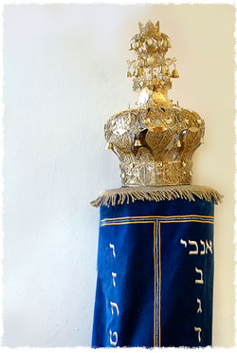

Stage | Strand of Faith | Experience and Outcome | Core Learning | Focus/Visit
P4 | Signs of God  Hours of God | RERC 1‐09a I am exploring the Sacraments of Initiation and Reconciliation and I have reflected on how the Sacraments help to nurture faith.  RERC 1‐16a I know that the Mass is at the heart of Catholic community life and I am developing an understanding of how to participate fully in this celebration. | I understand the significance of the following parts of the Mass:  • Gathering: Penitential Rite, Gloria (These take place at the Presidential Chair.)  • Liturgy of the Word: readings (including the Psalm); Gospel Acclamation; Gospel; Homily; Creed; Prayers of the Faithful (These take place at the Lectern.)  • Liturgy of the Eucharist: Offertory; Sanctus (Holy, Holy); Eucharistic prayer; Memorial Acclamation; Great Amen; Our Father; Sign of Peace; Agnus Dei (Lamb of  God); communion. (These take place at the Altar.)  • Dismissal.  I can show my understanding of the importance of the Liturgy of the Word by saying or singing the Gospel Acclamation and standing to greet the Gospel.  I can respond in word and gesture to the invitation to greet the reading of the Gospel.  I know that, during the Eucharistic Prayer, the priest offers the bread and wine to God and that this becomes the body and blood of Jesus.  I know that, at the Consecration, as the priest raises the bread and wine, transformed into the Body and blood of Jesus, I raise my gaze and then bow my head in prayer.  I can receive Communion prayerfully in word and gesture and take time to pray in thanksgiving for the gift of the Eucharist. | Visit to the Church to focus on the Lectern, Tabernacle and the Altar.  Visit – September/October

P4 – Other World Religions – Islam
Experiences and Outcomes | Core Learning | Focus /Visits
RERC 1-25a I know that the Muslim community believe in one God. | I know that the Muslim community believe in one God whom they call Allah | Tell children that Christians, Jews and Muslims believe in the same God
RERC 1-26a I am aware of family and community values in the Muslim faith | I know that being dutiful to God, parents and elders is an important element of living the Islamic faith and that this is taught and encouraged within the family and community.  I know that being dutiful means showing respect and kindness. | Discuss the term ‘dutiful’. How do we show this? How do we show respect? Talk about class/school rules and charter.  Watch:  https://www.bbc.co.uk/education/clips/zvd4d2p
RERC 1-27a I can identify the places of worship of the Muslim faith communities | I know that the Muslim community worship in a building called a Mosque and I can identify the key features of this building | Use:  http://www.bbc.co.uk/guides/z297hv4  Arrange visit to the Mosque - November
RERC 1-27b I know that the Muslim communities have special books which are important to their beliefs | I know that the Muslim community have a special book, called the ‘Qur’an’, which they believe is the sacred word of Allah | - The Qur'an, sometimes spelled Koran, (Arabic: القرآن) is the holy book of Islam  - The Qur'an is considered by Muslims to be "The Word of Allah (God)". This book is different from other religious texts in that it is believed to be written directly by God, through the prophet Muhammad.  - Muslims believe the Qur'an was first revealed to Muhammad by the archangel Gabriel in a cave on the mountain of Hira in Mecca  Ask some of the Muslim children their experince of learning to read the Qu’ran

Fact File:
Islam is the world’s second-largest religion.
People who follow the religion of Islam are called Muslims and there are around 1.6 billion Muslims in the world.
Like Christians and Jews, Muslims are monotheistic, which means they only believe in one God who they call Allah, the Arabic name for God.
Islam was founded in the Middle East over 1400 years ago by a man named Muhammad who gave Allah’s message to the people on Earth and introduced the faith of Islam.

Top 10 facts
- People who practise the religion of Islam are called Muslims.
- There are about 1.6 billions Muslims in the world, living in many countries (mainly in the Middle East, north Africa and parts of Asia).
- Muslims believe that there is only one God, called Allah.
- Muslims believe that Allah sent many prophets to Earth to give his message. A prophet is someone who speaks for God on Earth. For Muslims, a man called Muhammad was the final prophet of Allah. He was responsible for starting the faith of Islam and is referred to as the Messenger of God or the Prophet.
- Muhammad was born in Makkah (also known as Mecca), which is now in modern-day Saudi Arabia, in A.D. 570. Muhammad is so highly regarded by Muslims that they say "Peace be upon him" (pbuh) whenever they say or write his name.
- The Qur’an, or Koran as it is sometimes known, is the holy book of Muslims.
- The Qur’an is written in Arabic and Muslims always try to read and recite it in this language.
- The mosque is the building where Muslims go to worship.
- Friday is the Muslim holy day, the time of the week when Muslims go to the mosque and pray.
- Ramadan is the ninth month of the Islamic calendar; during Ramadan Muslims fast (consume no food or drink) from just before dawn until sunset.

Islam is an Arabic word meaning submission and obedience. It comes from a word meaning peace.
Like Christians and Jews, Muslims are monotheistic which means they only believe in one God, who they call Allah.
Although their faiths are different, Christians, Jews and Muslims do share many of the stories and traditions that are told in the Old Testament of the Bible. Muslims believe Jesus was a prophet.
Jerusalem is a holy city to Muslims as it is to Christians and Jews too.
Family life is very important in Islam and it is from their families that children learn about the Qur’an and how to pray. The mosque is also used as a place for children to have classes to learn the Qur’an.
Muslims believe that Allah’s message was passed to the prophet Muhammad after he was visited by the angel Jibril (Gabriel). Muhammad memorised what he was told and wrote down the exact words; this is the content of the Qur’an.
The name Qur’an means ‘that which has been read or recited’. The Qur’an provides Muslims with guidance on all aspects of their life and the Islamic religion is very much based on what it teaches people. Muslims believe that the Qur’an was Allah’s final communication with someone on Earth.
The Qur’an states five main duties for followers of Islam which are known as the Five Pillars.
One of the Five Pillars is Salah, the five daily prayers Muslims must perform. Muslims always wash their face, hands and feet before they pray and always face the direction of the holy city of Makkah.
The Mosque
A mosque is a place where Muslims worship.^{[1]} The word mosque comes from the Arabic word masjid.^{[2]} A mosque may be small, and privately owned. A larger, 'collective', mosque is called a masjid jāmi.^{[3]} Larger mosques offer more services to their community.
For many Muslim people, a mosque is more than a place of worship. Muslims worship, study and discuss Islam, and do many other things in a mosque and its compounds. In the United Kingdom, many mosques are used as community centres. They are also used to teach about Islam. Religious festivals and gatherings are held in mosques. Weddings are one example. Mosques have rules to control what people do inside. One of these rules is that it is considered rude to disturb another person who is worshipping.
Many mosques are known for their Islamic architecture. The earliest mosques, opened in 7th century were open-air spaces. They are the Quba Mosque and Masjid al-Nabawi. Later mosques were buildings that were specially designed. Nowadays, mosques are in every continent, except Antarctica.

The Qur’an – Koran
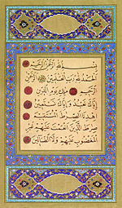

Stage | Strand of Faith | Experience and Outcome | Core Learning | Focus/Visit
P5 | Hours of God | RERC 2‐14a  I recognise the importance of personal prayer and communal prayer in the growth of all people’s relationship with God. I know a number of traditional Catholic  prayers and I have developed an understanding of the meaning of these prayers. I have participated in different approaches to, and experiences of, prayer. I  can describe how prayer is an important part of the liturgical and devotional life of the Church. I have reflected on how all of these are different ways of  Worshipping God.  RERC 2‐17a I have, through liturgical experiences, reflected on an ability to respond to symbols and take part in rituals in order to worship God. | I am familiar with the Stations of the Cross and I can reflect prayerfully on some of them.  I know that the Catholic Church uses icons, statues and images to enrich our worship and to focus our prayer and I have experienced such prayer. | Visit to the Church to pray the Stations of the Cross  Although this is not part of the Lent Planners, this could be done during Lent  This part of the September plan – Sacred Objects could be set up in class.  Use the Lenten visit to revise the use of Sacred Objects to enrich worship and prayer.

P5 – Other World Religions – Judaism
Experiences and Outcomes | Core Learning | Focus /Visits
RERC 2-25a I have explored some beliefs of the Jewish community  RERC 2-26a I can identify some of the principles by which people of the Jewish faith communities live | I can recall from my P3 learning that the Jewish community believe in one God.  I know that the Jewish community follow God’s law and that they keep the Holy Sabbath.  I can recall from my previous learning that the Jewish community believe that God commanded them to keep the Sabbath day.  I know some of the practices (lighting candles, preparing a family meal, saying prayers and greetings) involved in preparation for the Sabbath. | In January P5 are examining the following themes:  1. Moses and the Ten Commandments  2. Abraham  3. Prophets and Kings  This would be a good time to focus on Judaism  Read the story of the 10 commandments – focus on the fourth commandment  Watch  https://www.bbc.co.uk/education/clips/z3hyr82 - A Jewish family celebrating Shabbat at home  Complete the Symbols worksheet
RERC 2-27a I can share some of the key features and rituals associated with the Jewish communities’ place of worship and their festivals  RERC 2-27b I can identify some of the customs and artefacts related to the Jewish communities and their festivals | I can recall from my previous learning that the Jewish community go to the Synagogue to worship.  I can identify some of the key features of a Synagogue.  I know some of the practices and rituals (segregation, the service and clothing worn) associated with attendance at the Synagogue  I know some of the artefacts (the Ark, the Torah, the eternal light) in the Synagogue | Use http://www.bbc.co.uk/guides/zqdjrdm  This is a guide to the Synagogue  Follow up with a trip to the Synagogue - January

Shabbat Key Facts:
Shabbat is the most important day of the week for Jews, because it is a day on which we remember that God created the world and everything in it. God created the world in six days, but on the seventh day, Shabbat, He rested, and, like Him, we also rest on Shabbat.
The name Shabbat comes from the root Shin-Bet-Taf, which means ‘to end’ or ‘to rest’. In English, Shabbat is known as ‘Sabbath’ although Jews mostly use the Hebrew name, Shabbat (also pronounced ‘Shabbos’ by Ashkenazi Jews).
Shabbat is so important that it is the only ritual that is mentioned in the Ten Commandments. Shabbat is a precious day from God, a day which we look forward to all week.
Shabbat is described as being like a queen or a bride. There is a popular song, “Lecha Dodi Likrat Kalah” where we sing “Come, my Beloved to meet the Sabbath Bride.” We do this just as Shabbat is about to begin.

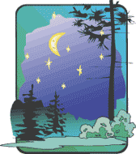
WHEN DO WE CELEBRATE SHABBAT?
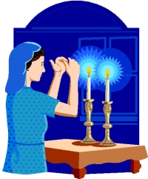
Shabbat begins at sunset on Friday and ends at nightfall on Saturday. It is a very precious time: a time for peace, harmony and relaxation that we do not have on other days of the week. For busy people, it is an opportunity to enjoy a type of peace and relaxation they do not get on other days when they must get their work done.

CUSTOMS
- We treat Shabbat as though she was our best friend coming to share the whole day with us. We look forward to her arrival and wait excitedly for her to get here. We prepare our home and get ready all the things she might like.
- What would you most like to eat? Better still, what would your friend most like to eat? We eat the nicest food of the week, like challah and sweet wine.
- For Shabbat we set the table to welcome our Shabbat Queen, with the best tablecloth, the knives and forks polished, and the candlesticks ready to be lit in time for the arrival of Shabbat.
- We eat three meals on Shabbat: one on Friday night, the second on Saturday lunch and the third on Saturday afternoon (before Havdalah).
- We wash before Shabbat and wear good clothes on Shabbat
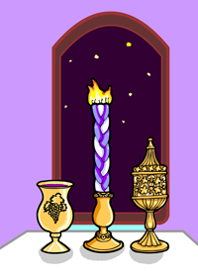
- We make blessings over the candles, the wine and the challah (a special, plaited bread).
- Our parents bless us on Friday night even if they were angry with us during the week.
- Husbands thank their wives for all their hard work by reciting the “Eshet Chayil”, a poem that says women are worth more than rubies.
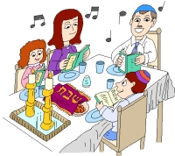
- We take the time to talk about our lives. Our parents have time to listen to us and we sing songs and tell stories until late.
- We stop working on Shabbat. We do not write or do homework, go shopping, drive cars, or turn o nor off electricity. We do not even tear paper. Shabbat is a time where we rest and take the time to enjoy doing nothing creative. This helps us remember that it was God Who created the world.
- We have more time to pray on Shabbat, and there are special prayers in synagogue, including the reading of the Torah portion of the week (Parshat haShavuah).
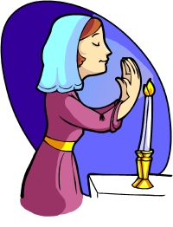
- To end the Shabbat, there is a ceremony called Havdalah (separation). Havdalah highlights the separation between Shabbat and the rest of the week. To hold on to Shabbat a little longer, we say a blessing over wine, we sniff spices and we light and extinguish a plaited candle.
Symbols and Objects

Candles
The candle is a very important symbol for Jews.
- Candles are lit on Friday before Shabbat to help create Shalom Bayit (peace in the home), and Oneg Shabbat (Sabbath joy). In olden times, before electricity, lighting candles ensured that there was light in the room, that people could see what was in the room and avoid accidents, and that Shabbat would be more enjoyable than if observed in a dark room.
- The woman of the house traditionally lights the candles, unless there is no woman. The candles can be lit up to one and a quarter hours before Shabbat begins, but usually, they are lit 18 minutes before sunset.
- Two candles (at least) must be lit in order to show shamor (observance) and zachor (remembrance) of Shabbat (the 4th of the 10 Commandments tells us to observe and remember the Sabbath day).

Shabbat Clothes
On Shabbat we put on our best clothes, dressing as if for an important occasion. This honours the Shabbat and reinforces the feeling that it is a special day.

The Shabbat Table
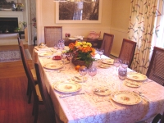
- The table should be covered with a special tablecloth (usually white), and set with the best china and silver to honour the Shabbat Queen. Shabbat food should be the tastiest and best. It is said that Shabbat adds a special flavour to your food. Foods which Ashkenazi Jews traditionally eat on Shabbat include gefilte fish, chicken soup, kugel, cholent and challah.
- White is the preferred colour for the tablecloth as white is the colour of (spiritual) purity and therefore appropriate as the base for what we eat and do. It is a reminder that especially on Shabbat we should try to be spirtually pure.

Food and Drink

Challah
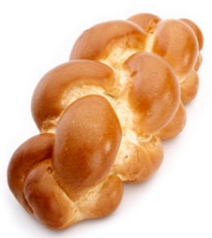
- Challah is the traditional plaited bread especially baked for Shabbat and other holidays. Even today some women bake their own challah to indicate their love of Shabbat, but many people simply buy their challot (the plural of ‘challah’) ready-made from a shop.

Wine and Kiddush Cup
- Wine is very special and has its own blessing. The blessing over wine is: “Blessed are you, Lord our God, King of the universe, creator of the fruit of the vine.”

ZEMIROT
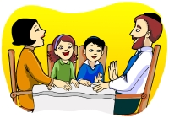
Special songs for the Shabbat table are called zemirot. As the zemirot are sung, we can forget our weekday worries, and completely relax. Sometimes modern songs in Hebrew or English are added to the traditional zemirot.

The Story of Moses and the 10 Commandments
by Sharla Guenther

Children's Version
The Israelites had been traveling in the desert for about 3 months (which is a little longer than regular summer holidays) when they came to Mount Sinai. They were going to stay there for a while plus they had excellent shelter from the mountain.
Moses got unpacked and decided to walk up the mountain to talk to God. Remember that this wasn't very easy for Moses, he was already over 80 years old.
God knew that Moses was coming so He spoke to Moses and told him to tell the Israelites to get ready. Moses came down to tell the people to have a bath and to clean all their clothes.
By doing this the people were getting prepared to hear important words from God. That is why we sometimes dress up or make sure we have clean clothes on when we go to church. It makes us hopefully behave a little nicer and shows respect to God.
On the third morning after Moses had talked to God, the Israelites where busy making their breakfast when all of a sudden there was a large rumble and a flash of light over the mountain. Anyone who was still sleeping were startled and woke up suddenly.
Everyone went out to look and just over the mountain there was lightning and thunder, and a very thick cloud hung over the mountain so you couldn't see the top. Even the mountain shook and the sound of trumpets could be heard getting louder and louder.
So Moses went up the mountain to hear from God once again. This time God told Moses, "Go down to the people and tell them not to follow you up the mountain, the mountain is a special place because I am here." So Moses warned the people not to touch or go to close to the mountain.
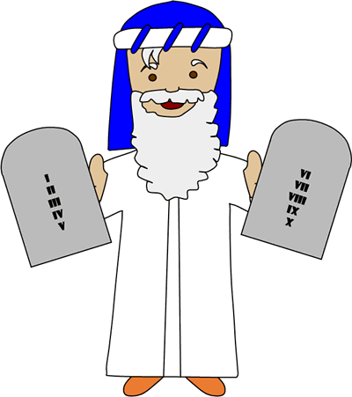
After that Moses went back up the mountain. But this time he stayed there for a long time (40 days and 40 nights), God sure had a lot to tell him. God wanted to instruct the people on how to live. By following His rules they would have less sadness in their lives. God just wanted to protect them.
It's just like when our parents give us rules to protect us: to look both ways before we cross the street, to not hit our brother or sister... They give us rules because they love us and know what's best for us.
We'll just talk about the first ten commandments God told Moses, otherwise we might be here for 40 days and we don't have time for that. Besides, the 10 commandments are the most important for us right now. Remember as you hear each commandment that they are all equally important, one is not more important than the other.
The first commandment is to put God first. This means that nothing should be more important than God - a hobby you enjoy, tv or video games, even your friends and family should not be more important than God.
The second command is to worship only God. This is like the first commandment in that God wants our love, and He doesn't want us to bow down and worship a statue just because we can't see Him. In other words God is the only one that we should pray to.
The third commandment is broken all the time. God commands us to use His name with respect. Many people use God's name like a swear word, or say it when they're upset. God wants us to use His name when we're talking to Him, or telling others about Him in a nice way. To use His name in these other ways is very disrespectful and hurts God to hear it.
The forth commandment should be easy, we are to remember God's Sabbath. God wants us to take one day of the week and rest. When God made the world in six days, He rested on the seventh day. This gets harder when you get older, there always seems to be something to do, but remember God commands us to take a day off.
The fifth commandment might be a little tricky for some of you, but its very important (like all the other commandments) that you follow it. He tells us to respect our parents. Sometimes you might think you know what's best, or you get frustrated because your parents won't let you do something. Remember your parents were once kids just like you, and they are trying to keep you safe and from making the same mistakes they've already made.
Which commandment is next...oh right, it's the sixth commandment. This commandment says don't hurt others. Now imagine for a minute if everyone in the whole world obeyed this rule like God wants us to. We probably wouldn't have any jails and we would all get along with one another.
The seventh commandment is for those who are married. God tells us to be faithful in marriage. He wants us to love our wife or husband someday (even if they get on your nerves once and a while) and treat them with respect.
The eighth commandment is don't steal. This means that we shouldn't take something that doesn't belong to us.
We are almost done, the next commandment is don't lie. It is always better to tell the truth, and while you're at it don't do anything that would make you want to lie. Usually parents know when you're lying anyway, and if you don't get caught God sees and hears everything and He knows.
The last commandment is don't be envious of others. This means that we shouldn't wish to have things that someone else has. I know there is always a new toy or game - there is always something that we want to get. It's important to remember that these things aren't really important. God is the most important (if you remember the first commandment).
Now I know this list might seem impossible to follow all the time. I know that I don't follow all these commands all the time, and I'm going to pray to God and ask His forgiveness and try to do my very best to not do it again.
Another thing to remember is that if you disobey a commandment God sees the smallest lie just the same as if someone hurt someone really bad. I know sometimes we think if we just told a little lie it wouldn't matter or God wouldn't notice, but it does matter and God does notice. It makes Him sad when we disobey Him, so when we make a mistake we need to say sorry to God and to the person you've wronged and try to be a better person next time.

Shabbat Symbols and Objects - Write a sentence about each symbol
Candles
___________________________________________________________________________________________

Shabbat Table

Food and Drink

_________________________________________________________________________________________

Stage | Strand of Faith | Experience and Outcome | Core Learning | Focus/Visit
P6 | Hours of God | RERC 2‐16a I know that the Mass is at the heart of Catholic community life and I am developing an understanding of how to participate fully in this celebration. | I know all the responses to the Mass and I can actively and prayerfully participate each time I attend.  I recognise the contribution of music to liturgy in Church.  I have been given opportunities, with support from my teacher and chaplain, to be involved in planning a celebration of the Eucharist. | P6 should actively be involved in preparing Liturgies in which the school and Parish community can participate. This should be linked to the Liturgical Year.
P6 | Reign of God | RERC 2‐21b I recognise the contribution of other Christian Churches to Jesus' Kingdom. I have explored ecumenical action and reflected upon its impact in the world. | I know that all those who are baptised, who identify Jesus as God’s Son and who believe in His Resurrection are called Christians.  I can recognise that all members of the Christian family are called to worship God, and to serve their local communities, in imitation of Jesus and the early Church.  I know that members of the Church of Scotland and other Christian denominations contribute to the building of Jesus’ Kingdom. | Children should visit the local Church of Scotland and any appropriate Christian Denominations.  This should take place in January when the class are looking at what it means to be a Christian.

P6 – Other World Religions – Islam
Experiences and Outcomes | Core Learning | Focus /Visits
RERC 2-25a I have explored some beliefs of the Muslim community | I can recall from my P4 learning, that the Muslim community believe in one Supreme Being.  I know that the Muslim community believe that Allah created all things and it is a duty of all Muslims to follow Allah’s will.  I know that the Prophet Mohammed (Peace be upon Him) is held in great esteem by the Islamic community. | Key facts:  - Islam is the second most popular religion in the world with over a thousand million followers. It is more often thought of as a complete way of life rather than a religion.  - Islam began in Arabia and was revealed to humanity by the Prophet Muhammad (peace be upon him). Those who follow Islam are called Muslims. Muslims believe that there is only one God, called Allah  - The prophet Muhammad (peace be upon him ), who was born in A.D. 570 at Mecca, in Saudi Arabia, is often regarded as the founder of Islam. He was the last prophet to be sent by Allah. However the first prophet was Adam.  - peace be upon him - Muhammad is so revered that it is usual to make this statement every time his name is mentioned  - Muslims believe - Allah 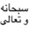had a plan for you before you were born, and He still has a plan for you. Allah’s plan for you is necessary and glorious. His plan is vital to your success and important to the world.  - Muslims believe - that Allah has a flexible plan for each human being: a plan that allows that person to benefit the world with his/her unique talents.

Experiences and Outcomes | Core Learning | Focus /Visits
RERC 2-26a I can identify some of the principles by which the Muslim Community live  RERC 2-27a I can share some of the key features and rituals associated with the Muslim community’s’ places of worship and festivals  RERC 2-27b I can identify some of the customs and artefacts related to the Muslim community and their festivals | I know that one of the fundamental principles by which the Muslim Community live, is adherence to the five pillars of Islam  I know that Muslims believe they must be clean before they pray and I know the key features of this ritual washing  I know that Ramadan is an important time for the Muslim community and that the festival which marks the end of this is known as ‘Eid ul Fitr’  I know some of the customs (fasting and prayer) associated with Ramadam.  I know some of the customs (forgiveness, wearing new clothes, celebrating with a special meal) of Eid ul Fitr.  Ramadan ppt attached | PowerPoint - http://www.primaryresources.co.uk/re/powerpoint/TheFivePillarsofIslam.ppt  Complete the 5 Pillars of Islam sheet.  Discuss why Muslims wash before prayer.  Watch - https://www.bbc.co.uk/education/clips/z4gkq6f  Key Fact:  When people go into the mosque they take off their shoes. This is to keep it clean for prayer.  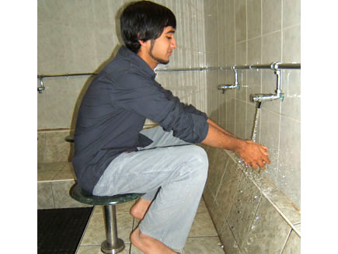  There is often a fountain or pool, or at least an area with water where people can wash (wudu). Muslim wash their hands, mouth, throat, nose, ears, arms up to the elbow and feet. This is a sacred wash that symbolises spiritual cleansing and purity in readiness for coming before God.  Ask some of the Muslim children to describe their experience of Ramdam & Eid ul Fitr.
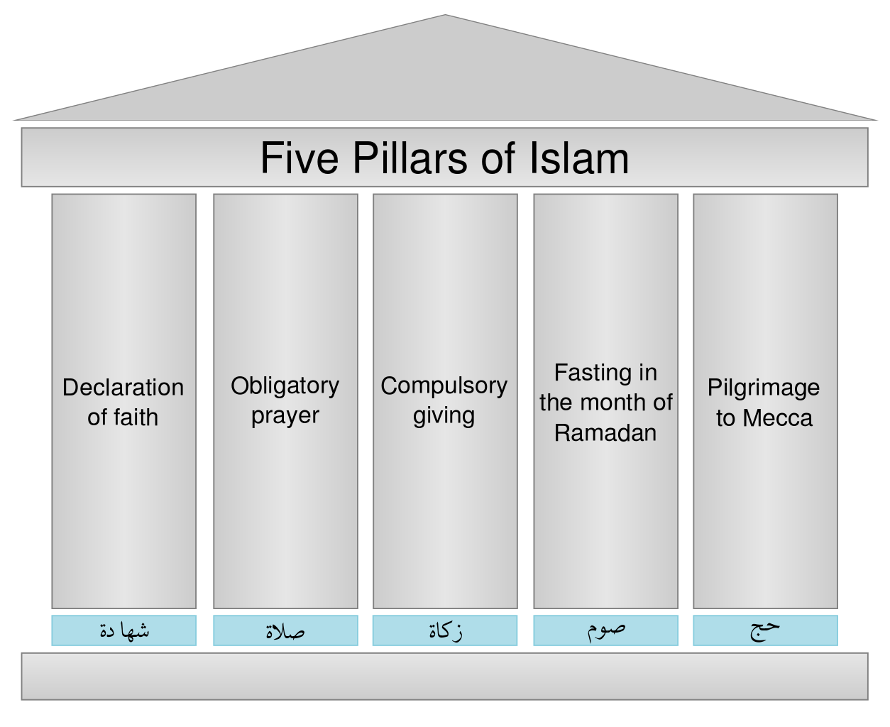
In each Pillar:
Draw how a Muslim could carry out their duty.
Write what that duty means.
Stage | Strand of Faith | Experience and Outcome | Core Learning | Focus/Visit
P7 | Hours of God | RERC 2‐16a I know that the Mass is at the heart of Catholic community life and I am developing an understanding of how to participate fully in this celebration. | I know that it is an obligation and privilege to attend Sunday Mass and I recognise my own responsibility to do so.  I am developing my ability to plan a celebration of the Eucharist and to participate in the various ministries open to me.  I understand and appreciate the role of the Altar servers and music ministry and have considered what my contribution to each of these could be. | P7 should actively be involved in preparing Liturgies in which the school and Parish community can participate. This should be linked to the Liturgical Year.
 | Reign of God | RERC 2‐21b I recognise the contribution of other Christian Churches to Jesus' Kingdom. I have explored ecumenical action and reflected upon its impact in the world. | I am aware that local Churches work together to build the Kingdom of God and I can identify ways in which my local parish collaborates with other Christian Churches. | Children should visit the local Church of Scotland and any appropriate Christian Denominations.  This should take place in May when the class are looking at the contribution of other Christian Denominations..

P7 – Other World Religions – Judaism
Experiences and Outcomes |  | Core Learning |  | Focus /Visits
RERC 2-25a I have explored some beliefs of the Jewish community.  RERC 2-26a I can identify some of the principles by which people of the Jewish faith communities live |  | I know that the Jewish community believe that their relationship with God is a Covenant one.  I know that, with Judaism, Abraham and Moses are people who entered into a relationship of covenant with God  I know that people of the Jewish faith seek to live by the 10 commandments as recorded in the Torah.  I know that love of God and neighbour are central principles within the Jewish faith community |  | Discuss the meaning of the word COVENANT  Covenant is a fancy word for a promise. In religion a covenant is a promise made between people and God.  Do a Bible search – find these Covenants  Watch https://www.youtube.com/watch?v=8ferLIsvlmI  This should be done in September when you are talking about the meaning of Covenants  God and Abraham  The covenant between God and the Jewish people is a thread running throughout the early parts of the Bible, and one of the vital pillars of Judaism.  God asks Abraham to do certain things, in return for which he will take special care of them.  The covenant between God and Jews is the basis for the idea of the Jews as the chosen people.  The first covenant was between God and Abraham.  God promised to make Abraham the father of a great people and said that Abraham and his descendants must obey God.  In return God would guide them and protect them and give them the land of Israel.
Experiences and Outcomes | Core Learning |  | Focus /Visits
As above |  |  | Abraham and Isaac  God ordered Abraham to abandon his way of life and leave his home country to live in the land of Canaan.  Abraham was 99 at the time, so this was a hard thing to ask.  This promise that Abraham would become the father of a great nation seemed impossible, since Abraham was very old, and his wife Sarah (90) had never been able to have children.  But God did cause Sarah to become pregnant with Isaac.  - By doing this God showed that he was in control of even the processes of nature like having children.  - God also showed that in order to keep his promises to his chosen people he would intervene in the world and alter it.  Later, God tested Abraham’s obedience by ordering him to kill his much-loved son Isaac as a sacrifice.  Abraham didn’t argue with God, he kept his side of the covenant and prepared to sacrifice Isaac. God stopped him from killing his son, but the story remains as a perfect example of the level of obedience that God expected.  The Second Covenant  The covenant that God gave at Mount Sinai reinforced the covenant that God had given to Abraham, and told the Jews what they would have to do as their side of the covenant.  God again promised to stay with the Jews and never to abandon them, because they were his chosen people.  ...if you will obey my voice and keep my covenant, you shall be my own possession among all peoples; for all the earth is mine, and you shall be to me a kingdom of priests and a holy nation...  God told the Jewish People, that for their part, they must dedicate themselves to serving God for ever, and to making the world a better and holier place by obeying God's laws.  The Jewish people agreed to do this by saying,  All that the LORD has spoken we will do.  Exodus 19: 1-8  The covenant at Sinai sets out in great detail the relationship between God and the Jews.  Much of Judaism can be seen as the working out of this relationship and the development of the God's rules into a complete lifestyle.  What does it all mean?  The covenant is made with the Jewish People as a whole, not with each individual Jew - and the result of this is that Jewish history is full of the Jews' attempts to create a good and just society. In modern times Jews continue to be very active in the fight for social justice and equality for all people
Experiences and Outcomes | Core Learning |  | Focus /Visits
RERC 2-27a I can share some of the key features and rituals associated with the Jewish community’s places of worship and festivals.  RERC 2-27b I can identify some of the customs and artefacts related to the Jewish community and their festivals | I know that the Jewish feast of Passover commemorates the delivery of the Jewish people from slavery.  I can describe the central rituals of the Passover meal, which is called the Seder meal.  I know that the Passover is commemorated every year and it is usually celebrated in the home.  I know that Hanukkah is an important festival for the Jewish community and this includes giving of gifts/cards/greetings and lighting of the menorah. |  | See Fact Sheet  Read the story of Passover  Watch  https://www.youtube.com/watch?v=UFU5NrPgutA  Discuss how Passover is celebrated today.  Make a plan/menu for a Passover feast.  Watch  https://www.youtube.com/watch?v=7tws_uMAEOs  Re write the story of Hanukah – research into how it is celebrated today.  Light Menora and say the prayers.  Watch http://www.chabad.org/holidays/chanukah/article_cdo/aid/103874/jewish/Blessings-on-the-Menorah.htm

Fact Sheet on Jewish Festivals
Fun Facts on Jewish Festivals for kids
 | Fun Fact 1 | What are the names of some Jewish celebrations and festivals? The Jewish people have many different festivals, they include; Passover, Shavuot, Rosh Hashanah, Yom Kippur, Sukkot and Hanukkah

 | Fun Fact 2 | One of the most important festivals in the Jewish year is called Passover (called Pesach in Hebrew). Passover is celebrated in springtime on the 15th day of the Jewish month of Nissan. Passover is a time when the Jewish people remember how their ancestors escaped from Egypt more than 3000 years ago

 | Fun Fact 3 | During Passover different festive foods are eaten. A Seder is a traditional plate of food, each item on the plate has a symbolic meaning to remind the Jews of the Pesach story

 | Fun Fact 4 | Foods in a traditional Seder meal include; a bitter herb, a paste of apple and walnuts, parsley or celery dipped in salt water, meat (traditionally a roasted lamb or goat bone, chicken wing or chicken neck) a baked egg, 3 separate matzot (yeast-less bread), and a bowl of salty water

 | Fun Fact 5 |  | Passover lasts for seven days in Israel and eight days in other countries
Fun Fact 6 |  | What is Hanukkah? Hanukkah is a celebration of historical Jewish military and religious triumphs

 | Fun Fact 7 | Hanukkah is a winter festival; it begins on the 25th day of the Jewish calendar month of Kislev and lasts for eight days and nights

 | Fun Fact 8 | The most important Hanukkah tradition is the lighting of the nine branched candlestick - the Menorah. Each night a candle is lit and a special blessing is given. The ninth candle is used to light the others it is called the Shamash or the servant candle

 | Fun Fact 9 | Traditional Hanukkah foods are often cooked in oil, common Hanukkah foods include latkes which are like potato pancakes

The Story of Passover

The story of the Passover
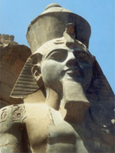
Moses went to see Pharaoh many times. Each time Pharaoh refused to release the Israelites. Moses warned Pharaoh that God would send terrible plagues on Egypt if Pharaoh did not let them go. The ten plagues were: blood, frogs, gnats, flies, blight of the livestock, boils, hail, locusts, darkness and the death of the first born
The final plague was the death of the first born. God told Moses that the Israelites should mark their doorposts with lamb's blood so that God could 'pass over' their houses and spare them from this plague. This is why the festival is called Passover.
Eventually Pharaoh gave in and told Moses and the Israelites to go at once. They left in such a rush that their bread did not have time to rise. This is why, during Passover, Jewish people eat unleavened bread called Matzah. It looks a bit like crisp bread.

How Passover is celebrated today
The celebrations last for seven or eight days, depending on where you live.
Some families clean their houses thoroughly to remove all crumbs of chametz (leaven). This remembers the Jews leaving Egypt who did not have time to let their bread rise. In many Jewish homes children enjoy taking part in a ritual search for any specks of leaven left behind
On the evening before the Passover begins, a special service called a Seder ('Order') takes place over a meal with family and friends in the home.
The Seder plate on the table consists of:
- A lamb bone
- A roasted egg
- A green vegetable to dip in salt water
- Bitter herbs made from horseradish
- Charoset (a paste of chopped apples, walnuts and wine)
On the table, there are three Matzot (unleavened bread) on top of each other. At the start of the Seder, the middle Matzah is broken and the largest piece is hidden. During the Seder the children hunt for it. The one who finds it receives a small prize.
Four small glasses of wine are drunk to represent the four expressions of freedom which refer to the Israelites being brought out of slavery. The wine symbolises joy and happiness.
An extra cup of wine is placed on the table and the door is left open for Elijah. Jews believe that the prophet Elijah will reappear to announce the coming of the Messiah and will do so at Pesach.
During the evening the story of how the Israelites fled from Egypt is retold from a book called the Haggadah ('Narration').
Everyone at the Seder each has a cushion to lean on. This is to remind them that they are now free people, no longer slaves.
Everybody takes part in reading the Haggadah, some in Hebrew and some in English, many songs are sung and four questions are asked by the youngest child. The father answers.

Hanukkah prayers

First blessing:
Blessed are You, Lord our G-d, King of the universe, who has sanctified us with His commandments, and commanded us to kindle the Chanukah light.

Second blessing:
Blessed are You, Lord our G-d, King of the universe, who performed miracles for our forefathers in those days, at this time.

Third blessing, recited only on the first night (or the first time lighting this Chanukah):
Blessed are You, Lord our G-d, King of the universe, who has granted us life, sustained us, and enabled us to reach this occasion.

Summary of RERC visits and OWR
Stage | Focus | Place | Time
P1 | I know the name of our parish(es) and priest(s) and I recognise that our priest(s) cares for our parish family. | Visit to St. Paul’s  Tour of Church / Meet Priest | September
P2 | I can find out about people and groups of people in my parish who care for children e.g. toddlers’ groups, children’s liturgy, our priest(s).  I recognise that we are all members of God’s family and, just as we celebrate special events with our families, we gather to celebrate special occasions with our Parish  family, e.g. Sunday Mass, baptisms, weddings, funerals. | Visit to St. Paul’s:  Tour of Church  Talk to Priest about how families celebrate special occasions in Church.  Meet representatives of Children’s Liturgy  See where children’s liturgy takes place.  Children should bless themselves from the font  Genuflect before sitting  Look at the Paschal Candle and Sanctuary Lamp | January
P3 | I have visited my local Catholic church and I can recognise the significance of the altar, holy water font, the tabernacle, Paschal Candle and the sanctuary lamp.  OWR – Judaism  I can recall from my learning that Jesus went to the Synagogue to pray  I know that the Jewish community today worship in a building called a ‘Synagogue’ | Visit to St. Paul’s  Preparation for the Sacrament of Reconciliation:  Visit to the Church to look at Baptismal Font & Confessional Boxes.  Preparation for the Sacrament of Reconciliation:  Visit to the Church to look at Baptismal Font & Confessional Boxes.  Find images of a Synagogue – discuss the main features  Visit to the Synagogue would be appropriate | February  September
Stage | Focus | Place | Time
P4 | I understand the significance of the following parts of the Mass:  • Gathering: Penitential Rite, Gloria (These take place at the Presidential Chair.)  • Liturgy of the Word: readings (including the Psalm); Gospel Acclamation; Gospel; Homily; Creed; Prayers of the Faithful (These take place at the Lectern.)  • Liturgy of the Eucharist: Offertory; Sanctus (Holy, Holy); Eucharistic prayer; Memorial Acclamation; Great Amen; Our Father; Sign of Peace; Agnus Dei (Lamb of  God); communion. (These take place at the Altar.)  • Dismissal.  I can show my understanding of the importance of the Liturgy of the Word by saying or singing the Gospel Acclamation and standing to greet the Gospel.  I can respond in word and gesture to the invitation to greet the reading of the Gospel.  I know that, during the Eucharistic Prayer, the priest offers the bread and wine to God and that this becomes the body and blood of Jesus.  I know that, at the Consecration, as the priest raises the bread and wine, transformed into the Body and blood of Jesus, I raise my gaze and then bow my head in prayer.  I can receive Communion prayerfully in word and gesture and take time to pray in thanksgiving for the gift of the Eucharist.  OWR – Islam  I know that the Muslim community worship in a building called a Mosque and I can identify the key features of this building | Visit to the Church to focus on the Lectern, Tabernacle and the Altar.  I know that the Muslim community worship in a building called a Mosque and I can identify the key features of this building  Visit to Mosque | September/October  November
Stage | Focus | Place | Time
P5 | I am familiar with the Stations of the Cross and I can reflect prayerfully on some of them.  I know that the Catholic Church uses icons, statues and images to enrich our worship and to focus our prayer and I have experienced such prayer.  OWR – Judaism  I can recall from my previous learning that the Jewish community go to the Synagogue to worship.  I can identify some of the key features of a Synagogue.  I know some of the practices and rituals (segregation, the service and clothing worn) associated with attendance at the Synagogue  I know some of the artefacts (the Ark, the Torah, the eternal light) in the Synagogue | Visit to the Church to pray the Stations of the Cross  Although this is not part of the Lent Planners, this could be done during Lent  Visit to Synagogue | Lent  January
P6 | Other Christian Denominations  I know that all those who are baptised, who identify Jesus as God’s Son and who believe in His Resurrection are called Christians.  I can recognise that all members of the Christian family are called to worship God, and to serve their local communities, in imitation of Jesus and the early Church.  I know that members of the Church of Scotland and other Christian denominations contribute to the building of Jesus’ Kingdom. | Visit to local Christian Churches | January

Stage | Focus | Place | Time
P6 | OWR – Islam  I know that Muslims believe they must be clean before they pray and I know the key features of this ritual washing | Visit to Mosque | (At time of Ramdam & Eid ul Fitr. )
P7 | Other Christian Denominations  I am aware that local Churches work together to build the Kingdom of God and I can identify ways in which my local parish collaborates with other Christian Churches.  OWR – Judaism  I know that the Jewish community believe that their relationship with God is a Covenant one.  I know that, with Judaism, Abraham and Moses are people who entered into a relationship of covenant with God  I know that people of the Jewish faith seek to live by the 10 commandments as recorded in the Torah.  I know that love of God and neighbour are central principles within the Jewish faith community | Visit to local Christian Churches  Visit to Synagogue | May  September

