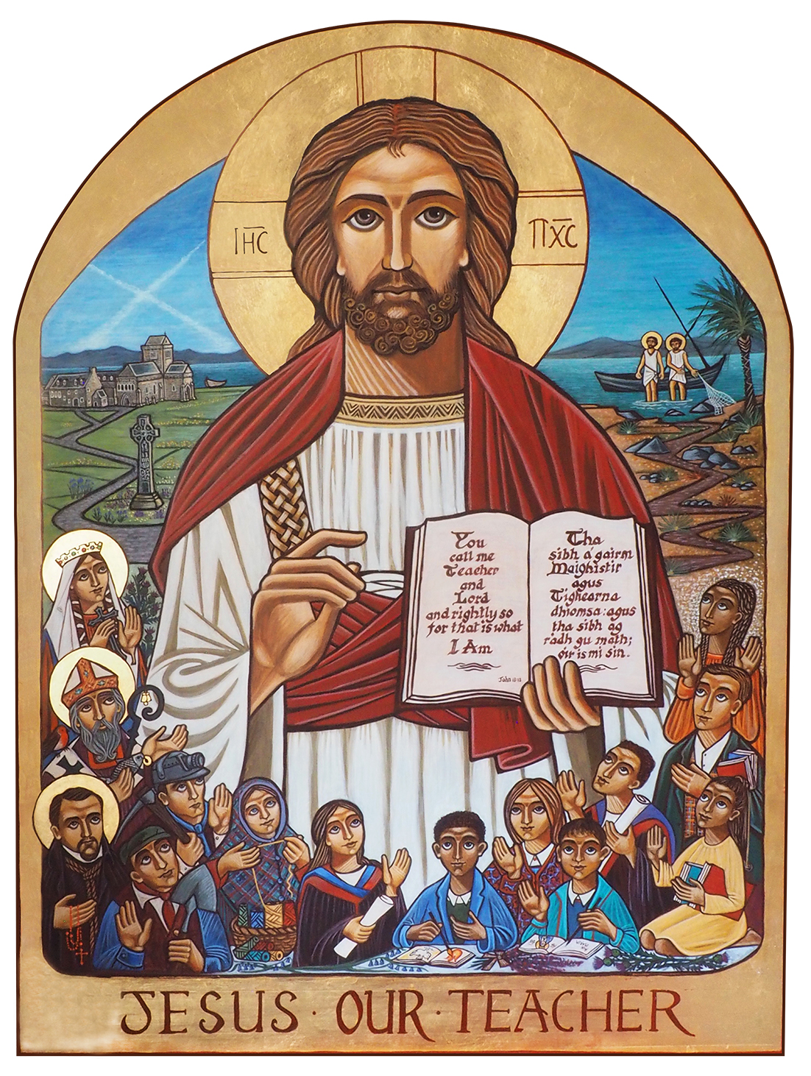

Jesus Our Teacher: Novena

“You call me Teacher and Lord—and you are right, for that is what I am.”
Gospel of St. John

What is a Novena?
In the Catholic Church, a novena is a devotion consisting of prayer for nine days, in which we ask God for special graces. These prayers may be simply a recitation of the Rosary, or small prayers throughout the day.

History of Novenas
The practice of saying novenas is derived from Scripture. After Jesus' Ascension into heaven, he told his disciples to pray together and devote themselves to constant prayer (Acts 1:14). The Apostles, Our Lady, and other followers of Jesus prayed together for nine consecutive days before, as promised by Jesus, the descent of the Holy Spirit on Pentecost.
A Novena is a spiritual pilgrimage and is often done by a group of people at the same time, praying for the same intention.

Novena to Jesus Our Teacher
Although we are in different parts of the country, each diocese will be preparing to welcome the Icon of Jesus Our Teacher at some point over the course of 2018. For the nine days before, during or after we welcome the Icon to the Archdiocese, we are invited to use scripture passages and reflections based on Jesus our Teacher to unite our thoughts and actions.

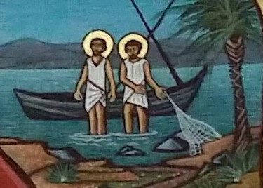
Day One

St Andrew

Reflection on the Icon

In the top right of our icon we see the patron saint of Scotland, St Andrew, called by Jesus to be an apostle.
We see a sign here of what is to come: the masts of the ship form the X of the Saltire, which represents the cross upon which St, Andrew was martyred for his faith in Jesus as the Son of God.
We thank God for the example of the saints, who show us how we can put our faith into action.

Prayer of St Andrew
Brother of Simon Peter, you heard John the Baptist say: “Behold the Lamb of God,” and you chose to follow Jesus. Leaving your nets, you became a successful fisher of souls. Lover of the Crucified Christ, you too were crucified like him. Teach us to live for Him and to bring others to Christ. Amen.
Novena Prayer to Jesus the Teacher
Jesus the Teacher help us to live up to the name of Christian. May we love our God, our neighbour and ourselves, may we trust you with every aspect of our lives, so that we will inherit eternal life. May we continue to build your Church through practising our faith in you as the Son of the living God.
We make these and all our prayers through Christ our Lord.
Our Father...
Hail Mary...
Glory Be to the Father..
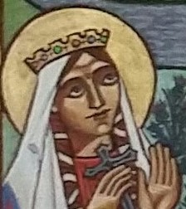
Day Two

St Margaret

Reflection on the Icon

On the left of our Icon we see the image of St Margaret of Scotland. St Margaret worked constantly to serve the poor in Scotland. She encouraged people to live devout lives and to grow in prayer and holiness.
St Margaret, gives us the perfect example of self-giving, always willing to reach out to others and not to count the cost.

Prayer of St Margaret
O God, who made Saint Margaret of Scotland wonderful in her outstanding charity towards the poor, grant that through her intercession and example we may reflect among all humanity the image of your divine goodness. Through our Lord Jesus Christ, your Son, who lives and reigns with you in the unity of the Holy Spirit, one God, for ever and ever. Amen.

Novena Prayer to Jesus the Teacher
Jesus the Teacher help us to live up to the name of Christian. May we love our God, our neighbour and ourselves, may we trust you with every aspect of our lives, so that we will inherit eternal life. May we continue to build your Church through practising our faith in you as the Son of the living God.
We make these and all our prayers through Christ our Lord.
Our Father...
Hail Mary...
Glory Be to the Father..
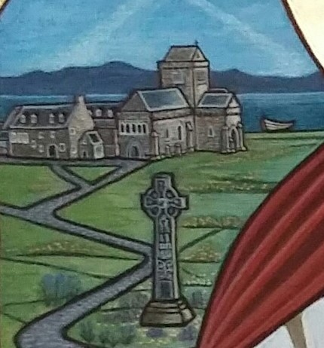
Day Three

St Columba

Reflection on the Icon
In the top left of our icon we see the island of Iona, founded by St Columba, with the Celtic cross representing how Columba and the other great Celtic saints brought Christianity to Scotland.
In the background we see the hills of Ireland, so important to the growth of the Catholic community in Scotland.
With buildings like Iona Abbey, and St Ninian’s Candida Casa in Whithorn, Christianity had a home here in Scotland. Again, we see St Andrew’s cross in the sky.

Prayer of St Columba
High King of Heaven, Almighty Father of us all, as your servant Saint Columba established a community built on love and trust, so grant that in all humility we may be your hands and your voices here on earth, working to build up the community of faith in the name of your Son, our Saviour Jesus Christ. Amen.

Novena Prayer to Jesus the Teacher
Jesus the Teacher help us to live up to the name of Christian. May we love our God, our neighbour and ourselves, may we trust you with every aspect of our lives, so that we will inherit eternal life. May we continue to build your Church through practising our faith in you as the Son of the living God.
We make these and all our prayers through Christ our Lord.
Our Father...
Hail Mary...
Glory Be to the Father..
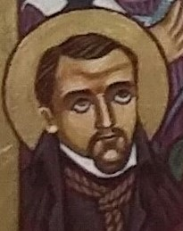
Day Four

St John Ogilvie

Reflection on the Icon
Saint John Ogilvie was a Scottish Catholic martyr. A Jesuit Priest, he ministered to the few remaining Catholics in the Glasgow area after the Scottish Reformation. In his endeavor to serve the Scottish Catholic community Saint John Ogilvie was arrested, tortured and killed.
St John Ogilvie, intercede for us, that we too might have the courage to share our faith with others and defend our beliefs, even in the most difficult of times.

Prayer of St John Ogilvie
Lord, you called John Ogilvie to follow Christ under the banner of the cross; to proclaim the gospel and to be a shepherd to your people. Inspired by his example of faith and courage, may we witness to Jesus Christ by the manner of our lives, marked by faith, hope and love. Through Christ our Lord. Amen.

Novena Prayer to Jesus the Teacher
Jesus the Teacher help us to live up to the name of Christian. May we love our God, our neighbour and ourselves, may we trust you with every aspect of our lives, so that we will inherit eternal life. May we continue to build your Church through practising our faith in you as the Son of the living God.
We make these and all our prayers through Christ our Lord.
Our Father...
Hail Mary...
Glory Be to the Father..

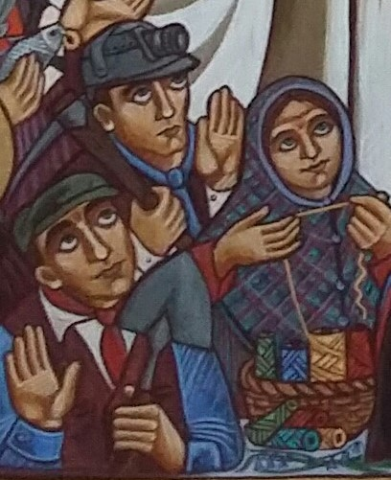
Day Five

Scottish Catholic Heritage

Reflection on the Icon
From the late 18th century to the early 20th century, the Catholic population grew quickly in Scotland, as people arrived from Ireland, Italy, Lithuania, Poland and other countries, coming to try to find work and freedom they could not find at home.
These people were not always welcomed, but worked hard in farming, construction, mining and weaving: poorly paid and tiring work.
They were very poor, but they paid out of their own pockets to set up Catholic schools, giving their children and grandchildren a way out of poverty while nurturing their faith.

Prayer for Immigrants
God of the journey, God of the traveller, we pray that those who seek to make a home in Scotland may find us welcoming and willing to help them build a home with us.
We pray for those who fan the flames of fear and discrimination against new Scots may be touched with your divine compassion.
We ask this through Christ our Lord. Amen.
Novena Prayer to Jesus the Teacher
Jesus the Teacher help us to live up to the name of Christian. May we love our God, our neighbour and ourselves, may we trust you with every aspect of our lives, so that we will inherit eternal life. May we continue to build your Church through practising our faith in you as the Son of the living God.
We make these and all our prayers through Christ our Lord.
Our Father...
Hail Mary...
Glory Be to the Father..
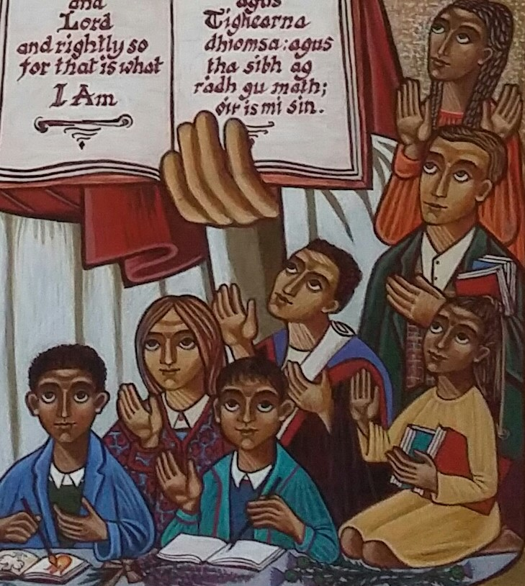
Day Six

Students of Catholic Schools Past and Present

Reflection on the Icon
In this image, the eyes of the students are turned towards Jesus, and they hold out their hands to him, ready to learn from him.
As we reflect on the students gathered around Jesus Our Teacher, we think also of ourselves and our own education. May we always be willing to lift our eyes and hands to God, to learn from him and to offer him our thanks and our praise.

Prayer for Students
Give students, O Lord, the vision to see the path You set before them. Grant them the courage to follow Your way, that through the gifts and talents You have given them, they may bring Your life and Your love to others. We ask this through Christ our Lord. Amen.

Novena Prayer to Jesus the Teacher
Jesus the Teacher help us to live up to the name of Christian. May we love our God, our neighbour and ourselves, may we trust you with every aspect of our lives, so that we will inherit eternal life. May we continue to build your Church through practising our faith in you as the Son of the living God.
We make these and all our prayers through Christ our Lord.
Our Father...
Hail Mary...
Glory Be to the Father..
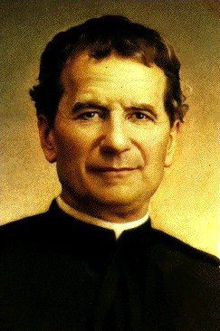
Day Seven

Saint John Bosco

Reflection
John Bosco is remembered as a man who dedicated his life to the service of young people and is regarded as the patron of all those involved in educating and caring for young people.
As we pray today, through the intercession of St John Bosco, we remember all those who taught in our Catholic schools before the 1918 Education Act: priests, sisters, brothers and laypeople who gave so much so that children could have a Catholic education.
We remember too all those who continue to work in our Catholic schools today. May they strive to help young people to make an informed and mature response to God’s call to relationship.

Prayer of St John Bosco (Patron Saint of Teachers)
O God, who raised up the Priest Saint John Bosco as a father and teacher of the young, grant, we pray, that, aflame with the same fire of love, we may seek out souls and serve you alone. Through our Lord Jesus Christ, your Son, who lives and reigns with you in the unity of the Holy Spirit, one God, for ever and ever. Amen.

Novena Prayer to Jesus the Teacher
Jesus the Teacher help us to live up to the name of Christian. May we love our God, our neighbour and ourselves, may we trust you with every aspect of our lives, so that we will inherit eternal life. May we continue to build your Church through practising our faith in you as the Son of the living God.
We make these and all our prayers through Christ our Lord.
Our Father...
Hail Mary...
Glory Be to the Father..
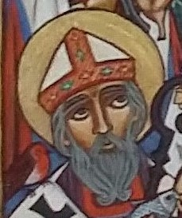
Day Eight

St Kentigern

Reflection
Through the intercession of St Kentigern, Scottish Bishop and Patron Saint of Glasgow, we pray for our Church in Scotland, Our Bishops and priests.
Heavenly Father, give our bishop holiness of life and wisdom to direct and guide our archdiocesan family so that we may grow in your love.
We ask this through Christ our Lord.

Prayer of St Kentigern
Lord our God, You chose St Kentigern as bishop to spread the light of faith by the preaching of your Word: Grant our prayer, that we who celebrate his memory may always be true to his teaching and so grow daily in faith and holiness.
We ask this through our Lord Jesus Christ, your Son, who lives and reigns with you and the Holy Spirit, One God, for ever and ever. Amen. Words © ICEL

Novena Prayer to Jesus the Teacher
Jesus the Teacher help us to live up to the name of Christian. May we love our God, our neighbour and ourselves, may we trust you with every aspect of our lives, so that we will inherit eternal life. May we continue to build your Church through practising our faith in you as the Son of the living God.
We make these and all our prayers through Christ our Lord.
Our Father...
Hail Mary...
Glory Be to the Father..
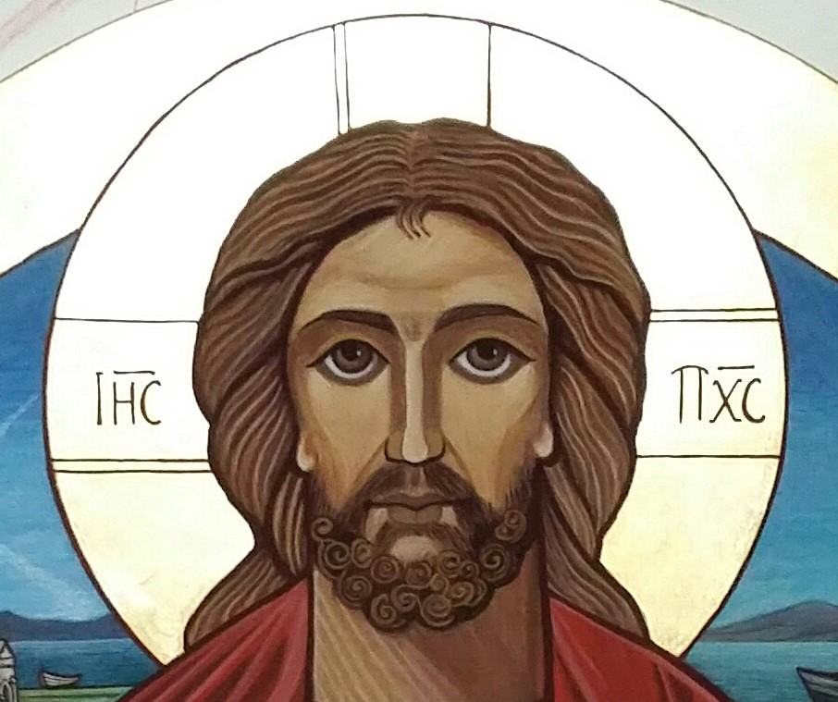
Day Nine

Jesus Our Teacher

Reflection
Jesus our Teacher, in your love for us, help us to develop our own talents so that we may become like you and lead lives of goodness.
Bless all learners and all teachers. May our Catholic schools continue to serve our families, our communities and our country.
Help us, through our learning, to believe in you and to celebrate the life of your Church.
Help us to grow in holiness as we grow in friendship with you and try to become your saints.
We make this prayer in the name of Jesus, our Lord.
Amen.

Novena Prayer to Jesus the Teacher
Jesus the Teacher help us to live up to the name of Christian. May we love our God, our neighbour and ourselves, may we trust you with every aspect of our lives, so that we will inherit eternal life. May we continue to build your Church through practising our faith in you as the Son of the living God.
We make these and all our prayers through Christ our Lord.
Our Father...
Hail Mary...
Glory Be to the Father..

