Advent Art
Theme: Preparing for Jesus’ Birth
Jesse Tree
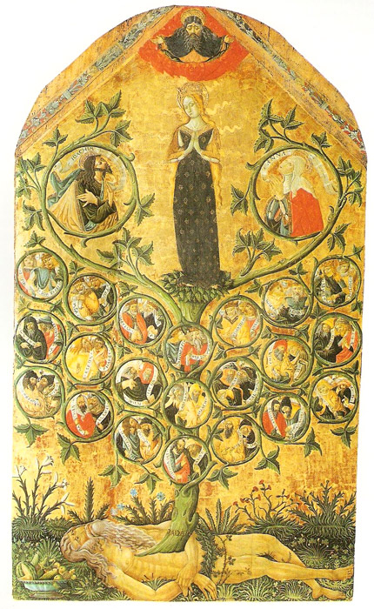
Matteo da Gualdo, Genealogical Tree of the Line of David (The Tree of Jesse) 1497 Gualdo Tadino, Museo Civico

Main focus: The birth of Jesus
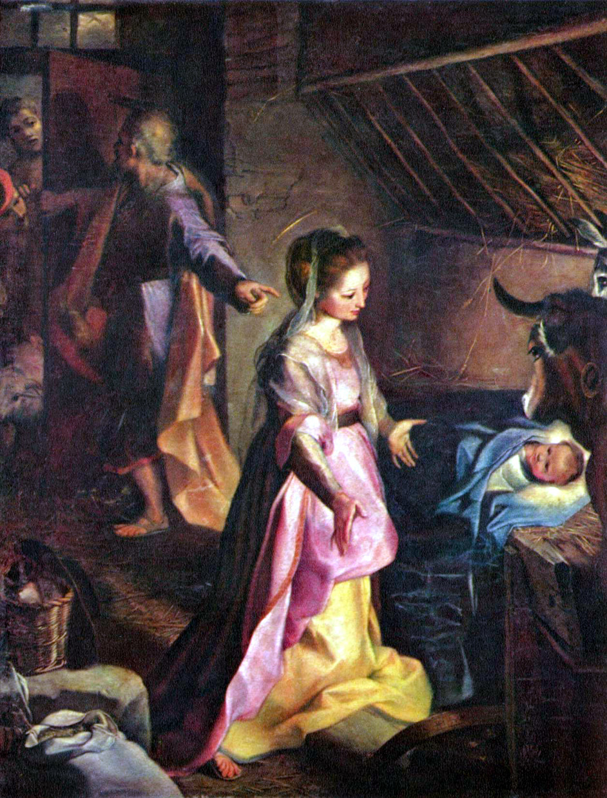

The Nativity, Federico Barocci

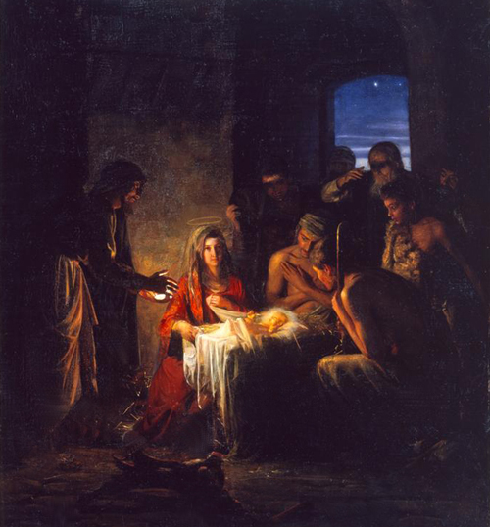

The Nativity/The Birth of Christ – Carl Bloch

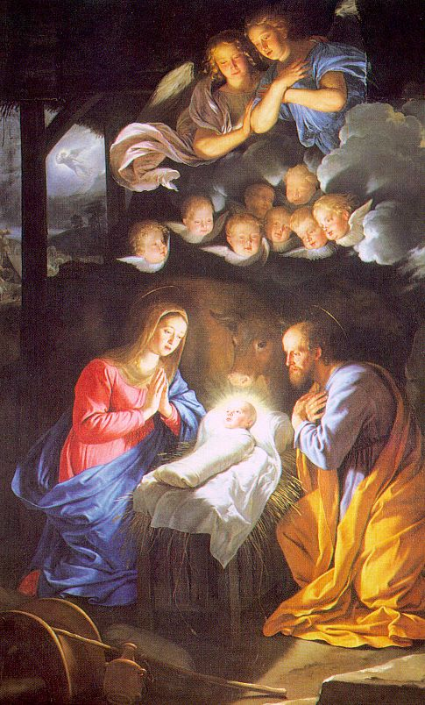
The Nativity, Philippe de Champaigne, 1643

Main Focus: Jesus had a family too

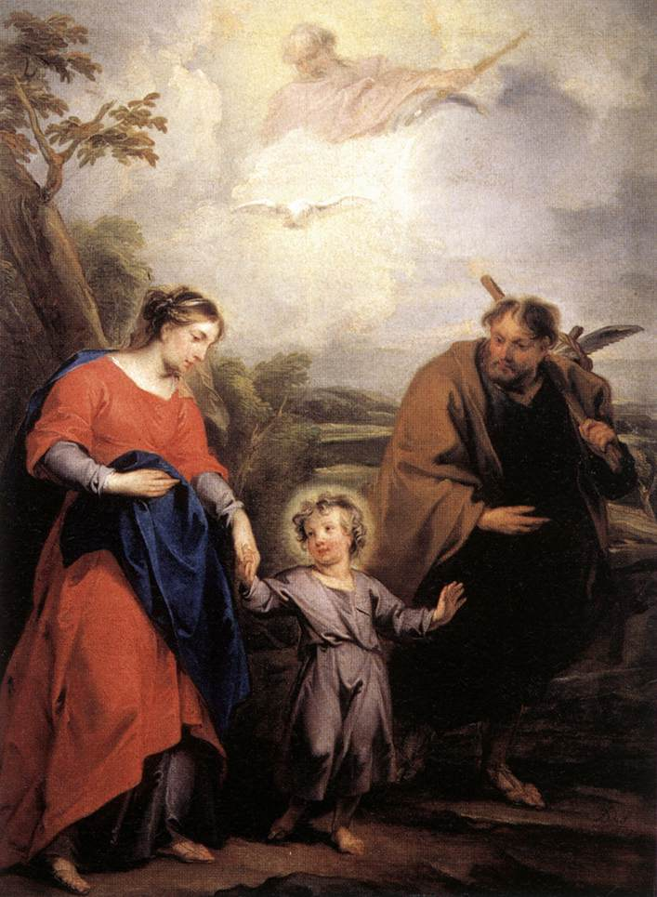

Trinity and the Holy Family - by WIT, Jacob de - from Amstelkring Museum, Amsterdam

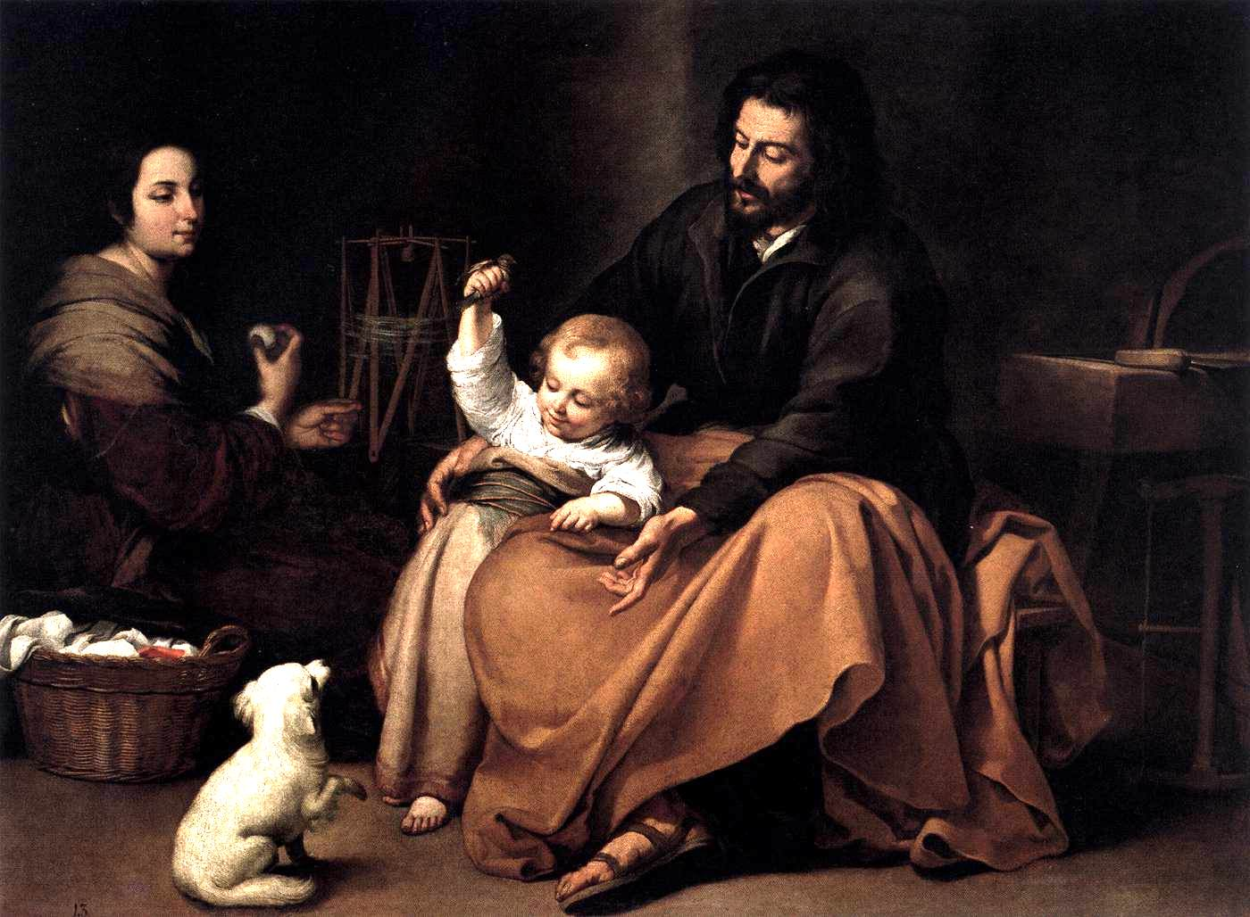
Bartolomé Esteban Murillo.The Holy Family with a Little Bird. c.1650. Oil on canvas. Museo del Prado, Madrid, Spain

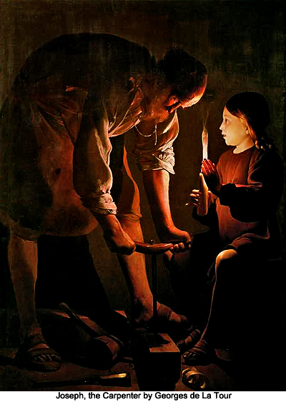
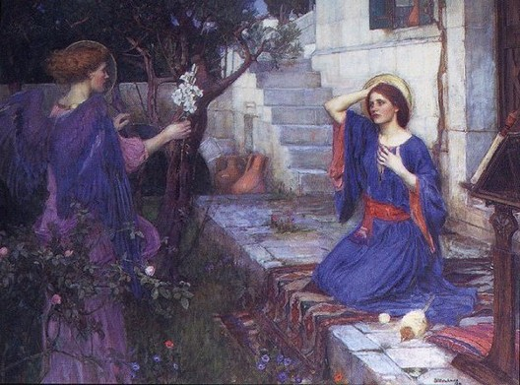
Main Focus: The Annunciation

The Annunciation – John William Waterhouse – 1914

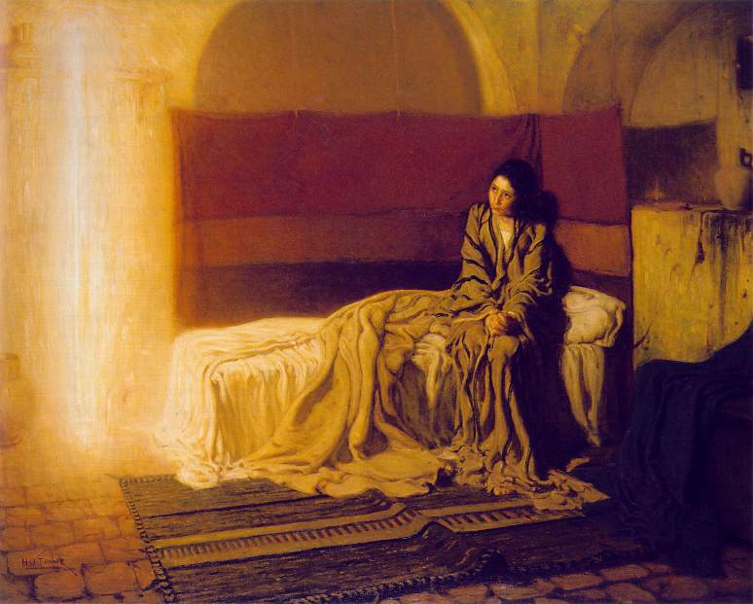

The Annunciation, Henry Ossawa Tanner, 1898

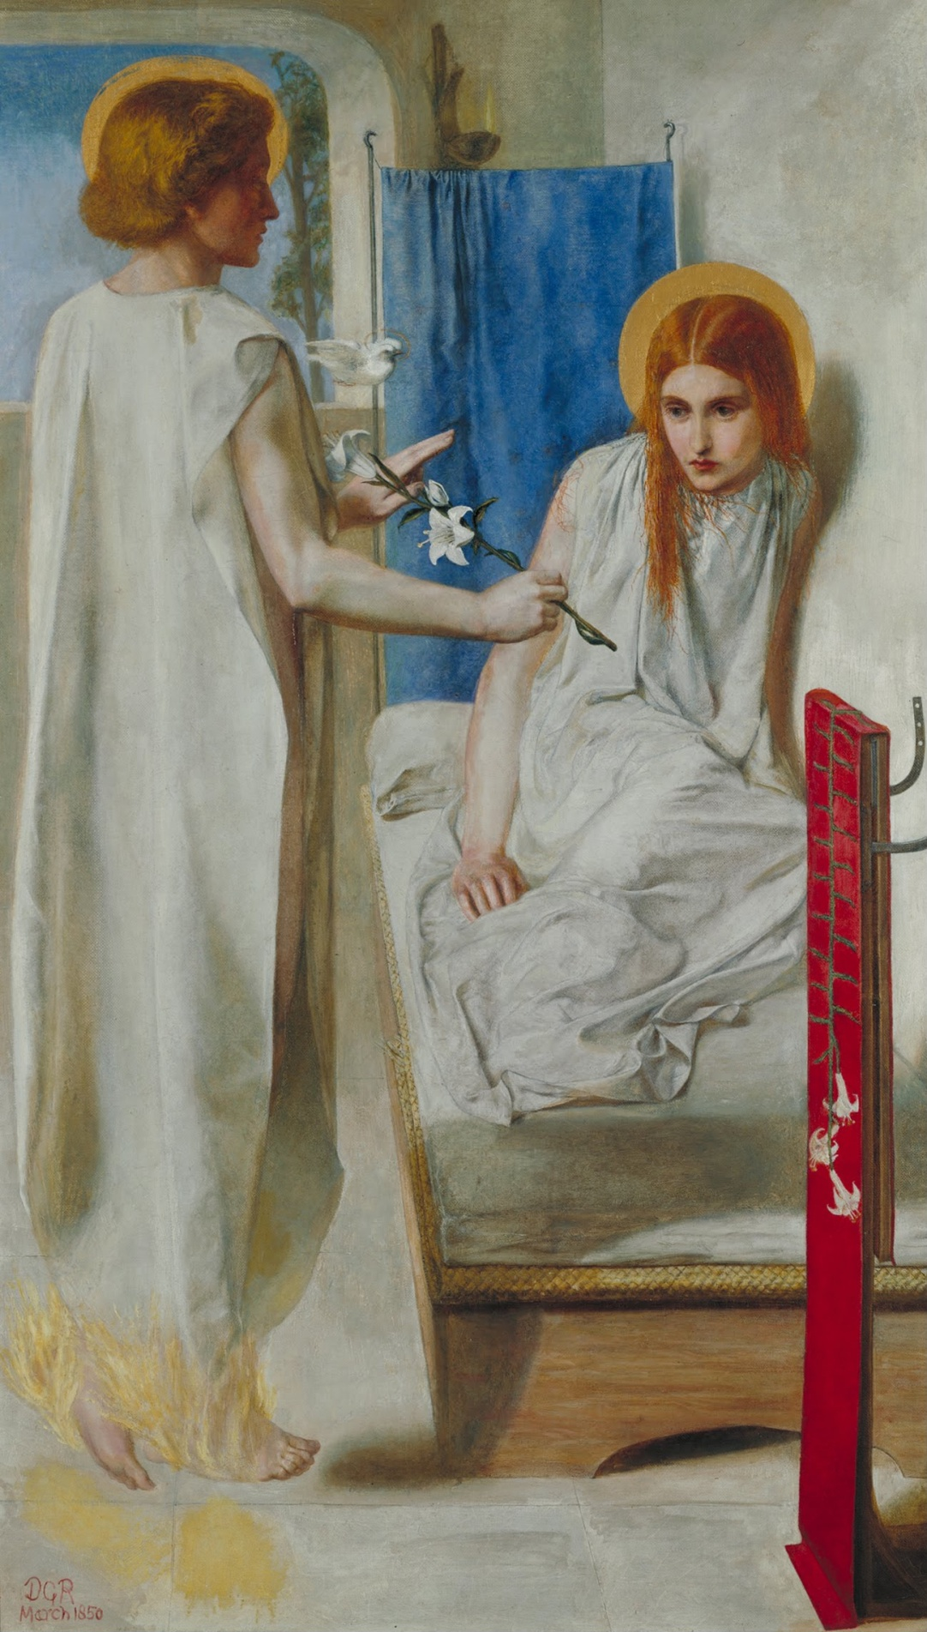

The Annunciation, Dante Gabriel Rossetti, 1949-50

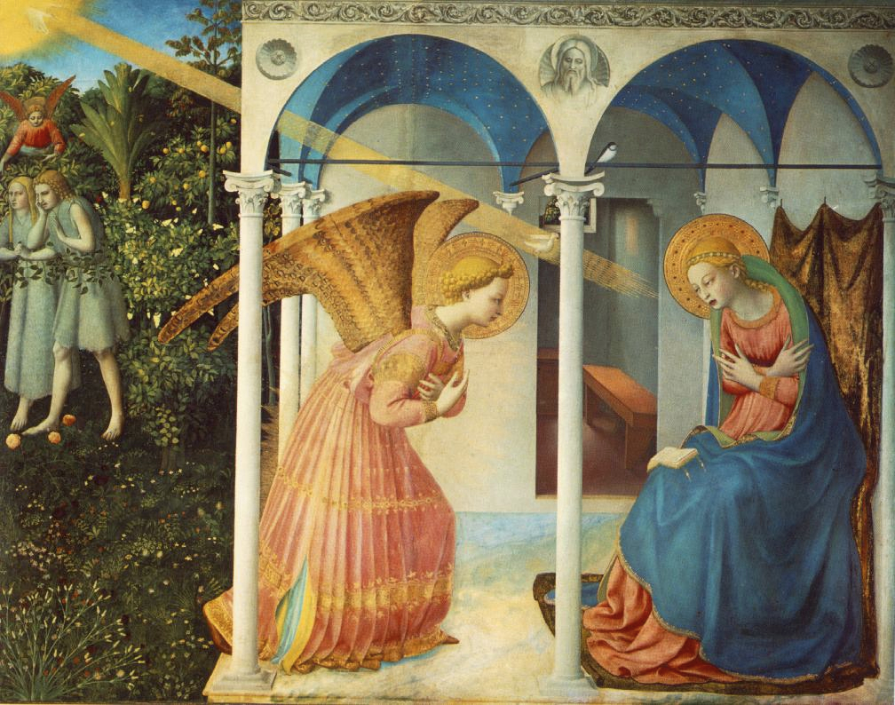

The Annunciation , Fra Angelico, 1436

