Primary 2 Advent Art
Theme: The Visitation
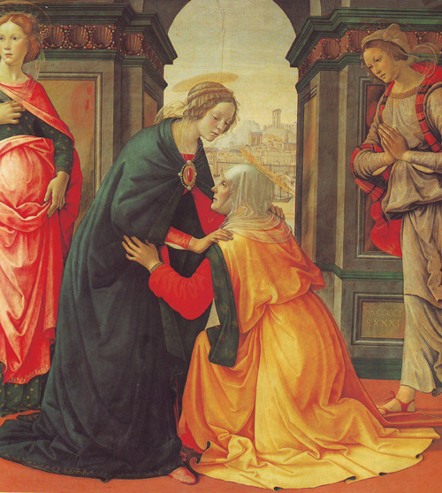

The Visitation, Domenico Ghirlandaio, 1491, Paris, Musee du Louvre

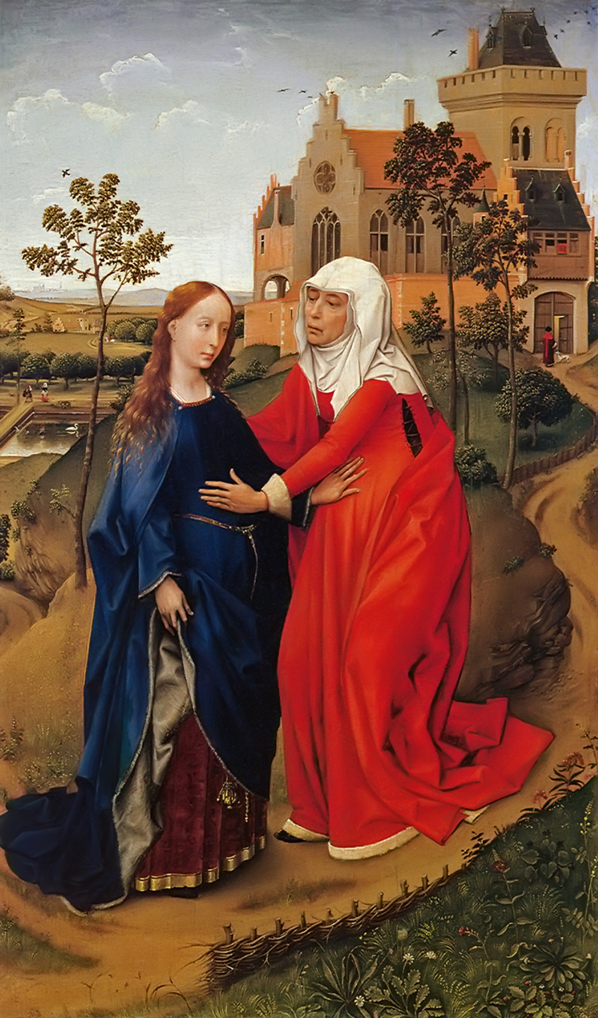

The Visitation, Rogier van der Weyden, 1426-30 Leipzig, Museum der Bildenden Kunste
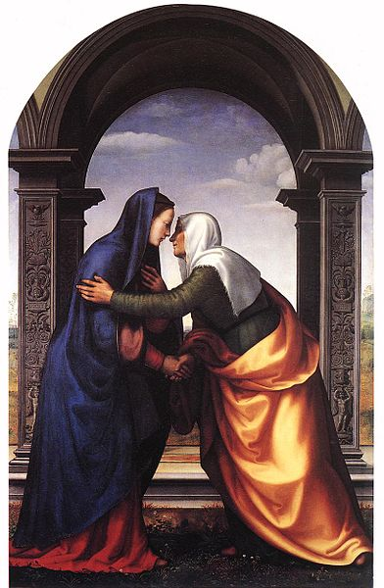

The Visitation, Mariotto di Bigio di Bindo Albertinelli, 1503
Galleria degli Uffizi, Florence
Theme: Preparations for the birth of Jesus
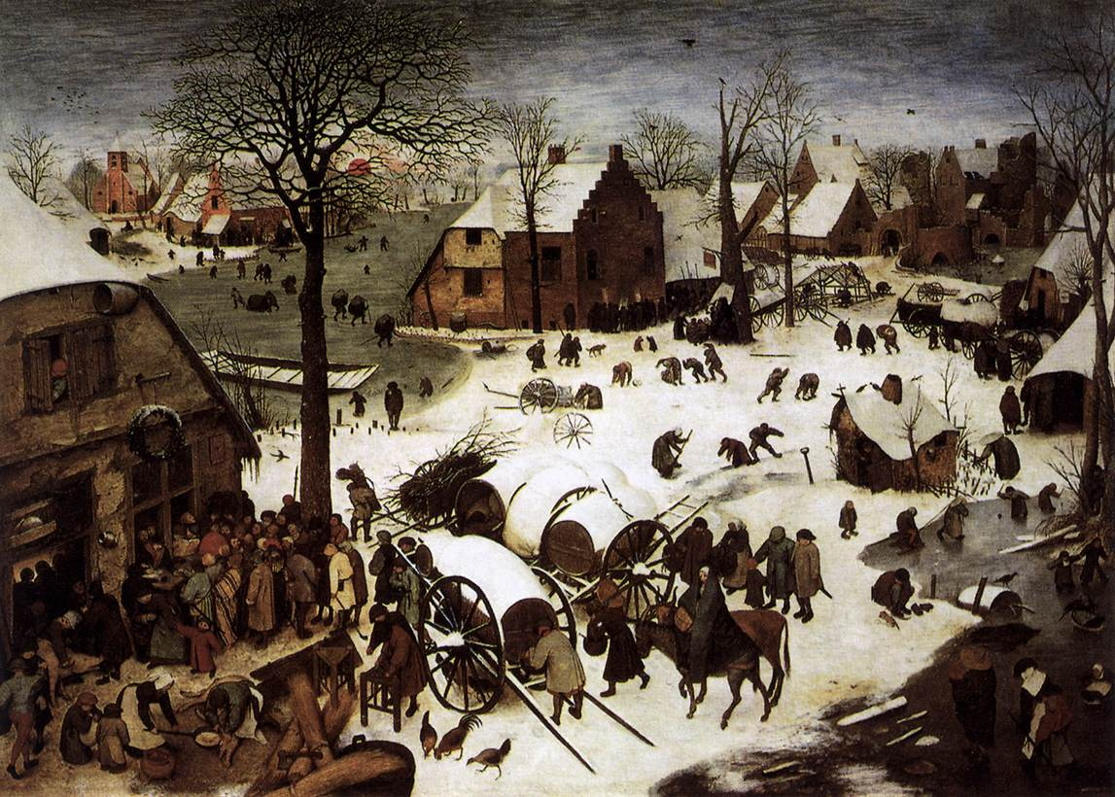

Pieter Bruegel the Elder, The Census at Bethlehem, 1566, Brussels, Musees royaux des beaux-arts

Theme: The Gloria
The song sung by the angels to rejoice the birth of Jesus.
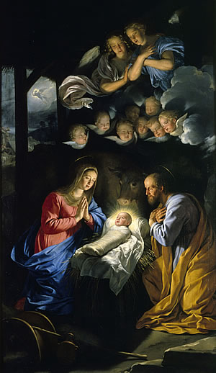
Nativity by Philippe de Champaigne

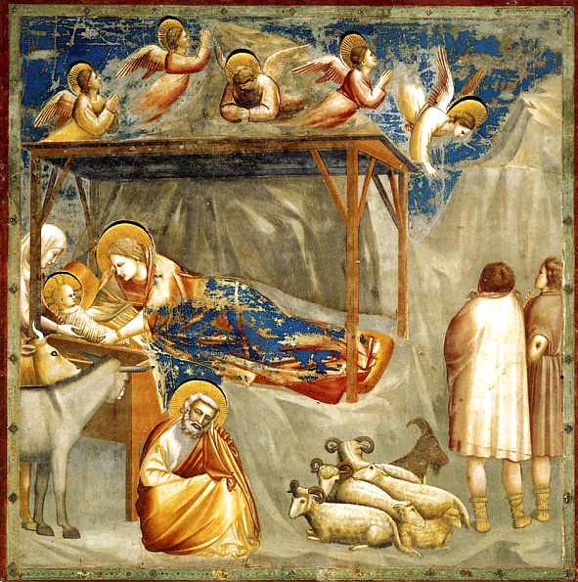

Giotto, The Nativity 1305-1306

