Primary 4 Advent Art
Theme: The Journey of the Magi
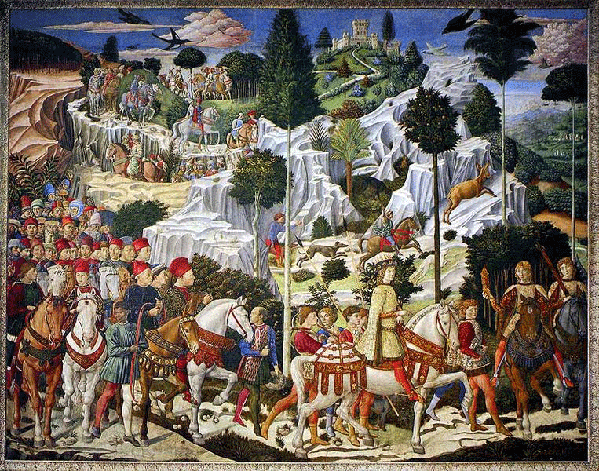

Benozzo Gozzoli's ''Journey of the Magi'', Fresco in the Medici-Ricardo Palace, Florence (1459–61)

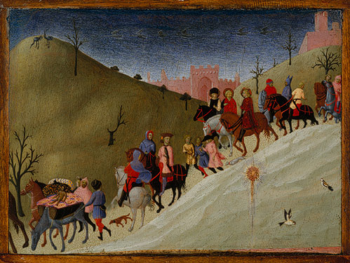
The Journey of the Magi (fragment), ca. 1435
Sassetta (Stefano di Giovanni) (Italian, Sienese, active by 1423, died 1450)
Tempera and gold on wood

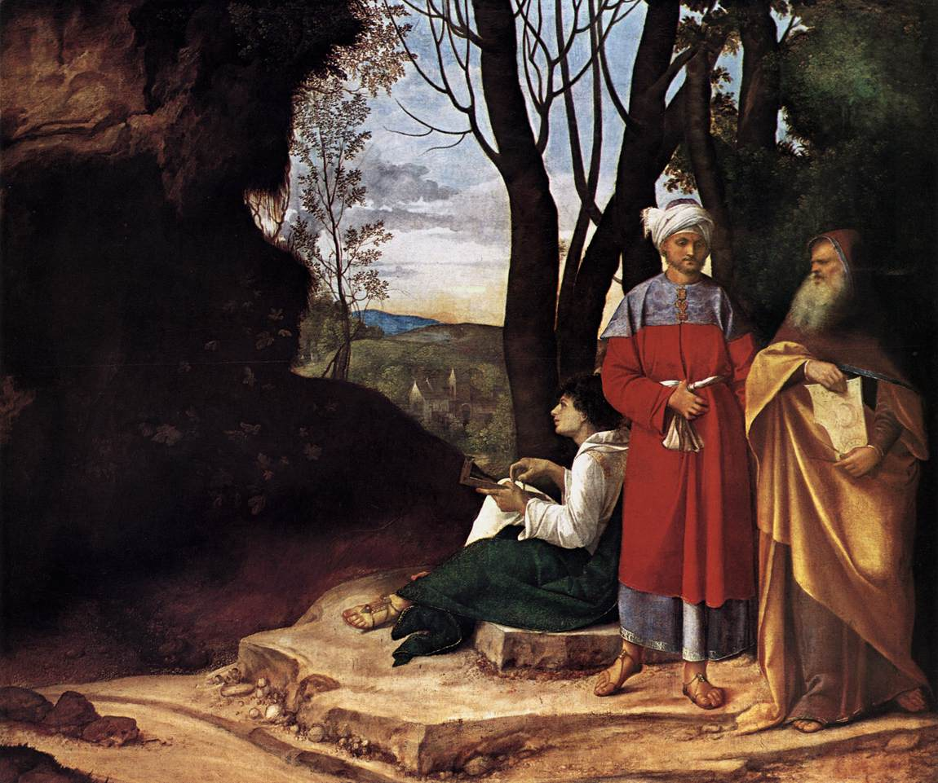

Giorgione. The Three Philosophers. c.1508. Oil on canvas. Kunsthistorisches Museum, Vienna, Austria.

Theme: Adoration of the Magi
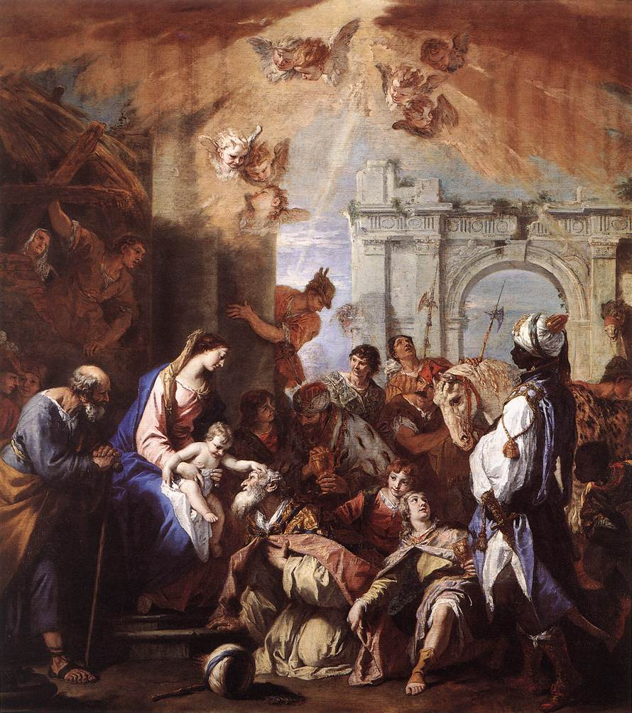
Sebastiano Ricci, The Adoration of the Magi, 1726-30.
Oil on canvas, 330,2 x 289,6 cm Royal Collection, Windsor

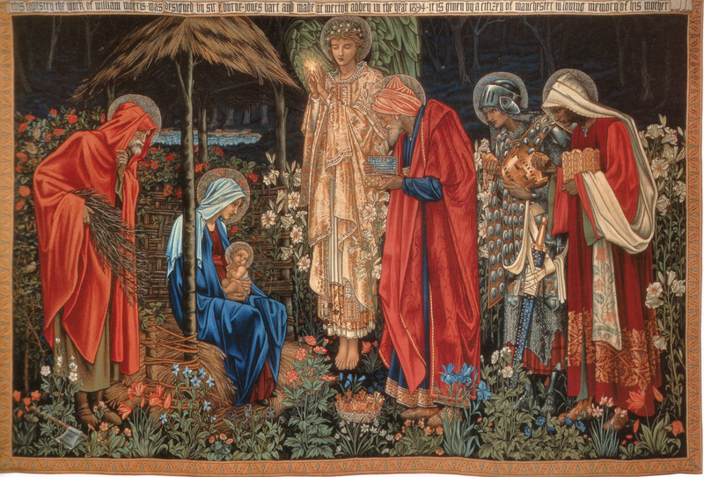

Adoration of the Magi Tapestry
The Adoration of the Magi, tapestry, wool and silk on cotton warp, 101 1/8 x 151 1/4 inches (258 x 384 cm.), Manchester Metropolitan University Designed 1888, woven 1894

