Primary 5 Advent Art
Theme: Mary as the first of all believers.
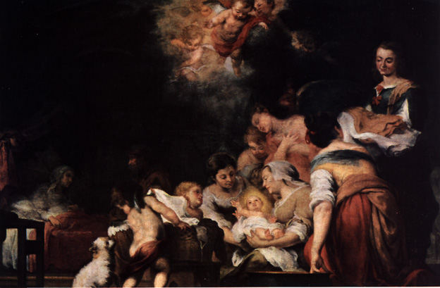

The Birth of the Virgin Mary - Esteban Murillo (Louvre, Paris)

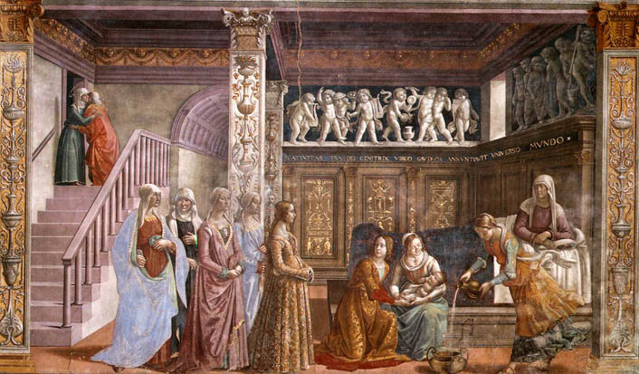
Birth of Mary: 1486-90
Cappella Tornabuoni, Santa Maria Novella, Florence

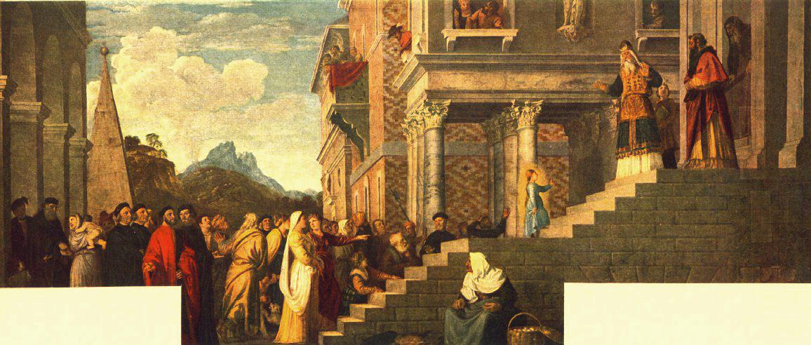

The Presentation of Mary in the Temple
Titian, 1534-38, Venice, Gallerie dell’Accademia

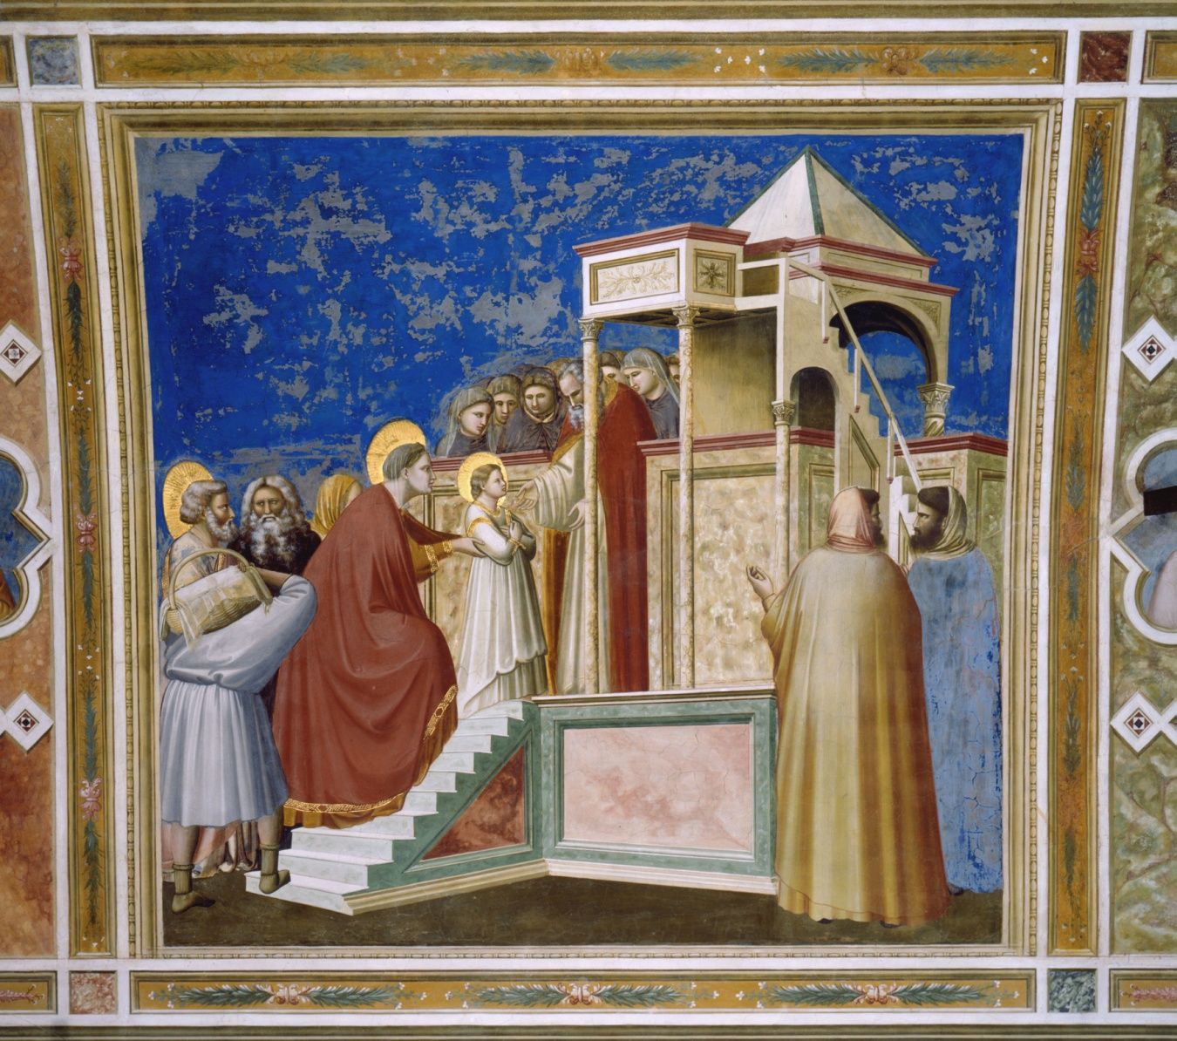
The Presentation of Mary in the Temple. Fresco by Giotto, 1303-05.

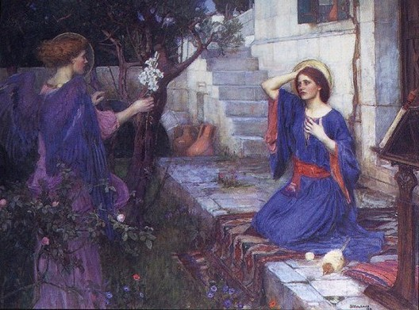
John William Waterhouse
The Annunciation 1614 Oil on canvas

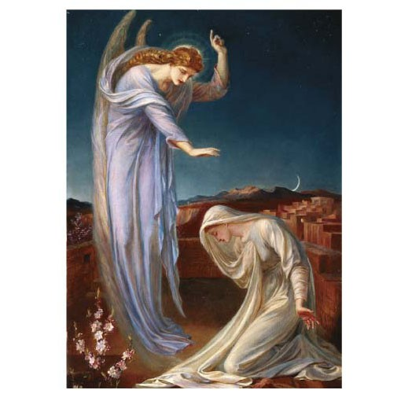

The Annunciation, Frederic James Shields

Theme: The Life of John the Baptist
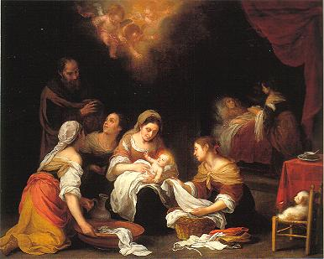
The Birth of John the Baptist
1540's
The Hermitage, St. Petersburg

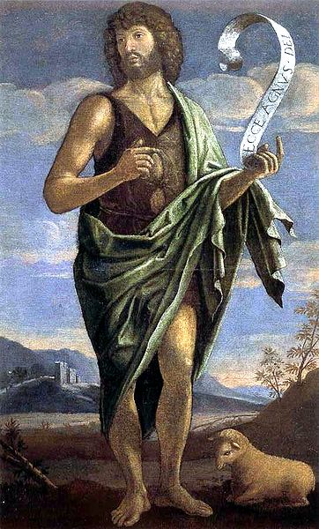

John the Baptist by Bartolomeo Veneto, 16th century

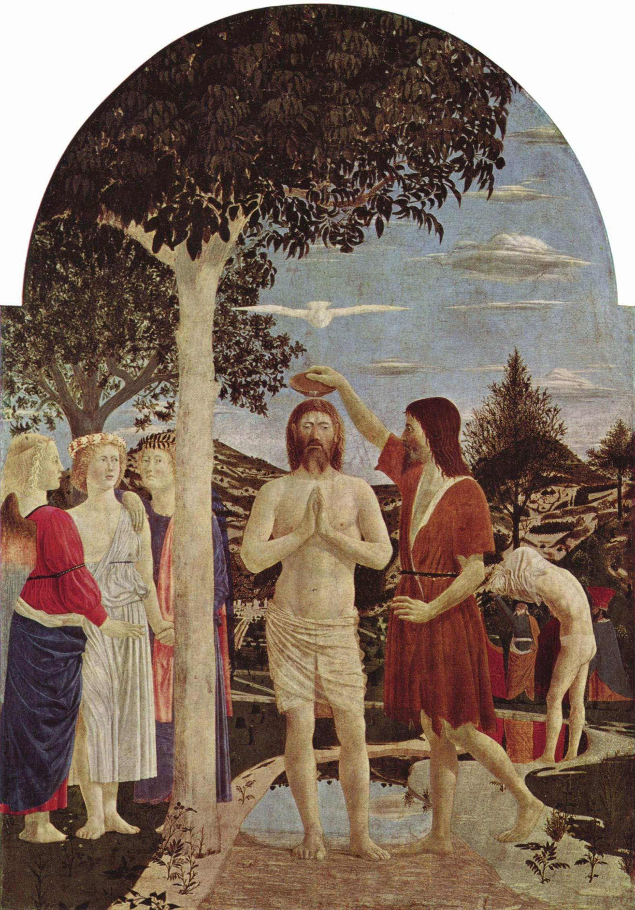

The Baptism of Christ

1450s, Piero della Francesca

