Primary 6 Advent Art
Theme: Advent
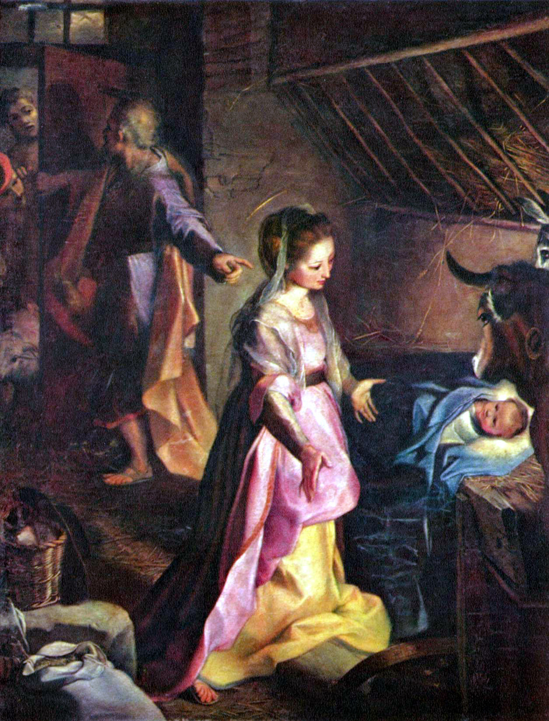

The Nativity, Federico Barocci

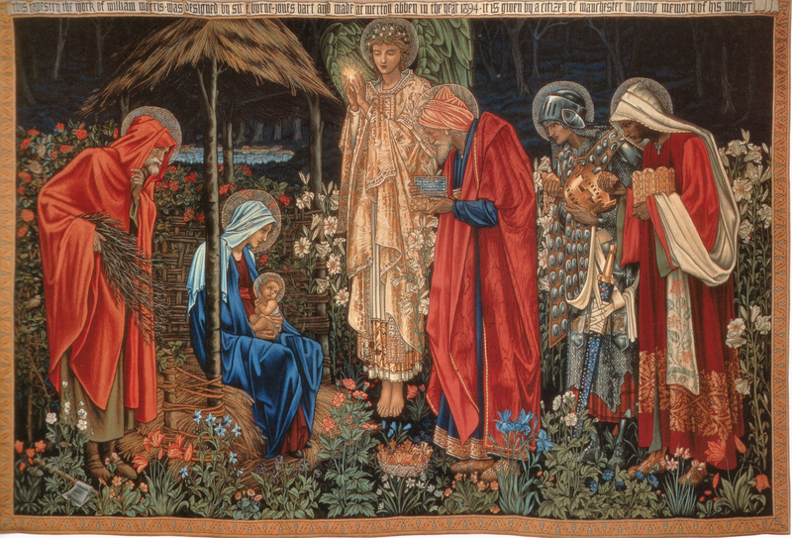
Adoration of the Magi Tapestry
The Adoration of the Magi, tapestry, wool and silk on cotton warp, 101 1/8 x 151 1/4 inches (258 x 384 cm.), Manchester Metropolitan University Designed 1888, woven 1894

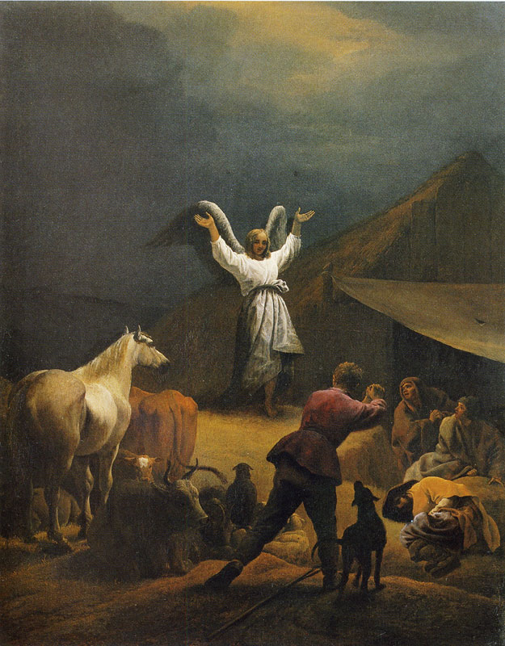
Pieter van Laer
Annunciation to the shepherds
60 x 47.5 cm Oil on panel
Museum Bredius, The Hague

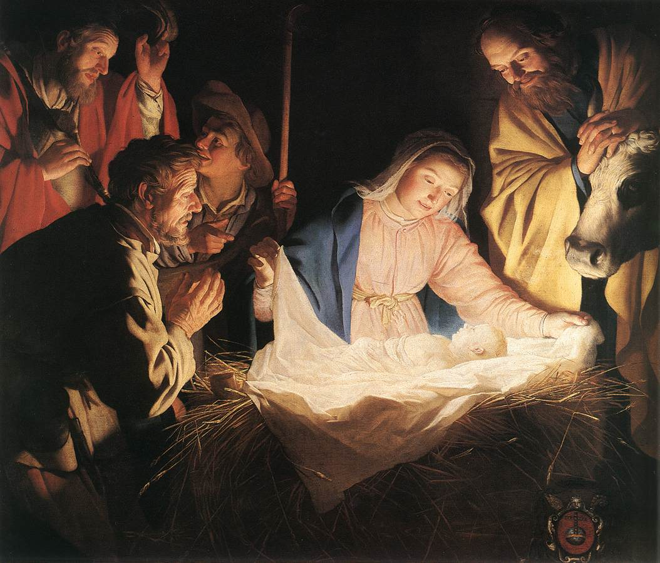
Gerard van Honthorst - Adoration of the Shepherds
1622 Oil on canvas Wallraf-Richartz-Museum

There: Reconciliation
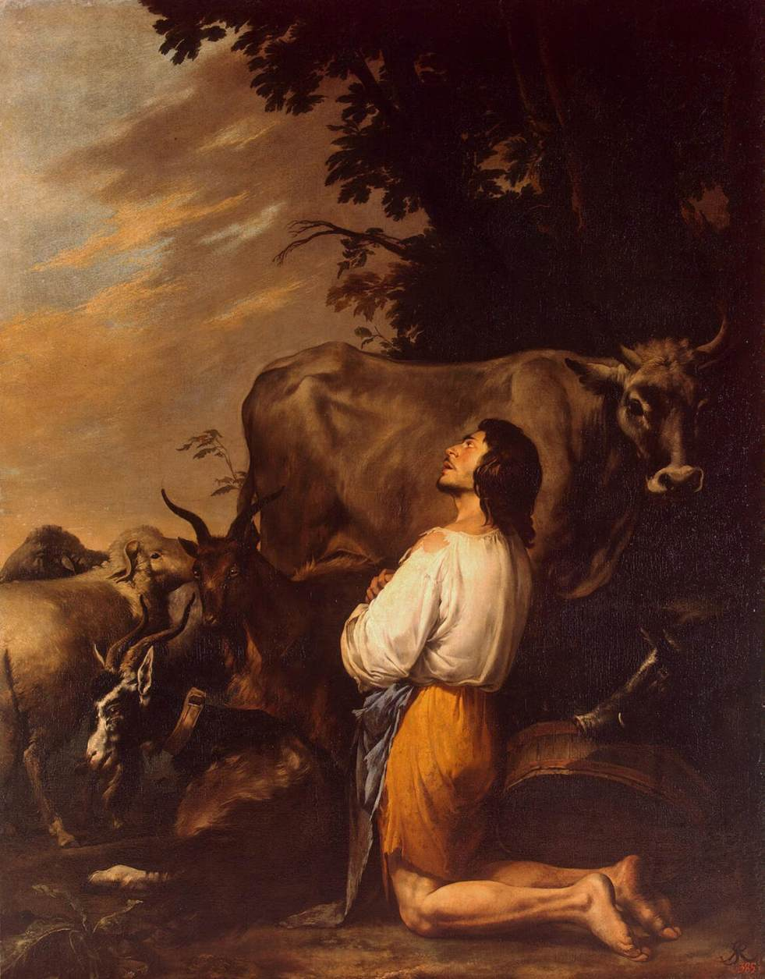
ROSA, Salvator
The Prodigal Son
1651-55
oil on canvas, 254 x 201 cm
The Hermitage, St. Petersburg
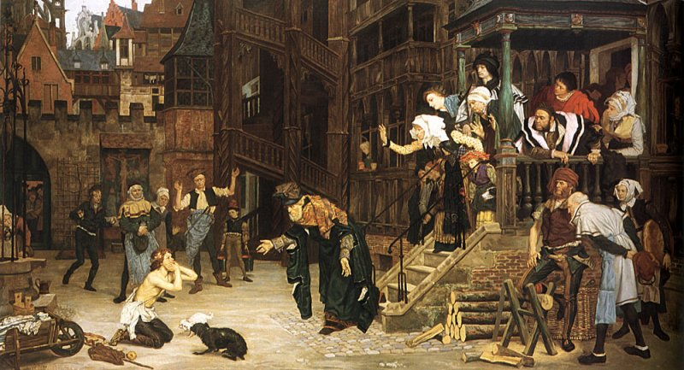

James Tissot 1836 – 1902 The Return of the Prodigal Son (1862)
oil on canvas — 1862 private collection

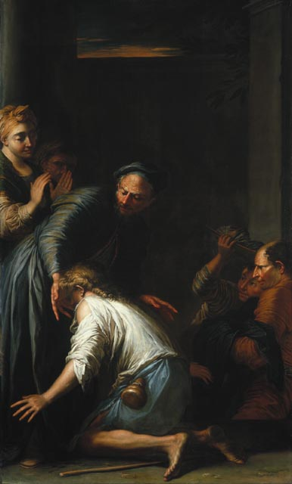
Salvator Rosa
Italian, 1615 – 1673 oil on canvas 200 x 118 cm
Purchased 1981 National Gallery of Canada

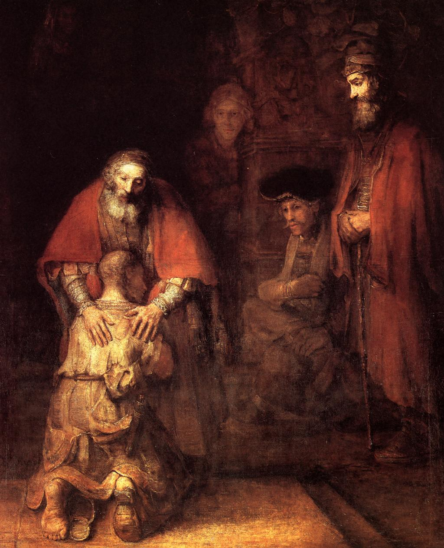
Rembrandt – The Return of the Prodigal Son – 1669
Oil on canvas, Hermitage, St. Petersburg, Russia

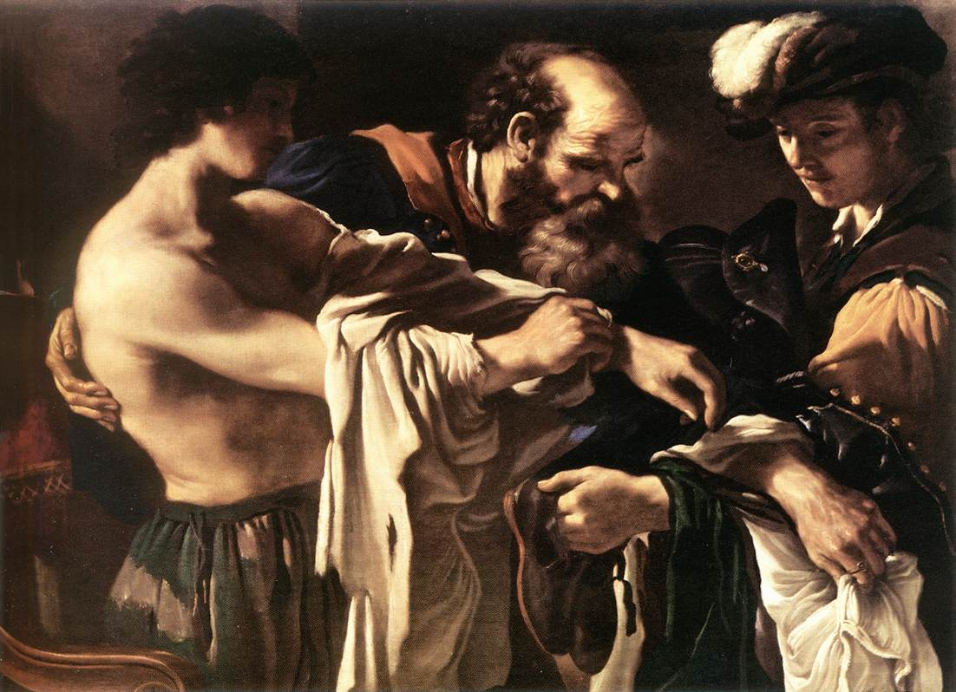

GUERCINO, Return of the Prodigal Son
1619 Oil on canvas, 107 x 144 cm
Kunsthistorisches Museum, Vienna

