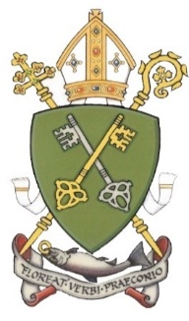

Jesus the Teacher: an Introduction to Our Icon
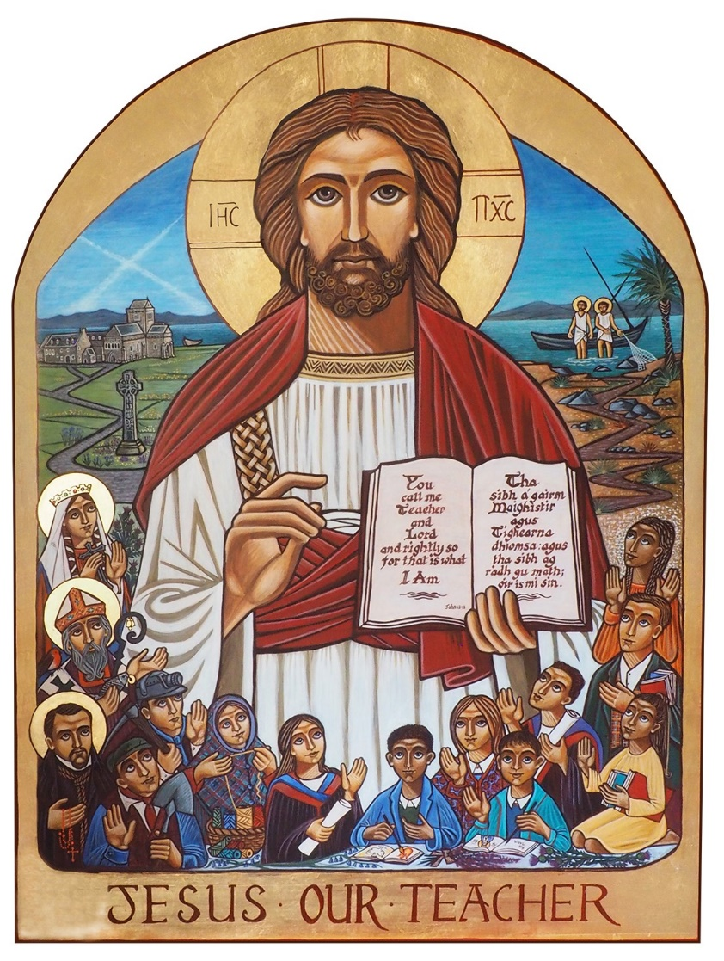

What is an icon?
Religious icons are symbols or representations of a greater “object,” but in this case, the “object” is a person: Christ or one of the saints in heaven. Icons are like quick links in that they give us a kind of symbolic snapshot of holy persons who are in heaven. More than that, religious icons are a form of prayer. When you look at an icon, it is meant to make you aware that you are in the presence of God. Icons, then, are not just art with a religious theme; rather, they are sacred art because they bring the viewer to the sacred.
Icons have been called windows to heaven or doorways to the sacred. When you are standing in front of an icon, it is as if you are looking through a window into the heavenly world of the mystery. But this is a two-way window. As you look through the window, you are also being seen with the eyes of love by those in the icon. It’s like you become a part of the mystery that the icon seeks to express.
“In the beginning was the Word,” wrote St John. “He is the image [ikon in Greek] of the invisible God, the firstborn of all creation,” wrote St. Paul. We meet him still in both word and image.
Jesus Our Teacher
The Icon of Jesus Our Teacher was commissioned by the Scottish Catholic Education Service to mark the centenary of the 1918 Education Act. It has been written by artist Bernadette Reilly and will be used as the focus for our prayer, meditation, reflection and liturgical celebrations to mark the centenary. We hope that the Icon, and all that it represents, will be a fitting legacy for the first 100 years of the partnership between Church and State in governing Catholic Schools in Scotland.
In the top right of our icon we see the patron saint of Scotland, St Andrew, called by Jesus to be an apostle. We see a sign here of what is to come: the masts of the ship form the X of the Saltire, which represents the cross upon which St, Andrew was martyred for his faith in Jesus as the Son of God.

Let us pray . . .
In silence, we take a moment to think about how we are called to learn from Jesus, and to take his message of love, justice and peace into our school and our communities.
We thank God for the example of the saints, who show us how we can put our faith into action.
St Andrew, pray for us.
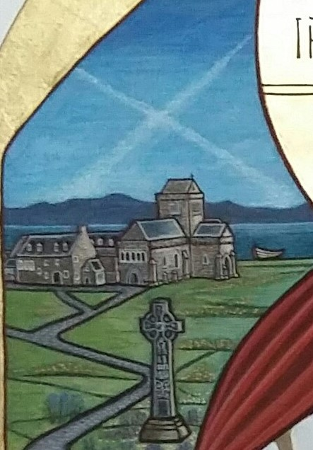
In the top left of our icon we see the island of Iona, founded by St Columba, with the Celtic cross representing Columba and the other great Celtic saints who brought Christianity to Scotland. In the background we see the hills of Ireland, so important to the growth of the Catholic community in Scotland. With buildings like Iona Abbey, and St Ninian’s Candida Casa in Whithorn, Christianity had a home here in Scotland. Again, we see St Andrew’s cross in the sky.

Let us pray . . .
In silence, let us think for a moment of how God finds a home in our own communities.
We reflect on our parishes and our Catholic schools.
We are grateful and pray for those men and women who bravely brought the Word of God and the faith and traditions of the Church to us, and to those who continue to do so today
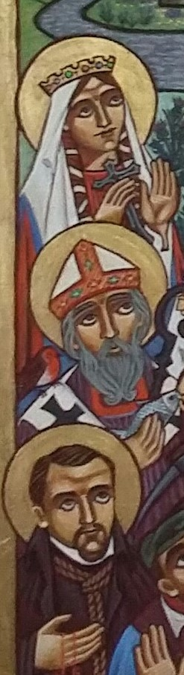
We pray for our priests and bishops, and all lay people who support the work of our parishes and schools.
St. Columba, pray for them.
Following the path from Columba’s Abbey at Iona, and at the right hand of Jesus, we find St. Margaret of Scotland, St. Mungo (St. Kentigern), and St. John Ogilvie, three great Scottish saints.
They serve as examples to us, and remind us of the great part that the Catholic Church and the faithful have played in shaping the history of our nation. They remind us of the importance of charity, leadership and devotion to our faith, and to always be aware of how we conduct ourselves in the service of God and our neighbour.
Through their goodness and devotion, they are now found at God’s right hand and continue to serve Him and intercede for us.
Let us pray . . .
In silence, we take a moment to think about those times when we may find it difficult to live our faith, and to stand up and say what we believe in, in a world that doesn’t always agree with us.
We thank God that, in those times, we can turn to Him and, through the intercession of the Saints and strengthened by the Holy Spirit, we can show His love through word and action. May we always remain faithful to his truth.
St Margaret, Saint Mungo, Saint John Ogilvie,
Pray for us.
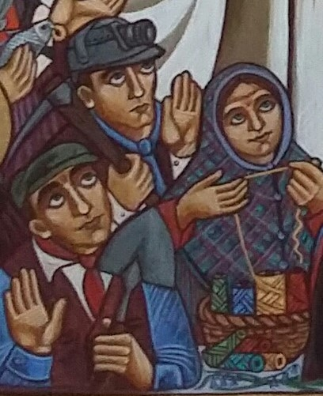
From the late 18th century to the early 20th century, the Catholic population grew quickly in Scotland, as people arrived from Ireland, Italy, Lithuania, Poland and other countries, coming to try to find work and freedom they could not find at home.
These people were not always welcomed, but worked hard in farming, construction, mining and weaving: poorly paid and tiring work.
They were very poor, but they paid out of their own pockets to set up Catholic schools, giving their children and grandchildren a way out of poverty whilst also nurturing their faith. These schools were supported by the Church through parishes and Religious Orders.
Let us pray . . .
Let us take a moment to think of what it must have been like for those people who arrived here with nothing, hoping to build a better life for their own families and for the wider community.
We are thankful that the sacrifices they were willing to make helped to provide us with the education we receive now, and have improved life for people throughout Scotland.
We pray for all those in our country today who have come to Scotland from other countries, bringing their gifts and talents. We ask that we may always welcome those who seek shelter here, recognising their potential and their dignity.
Jesus, teacher, teach us to welcome the stranger.
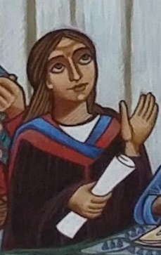
As the value of what was happening in Catholic schools became clear, and as the Church and the Catholic population fought for them to be recognised, the government agreed to fund Catholic schools, and to allow them to continue to run their schools in such a way as to ensure that young people were able to grow in knowledge and practice of their faith, as well as their academic knowledge.
More and more children from Catholic schools were able to stay at school for longer and to get better qualifications. Gradually, they were able to achieve places at universities and further education, and began to enter the professions and more skilled work.
Catholic schools were not just good for Catholics, they were good for Scotland. Everyone benefitted from the education they provided.
Let us pray . . .
In silence, let us take a moment to think of the impact of education in our lives.
We think of all the people we have relied upon and used their skill and learning to improve so many aspects of our lives.
We are thankful that, through the generosity and perseverance of others, we have received an education that allows us to be hopeful; to be confident; to be understanding and compassionate.
Let us use our education not just for ourselves, but for the greater good. Let us use our education as catechists for the good of our parishes.
Jesus, teacher, teach us your ways.
As we come to the present day, we find Catholic schools continuing to contribute to the common good in Scotland.
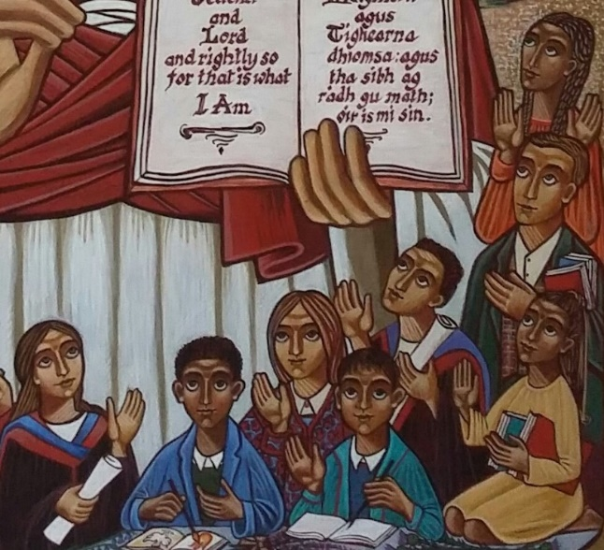
Many young people, of all faiths and none, of many races and cultures, benefit from the quality education provided. In addition, they gain from and add to the caring, inclusive Catholic ethos which looks beyond exam results to the love and development of the whole person.
Young people learn to be outward-looking global citizens, looking for ways to use their gifts and talents in living the Gospel.
In this image, their eyes are turned towards Jesus, and they hold out their hands to him, ready to learn from him. They are Scotland’s future. They are the future of the Church.
Let us pray . . .
We are thankful for the opportunities that we are given. We ask for God’s help in recognising them, and in making the best of them.
May we always be willing to lift our eyes and hands to God, to learn from him and to offer him our thanks and our praise.
Jesus, teacher, teach us your wisdom.
As we have explored our icon, and the history of Catholic schools in Scotland, we have looked at many images. However, at the centre of our journey is Jesus, the unchanging teacher and source of all our learning.
Like the figures in the icon, we are called to him; we gather to him, and we learn from him
Let us pray . . .
Lord,
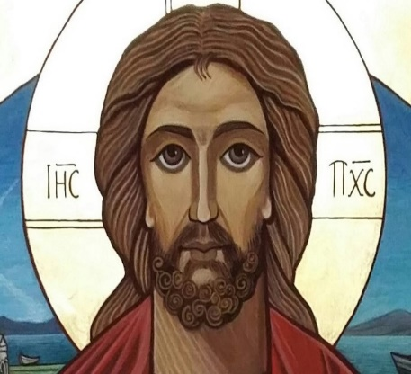
as we mark this important time in our history, we gather to you.
We thank you for all those who built and protected our school communities. May we appreciate the gift and the legacy they have left for us.
Help us to continue on their path, helping young people to grow in knowledge and love of you and your holy Church.
May we know ourselves and others better by knowing you. Let us take your love to all people.
Amen.

