Month/Season: January Class: Primary 3 Level: First
Themes:
1. Forgiveness
2. The Holy Trinity
3. Baptism

Strands of Faith : Experiences and Outcomes | Core Learning | Learning & Teaching  Class/School/Home/Parish | Resources | Assessment
In the image of God  RERC 1‐02a  I know that a loving God has created me and that my uniqueness can develop according to God's plan for me | I know that God has created me in his image (Genesis 1: 26‐27), that he loves me and that his love for me will never come to an end.  I know that one of the gifts God gives us is the gift of choice, called “free will” and that this is a sign of his love.  I know that sometimes we choose to respond to God’s love, and when we do we become more like Jesus, e.g. loving, compassionate, merciful.  I understand that we can pray to God to help us to make good choices.  I know that, just as Jesus and others forgive me, I am called to forgive others even when this is difficult. I know that we remember this when we pray the Our Father. | Class: - Teacher reads from the bible Genesis 1: 26‐27 to the class and discusses with the children that God created human beings in His image. What do we mean by God created human beings in His image? Why do you think God created human beings in His image? Do we all look the same? What things are similar among us? What things are different among us? Teacher explains to the class that although God made us in His image, we all have different hair colour, height, personalities, dislikes, etc. God has made each of us unique and he loves each and every one of us. Children complete God Created Me Worksheet.  Class: - Teacher discusses with the class the concept of love with the children. Who loves them? Who do you love? How do you show that you love someone? How do you know that someone loves you? Do you ever get annoyed with someone you love? Do you ever fall out with someone you love? Teacher explains to the children that the love God has for us will never come to an end. Teacher discusses with the class what this means. Does God still love you when you do something naughty? Does God love you when you are old? Does God love some people more than others? Children complete God’s Love Worksheet.  Class: - Teacher explains to the class that when God created them and because God loves them so much, God gave them the gift of choice. This means that God allows us to make choices on how we live our lives.  This gift of choices is called free will. When we choose to respond to God’s love, we become more like Jesus. Teacher discusses with the class what choices would make us more like Jesus e.g. forgiving their friends, sharing their toys and being kind. Teacher explains to the children that sometimes it is hard to make good choices and we can pray to God to help us to make good choices. Teacher discusses with the children the format of a personal prayer asking God to help us make good choices. What could the prayer start with? What help are we asking for? How would the prayer end? Children write a personal prayer asking God to help them make good choices. Writing a Prayer Worksheet is attached to planner.  Class: - Teacher explains that Jesus always showed forgiveness to everyone, even his friends who pretended that they did not know him and the people who sent him to die on a cross. Teacher discusses with the class the concept of forgiveness and how difficult this can sometimes be. Have you ever forgiven someone? Has someone ever forgiven you? Was it hard to forgive? Were you glad to be forgiven? Do you think Jesus found it hard to forgive? Could you have forgiven the friends who pretended not to know Jesus? Could you have forgiven the people who sent Jesus to die on a cross? Teacher explains that Jesus wants us to follow his example and forgive others even when this is difficult. Children complete Jesus Wants Us to Forgive Others Worksheet.  Class: - Teacher explains to the children that when we pray the Our Father we remember that we are asked by Jesus to forgive others even when this is difficult. Teacher discusses each line of the Our Father with the children and the children are then asked to complete the Our Father Worksheet.  KEY VOCABULARY: created in God’s image, gift of free will, | Bible  God Created Me Worksheet (attached to planner)  God’s Love Worksheet (attached to planner)  Writing a Prayer Worksheet (attached to planner)  Jesus Wants Us to Forgive Others Worksheet (attached to planner)  Our Father Worksheet (attached to planner) | Children demonstrate understanding that God created them in His image.  Children demonstrate understanding that God’s love for them will never come to an end.  Children show awareness that God gives us the gift of choice called “free will.”  Children write a personal prayer to God asking for help to make good choices.  Children demonstrate awareness that we are called to forgive others even when this is difficult.  Children can pray the Our Father and remember that we are asked to forgive others.

Strands of Faith : Experiences and Outcomes | Core Learning | Learning & Teaching  Class/School/Home/Parish | Resources | Assessment
Revealed truth of God  RERC 1‐04a  I can describe God as Father, Son and Holy Spirit and I have reflected on how God can support me in my life. | I have been given opportunities to pray to God the Father, God the Son and God the Holy Spirit.  I know that the Father, Son and Holy Spirit are always with me and I can pray at any time for myself, my family and the needs of the world.  I have reflected on the narrative of Jesus’ baptism in Mark’s Gospel (Mark: 1: 9‐11) and I can identify the presence of the Holy Spirit in this story.  I know that God is sometimes called ‘Abba’ by Jesus in the scriptures, which means ‘Dad’ or ‘Father’ (Mark 14: 33-36.) and I know that we have the privilege of doing the same (Galatians 4: 6). | Class – Teacher discusses with the children the prayer – The Sign of the Cross. When do you say this prayer? Who do you pray to when you say this prayer? Why do you pray to the Father, the Son and the Holy Spirit?  Teacher explains to the class that we can describe God as Father, Son and Holy Spirit. Teacher discusses these three names with the children.  Can you describe God the Father? Can you describe God the Son? Can you describe God the holy Spirit? Children complete The Sign of the Cross Worksheet.  Class: - Teacher tells the children that God the Father, God the Son and God the Holy Spirit are called the Trinity. Teacher explains that Saint Patrick used a shamrock to explain the Trinity to the people of Ireland. A shamrock is a plant with three leaves and the teacher could draw a shamrock on the whiteboard. Each leaf on the shamrock represents the three persons in the Trinity. The top leaf is God and the other two leaves represent Jesus and the Holy Spirit. Children complete The Shamrock Worksheet.  Class: - Teacher explains to the children that they are going to make a leaflet about The Trinity. Teacher shows the children the booklet and models how to complete it. Children complete My Leaflet of the Trinity.  Please note that the two sheets should be photocopied back to back and then folded.  Class: - Teacher explains to the class that the Father, Son and Holy Spirit are always with us and we can pray at any time for ourselves, our families and the needs of the world. Teacher gathers the children round the class altar and allows the children to pray to the Father, Son and Holy Spirit for the sick, the poor, etc.  Home: - Children take home The Trinity Pyramid to make as a homework activity.  Class: - Teacher reads from the bible Mark 1: 9-11 from the bible to the children. Teacher discusses the baptism of Jesus by John the Baptist and helps them to identify the presence of the Holy Spirit in this story. Where was Jesus baptised? Who baptised Jesus? What happened after Jesus came out of the water? What did Holy spirit appear as? What did the voice from heaven say? Who do you think was speaking? Children complete The Baptism of Jesus Worksheet.  Class: - Teacher explains that the Holy Spirit often appears as a dove and that they are going to make their own Holy Spirit dove. Children make the dove from The Holy Spirit Dove Template.  Class: -Teacher discusses with the class different name that you can call your father e.g. daddy and dad. Teacher explains that Jesus sometimes called God the Father Abba which means ‘Dad’ or ‘Father’. Teacher reads from the bible Mark 14:33-36 and discusses with children how Jesus must have felt just before he was arrested and how Jesus asked God the Father to help him. What name did he call God the Father? What did he ask his God the Father to do? How do you think Jesus felt? Was he prepared to do what God the Father had asked him to do? Children complete The Agony in the Garden Worksheet.  Class: - Teacher explains to the children that can also call God Our Father the special name Abba. Teacher reads from the bible Galatians 4: 6 and discusses the verse with the children. Who did God send to help us to be a son of God? What did the Spirit cry out? What did he call God the Father? Do you like calling God the Father the special name Abba?  Teacher teaches the class the hymn Abba Father (words attached to planner). Children complete Abba Father Worksheet.  KEY VOCABULARY: God the father, God the Son, God the Holy Spirit, Abba | The Sign of the Cross Worksheet (attached to planner)  The Shamrock Worksheet (attached to planner)  My Leaflet of the Trinity (attached to planner)  The Trinity Pyramid  (attached to planner)  The Baptism of Jesus Worksheet (attached to planner)  The Holy Spirit Dove Template (attached to planner)  The Agony in the Garden Worksheet (attached to planner)  Words of Hymn Abba Father (attached to planner)  Abba Father Worksheet (attached to planner) | Children can describe God as Father, Son and Holy Spirit.  Children demonstrate awareness that they can pray to the Father, Son and Holy Spirit for their own needs and the needs of others.  Children can identify the presence of the Holy Spirit in the story of the baptism of Jesus.  Children should demonstrate an understanding that God is sometimes called Abba.

Strands of Faith : Experiences and Outcomes | Core Learning | Learning & Teaching  Class/School/Home/Parish | Resources | Assessment
Signs of God  RERC 1‐09a  I am exploring the Sacraments of Initiation and Reconciliation and I have reflected on how the Sacraments help to nurture faith. | I can recall what I learned about Baptism in Primary 2. | Class: - Teacher revises with the children what they learned about the Sacrament of baptism in Primary 2. The children should be able to recall the significance of the following symbols of baptism.  - My baptismal name ‐ showing God’s and my family’s love for me  - The baptismal candle ‐ reminding us of the presence of the Risen Jesus in the world  - The holy water in Church ‐ with which we make the sign of the cross  - Journey of faith ‐ which begins in Baptism  - Family of God ‐ the Church, which we join through Baptism  Children complete Symbols of Baptism Worksheet.  Class: - Teacher explains to the children the significance of the following symbols of baptism.  - Water ‐ symbol of new life and cleansing from sin  - Holy oils ‐ symbol of healing and strength  - White garment ‐ symbol of Christian dignity, and of Jesus’ Resurrection which gives us new life  Children complete More Symbols of Baptism Worksheet.  Home: - Teacher encourages the children to ask their parents if they can bring into school any photographs or mementos of their baptism.  Parish: - Teacher asks school chaplain to show the children the Holy oils that are used in the Sacrament of baptism. | Symbols of Baptism Worksheet (attached to planner)  More Symbols of Baptism Worksheet (attached to planner) | Children can recall the significance of what they had learned in Primary 2 about the Sacrament of Baptism.  Children develop an understanding of the significance of:  - water  - holy oils  - white garments  in the Sacrament of Baptism.

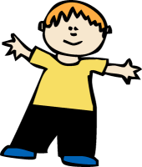
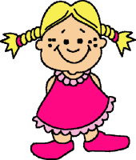
God Created Me
God created me in His image.

This is Me...

My name is: _________________________________________________
My age is:_________My eyes are the colour:_________________________
My hair colour is:_______________________________________________
My favourite food is:____________________________________________
My favourite drink is:____________________________________________
I enjoy:______________________________________________________
___________________________________________________________
When I grow up I want to be:_____________________________________

Name……………………………………………………………….
God’s Love
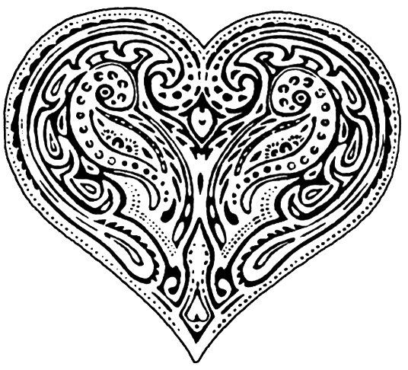

God’s love is
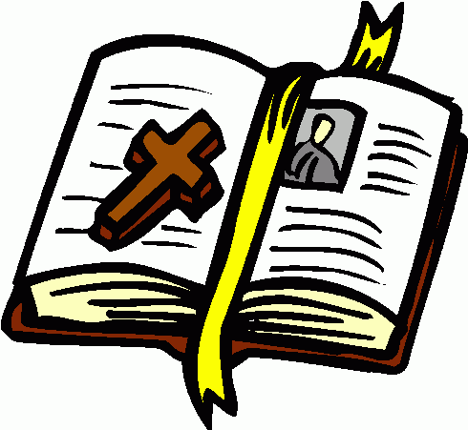
Name................................................................................

Write a prayer to God asking him to help you make good choices.

Dear God,

Help me

Amen

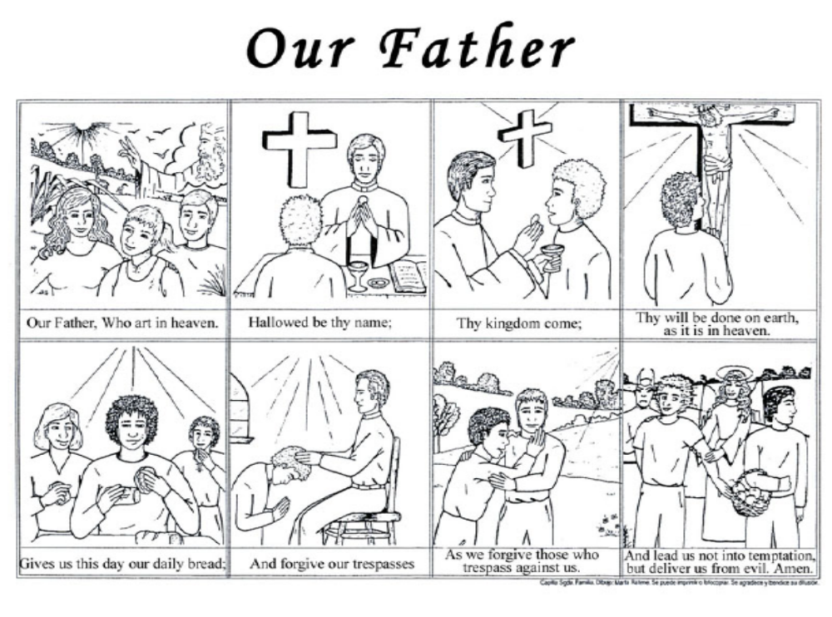
Name.................................................................................
Name………………………………………

Jesus Wants Us to Forgive Others
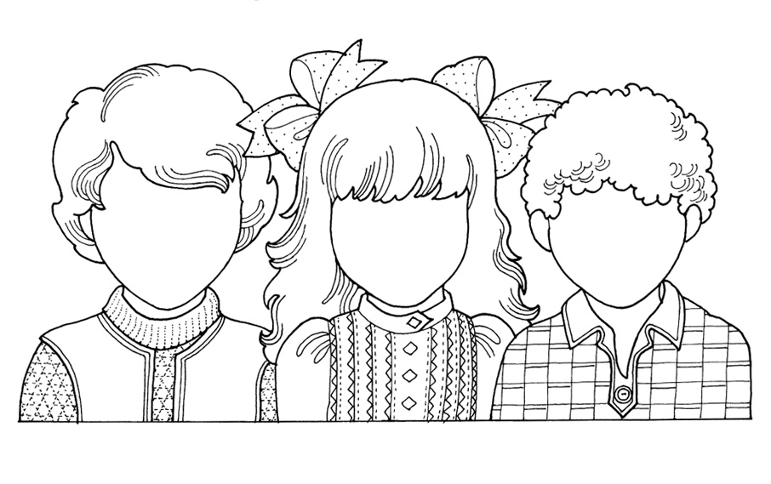

Jesus wants us to forgive others even when it is difficult. Write a story in the box below about a time you forgave somebody. Draw the faces of the children in the picture. Are they happy or sad? Have they been forgiven?
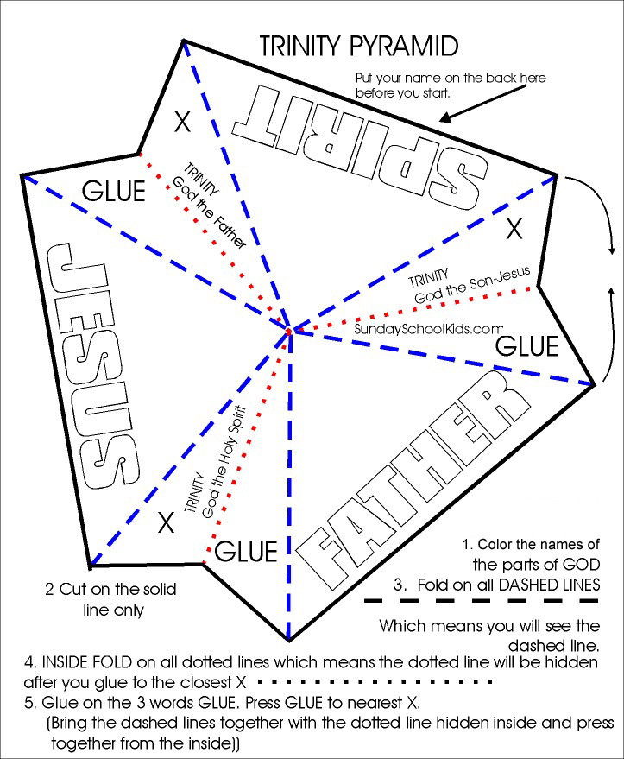
Name: …………………………………………………………….

Sign of the Cross
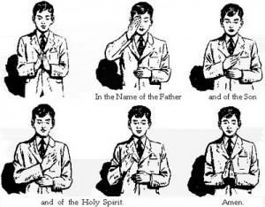
We make the sign of the cross when
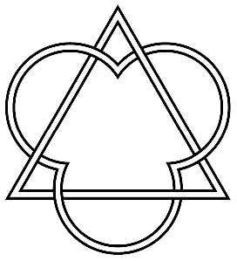

My Leaflet
Of
The Trinity

By

________________
Write about or draw the third person of the Trinity.

4
Write about the Sign of the Cross prayer below.

The End
of my Leaflet
The Trinity

5

Write about or draw the second person of the Trinity.

3
Who or what is the Trinity?

1
Write about or draw the first person of the Trinity.

2
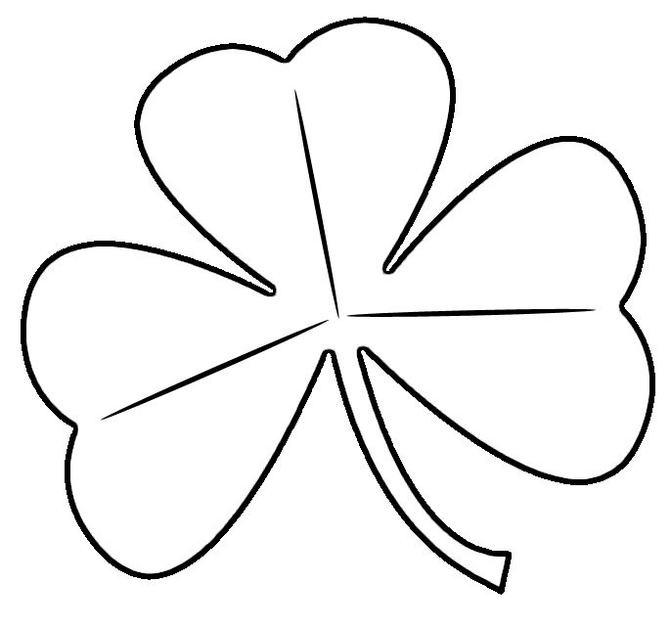
How did Saint Patrick explain the Holy Trinity to the people of Ireland?

Saint Patrick used a shamrock to
Mark each part of the leaf with the names of the Holy Trinity.

God the Father, God the Son and God the Holy Spirit
Shamrock Worksheet

Name: ………………………………………………………………….

The Baptism of Jesus
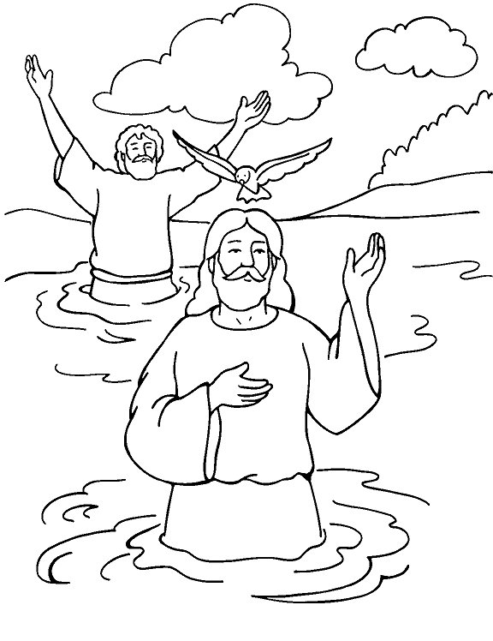

In the box below, tell the story of the baptism of Jesus.

Holy Spirit Dove Template
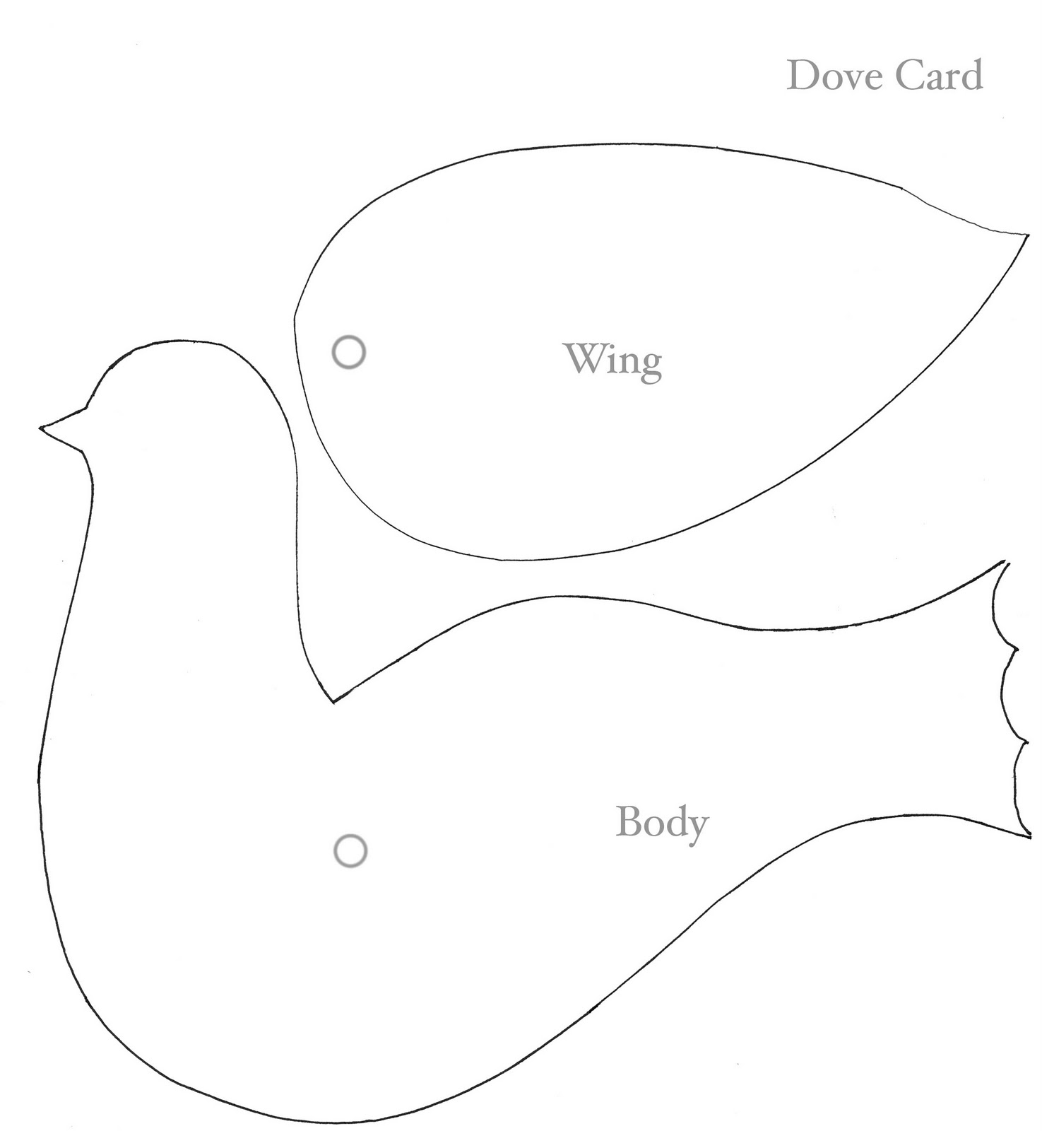

Name……………………………………………………………

The Agony in the Garden

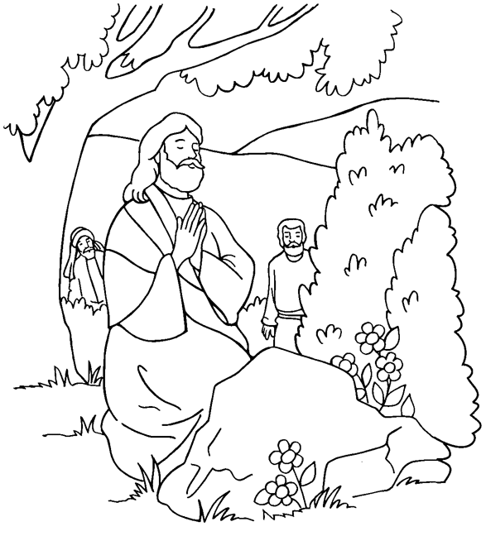

Jesus prayed to Abba, God Our Father and asked, “All things are possible for you. Take this cup of suffering away from me. Yet not what I want, but what you want.”
Name……………………………………………………………………..

Abba, Father, Send Your Spirit
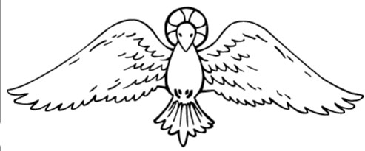

- Abba, Father, send your Spirit
Glory, Jesus Christ. (2)

Glory, hallelujah, glory, Jesus Christ! (2)

- I will give you living water…

Glory, hallelujah, glory, Jesus Christ! (2)

- If you seek me you will find me…

Glory, hallelujah, glory, Jesus Christ! (2)

- If you listen you will hear me

Glory, hallelujah, glory, Jesus Christ! (2)

- Come, my children, I will teach you

Glory, hallelujah, glory, Jesus Christ! (2)
Name…………………………………………………………………

Symbols of Baptism
Complete the sentences about the symbols of baptism.

 | The baptismal name is
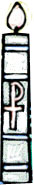 | The baptismal candle is
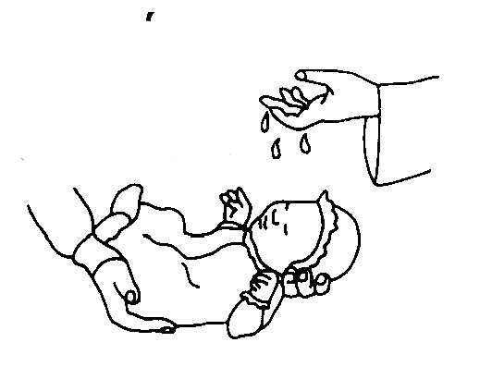 | The Holy water in Church is
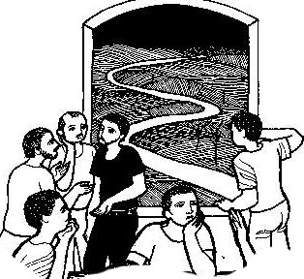 | The journey of faith is
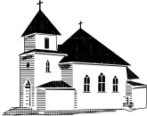 | The family of God is

Name……………………………………………......
More Symbols of Baptism

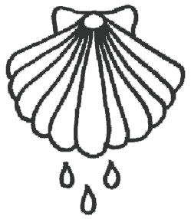 | 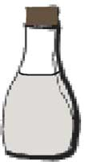 | 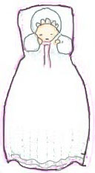
The water in baptism is the symbol of | The Holy oils in baptism is the symbol of | The white garment in baptism is the symbol of

