Month/Season: Lent/Easter Class: Primary 6 Level: Second
Themes:
1. The Three Lenten Traditions
2. Discipleship & the Christian Community
3. The Stations of the Cross & Holy Week

Strands of Faith : Experiences and Outcomes | Core Learning | Learning & Teaching  Class/School/Home/Parish | Resources | Assessment
Son of God  RERC 2‐06b I have examined the role of Jesus as a teacher and a healer and I have reflected on how His words and actions influence my own life and the lives of others. | I know that Jesus teaches us various ways to pray and invites us to actively trust in the loving providence of God e.g.,  - The Lord’s Prayer as the perfect prayer (Matthew 6:5-15)  - effective prayer and intercession (Matthew 7:7-12)  - trust in providence (Matthew 6: 25-34)  - prayer in common – “Where two or three are gathered” (Matthew 18: 19-20) | Class: Teacher reads to the class from the Bible Matthew 6:5-15 and discusses with the class what Jesus taught us about prayer. Where should you pray? What words should you use? What does God Our Father already know? What prayer did Jesus teach us? Teacher explains to the class that the ‘Our Father’ is also called ‘The Lord’s Prayer’, because Jesus taught it to us and it is such a good example of how to pray that is known as the ‘Perfect Prayer’. Teacher prays The Lord’s Prayer with the children. Teacher explains that this prayer tells us all about forgiveness. We must be prepared to forgive others the wrongs they have done to us and in return God our Father will forgive us for our wrongs.  The following website has an excellent explanation and break down analysis of the Lord’s Prayer.  http://www.bbc.co.uk/religion/religions/christianity/prayer/lordsprayer_1.shtml  Class: Teacher reads to the class from the Bible Matthew 7:7-12 and discusses with the children prayers of intercession. Prayers of intercession express the hopes and concerns of our community. We pray for our church, our country, we pray for people, situations and issues where God’s help or direction is needed.  What did Matthew tell us do? How will God Our Father respond? What message did he give us at the end of the reading? Teacher explains that when we celebrate Mass, there are Bidding Prayers which are prayers of intercession.  Each prayer ends with Lord Hear Us and the congregation respond Lord Graciously Hear Us.  Teacher teaches the class to sing Seek Ye First the Kingdom of God (attached to planner). Children can listen to the song on You Tube. http://www.youtube.com/watch?v=nrkTpRUCTp0&feature=related  The children will then write their own prayers of intercession.  School: Children read out their prayers of intercession at assembly. | Bible  Internet Access  Bible  Lyrics of Seek Ye First the Kingdom of God  Paper/Religious Jotter | The children have examined the role of Jesus as teacher and have a more in depth understanding of the meaning of ‘The Lord’s Prayer’.  The children understand which part of the Mass includes Bidding Prayers. The will write their own prayer of intercession and read them during assembly.

Strands of Faith : Experiences and Outcomes | Core Learning | Learning & Teaching  Class/School/Home/Parish | Resources | Assessment
 | I know that Jesus encourages us to develop the practice of fasting (Matthew 6: 16-18) and almsgiving (Matthew 6: 1-4) and that we focus on this particularly in Advent and Lent.  I know that Jesus called people to follow him e.g.,  -the call of the first four disciples (Matthew 4: 18‐22);  -the call of Matthew (Matthew 9: 9‐10);  -Jesus speaks to the rich young man (Matthew 19: 16‐20);  -the Parable of the Sower (Matthew 13: 18‐23).  I know that, through Jesus’ words, we are called to discipleship and that Jesus is with us in all we do. | Class - Explain to the children that there are three Lenten Traditions which Catholics uphold during the season of Lent. Alms-Giving, Fasting and Prayer.  Refer back to the previous lesson and recap on how God wants us to pray and ways in which we should make time to pray in our busy lives.  Ask the children if they know what ‘Fasting’ and ‘Alms Giving’ is. Explain that ‘Fasting’ means abstaining from food. On Good Friday and Ash Wednesday we refrain from eating meat. We might give up some of our favourite sweets and foods for Lent or try to adhere to the Catholic rule of fasting for one hour before communion. ‘Alms Giving’ is when we give a little more of something we have to someone who may have very little or nothing e.g. this might mean donating some of your pocket money to charity. Either way the reason we do these things is to deny oneself in order to focus on something greater. When we fast or give away something we take for granted we know we are doing it and focus more on why. Therefore our attention turns more toward God.  Read Matthew 6: 16-18 and discuss. If you had to sum up the message of this passage in one sentence what would it be?  Class – The teacher should write the word ‘Disciple’ and ‘Apostle’ on the board. Ask the children what these words mean. The word "disciple" comes from the Latin discipulus, meaning pupil. The word "Apostle" comes from the Greek word apostolos, meaning ‘one sent forth’ a delegate. The term ‘apostle’ was not used to describe the twelve until Jesus had ascended into Heaven and they changed from being the pupils to being the teachers. We are all called to be ‘disciples’. To listen, and learn the ways of Jesus.  The children should read from the Bible Matthew 4:18-22, the story of when Jesus calls the first disciples then complete the worksheet attached.  Class - Read from the Bible Matthew 19:16-20, The Rich Young Man and discuss.  The children should answer the following questions. These can be completed orally or in their jotter.  - What did the young man want to receive?  - How many of the 10 commandments did Jesus quote?  - Which command from the book of Leviticus did Jesus quote?  - What did Jesus ask the man to do?  - What was keeping the young man from following Jesus?  - To what did Jesus compare the rich man?  This story is not just hard for the rich man it is also hard for us. It hits a nerve and causes a reaction. However, I don't think that the following Jesus invites this man to do is just figurative. Jesus looked at this man and loved him (Mark 10:21).It is a lesson on where we base our priorities. A chance to rethink what is truly important in life.  KEY VOCABULARY: Providence of God, called to discipleship | Bibles  Bibles  Fisher’s of Men Worksheet attached to planner  Bibles | The children will have a deeper understanding of the meaning of Alms-Giving and Fasting and why these are important traditions in the Catholic faith.  The children will know the difference between ‘disciple’ and ‘apostle’. They will be able to retell the story of how the first disciples were chosen.  The children will understand that we are all called to be disciples of Jesus.

Strands of Faith : Experiences and Outcomes | Core Learning |  | Learning & Teaching  Class/School/Home/Parish | Resources |  | Assessment
Reign of God  RERC 2‐24a I have considered ways in which the Catholic Christian community works together to show care for the world and for the needs of all people. I have reflected on the implications of this for my life and that of others. | I know that SCIAF and MISSIO Scotland are Catholic organisations which respond to the needs of the world and I have been given opportunities to support the work of  MISSIO Scotland.  I recognise that, in our Catholic school, we are called to demonstrate our care for the world by engaging in activities such as justice and peace groups, Eco committees,  Twinning projects with developing countries etc.  With the help of my teacher, parish and local learning community, I have identified ways in which I can participate in these activities.  I have researched the founders of a religious order, such as the Franciscans, Dominicans, Daughters of St Paul, Carmelites, Redemptorists, Jesuits, Salesians or Sisters of  Mercy and I can identify the charisms of these religious orders.  I have used my research to inspire and challenge my response to God’s call to care for the poor. |  | School – Throughout the season of Lent the children will be involved in wider charity fund-raising events. The teacher should make the children aware that in doing this we as Christians are fulfilling our ‘Alms-Giving’ Lenten tradition.  Class – Discuss the word ‘charity’. What does it mean? It doesn’t just mean money it may mean donating clothes, toys, your time etc. Discuss ways in which they already donate to charity and how the school donates to charity.  How is the school eco-committee involved in charity? E.g. Fairtrade.  There are lots of worksheets, activities, power point presentations and short videos to show the children at the following website:  http://www.cafod.org.uk/primary/fairtrade  Parish - *If possible invite a representative from the Justice and Peace Commission to visit the school and explain to the children what they do.  Contact:  Archdiocese of Glasgow  Justice and Peace Commission  196 Clyde Street  Glasgow  G1 4JY  Home/Class (Homework Assignment) – Explain to the children that they are going to be given a religious order to research as part of their homework. There are eight topics and the teacher should share them out amongst the children as they see fit. Homework sheet attached.  The teacher will assign a religious order to each child:  The Franciscans  The Dominicans  The Daughters of St Paul  The Carmelites  The Redemptorists  The Jesuits  The Salesians  The Sisters of Mercy  Give the children a week to complete this task and they should present their findings to the class and give others the chance to ask questions about what you have researched. The teacher should give the children some guidance on what to research i.e. who began the order, when and why? A little about their lives. Does the order have a symbol?  KEY VOCABULARY: SCIAF, MISSIO Scotland, Religious Orders | Internet Access  Contact Justice and Peace Commission  Homework sheet attached to planner |  | The children have knowledge of some of the charity organisations in Scotland.  Children will be assessed through their finalised projects and their ability to answer questions from their peers.
Strands of Faith : Experiences and Outcomes |  | Core Learning | Learning & Teaching  Class/School/Home/Parish |  | Resources | Assessment
Hours of God  RERC 2‐18a  I know some of the signs and symbols related to Lent, Easter, Pentecost, Advent and Christmastide and I can use this understanding to help me explore the  themes of these celebrations. |  | I can participate in prayer, fasting and almsgiving during Lent with my school, parish and family.  I can reflect on the suffering and death of Jesus through praying the Stations of the Cross and I can respond with gratitude to Christ’s love. | Parish /School – The children will actively participate in charity work, prayer services, assemblies, mass etc which encompass the Three Lenten Traditions throughout Lent.  Class – Discuss: What is a station? It is a place where people wait to go from one place to another. What are the stations of the cross? It is a place where we wait and reflect on what Jesus sacrificed for us. How many stations are there? 14. Can you think of any of them?  The teacher should prepare for the children the Stations of the Cross Sequencing Activity attached to the planner. A set of cards and Title labels should be pre-cut and if possible laminated for future use. These should be places in an envelope and placed one per group. The group should then work together to match the card to the title and then put them in the correct order of occurrence. When the given time is up the children should check their answers using a Bible.  Class – The teacher should explain that today they are going to pray the Stations of the Cross together. Explain to the children that they are going to be responsible for one of the stations. They should note the title and write a short prayer (only a few lines) so that the rest of the class can reflect. The teacher should give examples e.g.  Station Title: The First Station – Jesus is Condemned to Death  What happened: Jesus stood before angry people who shouted at  Him. They said that He had done bad things and  should be punished.  Reflection: Sometimes people say mean and hurtful things to  us. Let us try to be more like Jesus and not shout  back or say hurtful things in return but forgive  those who at times treat us unfairly.  There is a sheet attached which can be distributed to the children to help with this task.  *It is important to stress to the children the point of silence and kneeling at the Twelfth Station.  Once complete pray the Stations of the Cross using the children’s reflections. A good version for your whiteboard is :  http://www.youtube.com/watch?v=HwkznTGOFAc |  | Stations of the Cross sequencing cards, title s and descriptions – attached to the planner  Stations of the Cross prayer worksheets – attached to planner  Internet access | The children will know the fourteen stations of the cross and will understand the suffering of Christ (emotionally and physically) at each station.  The children will actively participate in class/whole school stations of the cross.

Strands of Faith : Experiences and Outcomes | Core Learning | Learning & Teaching  Class/School/Home/Parish | Resources | Assessment
RERC 2-07a  Son of God  I have explored the events of the Passion, Death and Resurrection of Jesus and I have reflected on the Catholic meaning of Eternal Life  Hours of God  RERC 2‐18a  I know some of the signs and symbols related to Lent, Easter, Pentecost, Advent and Christmastide and I can use this understanding to help me explore the  themes of these celebrations. | I can understand that the symbolic action of the priest washing the feet during the Holy Thursday liturgy shows us Jesus as a model of service.  I know that Holy Thursday, Good Friday and Easter Sunday are known as the ‘Triduum’ (which means three days) and I can reflect on the Church’s invitation to participate in the Holy Week Liturgies.  I can recognise the Paschal candle and I know its significance in the Easter liturgies. | Class – Teacher should write on the board, ‘Maundy Thursday’. Ask the children if anyone has heard of this and if so when. Explain that ‘Maundy Thursday’ is observed during Holy Week and is also referred to as ‘Holy Thursday’. It is the first day of the Triduum (the three important days which come at the end of Lent). Maundy Thursday commemorates the Last Supper when Jesus shared the Passover meal with his disciples on the night before he was crucified.  Read from the Bible John 13:1-20  What is happening in this story?  What is Jesus teaching us?  What emotions do you think Judas is feeling at this point?  Would you commend Peter for his comments?  What is pride? Is it a good thing or a bad?  How might pride stop us from doing something good?  The church describes all leaders as servants. How do they serve our community and school?  Ask the children to write a letter of thanks to the parish priest expressing what an important part of our community they are and how much we value their service.  Class – If possible show the children an actual paschal candle. Where this is not possible use images on Google to show the children on the class whiteboard.  Give the children the worksheet ‘The Paschal Candle’. Tell the children that you are going to explain the different images on the candle and they are going to cut and paste them onto the picture of the candle in the correct position. The finalised candle can be cut out and placed into their RERC jotter.  - There is a large cross at the centre of the candle. This cross identifies it as the ‘Paschal Candle’.  - The Greek symbols for Alpha and Omega appear on the candle to signify that God is the beginning and the end. The sign for Alpha is above the cross (looks like a capital A) and the sign for Omega is below the cross (looks like a lower case ‘n’)  - The current year appears below the omega sign. (You will have to fill in the correct last two digits).  - Five grains of incense are places in the candle to represent the five wounds of Christ. Can you recall these wounds and their position? | Bibles  Art and craft materials  Paschal Candle (if possible)  Image of candle from internet  Paschal Candle worksheet | The children will be able to recount the story of the ‘Washing of the Feet’  They will write a suitable and meaningful letter to the parish priest.  The children will understand the significance of the Paschal Candle and when it’s used in the church.

Strands of Faith : Experiences and Outcomes | Core Learning | Learning & Teaching  Class/School/Home/Parish | Resources | Assessment
Reign of God  RERC 2‐20a  I know that I have been called by God to grow in love, justice and peace in my relationships with others.  Signs of God  RERC 2‐10a  I can reflect on the Holy Spirit's prophetic influence. | I can identify the practical implications of God’s call to live a life of justice and peace, having studied this scripture passage: First Letter of John 3: 17‐18 ‐ real and active love.  I can identify factors which cause economic poverty and have focused specifically on unjust trading.  I know that God’s call to grow in justice and peace challenges me to use the resources of the earth fairly.  I can identify some of the ways in which the Church works for justice and peace, by investigating the work of a missionary religious order /congregation, a project my school is twinned with, or the work of a Catholic aid agency. | Class – Read from the Bible the First Letter of John 3:17-18. Discuss the passage. In what way can people be in need? What does it mean to ‘close your heart’ to someone? We can explain how we love someone but in what ways can we show them?  Art Activity – The children will be given a copy of the handprint worksheet attached to the planner. They will write a practical way that they could help someone in the centre of the hand. E.g. I can show love by spending more time with my grandparents and helping them round their house.    The children will then paint around their message to give their hand colour. Each group should use a different colour. (single colour per hand). These should be placed together to create a large heart shape which can be displayed on the class altar.  A quote from the passage should be written on a banner below the display.  School – The children will participate in school activities during ‘Fairtrade Fortnight’.  KEY VOCABULARY: Universal Church, prayer, fasting and almsgiving, Stations of the Cross, Paschal candle, Jesse tree, ancestry of Jesus, symbolic actions, the Washing of the Feet, Jesus, a model of  Service  Class – Ask SCIAF/ MISSIO/Mary’s Meals etc. to visit the school to talk to the children about the year round charity work that they do.  KEY VOCABULARY: Justice and Peace, missionary work, religious order/congregation | Bibles  Paint  Paint brushes  Black marker pens  scissors  Photocopy of handprint sheet – attached to planner. | The children will write an appropriate statement describing a way in which they can show love through action.  Children can name some of the ways in which the Church works for justice and peace.
Strands of Faith : Experiences and Outcomes | Core Learning | Learning & Teaching  Class/School/Home/Parish | Resources | Assessment
RERC 2-07a  Son of God  I have explored the events of the Passion, Death and Resurrection of Jesus and I have reflected on the Catholic meaning of Eternal Life | I can read, recount and recall the story of the Passion, Death and Resurrection of Jesus (the Paschal Mystery) as outlined in Matthew Chapter 26-28, paying particular attention to the role of Pilate.  I understand that when people encounter the Risen Christ they fell on their knees and worshipped Him. (Matthew 28:9-10 & 28:16-18)  I recognise that, when I genuflect and kneel at appropriate times in church, I show my respect for the real presence of Jesus in the Blessed Sacrament. | Class – Remind the children of the story of the Passion (covered previous in the Stations of the Cross). Write on the board the main characters involved in the story.  - Mary, Jesus’ mother  - Pontius Pilate  - The Roman Guards  - Barabbas  - Peter, Jesus’ disciple  - Joseph of Aramathia  Ask the children to discuss in their groups how each of these people would feel now that Jesus had died. Remind them to give reason. Feedback to the class.  Children should complete the attached worksheet, ‘How Do You Feel Now!’  Class – Focus on the role played by Pontius Pilate. Children should read the passage attached to the planner. The children should work in groups to carry out a reciprocal task. There is a sheet attached which the children should use as a record. The names should be written along the top and the box below only ticked if the child contributes.  The completed sheet should be copied so each child has a record for their jotter.  Class – Children read from the Bible passages Matthew 28:9-10 & 28:16-18. Ask the children to imagine that they had encountered the risen Jesus and to work in active learning groups to write a dramatisation of the events in the gospel. Children will write a script with stage directions and could perform the drama at a school assembly.  Class: Teacher recounts with the class how the people who encountered the Risen Christ fell on their knees and worshipped Him. Teacher relates this gesture to genuflecting and kneeling in church to show respect for the real presence of Jesus in the Blessed Sacrament. Teacher distributes the Order of the Mass and discusses with the children when they should genuflect or kneel. Teacher explains other times when the congregation or clergy kneel or genuflect (Information Sheet attached to planner). Children work in active learning groups to design and make a poster illustrating and explaining when and why you genuflect in church.  KEY VOCABULARY: Passion, Death and Resurrection, Paschal Mystery, Pilate, Matthew’s Gospel, Risen Christ, genuflect, Real Presence, Blessed Sacrament | How Do You Feel Now! Worksheet! (attached to planner)  Reciprocal Reading Record Sheet  Bible  Paper  Copies of The Order of the Mass  Information Sheet-Genuflecting  Paper  Art materials | Children can read, recount and recall the story of the Passion, Death and Resurrection of Jesus, paying particular attention to the role of Pilate.  Children know that when you genuflect and kneel at church, you are showing your respect for the real presence of Jesus in the Blessed Sacrament.

Seek ye first the kingdom of God

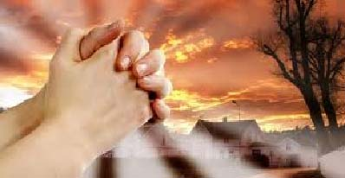

Verse 1
Seek ye first the kingdom of God
and his righteousness,
and all these things shall be added unto you.
Al-le-lu, Alleluia.

Chorus
Alleluia, Alleluia, Alleluia, Al-le-lu, Alleluia

Verse 2
Ask and it shall be given unto you.
Seek and ye shall find.
Knock, and the door shall be opened unto you,
Al-le-lu, Alleluia.

Chorus
Alleluia, Alleluia, Alleluia, Al-le-lu, Alleluia

THE FISHERS OF MEN
Matthew 4: 16-18

Read the passage from the Bible and complete the following in your jotter.

FILL IN THE BLANKS

As _____________________ walked along the shore of ____________________________, he saw two brothers who were ___________________________, _____________________ (called Peter) and his brother _______________, catching fish in the lake with a __________________. (Matthew 4:18)

REWRITE THE SENTENCES USING THE CORRECT WORD

- Jesus told the two fishermen that he would teach them to catch (MEN, FISH).
- The brothers left the shore of Galilee (THE NEXT MORNING, THAT NIGHT, STRAIGHT AWAY)
- As they walked on they saw two other brothers (PHILIP AND JUDAS, JOHN AND JAMES)

WRITE DOWN THE STATEMENT AND SAY WHETHER IT IS TRUE, FALSE OR CAN’T TELL

- Then He got into one of the boats and asked Simon to take Him out to sea.
- The second two brothers Jesus met were in their father’s boat.
- Zebedee left the boat also, and followed Jesus.
- Peter had to think before leaving behind his nets and boat to follow Jesus.


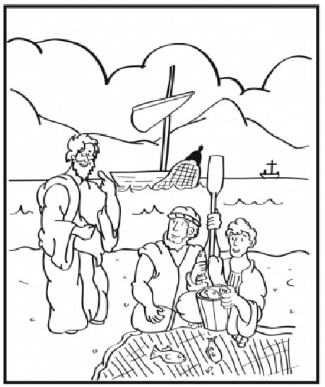

Think About It

Discuss with your partner, how you would have reacted. Imagine Jesus, a man you didn’t know approached you and asked you to leave behind everything, your possessions your family and follow him. What would you think? What would you do?

Why do you think these men said ‘Yes’?

What words would you use to describe these men?

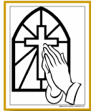
Religious Orders Research Task

Throughout the season of Lent we are reflecting on the lives of those who have made sacrifice for the good of others and God. We are looking closely at those who have given their lives to a religious order.

I am researching the order of

____________________________________________________________

Stations of the Cross Sequencing Cards

Cut out and laminate a pack of cards for each group.

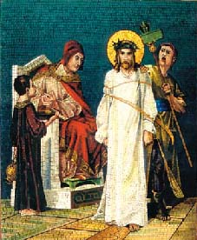
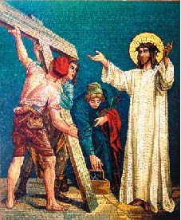
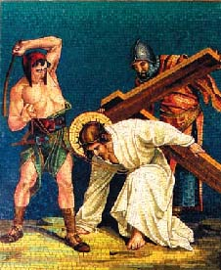
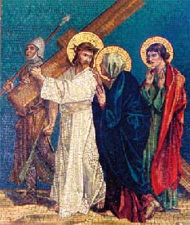
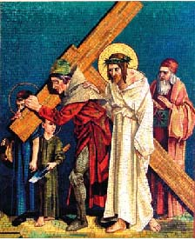
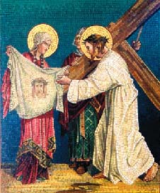
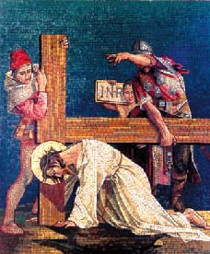
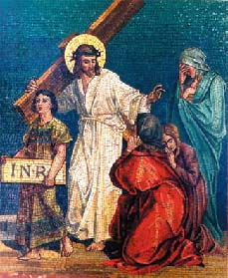

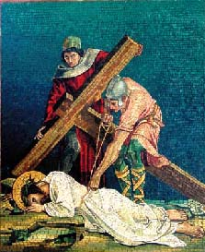
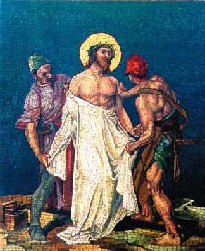
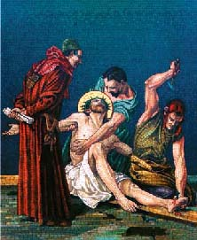
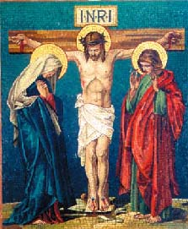

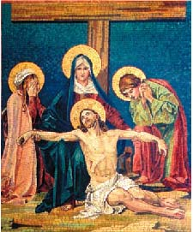
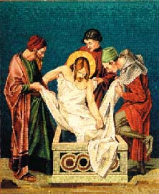
Titles for Stations of the Cross Sequencing Activity

These should be cut and laminated and placed in pack with a set of Stations of the Cross Picture Cards.
Station 1
Jesus is Condemned
Station 2
Jesus Receives the Cross
Station 3
Jesus is Falls for the 1st Time
Station 4
Jesus Meets His Mother
Station 5
Simon Helps Jesus Carry the Cross
Station 6
Veronica Wipes the Face of Jesus
Station 7
Jesus Falls for the 2nd Time
Station 8
Jesus Meets the Women of Jerusalem
Station 9
Jesus Falls for the 3rd Time
Station 10
Jesus Is Stripped of His Clothing
Station 11
Jesus is Nailed to the Cross
Station 12
Jesus Dies on the Cross
Station 13
Jesus Is Taken Down from the Cross
Station 14
Jesus is Laid in the Tomb
Stations of the Cross Reflections

Cut out each station for an individual/pair to prepare a reflection for the class Stations of the Cross.

The First Station – Jesus is condemned to Death

What is happening at this station? - __________________________________________________________
___________________________________________________________________________________________

Reflection - ________________________________________________________________________________

__________________________________________________________________________________________

The Second Station – Jesus Receives The Cross

What is happening at this station? - __________________________________________________________
___________________________________________________________________________________________

Reflection - ________________________________________________________________________________

__________________________________________________________________________________________

The Third Station – Jesus Falls for the First Time

What is happening at this station? - __________________________________________________________
___________________________________________________________________________________________

Reflection - ________________________________________________________________________________

__________________________________________________________________________________________

The Fourth Station – Jesus Meets His Mother

What is happening at this station? - __________________________________________________________
___________________________________________________________________________________________

Reflection - ________________________________________________________________________________

__________________________________________________________________________________________

The Fifth Station – Simon Helps Jesus to Carry The Cross

What is happening at this station? - __________________________________________________________
___________________________________________________________________________________________

Reflection - ________________________________________________________________________________

__________________________________________________________________________________________

The Sixth Station – Veronica Wipes the Face of Jesus

What is happening at this station? - __________________________________________________________
___________________________________________________________________________________________

Reflection - ________________________________________________________________________________

__________________________________________________________________________________________

The Seventh Station – Jesus Falls for the Second Time

What is happening at this station? - __________________________________________________________
___________________________________________________________________________________________

Reflection - ________________________________________________________________________________

__________________________________________________________________________________________

The Eighth Station – Jesus Meets the Women of Jerusalem

What is happening at this station? - __________________________________________________________
___________________________________________________________________________________________

Reflection - ________________________________________________________________________________

__________________________________________________________________________________________

The Ninth Station – Jesus Falls for the Third Time

What is happening at this station? - __________________________________________________________
___________________________________________________________________________________________

Reflection - ________________________________________________________________________________

__________________________________________________________________________________________

The Tenth Station – Jesus is Stripped of His Clothing

What is happening at this station? - __________________________________________________________
___________________________________________________________________________________________

Reflection - ________________________________________________________________________________

__________________________________________________________________________________________

The Eleventh Station – Jesus is Nailed to the Cross

What is happening at this station? - __________________________________________________________
___________________________________________________________________________________________

Reflection - ________________________________________________________________________________

__________________________________________________________________________________________

The Twelfth Station – Jesus Dies on the Cross

What is happening at this station? - __________________________________________________________
___________________________________________________________________________________________

Reflection - ________________________________________________________________________________

__________________________________________________________________________________________

The Thirteenth Station – Jesus is Taken Down From the Cross

What is happening at this station? - __________________________________________________________
___________________________________________________________________________________________

Reflection - ________________________________________________________________________________

__________________________________________________________________________________________

The Fourteenth Station – Jesus is Laid in the Tomb

What is happening at this station? - __________________________________________________________
___________________________________________________________________________________________

Reflection - ________________________________________________________________________________

__________________________________________________________________________________________
The Paschal Candle

Listen carefully to your teacher and mark the Paschal Candle with the correct symbols. This should then be cut out and pasted into your RERC jotter.

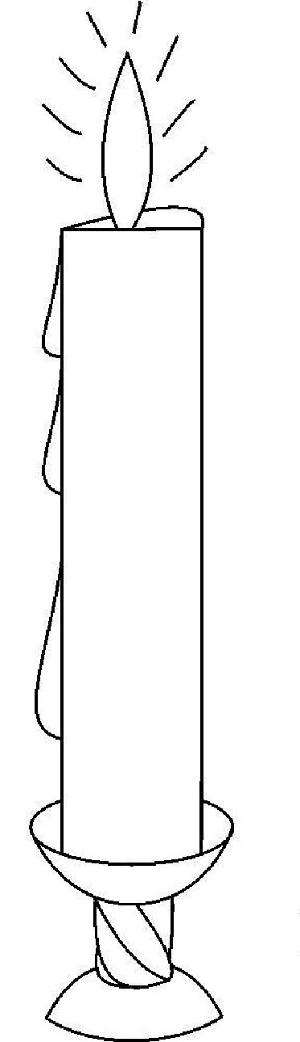
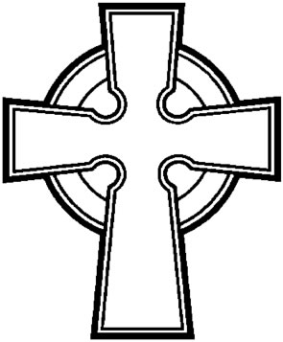
Ω

A
20

How Do You Feel Now?

Many people were affected by the Passion of Jesus. How do you think they felt after His death? Use passages from scripture to help you.

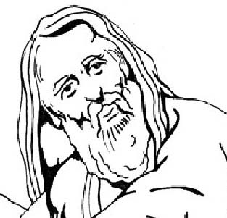
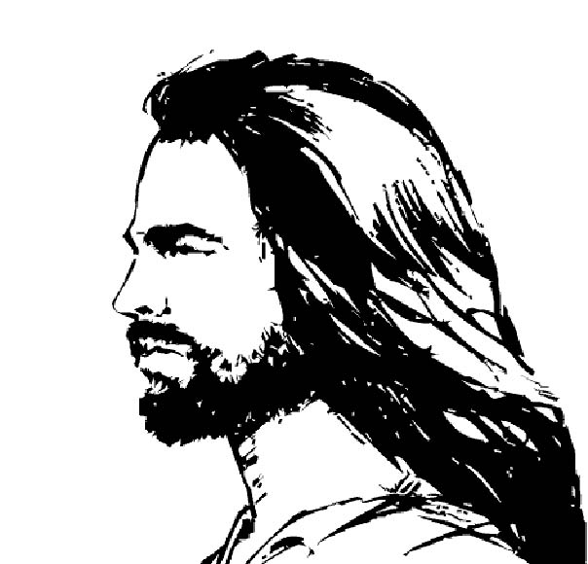
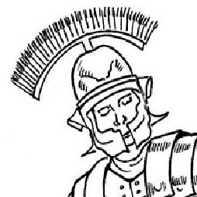
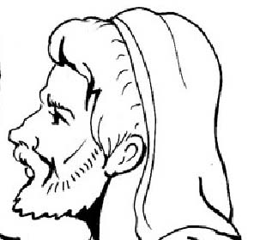
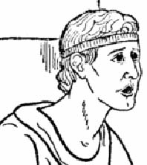
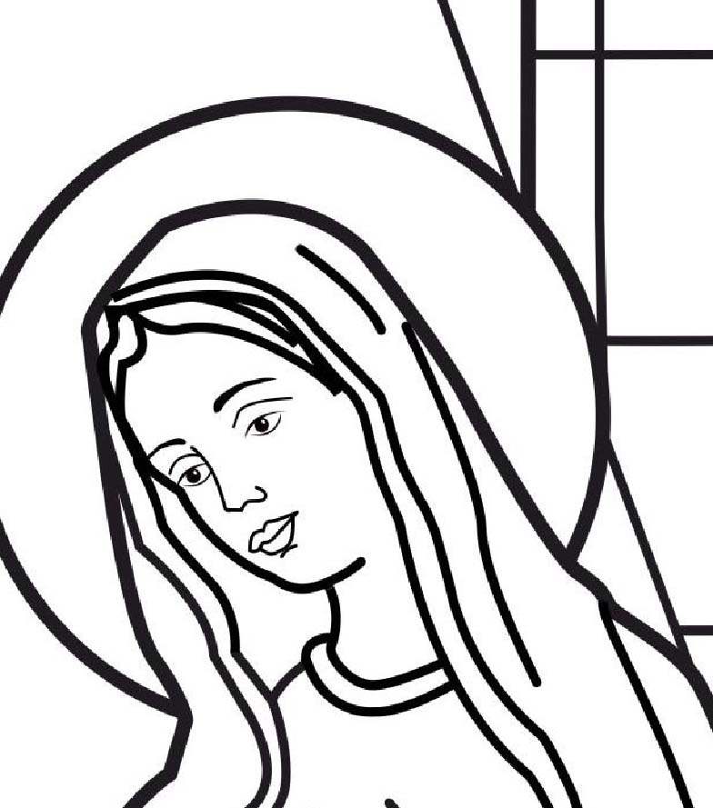
Peter the Disciple
Joseph of Aramathia
The Roman Soldiers
Barabbas
Pontius Pilate
Mary, Jesus’ Mother
Pontius Pilate
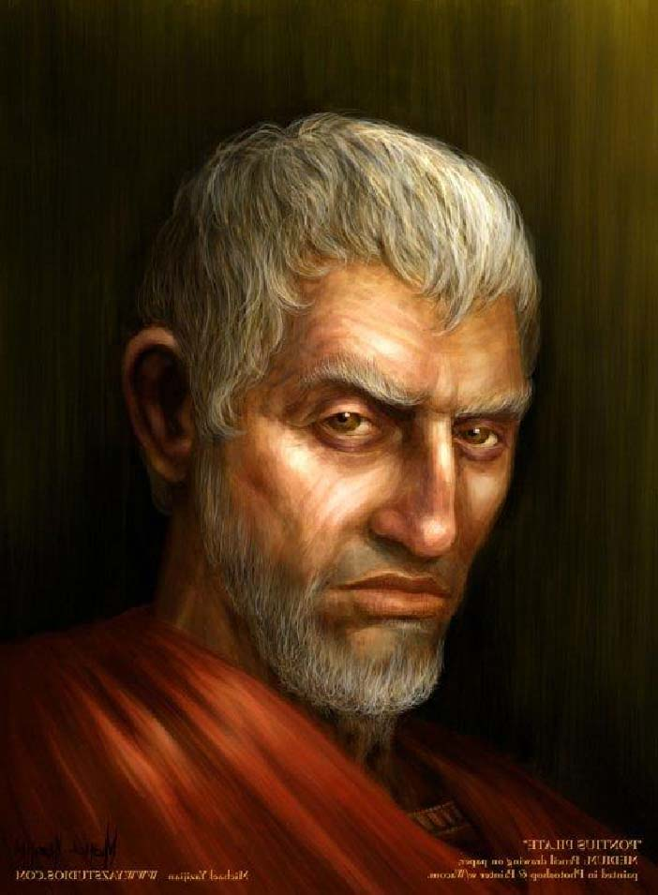
Pontius Pilate was a Roman governor of Judea during the reign of Tiberius Caesar. The people of Jerusalem did not think very highly of him, and unfortunately the feeling was mutual. He had proven his distaste for the Jews by authorizing a raid of their Temple treasury in order to build an aqueduct into the city.

The people of Jerusalem began to verbally fight against what they considered sacrilegious, and Pilate sent a regiment of Roman soldiers to quell the uprising. But rather than scaring the unarmed people into subjection, the soldiers killed a great number of them. This event created great tension between Pilate and the Jews. That tension also carried up into the Roman government.
As a representative of the Roman Empire, it was Pilate's responsibility to collect taxes and to keep the peace among the people. His decision to raid the treasury put both him and the Roman Empire at odds with the Jews, which in turn, did not grant him favor among the Roman officials. Pilate remained governor of Judea to maintain civil order, especially during religious festivals, such as Passover, when throngs of Jews would migrate into Jerusalem.
At one such occasion, the chief priests and officials brought Jesus of Nazareth before him. Pilate tried to pass Jesus off to be judged under the Jewish law, but the Jews were seeking the death penalty, a punishment that could only be carried out by the hands of Romans. If he were to go against their wishes, Pilate knew the people would start a revolt, which would jeopardize his standing with Roman authorities even further.
Pilate was in a difficult position. He ordered Jesus to be beaten, thinking it would appease the mob. But when Pilate brought him back out and presented him before the people, it was obvious that scourging was not sufficient enough for them. The mob began to shout for his crucifixion, stating that according to their law, someone who made themselves out to be the Son of God was worthy of death. This response stirred up great fear in Pilate. He demanded that Jesus tell him where he was from.
When Jesus did not respond, Pilate's tension grew. He attempted to exercise his authority over Jesus, saying that he had the power to either execute him or release him. But Jesus told Pilate that the only power he had over him was the power that was given to him from heaven. During this exchange, only for a moment, Pilate had a revelation of who Jesus was. He realised that Jesus was no ordinary man.
Although Pilate plainly stated that he found no fault with Jesus, the people shouted violently for his death. The fury of the rioters was greater than Pilate's power to control them.
Pilate is often thought of as a coward; one who did not have the personal integrity to stand up against the raging mobs. However, in a last attempt to communicate his disapproval of Jesus' execution, Pilate wrote the title, "Jesus of Nazareth, the King of the Jews" in Hebrew, Greek and Latin to be hung above the cross."
There are those who come face to face with the truth, and though they recognise it, they also choose to reject it. Pilate believed that Jesus was innocent, and did not want the moral responsibility of condemning an innocent man. Although Pilate had the power to set Jesus free, his fear of insurrection prevented him from making the right moral choice.
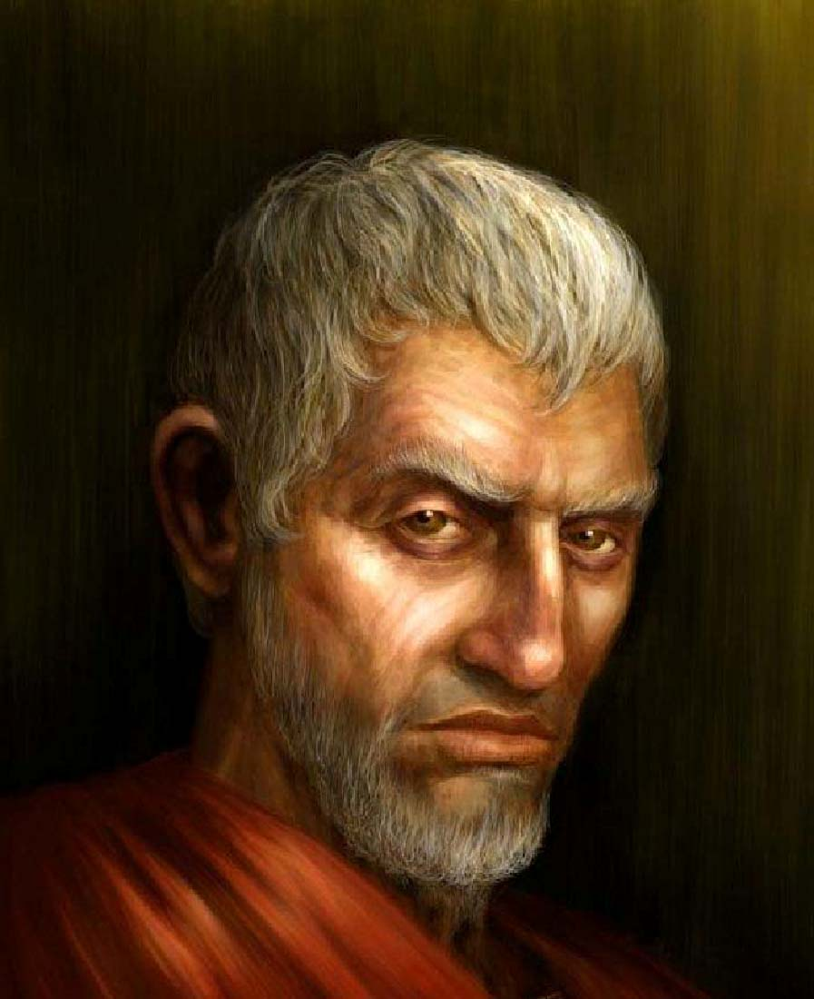
Pontius Pilate – Reciprocal Reading Sheet
Group members: ____________________________________________________________________

What is an aqueduct and why do you think it was important to the city? Why would a raid on the Jewish Temple be carried out?

NAMES
Tick if contributed

Why do you think it was important for Pilate to keep peace among the people?

NAMES
Tick if contributed

Do you think Pilate cared what happened to Jesus? Why?

NAMES
Tick if contributed

Why do you think Pilate posted the sign ‘King of the Jews’ over Jesus on the cross?

NAMES
Tick if contributed

What would you have done if in Pilate’s shoes?

NAMES
Tick if contributed

Teacher’s Information Sheet- Genuflecting

- All genuflect (bending both knees) when adoring the Blessed Sacrament unveiled, as at Expositions.

- All genuflect (bending the right knee only) when doing reverence to the Blessed Sacrament, enclosed in the Tabernacle, or lying upon the corporal during the Mass. Mass-servers are not to genuflect, save when the Blessed Sacrament is at the altar where Mass is being said. The same honour is paid to a relic of the True Cross when exposed for public veneration.

- The clergy in liturgical functions genuflect on one knee to the cross over the high altar, and likewise in passing before the bishop of the diocese when he presides at a ceremony. From these genuflexions, however, an officiating priest, as also all prelates, canons, etc., are dispensed, bowing of the head and shoulders being substituted for the genuflexion.

- On Good Friday, after the ceremony of the Adoration of the Cross, and until Holy Saturday, all, clergy and laity alike, genuflect in passing before the unveiled cross upon the high altar.

