Month / Season: Lent/Eastertide Class: Primary 5/6 Level: Second
Themes:
- Discipleship
- Teacher as healer and teacher
- The Stations of the Cross
- Eastertide

Strands of Faith : Experiences and Outcomes | Core Learning | Learning & Teaching  Class / School / Home / Parish | Resources | Assessment
Son of God  RERC 2-06b  I have examined the role of Jesus as a teacher and a healer and I have reflected on how His words and actions influence my own life and the lives of others. | I know that Jesus proclaimed the Good News from God and called people to repent (Mark 1:14-15).  I know that Jesus called the disciples to follow Him:  - The call of the first four disciples (Mark 1:16-20)  - The call of Levi (Mark 2:13-15)  - The call of the Twelve (Mark 3:13-19) | Class – Background Information for the Teacher - By the time of this scripture passage, John the Baptist's preaching had made the Romans nervous. Herod Antipas (not the same Herod who was around at the Nativity but his grandson. Herod is their surname) had thrown John the Baptist into prison. Under Roman rule, formal charges did not have to be brought, nor did people have to be found guilty to be sent to prison; it was enough that the Romans thought John might possibly lead some sort of revolution, especially since he had gathered a large group of followers of all sorts.  Read Mark 1:14-15. Explain why John had been arrested.  How do you think Jesus’ news was spread (word of mouth). Imagine that Jesus was alive today. Think of the different ways His message could be spread? Would it spread quicker and further?  The children should create complete the ‘Fakebook’ worksheet attached to the planner. They should create a social network style page as though they were a fisherman in Galilee hearing Jesus proclaim the good news. Base this on the scripture passage Mark 1:14-15.  To be effective this should be printed out in colour.  Class – What is a disciple? Who were the disciples? How many disciples did Jesus have? (Jesus would have had many disciples not just the twelve, however he selected twelve to do important jobs) What special name did he give to them? (apostles) Ask the children to imagine if they are given the position of ‘captain’ in sports game and asked to pick your team. Who do you pick and why?  Read from the Bible Mark 3:13-19.  Children should complete the Disciple/Symbol challenge attached to the planner (2 pages). | Bibles  Fakebook Worksheet  Attached to planner  Bibles  Bibles  Disciple/Symbol challenge sheets attached to planner. | Children will be able to correctly match the disciples to their symbols and explain which they mean.

Strands of Faith : Experiences and Outcomes | Core Learning | Learning & Teaching  Class / School / Home / Parish | Resources | Assessment
 | I know  - Jesus taught that the greatest commandment of all was to love God and he also taught us to love your neighbour as yourself (Mark 12: 28-34)  I recognise that I too am called to a life of discipleship like the first Apostles. | Class – Slip the class into three groups. Give each third of the class one of the following scripture passages to read silently.  - The call of the first four disciples (Mark 1:16-20)  - The call of Levi (Mark 2:13-15)  - The call of the Twelve (Mark 3:13-19)  Bring the class back together and ask what they think the main message is in each passage.  - http://vimeo.com/46268582  Jesus chose fishermen. Why do you think he did this? They were not rich and they did not have any standing or power within their community.  - http://www.youtube.com/watch?v=P_0fCjTCEq4  Why did Jesus choose a man who was hated by the people? What do you think made Levi go with Jesus? Who came to Levi’s house? What did the others think? What was Jesus’ reason for meeting with Levi and his friends?  - http://www.youtube.com/watch?v=LkQCB9AkNIs  What was Jesus asking the twelve disciples to do?  The common theme is that a disciple is a ‘fisher of men who give the good news to people who have turned away from God or do not know Him’  The children should complete ‘What Makes Disciples Unique?’ worksheet attached to the planner.  Class- Children will apply their knowledge and understanding of these scriptural passages by writing a diary extract as though they were one of the chosen twelve. A planning sheet and template is attached to the planner.  Class – Ask the children to recall what they had been learning in the previous lesson. The Pope leads us to be God’s disciples on earth. Watch the following clip of Pope Francis speaking to the young people in Rome about God calling them to be disciples. Discuss how we can do this?  In their jotters are the children to paste in the picture of the boat attached to the planner in the middle of their page. Then should write different ways in which they can spread the Good New and draw a fish around it linking it to the boat with a line. (example attached) | Bibles  Internet Access  What Makes Disciples Unique? worksheet attached to planner.  Diary Planning Sheet  And writing template attached to planner.  Internet Access  Boat images and jotter layout attached to planner. | Children will have a deeper understanding of Jesus’ choices when choosing His Twelve disciples. They will be able to identify the common themes in the type of people Jesus chose.  Children will apply their knowledge and understanding of the scripture associated with Jesus’ choosing the twelve by creating a diary extract.
Strands of Faith : Experiences and Outcomes | Core Learning | Learning & Teaching  Class / School / Home / Parish | Resources | Assessment
 | I know that:  - Jesus calls us to show leadership through service and that all followers of Jesus are invited to put God first in their lives (Mark 10:41-45)  - Jesus was called Rabbi and this means teacher (Mark 11:21-22)  I have examined and discussed what Jesus said and did in three of more of these healing miracles:  - The man possessed by a Demon (Mark 1:21-28)  - Simon’s mother-in-law (Mark 1:40-46)  - The man with leprosy (Mark 3:1-6)  - The man with the withered hand (Mark 3:1-6)  - The woman with the haemorrhage (Mark 5:21-34)  - The deaf man (Mark 7:31-37)  - The blind man at Bethsaida (Mark 8:22-26)  Having considered these miracles, I know that, through them, Jesus showed love of God and showed His divine power. | Class - What the following clip:  http://www.youtube.com/watch?v=rk8ERxqCZqQ  After watching explain to the children that disciples serve one another. Ask them to think of ways in which Jesus served. i.e. washing of the feet, feeding of 5000, he healed the sick and he served us all by giving his life.  Not only did Jesus serve but he also taught. Jesus was referred to as Rabbi by his followers. Ask the children to think of ways in which Jesus was a teacher. i.e. the parables, the Lord’s prayer (how to pray), the Beatitudes, Good News about the Kingdom of God, Through His example of loving his neighbour unconditionally.  Learn the Hymn - Servant Song  https://www.youtube.com/watch?v=kdmgpMfnjdU  Perform this at the next assembly with an explanation of what you are learning in class or the next whole school Mass.  Class – Read from the Bible the following passages:  - The woman with the haemorrhage (Mark 5:21-34)  * Explain to the children that hemorrhaging means that she had a problem with her blood.  - The deaf man (Mark 7:31-37)  - The Blind Man at Bethsaida  Children should complete the worksheet ‘Jesus the Healer’.  Class – Discuss – There are many sick people in the world today and sometime we too become sick with colds and bugs. How do we get better? Over time, medicine, bed rest, hospital treatment, operations etc.  How did Jesus heal? When Jesus healed He did it by word or by touch. How long did it take the person to get better? They got better instantly no matter how seriously ill they were.  But there was one thing that Jesus did that no medicine in the world can do – He raised people from the dead.  This shows that Jesus had ‘divine power’. (This should not be mistaken for magic).  It was this ‘divine power’ that made Jesus different from all other humans.  What good deeds would you do if you had divine power for a day? How would you act like Jesus to make the world a better place? | Internet Access  Bibles  Jotters  ‘Jesus the Healer’ worksheet attached to planner | Children will understand ways in which Jesus was both healer and teacher. They will be able to give clear examples of both.  The children will be able to recall three healing miracles performed by Jesus and understand that it was through ‘divine power’ that Jesus was able to heal and raise the dead.

Strands of Faith : Experiences and Outcomes | Core Learning | Learning & Teaching  Class / School / Home / Parish | Resources | Assessment
Hours of God  RERC 2-14a  I know a number of traditional Catholic prayers and I have developed an understanding of the meaning of these prayers. I have participated in different approaches to, and experienced prayer.  Reign of God  RERC 2-07a  I have explored the events of the passion, death and resurrection of Jesus and I have reflected on the Catholic meaning of eternal life. | I know that we too can experience repentance and forgiveness particularly during Lent and through the Sacraments of the Church.  I can join in a simple chant (e.g. Gregorian, Taize) or meditation on scriptural words or phrases to praise God.  I can hear, read and recall the events of the passion, death and resurrection of Jesus in the account from Mark’s Gospel (Mark 14-16)  I know that Jesus died on the cross for me, and that this is the greatest demonstration of God’s love me (Mark 1045;; John 15:13) | Class – Explain to the children that we are now in the season/ about to be entering the season, or Lent. What liturgical colour represents Lent? (purple) Why? (It is a time of reflection, penance and reconciliation).  Ask the children to recall their First Reconciliation. Where did it take place? Which priest heard it? How did they feel before and after it?  http://www.youtube.com/watch?v=QtbpOERgMvk  Explain to the children that during Mass we say a very special prayer called the Confiteor. In this prayer we say sorry to God for our sins and ask His forgiveness. Learn the prayer by heart. The children should make a prayer card using ICT which can be laminated. (Example attached to planner).  Class – Explain to the children that some people use chanting as a way of praising God. Ask them if they know what chanting means?  Use the P5/6 ‘Praising God Through Chanting’ Power Point Presentation and complete the art lesson outlined in the Power Point.  Class – Watch the following clip on BBC Teacher (Palm Sunday)  http://www.bbc.co.uk/learningzone/clips/the-riddle-of-palm-sunday/290.html  Discuss the clip.  The children should complete the attached worksheet based on what they have seen and heard on the clip. (attached to planner)  Class – Watch the following clip on BBC Teachers (The Last Supper)  http://www.bbc.co.uk/learningzone/clips/the-last-supper/676.html  This clip is a continuation of the previous ‘Riddle of Palm Sunday’.  Discuss the clip.  Create a piece of artwork based on the symbols of bread and wine, e.g. draw out the word body in the shape of a loaf of bread and the word blood as if it is being poured from a wine glass.  https://www.youtube.com/watch?v=ACHPwx7EGQA (teach the children the following hymn and perform it at the next school Mass) | *Throughout the season of Lent the children should have the opportunity to receive the sacrament of reconciliation.  Internet Access  ICT suite  Power Point ‘Praising God through Chanting’ attached to the planner.  Art materials  Tea bags  Cartridge paper  Internet Access  Palm Sunday Worksheet attached to the planner.  Internet Access  Art Materials  Templates of bread from Internet if necessary. | The children will be able to identify the liturgical colour linked to Lent and explain its significance.  The children will experience and have a deeper understanding of different approaches to prayer.  The children will be able to recall the events leading up to the crucifixion in correct sequence.

Strands of Faith : Experiences and Outcomes | Core Learning | Learning & Teaching  Class / School / Home / Parish | Resources | Assessment
Reign of God  RERC 2-07a  I have explored the events of the passion, death and resurrection of Jesus and I have reflected on the Catholic meaning of eternal life.  Hours of God  RERC 2-14a  I recognise the importance of personal prayer and communal prayer in the growth of all people’s relationship with God.  Hours of God  RERC 2-18a  I know some of the signs and symbols related to Lent and Easter and I can use this understanding to help me explore the themes of these celebrations. | I can recall that Peter denied Jesus three times (Mark 14:66-2) and I can identify occasions when we may not be faithful to Jesus.  I am familiar with the Stations of the Cross and I can reflect prayerfully on some of them.  I recognise that the Catholic Church encourages prayer, fasting and alms-giving during Lent and I am increasing my understanding of these practises in association with my school, parish and family.  I can reflect on the suffering and death of Jesus through praying the Stations of the Cross and I can respond with gratitude to Christ’s love. | Class – Watch the following clip on BBC Teacher  http://www.bbc.co.uk/learningzone/clips/the-crucifixion-and-peters-denial/677.html  This follows on from two other clips explaining the events of Easter week, 'the riddle of Palm Sunday' and 'the Last Supper'. These help to explain why Jesus had enemies and was arrested. Pupils could imagine themselves as someone who let Jesus down - either Judas or Peter. They could develop a piece of drama where they explain their actions or feelings. The word 'deny' in the context of Peter's 'denial' of Jesus will need explaining. Explore and compare the symbol of the cross in different forms - e.g on a chain worn as a necklace, at the front of a church or on a headstone/grave. Make a big Celtic Cross decorated with illustrations and/or symbols that depict the story of Easter.  Class – Assess the children’s previous knowledge of ‘The Stations of the Cross’ by asking how many they can recall and ask them to give a brief description of each one.  Attached to the planner are stations of the cross image cards. Cut these out and give one set to each child. Ask the children to place these into the correct order. Once correct they should write the correct number into the box. Check these as a class and paste into their RERC jotter. Children should colour appropriately.  At the end of the lesson put the Stations of the Cross prayer on the board. Ask the children to copy this neatly into their RERC jotter and give it a colourful purple border. Explain to the children that each time you prayer the Stations together you will say this prayer.  “I love you Jesus, my love above all things. I repent with my whole heart for having offended thee. Never permit me to separate myself from thee again. Grant that I will love thee always and then do with me what you will.’  Class – Ask the children to think back on the lesson about the sites of the Holy Land. Ask them is they remember the name given to the road which Jesus walked with His cross. (Via Dolorosa). The children should imagine that they are standing amongst the crowds that day and write a short account of what they see, hear and feel as Jesus passes them by.  Writing planner attached. | Internet Access  RERC Jotters  Stations of the Cross sequencing cards and statements attached to the planner.  Glue  Colouring pencils.  RERC Jotters  Writing Planner attached to the planner.  RERC Jotters | The children will correctly order the Stations of the Cross and participate in praying them. They will learn by heart the prayer associated with the Stations.

Strands of Faith : Experiences and Outcomes | Core Learning | Learning & Teaching  Class / School / Home / Parish | Resources | Assessment
 |  | Class – Watch the following clip on BBC Teacher  http://www.bbc.co.uk/learningzone/clips/good-friday-and-easter-eggs/678.html  Ask the children to create an Easter Mind Map in their jotters. Following the layout attached to the planner ‘Easter Mind Map’.  TEACHERS HINTS  Answers might include:  Where? – Church, home, at granny’s house.  Food – Hot Cross buns, Sunday lunch, Lamb  Gifts – Chocolate Eggs, daffodils.  Songs – Easter Hymns  Traditions – Stations of the Cross, Lenten Promises, rolling eggs, family gatherings.  Special Words – Ascension, resurrection, tomb, cross, crucifixion.  Homework – Ask the children to find out about Easter traditions in two other countries. Ask them to use draw or print pictures to illustrate their work. | Internet Access  RERC Jotters | The children will create a personal Mind Map on Easter.

Complete the following:
- Draw a picture of yourself in the box below. Remember you are a fisherman from Galilee.
FAKEBOOK
- Write a short message about what you saw on the shores of Galilee.
- In the bottom box ask a friend to comment as someone responding to your post and draw a picture of themselves.
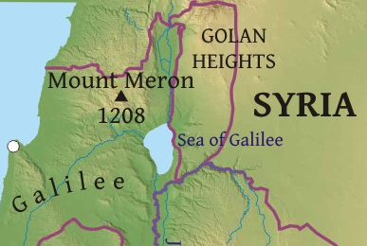

- Cut out and paste into your jotter.
PreacherproclaimingnewsaboutGodatSeaofGalilee#GOODNEWS!
View Photos (6)
Send a message
Disciple / Symbol Challenge

Write in your jotter the correct description and cut and paste the picture of the
symbol that you think matches the disciple. The Symbols are on a separate page.

Simon Peter was the leader of the twelve. He is said to be the doorkeeper of heaven. His symbol would be needed to let people into heaven.

Simon was a Zealot, a person who fought to free Israel from Roman rule. He was a fisherman and his symbol represents his job.

Philip was a shy and simple man. He looked after the food for the disciples and his symbol represents this.

Andrew was the brother of Peter. He was killed on a cross in the shape of an X. His symbol represents this.

Judas was the only disciple not from Galilee. He looked after the money for the disciples. He betrayed Jesus for 30 silver coins. His symbol is a yellow shield.

Bartholomew was also known as Nathaniel. He was brought to Jesus by Philip. It is believed that he was flayed to death. His symbol is a Bible and a flaying knife.

James was the son of Zebedee and a fisherman. He was beheaded by Herod in CE44. His symbol is a pilgrim
wallet and staff.

James the son of Alphaeus was sawn to death. His symbol represents how he died.

Matthew was a tax collector. His symbol was three bags of money.

John is the brother of James. Legend states that a pagan priest dared John to drink a cup of poisoned wine. John made the sign of the cross over the top of the chalice and the devil in the shape of a snake flew out of it. He then drank the wine which was harmless. His symbol represents this.

Thaddaeus travelled to Persia to be a missionary. His symbol is the form of transport he used to get there.

Thomas was not there when Jesus first appeared to the disciples and would not believe that he had risen from the dead. He became known as ‘doubting Thomas’. His symbol is a spear and carpenter’s square.



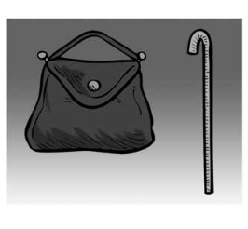
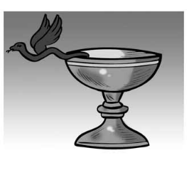
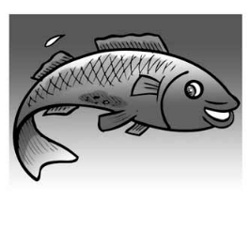

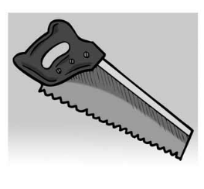
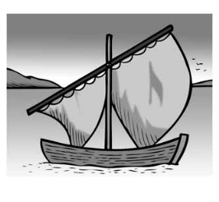
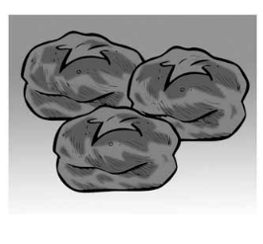
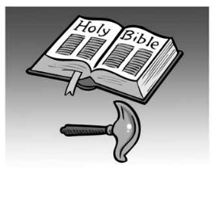
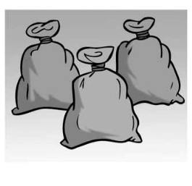
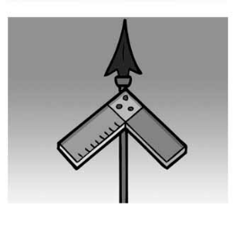
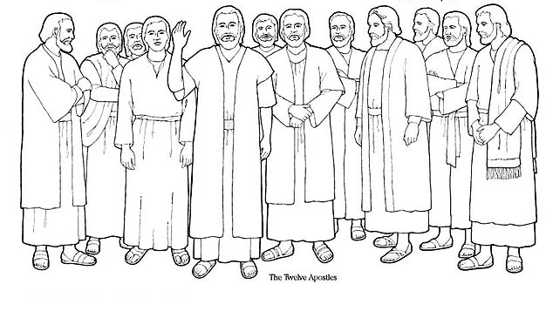
Symbol s to cut and paste
Colour, cut and paste the picture below into your jotter to make your work bright and colourful.
What Makes a Disciple Unique?

Complete the following in your jotter. Colour, cut and paste the image to illustrate your work.
Refer to Matthew 4:18-22 and Mark 3:13-19 to help you.

Write your answers in full sentences!

- When Jesus called the disciples to be his followers, what did he promise them?
- What were the reactions of the disciples when Jesus called them to be his disciples?
- What do you think the disciples had to give up in order to follow Jesus?
- Why do you think these twelve men decided to become disciples of Jesus?

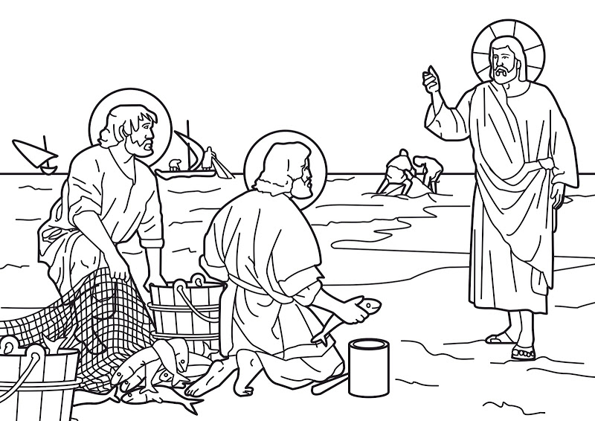

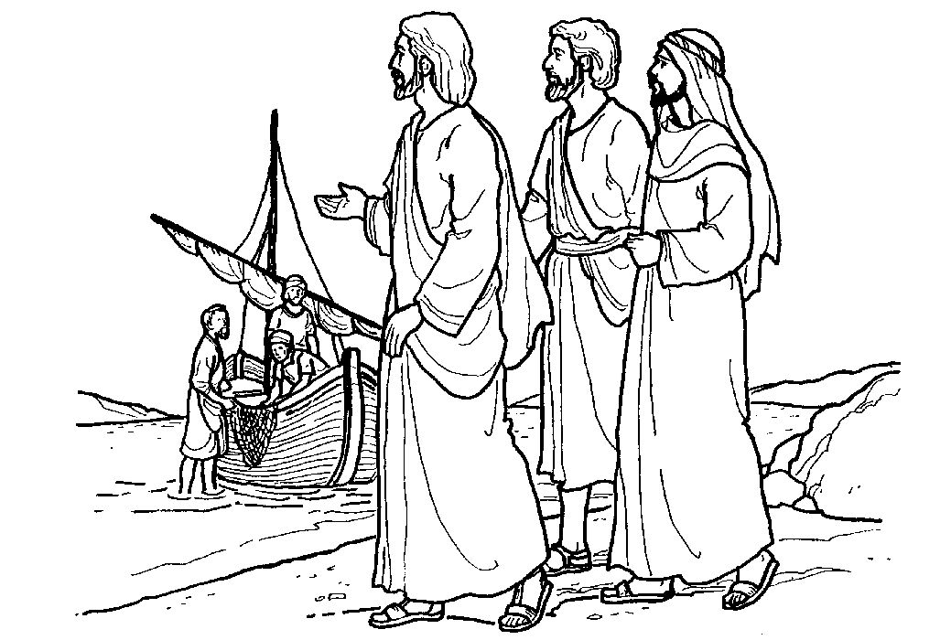
Disciple Diary Extract

L.I. We are applying our knowledge and understanding of the scripture passages of the calling of the twelve disciples by creating a diary extract from the point of view of one of the chosen.

An amazing thing happened to me today; Jesus called me to be his disciple.
I was… (What were you doing?)

Jesus said to me…..

I couldn’t believe my ears. Imagine Jesus wanting me to be his disciple!
So I… (How did you react?)

I had to say goodbye to…
(What did you give up?)

My friends thought I was mad and asked why I had decided to become Jesus’ disciple. The answer is simple…

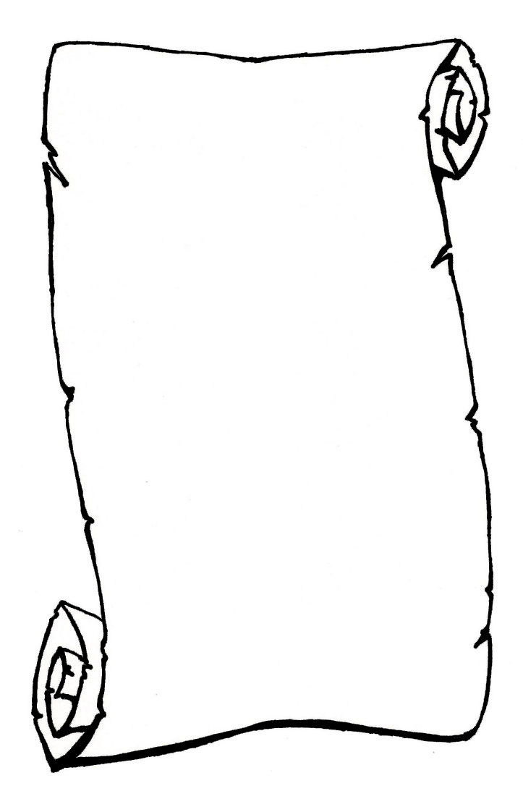
Diary Extract Scroll Template
Use a lined backing paper to help with presentation

Page layout example for Discipleship
I could show care and compassion to everyone I meet.

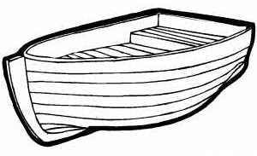

Tip – Draw the fish after writing to avoid making mistakes. Draw the outline of the fish in different colours to improve presentation.

Jesus as Healer

The Hemorrhaging Woman  (Mark 5:21-34)  How did Jesus treat the woman?  ___ with compassion  ___ with anger  ___ with indignation  After the woman touched his garment, Jesus asked, “Who touched my clothes?” Why?  ___ He didn’t know.  ___ He wanted the disciples to know.  ___ He wanted to give the woman a chance to  talk with him.  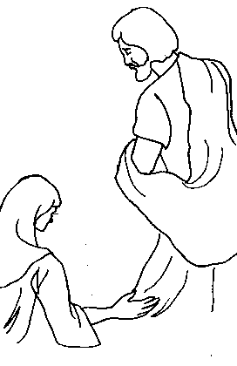  What caused the woman to be cured? | The Deaf Man  (Mark 7:31-37)  How did Jesus come to meet this man?  Jesus:  ___ performed the miracle in from of crowds.  ___ took the man aside away from the public.  ___ sent the man away.  What did Jesus do to help the man?  - __________________________________  - ___________________________  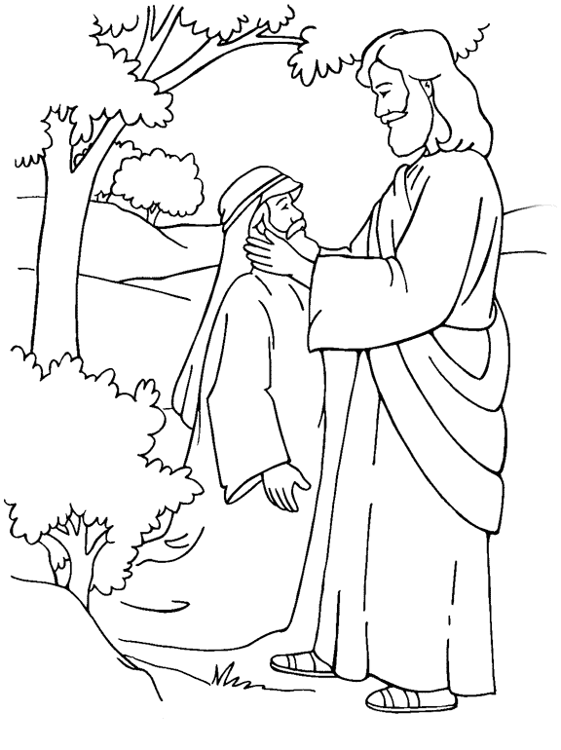  - ___________________________  What caused the woman to be cured? | The Blind Man  (Mark 8:22-26)  Where was Jesus?  ____________________________  The blind man:  ___ begged Jesus to touch him.  ___ asked His friends to ask Jesus for help.  ___ was approached by Jesus.  What did Jesus do to help the man?  1.__________________________________  2.__________________________  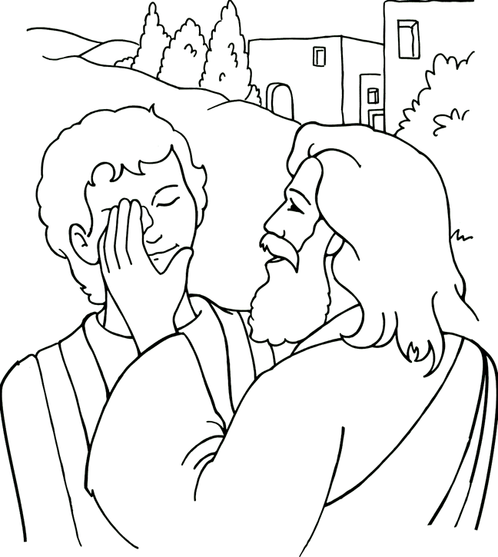  3.___________________________  What caused the woman to be cured?

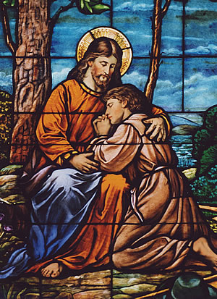
Peter Johnston’s Prayer Card
Lent 2014
THE CONFITEOR
I confess to almighty God
and to you, my brothers and sisters,
that I have greatly sinned
in my thoughts and in my words,
in what I have done,
and in what I have failed to do;
through my fault, through my fault,
through my most grievous fault;
therefore I ask blessed Mary ever-Virgin,
all the Angels and Saints,
and you, my brothers and sisters,
to pray for me to the Lord our God.

Tips and Hints
- Created in Microsoft Word
- Clipart taken by searching for forgiveness, confession or reconciliation on Google.
- Draw a picture box and add picture. Click ‘format’ and ‘text wrapping’ to bring in front of text.
- Add a text box and select appropriate font and point size.
- Add name and date so this can be kept as a keepsake.
- Print two copies so that one can be pasted into RERC jotter.
- Laminate final copy and use during daily prayers to help learn by heart.

Stations of the Cross – Sequencing Activity

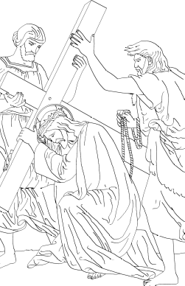
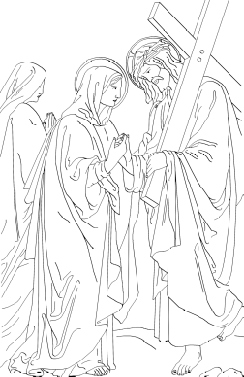
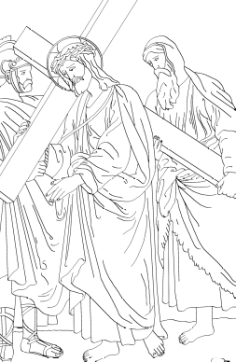

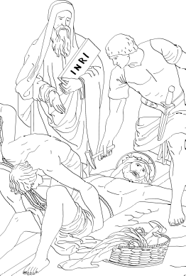
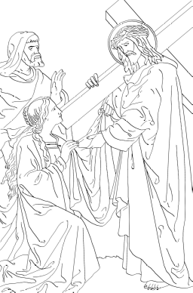
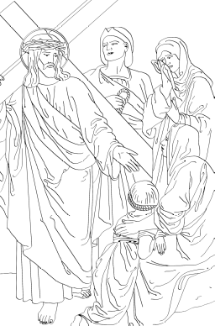
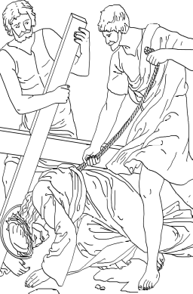

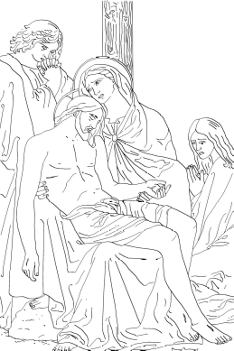

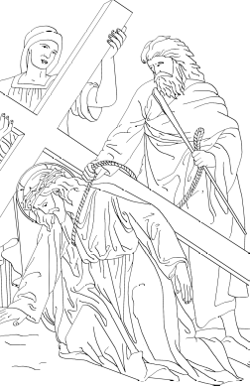
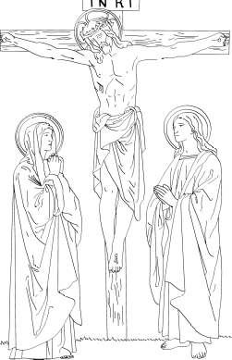
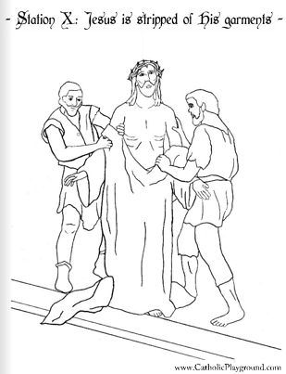
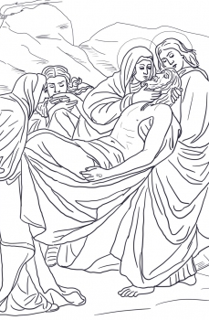

Write the correct description under each Station.
- Jesus is stripped of His garments.  - Veronica wipes the face of Jesus.  - Jesus falls for the first time.  - Jesus takes up His cross.  - Jesus falls for the second time.  - Jesus falls for the third time.  - Jesus is nailed to the cross. | - Jesus meets His mother.  - Jesus dies on the cross.  - Simon helps Jesus carry His cross.  - Jesus is condemned to death.  - Jesus is taken down from the cross.  - Jesus comforts the women of Jerusalem.  - Jesus is laid in a tomb.

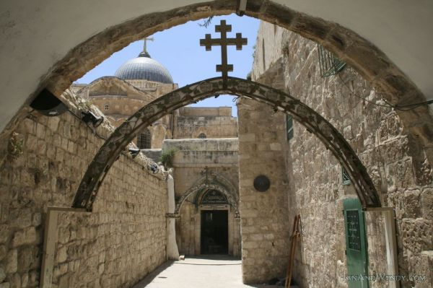
The Via Dolorosa

L.I. We are using our knowledge of the Stations of the Cross and our imaginative writing skills to create an account of someone witnessing Jesus passing by on the Via Dolorosa. We are taking into account our senses and reflecting on how this event would have made us feel.

Where were you standing?

What was the atmosphere like?

Who was around you?
How were they reacting?
What were they saying?

How did you know Jesus was approaching?

What did you hear and see as Jesus passed by?

How did Jesus look?

How did you feel?

Palm Sunday – Questions following BBC Teacher Clip

Answer the following questions in your RERC jotter. Remember to answer in full sentences.

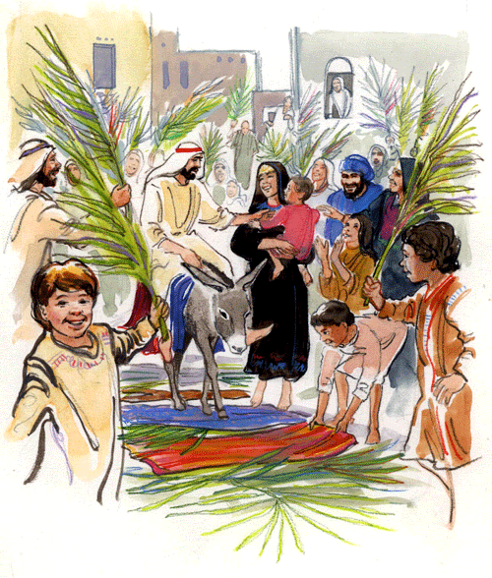

1. Give definitions to the following words. Miracle,
disciple and Passover.
2. How did Jesus arrive in Jerusalem?
3. How did the people react? Why do you think they
reacted in this way?
4. What word did the people keep shouting?
5. What were they waving in the air? Give three
examples of what people in Jerusalem might have
used these for?
6. Can you identify which part of Holy Mass is linked to
the cries of the people of Jerusalem on
Psalm Sunday?

Easter Mind Map – (For whiteboard display) – Use the titles as a guide to creating your own Easter Mind Map.

Where?
Songs
Easter
Special Words
People Attending
Food
Gifts
Traditions
Key Words

