Month/Season: May Class: Primary 1 Level: Early
Themes:
1. Queen of the May
2. Speaking to God through Prayer
3. The Bible – God’s Holy Book

Strands of Faith : Experiences and Outcomes | Core Learning | Learning & Teaching  Class/School/Home/Parish | Resources | Assessment
Hours of God  RERC 0‐15a  I am aware that Mary is the Mother of Jesus and Our Mother. | I know that Jesus’ mother is called Mary.  I am becoming familiar with the story of the Birth of Jesus (Luke 2: 8‐20; Matthew 2: 1‐12).  I know that Mary is Mother of us all. | Class: Teacher explains to the class that the month of May has the liturgical colour of green and asks the children to help in dressing the class altar with a green cloth. Teacher places a statue or a picture of Mary on the altar and explains to the children that the month of May is a special month of the year when we pray to Mary, the mother of Jesus.  Teacher leads the children in praying a Hail Mary around the May Altar and singing one verse of Immaculate Mary.  Class: Children read and colour May is the month of Mary from their May is the Month of Mary Workbook (attached to planner).  Class: Teacher discusses with the children the story of the Birth of Jesus that they heard at Christmas time. Where did Mary and Joseph travel to? Why could they not find a room to stay for the night? How do you think Mary felt? Where was Jesus born? What did the angels tell the shepherds? What gift did the shepherds bring baby Jesus? Who followed a star that led them to baby Jesus? What gifts did the three wise men bring baby Jesus?  Class: Children read and colour Month we all love so well from their May is the Month of Mary Workbook (attached to planner).  Class: Teacher discusses with the class that when Jesus was growing up Mary cared for him just like their mums care for them. How would Mary have cared for Jesus when he was a baby? What would Mary have taught Jesus to do as he was growing up? How does your mum care for you? Do you think Mary would have done the same things for Jesus?  Class: Children read and colour Mary is God’s own mother from their May is the Month of Mary Workbook (attached to planner).  Class: Teacher explains to the class that Mary is also our mother and she loves and cares for us. We are her children and we can ask her for her help at any time by praying to her. Teacher discusses with the children times when they, as a class or at home, have prayed to Mary. Have you prayed to Mary when someone was sick? Have you prayed to Mary when someone was having a baby? Have you prayed to Mary when someone was  going on a long journey? Teacher leads the children in praying a Hail Mary around the May Altar and begins to teach them a special hymn to Mary called May is the Month of Mary ( words attached to planner).  Class: Children read and colour Gladly her praises we tell from their May is the Month of Mary Workbook (attached to planner).  Class: Teacher explains to the class that during the month of May there are always beautiful blossoms on the trees and in honour of Mary the petals are collected and put in baskets. Sometimes there are May processions when people gather together and pray to Mary and sing hymns praising her for being the Mother of Jesus and our mother too. At these processions, the petals are scattered on the ground making a beautiful carpet in her honour. Children are each given a cardboard petal and write their name on it and colour the petal pink (petal template attached to planner).  Class: Children continue to learn the hymn May is the Month of Mary and read and colour Mary is beautiful Mary is fair from their May is the Month of Mary Workbook (attached to planner).  Class: Teacher gathers children round the May Altar and each child is given the opportunity to place their petal on the altar. Teacher leads the children in praying the Hail Mary and singing May is the Month of Mary.  Children read and colour Gladly we love her in song and in prayer from their May is the Month of Mary Workbook.  School: Children participate in school assemblies in honour of Mary.  KEY VOCABULARY: Jesus’ mother, Mary, Mother of us all | May is the Month of Mary Workbook  Art Materials  Words of Hymn May is the Month of Mary  Petal Template  Pink Crayons /Pencils/Felt Pens | Children know Jesus’ mother is called Mary.  Children know that Mary is Mother of us all.

Strands of Faith : Experiences and Outcomes | Core Learning | Learning & Teaching  Class/School/Home/Parish | Resources | Assessment
Hours of God  RERC-014a  I know that when I pray I am speaking to God. | I understand that, when I pray, God is calling me to be with him, to talk to him and to listen to him.  I am aware that I can pray to God anytime, in my heart or aloud and that God always hears me.  I know that often, when we pray to God, Father, Son and Holy Spirit, we start by making the Sign of the Cross and joining our hands.  I have learnt by heart the following prayers Our Father, Glory Be, Hail Mary, Morning and Evening Prayer and Grace Before/After Meals.  I know that we can pray through words, gestures and song.  I remember that, when I pray, I can ask God to help me and others and I can thank God and honour God.  I can use these prayers in my class and in personal prayer. | Class: Teacher discusses with the class that when we pray, we are talking and listening to God. What do you say to God? Do you ever ask him to help you or your family? Do you listen to God? What does he say to you?  Teacher explains to the children that we can pray to God anywhere and anytime of day. We can speak to Him in our heart or aloud and God always hears us.  Class: Children complete When I Pray Worksheet (attached to planner).  Class: Teacher discusses with the class that when you pray you start by making the sign of the Cross and joining your hands. What words do you say when you are making the Sign of the Cross. What are the actions? Teacher allows the children to practice making the Sign of the Cross.  Class: Children make Praying Hands Stained Glass Window (templates and instructions attached to planner).  Class: Teacher explains to the class that there is a special prayer that we say to God called the Our Father. Teacher says the words of the Our Father to the children. Teacher explains that God is Our Father and he loves and cares for us and we pray the Our Father every time we go to mass. Teacher spends time teaching the children how to pray the Our Father. The words of the Our Father which can be displayed around the class altar are attached to the planner.  Class: Children read and colour Our Father Worksheet (attached to planner).  Home: Children take the Our Father Worksheet home to pray with their family.  Class: Teacher teaches the class actions for the Our Father (attached to planner).  Class: Teacher gathers class round the class altar and leads a prayer time giving the children the opportunity to ask God for his help e.g. to help someone who is sick and to thank God for all the good things he has given us e.g. our family.  School: Children participate in prayer at school assemblies and the celebration of Mass.  KEY VOCABULARY: God, Sign of the Cross, pray, Our Father, Hail Mary, | When I Pray Worksheet  Art Materials  Praying Hands Stained Glass Window Templates and Instructions  Art materials  Wall Display of the Words of the Our Father  Our Father Worksheet  Art Materials  Instructions for actions to Our father | Children can make the Sign of the Cross.  Children can pray the words of the Our Father.  Children develop understanding that when we pray, we are talking and listening to God.

Strands of Faith : Experiences and Outcomes | Core Learning | Learning & Teaching  Class/School/Home/Parish | Resources | Assessment
Word of God  RERC 0‐11a  I am aware of some Bible stories. | I know that God’s Holy Book is called the Bible.  I can hear, recall and respond to different types of stories from the New Testament:  - an event: e.g., the Widow’s Mite (Mark 12: 41-44)  - a parable: e.g., the good Samaritan (Luke 10:29-37)  - a miracle: e.g., Walking on the water (Matthew 14: 22‐31) | Class: Teacher shows the class a bible and explains that this is a very special book. It is God’s Holy Book and contains lots of stories that God wants us to read and think about. Teacher asks the children if they know any of the stores in a bible, perhaps they have a children’s bible at home and might be familiar with stories such as Noah’s ark. Teacher discusses the different stories they have heard from the bible and then explains that when we go to mass, the priest reads to us stories from the bible. The teacher places the bible on the class altar.  Class: Children read and colour God’s Holy Book Worksheet.  Class: Teacher explains to the class that a part of the bible is called the New Testament and contains lots of stories about Jesus. The bible stories tell us about the people Jesus met, what Jesus did and what he said. Teacher reads from the bible the story of the widow’s mite (Mark 12:41-44) and discusses the event with the children. Where was Jesus? What did the rich people drop in the box? What did the poor widow drop in the box? Did the rich people have lots of money? Did the poor widow have lots of money? What did Jesus say about the two coins given by the poor widow? Teacher should explain to the children that the poor widow actually gave more because she gave everything she had.  Class: Children complete The Widow’s Purse worksheet.  Class: Teacher explains to the class that when Jesus was on earth, he told many stories. In God’s holy Book, the bible, these stories are called parables. The people who came to hear these stories were sometimes happy about the story and sometimes they were sad. Sometimes they had to think about the story and how it taught them how to live their life as God wanted them to. Teacher reads from the bible the parable of the good Samaritan (Luke: 10:29-37) and discusses the parable with the children. Where was the man going? What happened to him? What did the priest do? What did the Levite do? What did the Samaritan do? Who acted like a neighbour towards the man attacked by the robber? What did Jesus say we should do? Teacher explains to the children that Jesus wants us to treat everyone as our neighbour and to be always kind and helpful towards them.  Class: Teacher organises the children to play the game- Who is my neighbour? (Instructions attached to planner).  Class: Teacher explains to the class that when Jesus was on earth he performed some miracles. Miracles are things which we do not think can ever take place. Teacher reminds the children that Jesus was the Son of God and could sometimes do things which we could not do ourselves. Teacher reads from the bible the miracle of Jesus walking on the water (Matthew 14: 22-31) and discusses the miracle with the children. What did Jesus stay behind to do? What happened to the boat that the disciples were in? How did Jesus reach the boat? Would you have thought that someone could walk on water? What did the disciples do when they saw him? What did Jesus say to them? What did Peter say to Jesus? Why did Peter begin to sink in the water? What did Jesus tell Peter he did not have? Teacher explains to the children that we must believe in Jesus and he will take good care of us.  Class: Children make a Jesus Walks on Water Collage (Resources, templates and instructions attached to planner).  KEY VOCABULARY: God, Holy Book, Bible, Old Testament, New Testament, parables, miracles  * Pentecost is a movable feast so should be checked on the liturgical calendar. If the feast falls in May please refer to first lessons of the June Planner. | Bible  God’s Holy Book Worksheet  Bible  The Widow’s Purse Worksheet  Art Materials  Scissors  Glue  Instructions for Who is my Neighbour? Game  Jesus Walks on Water( Resources, templates and instructions attached to planner) | Children know that God’s Holy Book is called the Bible.  Children can hear, recall and respond to the story of the Widow’s Mite.  Children can hear, recall and respond to the story of the good Samaritan.  Children can hear, recall and respond to the story of Jesus walking on the water.

Name_____________________________

When I Pray
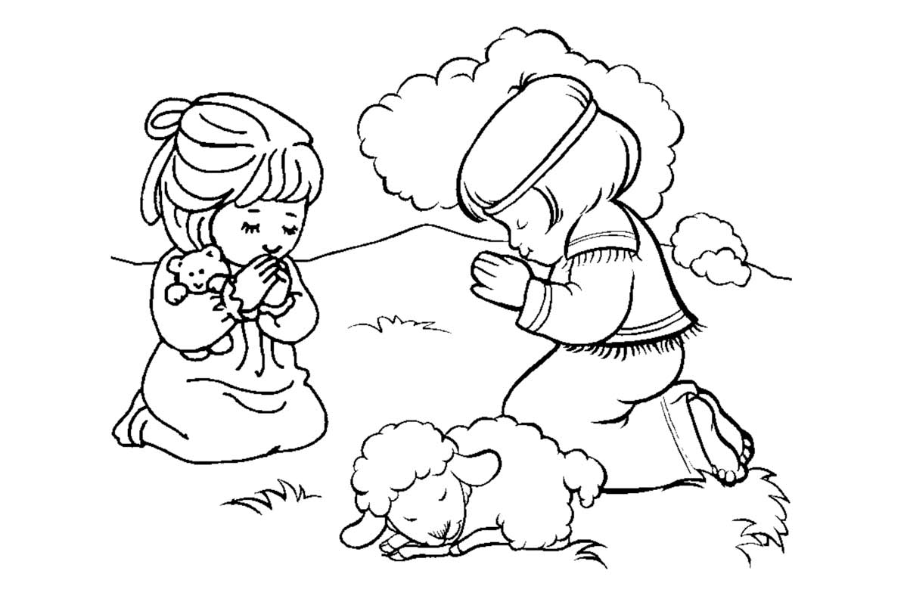

When I pray I am __________________________

and __________________________________

to God.

talking listening
Praying Hands Template

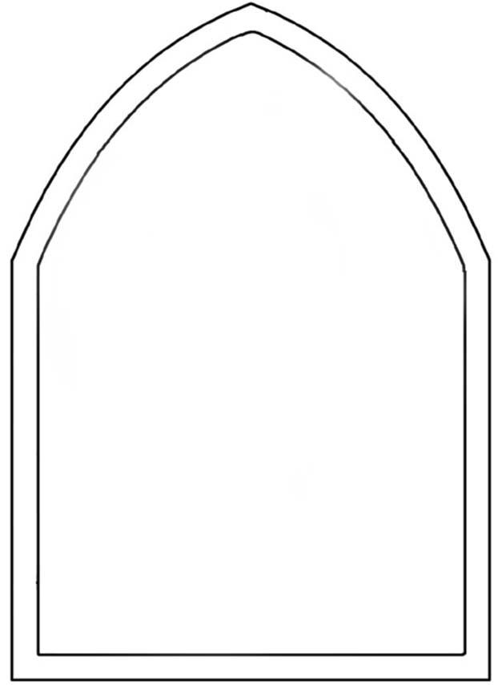
Template - Stained Glass Window

Instructions for Praying Hands Stained Glass Window
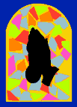

You will need:
- Praying hands silhouettes cut out of black paper
- Stained glass window template cut out of cardboard
- Gummed coloured paper
- Scissors
- Dark coloured A4 paper

How to make the Praying Hands Stained Glass Picture:
- Stick the praying hands silhouette onto the stained glass window template
- Cut up the coloured, gummed paper into small pieces
- Stick the coloured pieces around the praying hands
- Mount the completed window on dark coloured A4 paper

May is the Month of Mary

May is the Month of Mary
Month we all love so well.
Mary is God’s own mother
Gladly her praises we tell.

Mary is beautiful
Mary is fair.
Gladly we love her
In song and in prayer.

May is the Month of Mary
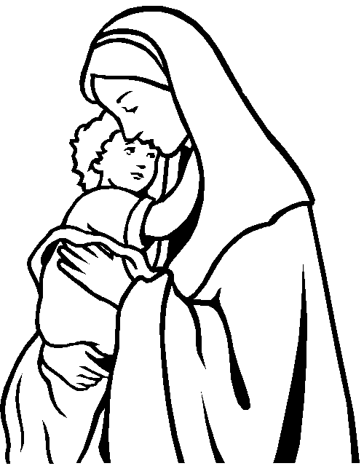

Name___________________ Primary 1
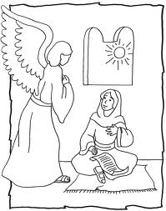

May is the month of Mary.
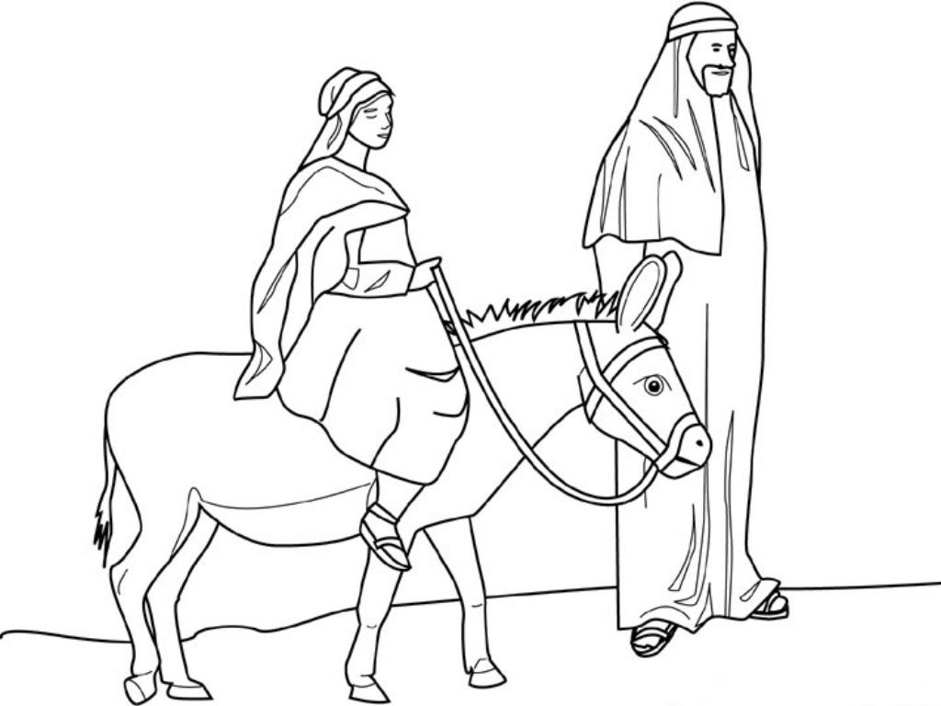

Month we all love so well.

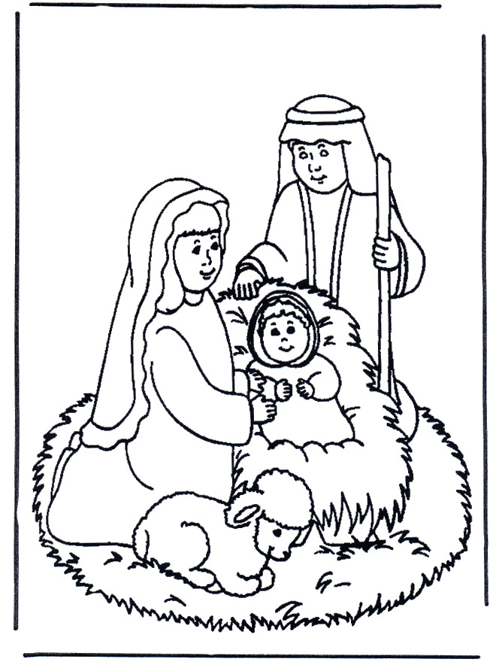

Mary is God’s own mother

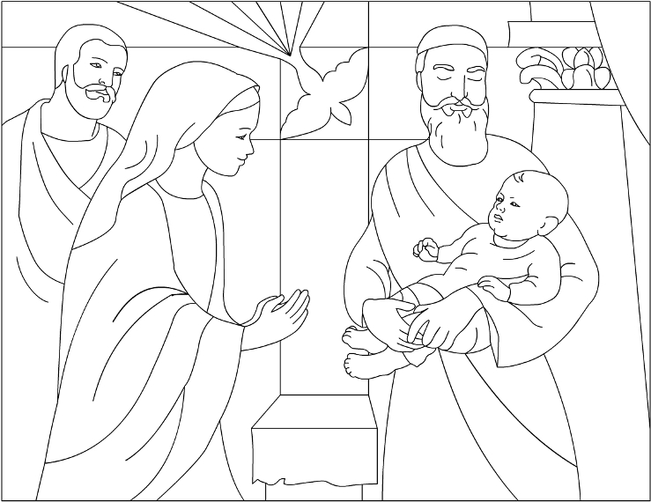

Gladly her praises we tell.

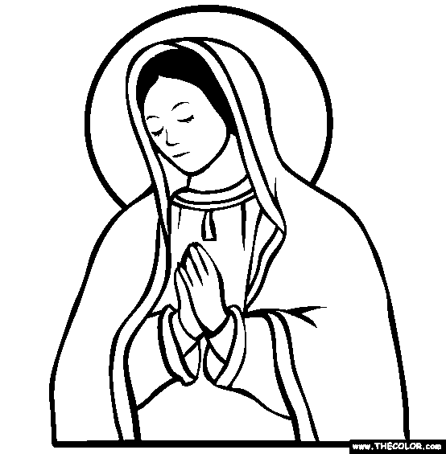

Mary is beautiful
Mary is fair.

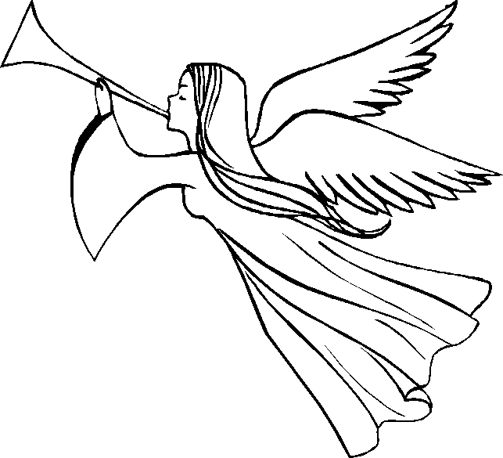

Gladly we love her
In song and in prayer.

Petal Template

Our Father, who art in heaven,
hallowed be thy name.

Thy kingdom come,
Thy will be done on
earth as it is in heaven.
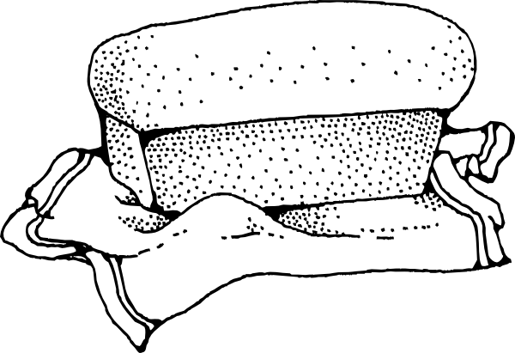

Give us this day
our daily bread.

And forgive us our trespasses.
As we forgive those who
trespass against us.

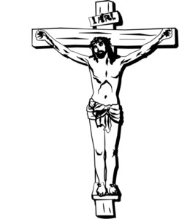

And lead us not into
temptation, but
deliver us from evil. Amen
Name____________________________

Our Father
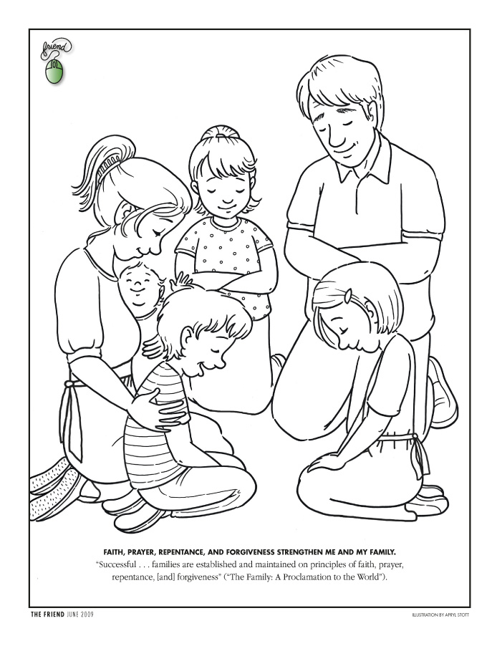

Our Father, who art in Heaven,
hallowed be thy name.
Thy Kingdom come.
Thy Will be done on earth, as it is in Heaven.
Give us this day our daily bread.
And forgive us our trespasses as we
forgive those who trespass against us.
And lead us not into temptation
but deliver us from evil.
Amen.
Our Father with Actions
Our Father (hands joined)
Who art in heaven (raise both hands up high)
Hallowed be thy name (head bowed)
Thy Kingdom come (raise outstretched hands above head in a V shape)
Thy will be done (cross arms in front of chest and bow head)
On earth (point open hands down toward the earth)
As it is in heaven (swoop hands both up over head)
Give us this day our daily bread (hands out ready to receive)
And forgive us our trespasses (join hands)
As we forgive those who trespass against us (pretend to shake hands with someone beside you)
And lead us not into temptation (hold flat palm out in front of body in a “stop” gesture)
But deliver us from evil (hug yourself)
Amen

Name_____________________

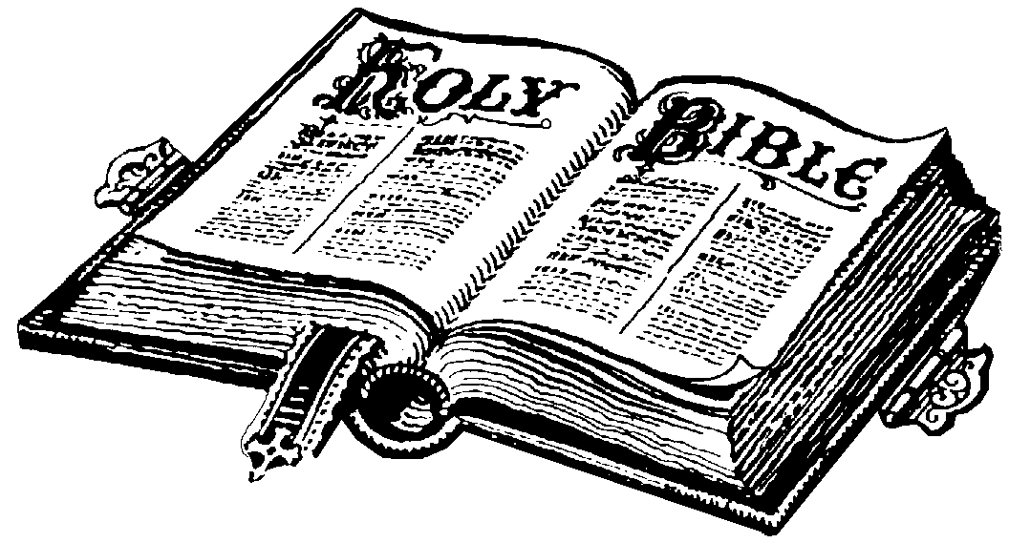
God’s Holy Book is called the Bible.

Name________________________________

Cut out the two coins and glue them in the widow’s purse.

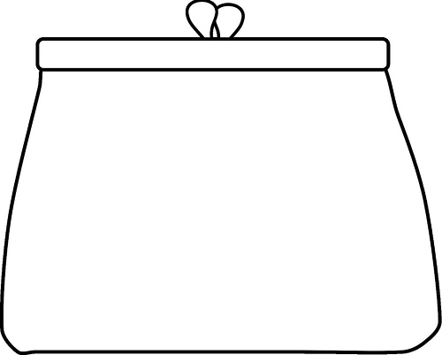

Game: Who is my Neighbour?
Ask the children sit or stand in a circle. Tell the children they are all neighbours. Make one child stand in the centre of the circle. She will be the "new" neighbour. The new neighbour must pick out one of the neighbours in the circle and say something like, "My neighbour is wearing brown shoes." If a child thinks he might be the one she is talking about he must raise his hand. If multiple children raise their hand, the new neighbour says, "Yes, it is one of you." Next, the new neighbour says something else about the person she has picked. She might say, "My neighbour has black hair." Again, if a child thinks he is the one she is describing he must raise his hand. The game continues until only one child has his hand up, and he is the correct person. He then becomes the "new" neighbour.
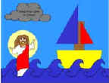
Jesus Walks on Water
You will need:
- A4 blue paper
- Art materials
- scissors
- Glue
- Templates 1 and 2

Instructions

- Colour the pictures on the templates.
- Cut out the pictures and divide the triangles, circle and rectangle into halves.
- Glue one set of waves to the bottom of the blue paper
- Assemble the boat on the bottom right corner of the paper, so it sits in the waves:
  - The half circle is the body of the boat
  - The rectangle is the mast
  - The two triangles are the sails.
- Glue Jesus to the left hand corner.
- Glue another set of waves in front of him.
- Glue the cloud to the top left hand corner.

Template No. 1 – Jesus Walks on Water
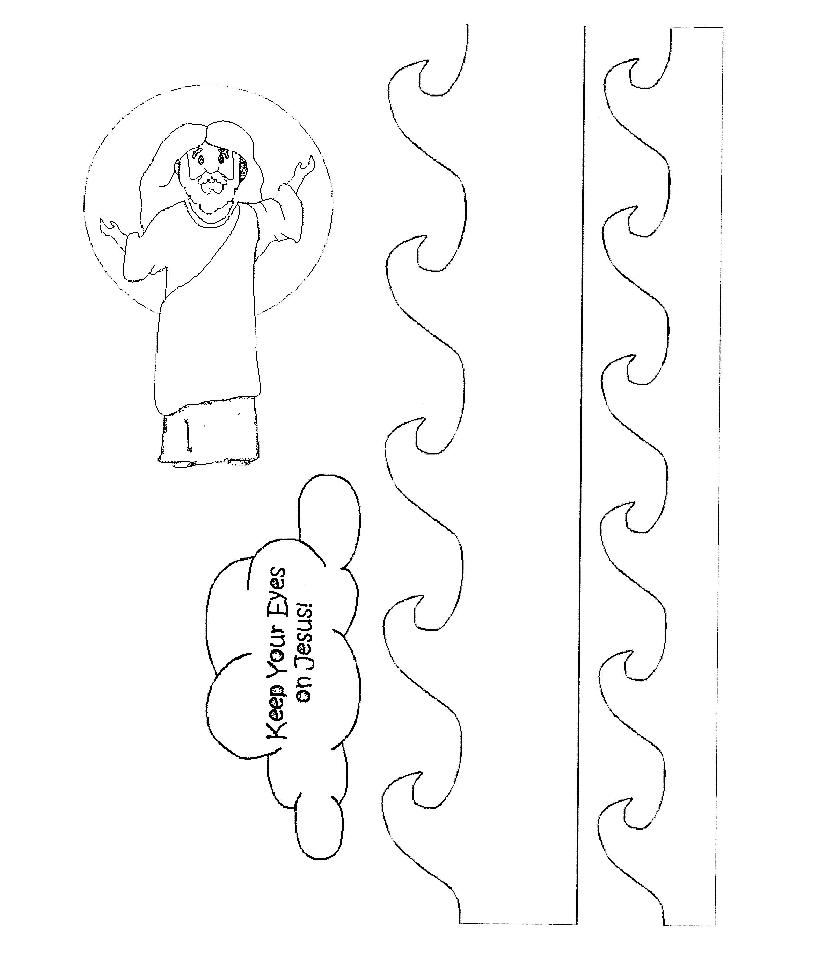

Template No. 2 – Jesus Walks on Water

Fold each shape in half and use to make a sail boat

