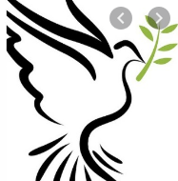
The Feast of Pentecost – P1
We celebrate when the Holy Spirit came to Jesus’ friends.
When we say our prayers we start and end with:
In the name of the Father and of the Son and of the Holy Spirit – Amen
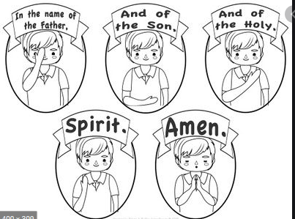
Practice this with your family
Think about / Talk about:
When do we say prayers? 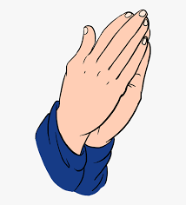
Why do we say prayers?
What prayers do we know?
Why not say a prayer asking God to look after you and your family. Start and end with the sign of the cross.

Now - Listen to the story of Pentecost
Imagine you were there with the Apostles and Mary, what would think?, feel? Hear? See?
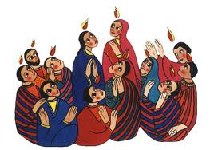
Pentecost
What is Pentecost? This is a very special time in the Bible when Jesus’ friends received the Holy Spirit. Before I explain why and how this happened there are a few things you need to know first.
Pentecost happened after Easter Sunday when Jesus rose from the dead. Jesus had already gone back to Heaven so his friends were waiting to be visited by the Holy Spirit because that's what Jesus told them would happen.
Just before Jesus was taken up to heaven he told his friends that the Holy Spirit would visit them to give them new gifts and talents.
Jesus’ friends had got together and suddenly a sound like the blowing of a strong wind came from heaven and filled the whole house where they were sitting.
Next they saw flames that separated and came to rest above the heads of everyone in the room. The fire which had come into the room was the Holy Spirit. He gave them the gift of being able to speak in different languages. It was pretty exciting and things got a bit noisy.
It says that there were people of many different countries staying in Jerusalem from all over and many of them spoke different languages. These people ran over to see what all the noise was about and were surprised to hear their own languages spoken throughout this group. Things must have sounded crazy! Imagine all these people speaking many different languages at the same time and shouting out praises to God excited that something amazing from God had just happened to them.

