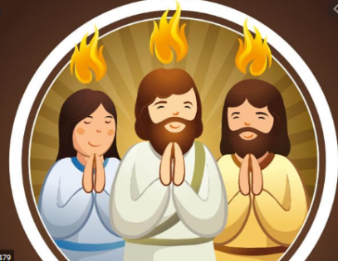
P2 – Pentecost – June
Jesus promised the disciples that the Hoy Spirit would come and help them when He was gone. Pentecost happened 50 days after Easter Sunday or 50 days after Jesus rose from the dead. Jesus had already gone back to Heaven so the disciples were waiting to receive the Holy Spirit because that's what Jesus told them would happen.
Now listen to, or read the story of Pentecost:
Pentecost happened after Easter Sunday when Jesus rose from the dead. Jesus had already gone back to Heaven so his friends were waiting to be visited by the Holy Spirit because that's what Jesus told them would happen.
Just before Jesus was taken up to heaven he told his friends that the Holy Spirit would visit them to give them new gifts and talents.
Jesus’ friends had got together and suddenly a sound like the blowing of a strong wind came from heaven and filled the whole house where they were sitting.
Next they saw flames that separated and came to rest above the heads of everyone in the room. The fire which had come into the room was the Holy Spirit. He gave them the gift of being able to speak in different languages. It was pretty exciting and things got a bit noisy.
It says that there were people of many different countries staying in Jerusalem from all over and many of them spoke different languages. These people ran over to see what all the noise was about and were surprised to hear their own languages spoken throughout this group. Things must have sounded crazy! Imagine all these people speaking many different languages at the same time and shouting out praises to God excited that something amazing from God had just happened to them.
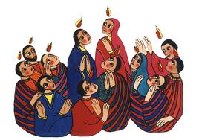
Talk about/Think about:
Where were the disciples? What strange noise came from the sky? What touched every person? What were they filled with? What could they do that they couldn’t do before? Do you think they were glad to be filled with the Holy Spirit?
Imagine that you were with the Apostles – draw/paint a picture of what it would have been like.
The disciples could not see the Holy Spirit, they felt Him around them. They felt the wind blowing through the whole house and they saw the tongues of fire touching each person. They also felt stronger and braver and were ready to go out and spread the good news about Jesus.

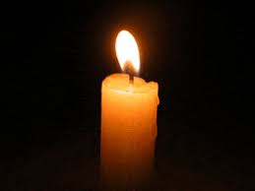
Now – Let us pray together and thank God for the Holy Spirit
In the name of the Father and of the Son and of the Holy Sprit . Amen

Glory be to the Father, and to the Son, and to the Holy Spirit.
As it was in the beginning, is now, and will be forever.
Amen
Holy Spirit help us to look after each other and care for each other.

In the name of the Father and of the Son and of the Holy Spirit. Amen

