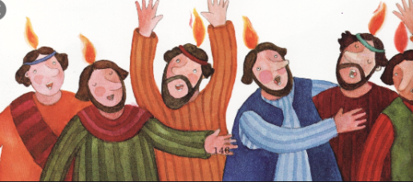P3 – Pentecost – June

When we celebrate the feast of Pentecost, we are celebrating the disciples of Jesus receiving the Holy Spirit. Pentecost happened 50 days after Easter Sunday or 50 days after Jesus rose from the dead. The liturgical colour for Pentecost is **red** and on Pentecost Sunday the priest wears **red vestments**.

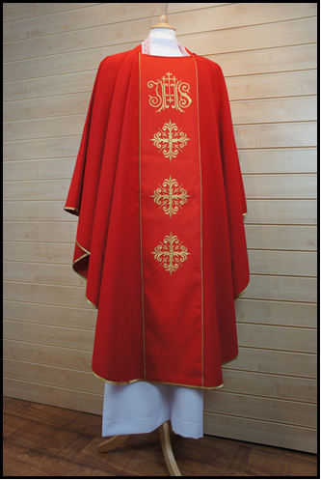***Why not make a Pentecost Altar at home. Use a red cloth, or paper.***

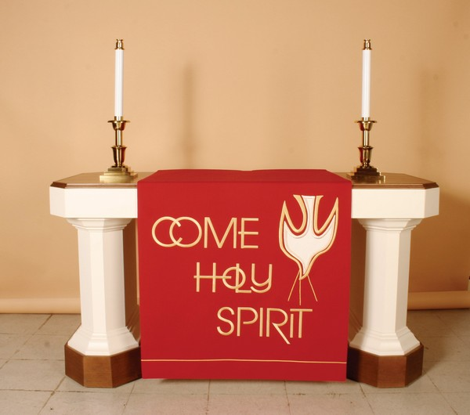

Now let us pray to the Holy Spirit for strength and courage:

*Come Holy Spirit fill the hearts of your faithful and give them the fire of your love.*

*Holy Spirit give us the courage to be a true friend of Jesus. Amen*

**Listen to, or read the story of Pentecost:**

When the day of Pentecost came, they were all together in one place. 2Suddenly a sound like the blowing of wind came from heaven and filled the whole house where they were sitting. They saw what seemed to be tongues of fire that separated and came to rest on each of them. All of them were filled with the Holy Spirit and began to speak in other languages as the Spirit filled them.

Now there were staying in Jerusalem Jews from every nation under heaven. When they heard this sound, a crowd came together in bewilderment, because each one heard their own language being spoken.

Think about, or talk about:

*Where were the disciples? What strange noise came from the sky? What touched every person? What were they filled with? What could they do that they couldn’t do before? Do you think they were glad to be filled with the Holy Spirit*?

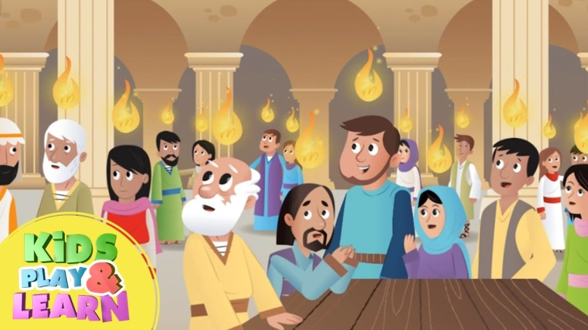

**Pentecost Reporter**

Imagine you are a television reporter and you were present at the scene of Pentecost. Write out three questions you would ask the disciples. Remember a question usually starts with:

**Where? What? Why? When? How?**

**Question 1:**

**_______________________________________________________________________________**

**Question 2:**

**_______________________________________________________________________________**

**Question 3:**

**_______________________________________________________________________________**

*Ask one of your family to pretend to be an Apostle, ask them the questions. You could record/write their answers.*