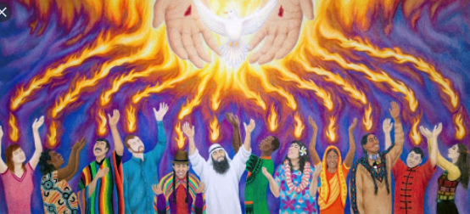
P4 – Pentecost – June
We are celebrating the disciples of Jesus receiving the Holy Spirit. Pentecost happened 50 days after Easter Sunday or 50 days after Jesus rose from the dead.
Our Timeline:
The Holy Spirit comes to the Apostles and Mary
10 days
Jesus goes back to Heaven
40 days
Jesus rises from the dead
3 days
Jesus dies on the Cross

Draw a picture of each event.
Now – Listen to, or read the story of Pentecost:
After Jesus went back to Heaven the Apostles and Mary went back to the upper room where they had eaten the Last Supper. They were very frightened as they worried that they would also be crucified, or killed by the Romans. They were also excited as Jesus had promised not to leave them alone and that he would send the Holy Spirit to be with them for all time.
Suddenly a sound like the blowing of a strong wind came from heaven and filled the whole house where they were sitting.
Next they saw flames that separated and came to rest above the heads of everyone in the room. The fire which had come into the room was the Holy Spirit. He gave them the gift of being able to speak in different languages. It was pretty exciting and things got a bit noisy.
There were people of many different countries staying in Jerusalem from all over and many of them spoke different languages. These people ran over to see what all the noise was about and were surprised to hear their own languages spoken throughout this group. Things must have sounded crazy! Imagine all these people speaking many different languages at the same time and shouting out praises to God excited that something amazing from God had just happened to them. The Apostles told everyone about God and praised Him.
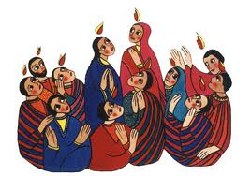
Think of before/After Pentecost. Write some words to describe the Apostles:
After
- _____________
- _____________
- _____________
Before
- _______________
- _______________
- _______________

Think about, write/draw some of the things that make you afraid:

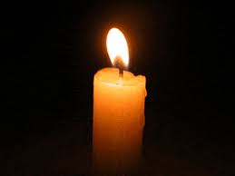
Now – Let us pray:
Lest us ask the Holy Spirit to help us overcome those things that makes us frightened. Ask for the courage of the Holy Spirit.
In the name of the Father and of the Son and of the Holy Spirit. Amen.
Dear Holy Spirit, help me to not be afraid. Give me courage in the same way that you gave the Apostles courage at Pentecost. I offer you all me fears and my worries. Thank you for looking after me and my family.
Amen

In the name of the Father and of the Son and of the Holy Spirit . Amen.

