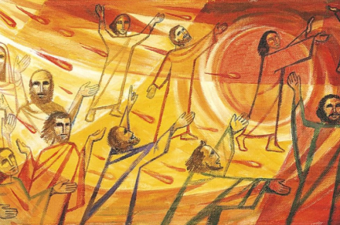P5 – Pentecost – June

God sent the Holy Spirit at Pentecost to be with us always and the Holy Spirit:

* strengthens our faith
* informs our conscience
* guides us in all moments of our life

Look at this image of Pentecost – think of the colours, the movement. Draw, paint your own dove to show the excitement of Pentecost.

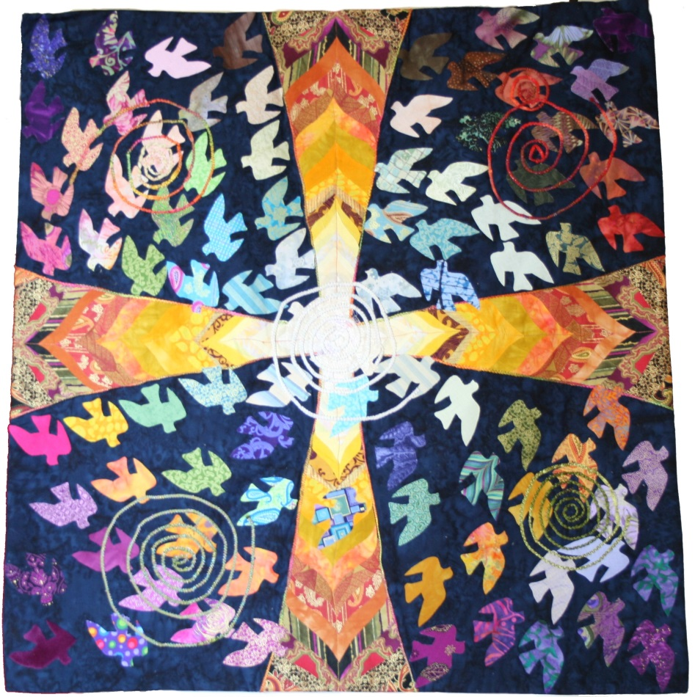

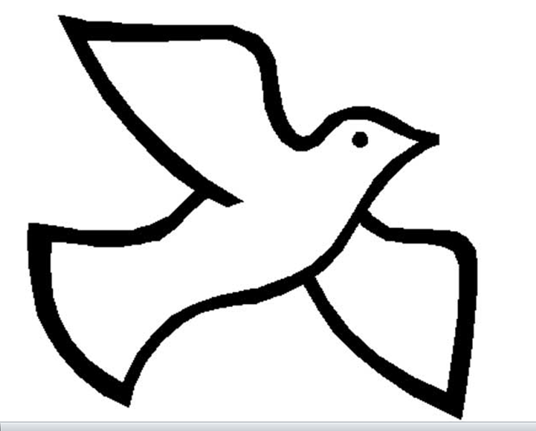

**At Baptism, we receive seven special gifts from the Holy Spirit. These gifts are freely given to us to help us live as followers of Jesus and to build up the Body of Christ, the Church. The Gifts of the Holy Spirit are sealed and strengthened within us at Confirmation**.

*Read about each of the gifts of the Spirit:*

**Wisdom** helps you to avoid the things that could lead you away from God

**Understanding** is the gift of comprehension, or the ability to grasp the meaning of the teachings of the Church. The gift of understanding helps you be tolerant and sympathetic of others. It helps you sense when someone is hurting or in need of compassion.

**Right Judgement** is the gift that helps you make choices to live as a faithful follower of Jesus.

**Courage** is the gift that helps you stand up for your faith in Christ. The gift of courage helps you overcome any obstacles that would keep you from practicing your faith.

**Knowledge** is the gift of that enables you to choose the right path that will lead you to God. It encourages you to avoid obstacles that will keep you from him.

**Reverence** is the gift of confidence in God. This gift of reverence inspires you to joyfully want to serve God and others

**Wonder and Awe in God’s Presence** is the gift that encourages you to be in awe of God. The gift of wonder and awe moves you to love God so that you do not want to offend him by your words or actions.

Now – Write about how you have used one of these gifts, illustrate your story.

**How I used the Gifts of the Holy Spirit Name: _____________________**

**_______________________________________________**

**_______________________________________________**

**_______________________________________________**

**_______________________________________________**

**_______________________________________________**

**_______________________________________________**

**_______________________________________________**

**_______________________________________________**

**_______________________________________________**

**_______________________________________________**

**_______________________________________________**

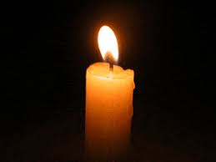Let us pray:

Thank the Holy Spirit for the gifts and ask for guidance in using them.

Holy Spirit thank you for gifts of:

Wisdom

Understanding

Right judgement

Courage

Knowledge

Reverence

Wonder and awe

Help me to use these gifts wisely for the good of others and for the good of the Church.

Holy Spirit pray for us. Amen