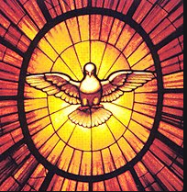
P6 – Pentecost – June
A reminder:
Fruits of the Holy Spirit | Gifts of the Holy Spirit
Wisdom  Understanding  Right Judgement  Courage  Knowledge  Reverence  Wonder and awe | Love  Joy  Peace  Patience  Kindness  Goodness  Gentleness  Faithfulness  Self-control

The fruits of the Holy Spirit are signs that the Holy Spirit is alive within us and helping us live the Catholic faith in our daily lives.

Read about each fruit of the Spirit.
Love: We exhibit the virtue of charity, or love, by our unselfish devotion and care for God and our neighbour.
Joy: We live with joy when we recognise that true happiness comes, not from money or possessions, but from knowing and following Christ.
Peace: We are freed from worrying about trivial things because of the inner peace we experience with God in our hearts. We work and pray for peace throughout the world.
Patience: We demonstrate patience by treating others with thoughtfulness and tolerance. We know that we can overcome the temptations and sufferings of life because God is always with us.
Kindness: We live the virtue of kindness by treating others as we want to be treated.
Goodness: We exhibit goodness when we honour God by avoiding sin and always trying to do what we know is right.
Gentleness: Gentle people act calmly and avoid actions that might lead others to anger or resentment.
Faithfulness: We are faithful when we live out our commitment to the teachings of Jesus, the Scriptures, and the Catholic Church.
Self-control: We exercise self-control by working to overcome the temptations we face and by trying always to do God’s will
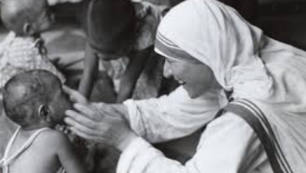
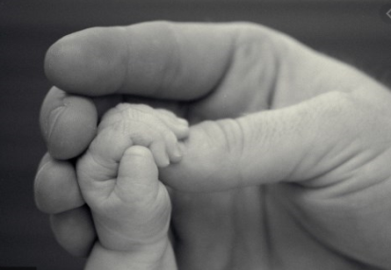
Label each image – Write which fruit of the Spirit it represents.

Using the Fruits of the Spirit – Write a sentence about how you use each gift of the Spirit to help others and the Church
Fruits of the Spirit | How I use them
Love

Joy

Peace

Patience

Kindness

Goodness

Gentleness

Faithfulness

Self-control

Let us pray:
Ask the Holy Spirit to give us help in using the Fruits of the Spirit:
Come Holy Spirit fills the hearts of your faithful and kindle in them the fire of your love.
Send forth your Spirit and they shall be created. And You shall renew the face of the earth.
Amen
Now – Sit quietly, think and pray about how you will try harder to use the fruits of the Spirit.

Complete – I will try hard to use the gift of __________________ by _______________________
_____________________________________________________________________________ .

Come Holy Spirit

