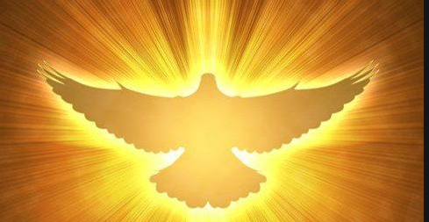P7 – Pentecost – June

Read the story of Pentecost:

After Jesus went back to Heaven the Apostles and Mary went back to the upper room where they had eaten the Last Supper. They were very frightened as they worried that they would also be crucified, or killed by the Romans. They were also excited as Jesus had promised not to leave them alone and that he would send the Holy Spirit to be with them for all time.

Suddenly a sound like the blowing of a strong wind came from heaven and filled the whole house where they were sitting.

Next they saw flames that separated and came to rest above the heads of everyone in the room. The fire which had come into the room was the Holy Spirit. He gave them the gift of being able to speak in different languages. It was pretty exciting and things got a bit noisy.

There were people of many different countries staying in Jerusalem from all over and many of them spoke different languages.  These people ran over to see what all the noise was about and were surprised to hear their own languages spoken throughout this group.  Things must have sounded crazy!  Imagine all these people speaking many different languages at the same time and shouting out praises to God excited that something amazing from God had just happened to them. The Apostles told everyone about God and praised Him.

*Now answer the questions:*

1. What is the name given to the time when Jesus went back to Heaven?

_______________________________________________________________________________

2. Why were the Apostles frightened when Jesus left them?

_______________________________________________________________________________

_______________________________________________________________________________

3. What do you think the Apostles heard and saw when the Spirit came?

_______________________________________________________________________________

_______________________________________________________________________________

4. How would you have felt if you were one of the Apostles?

_______________________________________________________________________________

_______________________________________________________________________________

5. What difference was there in the Apostles after the Spirit came?

_______________________________________________________________________________

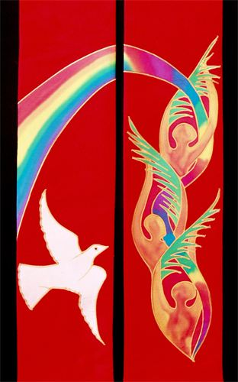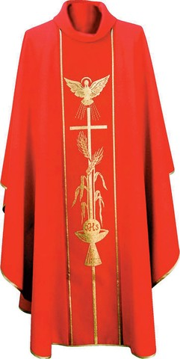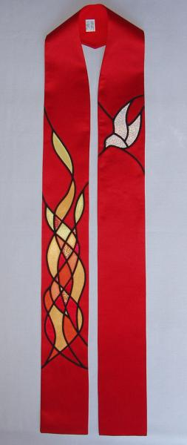

Why does the Priest wear red during Pentecost?

At what other celebration does the Priest wear red vestments?

NOW:

Design you own Pentecost Stole

Think of the colours and symbols

Altar Cloth

Red Vestments

Pentecost Stole

Stole Template

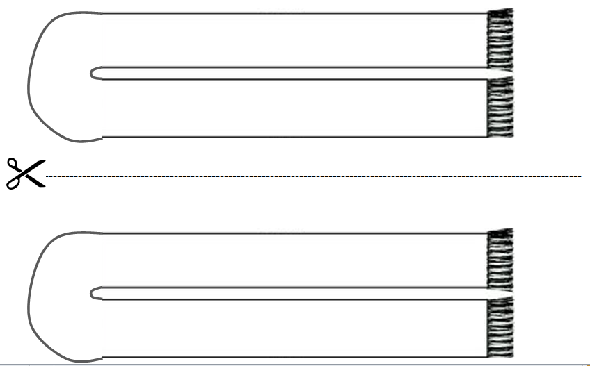

Pentecost by Giotto di Bondone

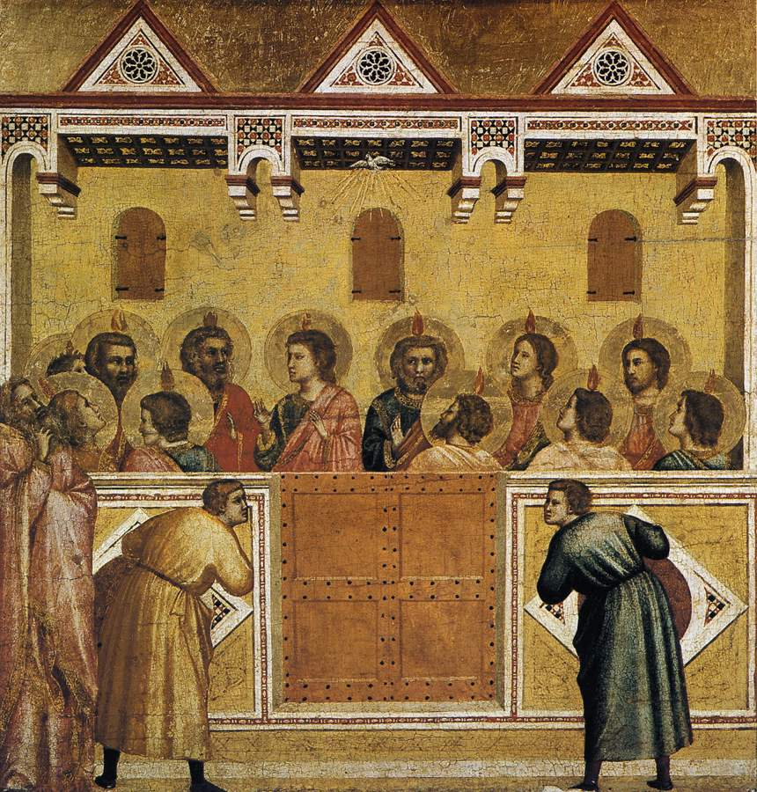

**Complete the following:**

1. Study the painting for one minute. Write down five things you’ve noticed about the painting.
2. Imagine that the two men at the front of the picture have speech bubbles. What could they be saying to each other?

Cut out the speech bubbles below and stick them onto the picture.

1. Who do you think the man outside the room without the halo is? He looks deep in thought what do you think he is thinking about.
2. According to the Acts of the Apostles the Holy Spirit appeared as wind and fire. Imagine that you are choosing two symbols what would you choose to represent the Holy Spirit and why?

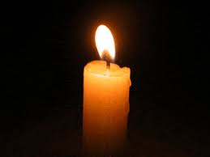Now let us pray:

***Come Holy Spirit fills the hearts of your faithful and kindle in them the fire of your love.***

***Send forth your Spirit and they shall be created. And You shall renew the face of the earth.***

***Amen***

Now – Sit quietly, think and pray about how you will try harder to be a true follower of Jesus by using the gifts and fruits of the Holy Spirit

Complete – I will try hard to use the gifts and fruits of the Spirit by _________________________

_____________________________________________________________________________ .

**Come Holy Spirit**