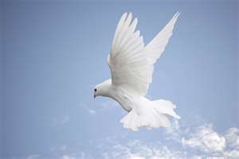
Let us pray ………….

Father, teach us to help young people to appreciate their own worth.
enable us to touch their hearts and to empower us to reveal your love for them.
Inspire us to support and encourage and build others up as members of one body.
Helps us to follow Christ our Teacher.
And be incredible witnesses to your love. AMEN
All sing:
One bread, one body, one Lord of all
One cup of blessing which we bless
And we though many, throughout the earth
We are one body in this one Lord
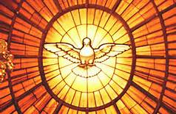
Gentile or Jew, servant or free
Woman or man, no more
Many the gifts, many the works
One in the Lord of all

Prayer to the Holy Spirit
Come Holy Spirit, fill the hearts of your faithful and kindle in them the fire of your love.
V. Send forth your Spirit, and they shall be created.
R. And You shall renew the face of the earth.

