Month/Season: November Class: Primary 2 Level: First
Themes:
1. Remembrance and Heaven
2. Jesus Calls the First Disciples
3. Respect during Mass and Prayer Time

Strands of Faith : Experiences and Outcomes | Core Learning | Learning & Teaching  Class / School / Home / Parish | Resources | Assessment
In the image of God  RERC 1‐02a  I know that a loving God has created me and that my uniqueness can develop according to God's plan for me  GLP  HWB 1-50a  I am learning about where living things come  from and about how they grow, develop and  are nurtured. | GLP  I know that everything created by God, including ourselves, begins life, grows, develops and eventually dies e.g. plants, fish, pets, and people.  I know that, although people die, they can live forever with God in heaven.  I can explore ways in which we learn to share and care for our friends. | Class/Home – In the summer our world is full of beautiful coloured flowers. When winters come the flowers are gone. What happens to them? (They die). Everything in our world will eventually die and new life will follow. For example, although the flowers die in winter new life follows in the spring with the buds on the trees and the daffodils and crocuses. Some of you may have had pets that have died. It is very sad when this happens but we can remember the fun times that we spent with our pets, perhaps you have photographs to help you to remember them. People die too but there is one very big difference because we have something very special that has been given to us by God. It is called a soul. You cannot see your soul and you cannot feel it but it is something that we can keep in good shape by being kind, generous and caring. Our soul is what lives on after our bodies die. When someone close to us dies we are very sad and miss them very much but we can remember them by talking about them and looking at photographs. We can also pray to God to look after them in heaven. Children will take home the remembrance sheet attached to the planner. They will complete this with their parent and bring it back to school. These will be placed on the altar and prayers will be said in class throughout November commemorating those who have died.  Class - Have you ever wondered about heaven? Where is it? What it's like? Who lives there? If you can think of a beautiful mountain, waterfall or even the prettiest flower you've ever seen and think of a place even more amazing than that. God has told us that in heaven. Show the children the colouring page attached (The Gates of Heaven). Ask the children to draw what they think lies beyond these gates. Worksheet attached to the planner ‘What I Think Heaven Looks Like’.  Class – We have to prepare to go to heaven our whole lives. This means what we have to try very hard to always be good. How can we do this?  Activity – ‘Kingdom of Heaven Cards’ attached to planner  KEY VOCABULARY: created, life and death, live forever, heaven.  Class – Read from the Bible ‘Jesus Calls the First Disciples’ (Luke 5: 1‐11).  Discuss the story. Children will complete the worksheet attached to this story. Children should draw a picture of themselves inside the fish and write their name at the bottom.  KEY VOCABULARY: Bible, Word of God, | Remembrance Sheet (attached to planner)  GLP  God’s Loving Plan CD, Primary 2, Worksheets 1, 2 & 3  Diocese of Motherwell Planning exemplars  www.rcdomeducation.org.uk/p2-my-uniqueness.html  Link to Science topics e.g.,  • Living Things: sorting living and non living things; growing  and caring for plants; features of each season as  appropriate;  • Topics related to Food, Health and Nutrition – how food is  produced, where it comes from, how to preserve it;  Glasgow SHRE Programme, P2 Lesson 1  Lanarkshire RSHP Pack Primary 1 page 30  ‘What I Think Heaven Looks Like’  (attached to planner)  Activity – ‘Kingdom of Heaven Cards’ (attached to planner)  Prayer service (attached to planner | Children will have some understanding that everything is created by God, grows, develops and eventually dies.  They will know that when we die we live forever with God in heaven.

Strands of Faith : Experiences and Outcomes | Core Learning | Learning & Teaching  Class / School / Home / Parish | Resources | Assessment
Word of God  RERC 1‐11a  I can share some Bible stories and I can explore how God speaks to us through these stories. I have reflected on how these stories can help me to live a Christian life.  Hours of God  RERC 1‐14a  I recognise the importance of personal prayer and communal prayer in the growth of all people’s relationship with God.  I know a number of traditional Catholic  Prayers and I have developed an understanding of the meaning of these prayers.  I have participated in different approaches to, and experiences of, prayer. | I know that God speaks to us through the Bible which is the Word of God.  I can hear, read and recount two or more of the following narratives from the Bible about people who listened to God’s Word and responded to it. e.g.  The First Four Disciples (Luke 5: 1‐11).  During class prayer times, I can contribute to prayers of thanksgiving to God for the good things in my life and world.  I can sit quietly for a few moments praying to God in my heart – listening and talking to God, thanking Him for His help.  I can use gestures and movements as types of prayer (e.g. kneeling, clapping, raising arms, genuflecting, and bowing).  I can take part in a simple prayer service led by my teacher or chaplain. | Class – Read from the Bible ‘Jesus Calls the First Disciples’ (Luke 5: 1‐11).  Discuss the story. Children will complete the worksheet attached to this story. Children should draw a picture of themselves inside the fish and write their name at the bottom.  KEY VOCABULARY: Bible, Word of God,  Class – Does anyone know what genuflecting is? When do we see people genuflecting? (In Church, to a King or Queen) Why do you think we do it?  We genuflect to show respect and obedience. Do you know what obedience means? This means that you understand that that person is important.  When the wise men visited Jesus at Christmas they genuflected before Him to show that they knew that even though he was born in a stable that he was a King.  The teacher should demonstrate to the children how to genuflect correctly. Slowly and when on one knee make the sign of the cross before rising. It should be meaningful and respectful. Children should copy.  The teacher should explain to the children that when they go to Church they should be respectful. They should not talk and listen carefully to the priest. On entering and leaving the pew we should genuflect to show that we are showing we know that God is present in His house.  Children should complete with the children the worksheet attached ‘How to Behave at Mass’ (attached to planner).  Class – Children will discuss the different ways that we can pray to God. Teacher will explain that through silent prayer, singing hymns, going to mass, praying in class/school are all ways of praying to God.  KEY VOCABULARY: Prayers of thanksgiving, talking to God, listening to God, genuflect, prayer service. | Bible  ‘Come Follow Me’ worksheets (attached to planner)  ‘How to Behave at Mass’ (attached to planner) | Children will be able to retell the story of Jesus calling the first disciples.  They will understand that this story comes from the Bible.  Children will have some understanding of the gestures and movements we use at mass.  Children will know what behaviour is and isn’t acceptable in Church.  Children will participate during mass and prayer services .
Remembrance Wreath
Please make time to help your child to write the name(s) of any family or friends who have died in the middle of the poppy wreath. Those mentioned will be prayed for throughout the month of November and at our class Remembrance Prayer Service. Ask your child to take care and carefully colour the wreath green, red and black.
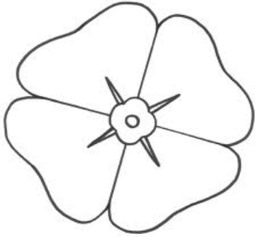

Child’s Name:

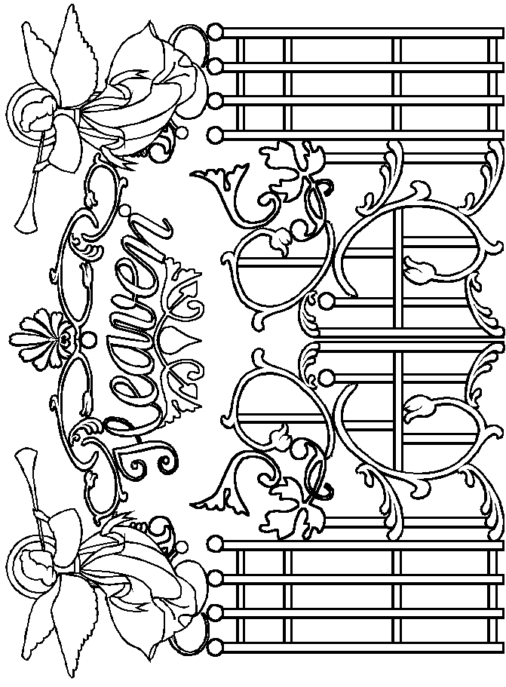
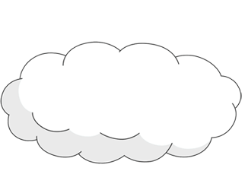
‘What I Think Heaven Looks Like’ by
Kingdom of Heaven Cards
These cards should be cut and laminated back to back
The teacher will hold up the image side of the card and read the reverse to the children. They must decide if this act would be something which would please God and be a way of preparing for heaven.
Front
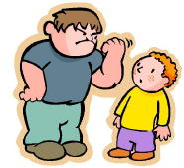
Front

Back

Jane was out shopping with her mum. She saw a toy that she really wanted. She had seen the advert on TV and one of her friends had gotten it for their birthday.

Mum told Jane that she could not afford the toy and that it was the kind you receive on your birthday or for Christmas.

Jane was so unhappy at not getting the toy that she began to cry. She thought that this was unfair and that Mum was just being mean!

Is this a good way to prepare for the Heaven?
What should Jane have done?

Back

Big John was angry after David kicked his football out of the school yard. He said some mean things to David and threatened to punch him on the nose!

David explained that it was an accident and that he was sorry but Big John was so annoyed that he had lost his ball he didn’t care that David was sorry.

Is this a good way to prepare for the Heaven?
What should Big John have done?

Front
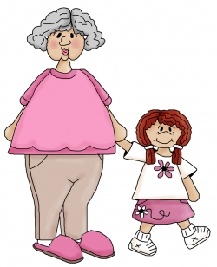
Front
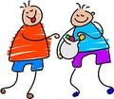

Back

Emma’s friends came to see if she wanted to go out to play. She had promised to visit her Grandma who isn’t able to go outside. Grandma looks forward to her visiting and enjoys her company. Emma’s friends say that she shouldn’t go and come outside and have some fun with them.

Emma tells her friends that she is sorry but she promised Grandma that she would visit.

Is this a good way to prepare for the Heaven?
Would you have made the same decision?
Back

Michael and Jason are good friends. One day Jason arrived at school and he had forgotten his snack. He was very upset. Michael said that Jason could have some of his sweets. Jason was very pleased and so was Michael as even though he had half the amount of sweets his friend was happy again.

Is this a good way to prepare for the Heaven?
Would you have made the same decision?

Name ___________________________________ Date__________

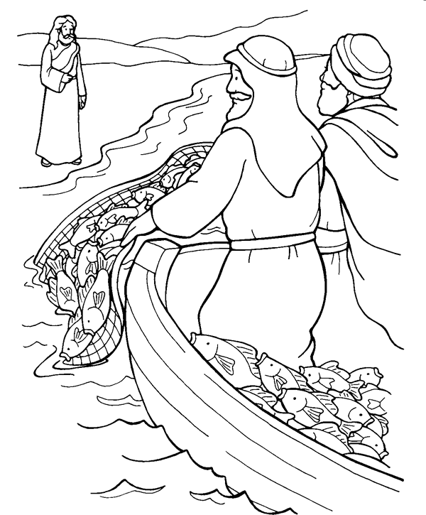

Copy these words into the speech bubble:
Come Follow Me!

Name ___________________________________ Date__________

I will make you fishers of men
Matthew 4:19
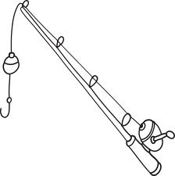



Name ___________________________________ Date__________

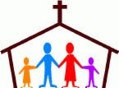
How to Behave at Mass
Draw a smiley face next to the good things to do during Holy Mass.
Draw a sad face next to the things that you should not do at Holy Mass.
Talk with friends

Listen carefully

Stay until the last hymn is over
Leave Mass early

Squeeze hands hard during the sign of peace

Eat food or sweets

Talk or text on the phone

Try to sing along with hymns

Wear football strips

Get to Mass early

Run down the aisle
Try to join in with some responses

Play around with friends or toys

Genuflect

Wear nice clean clothes

Chew bubble gum

November Prayer Service
Primary 1and 2
Theme: Remembrance

We remember our family and friends in our prayers

Resources:
- Candle
- Leader’s readings
- Children’s readings
- Reflective music
- Presentation Board
- Heading for Presentation Board
- Worksheet for children’s scrolls
- Music and lyrics of:
How Good is the Lord
Bind Us Together Lord
Be still and know that I am God
God’s Spirit is in My Heart

Scroll Worksheet
Each child will write the name(s) of family and friends and/or draw their picture(s) that they want to remember and pray for at the Remembrance Service. These scrolls will be placed on a presentation board during the service.

Leader
Sign of the Cross
Light the candle

All Sing
How Good is the Lord

Leader: Opening Prayer

God our Father today we remember,
in our prayers, our friends and family.
We are so lucky to have people in our lives
who love and care for us.
We love and care for them.
Heavenly Father we ask you to look after
our friends and families
and make them happy throughout their life.
Amen
All Sing
Bind Us Together Lord

Leader
Let us listen to the story of Jairus’ daughter from the Gospel of Mark.

Jesus went back across to the other side of the lake. There at the lakeside a large crowd gathered round him. Jairus, an official of the local synagogue, arrived, and when he saw Jesus, he threw himself down at his feet and begged him earnestly, “My little girl is very ill. Please come and place your hands on her, so that she will get well and live!”

While Jesus was saying this, some messengers came from Jairus’ house and told him, “Your daughter has died. Why bother the teacher any longer?”

Jesus paid no attention to what they said, but told him, “Don’t be afraid, only believe.” When they arrived at Jairus’ house, Jesus saw the confusion and heard all the loud crying and wailing. He went in and said to them, “Why all this confusion? Why are you crying? The child is not dead- she is only sleeping.” Jesus took the little girl by the hand and said to her, “Little girl, I tell you to get up.”

She got up at once and started walking around. When this happened they were completely amazed. But Jesus gave them strict orders not to tell anyone and he said, “Give her something to eat.”

All Sing
Be still and know that I am God

Leader: The response to our prayers is -
Jesus remember them when they come into your kingdom.

Child
We would like to remember all the grannies and grandpas who have died and gone to heaven.

All
Jesus remember them when they come into your kingdom.

Child
We would like to remember all the brave soldiers who have died in wars.

All
Jesus remember them when they come into your kingdom.

Child
We would like to remember anyone in our family who has died and gone to heaven.

All
Jesus remember them when they come into your kingdom.

Child
We would like to remember our friend and neighbours who have died and gone to heaven.

All
Jesus remember them when they come into your kingdom.

Placing of the Scrolls
Reflective music is played as each child places his/her scroll on a presentation board with the heading-

Jesus remember them when they come into your kingdom

Leader

Let us all the say the prayer Jesus taught us – Our Father…

Child
Thank you for coming to our prayer service and helping us to remember all our family and friends who are with Jesus in heaven. Please join in as we sing the hymn – God’s Spirit is in My Heart.

Leader
Sign of the cross

How Good is the Lord

Oh! Oh! Oh! How good is the Lord (3)
I will never forget what he has done for me.
He gives me salvation, how good is the Lord (3)
I will never forget what he has done for me.

Oh! Oh! Oh! How good is the Lord (3)
I will never forget what he has done for me.
He gives me his blessings, how good is the Lord (3)
I will never forget what he has done for me.

Oh! Oh! Oh! How good is the Lord (3)
I will never forget what he has done for me.
He gives me his Spirit, how good is the Lord (3)
I will never forget what he has done for me.

Oh! Oh! Oh! How good is the Lord (3)
I will never forget what he has done for me.
He gives me his healing, how good is the Lord (3)
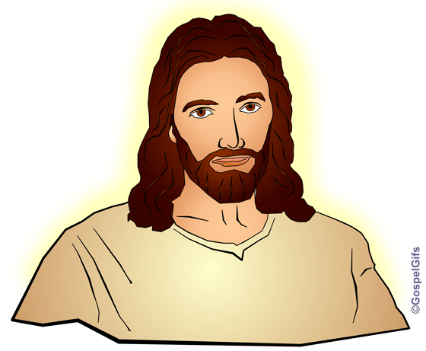
I will never forget what he has done for me.

Bind Us Together Lord


Refrain
Bind us together, Lord, Bind us together
With cords that cannot be broken.
Bind us together, Lord,
Bind us together,
Bind us together with love.
There is only one God,
There is only one King;
There is only one Body,
That is why we sing:
Refrain
Bind us together, Lord, Bind us together. . .
Made for the glory of God,
Purchased by His precious Son;
Born with the right to be clean,
For Jesus the victory has won.
Refrain
Bind us together, Lord, Bind us together. . .

You are the family of God,
You are the promise divine;
You are God’s chosen desire,
You are the glorious new wine.

Refrain
Bind us together, Lord, Bind us together. . .

Be Still and Know that I am God

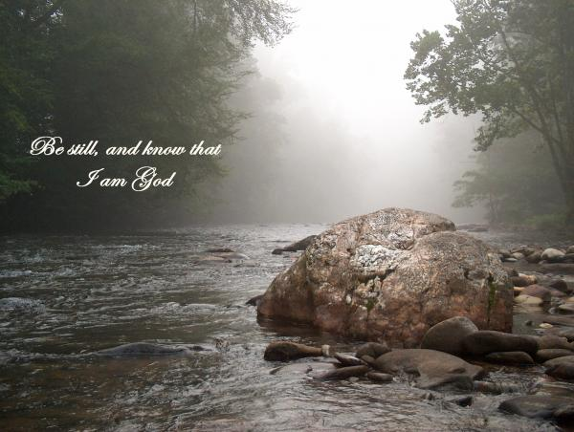
Be still and know that I am God,
be still and know that I am God,
be still and know that I am God.
I am the Lord that healeth thee,
I am the Lord that healeth thee,
I am the Lord that healeth thee.
In thee, O Lord, I put my trust,
In thee, O Lord, I put my trust,
In thee, O Lord, I put my trust.

God’s Spirit is in My Heart

God’s Spirit is in my heart
He has called me and set me apart.
This is what I have to do,
what I have to do.

Refrain
He sent me to give the Good News to the poor
Tell prisoners that they are prisoners no more
Tell blind people that they can see
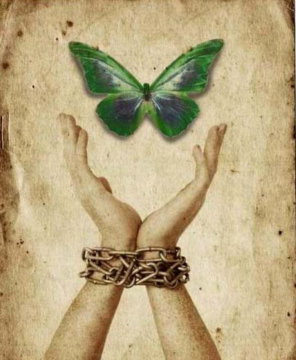
And go tell everyone the news that the
Kingdom of God has come
And go tell everyone
The news that God’s Kingdom has come.

Just as the Father sent me
So I’m sending you out to be,
My witnesses throughout the world,
the whole of the world.

Refrain
He sent me to give the Good News to the poor . . .
Name______________________ Class____________

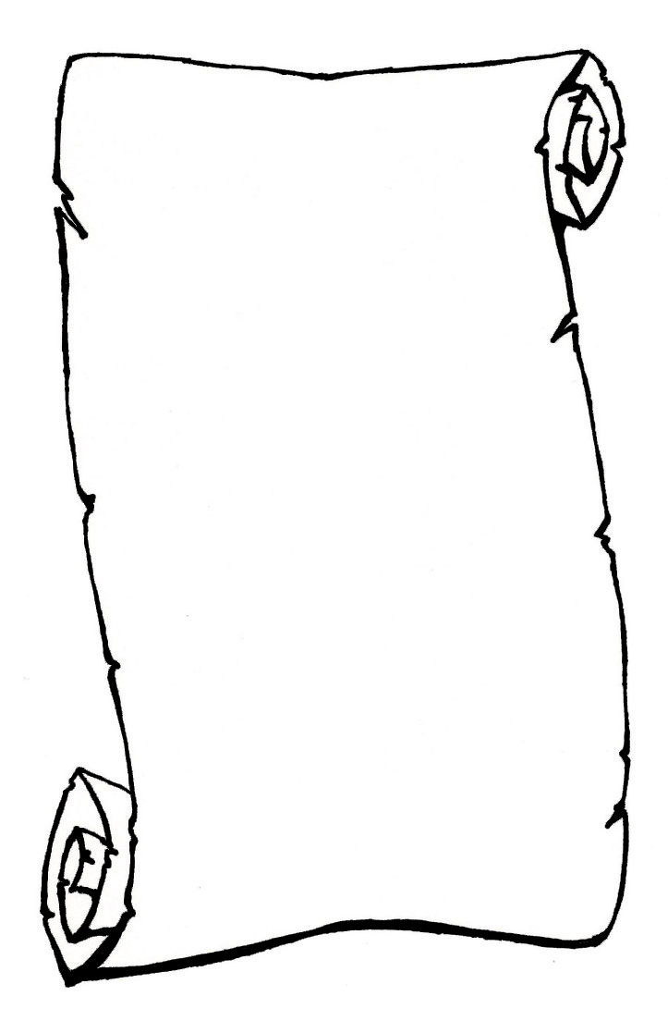
Jesus Remember Them When They Come Into Your Kingdom

Inscription for Presentation Board at Remembrance Service

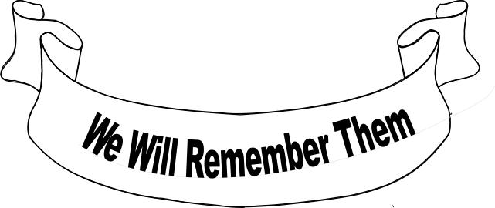

Jesus Remember Them When They Come Into Your Kingdom

Jesus Remember Them
When They Come Into Your Kingdom

