**Month/Season: November Class: Primary 7 Level: Second**

**Themes:**

**1. God’s Precious Gift of Life**

**2. Eternal Life - Heaven and Hell**

**3. Remembrance**

|  |  |  |  |  |
| --- | --- | --- | --- | --- |
| **Strands of Faith Experiences and Outcomes** | **Core Learning** | **Learning & Teaching**  **Class / School / Home / Parish** | **Resources** | **Assessment** |
| ***Mystery of God***  **RERC 2‐01a I examine God's precious gift of life and can reflect and act upon my God‐given role.**  **GLP**  ***HWB 2-15a***  *I am developing my understanding of the*  *human body and can use this knowledge to*  *maintain and improve my wellbeing and*  *health.*  **P7 RERC 2-02a In the Image of God**  **I know that God wants me to develop my God-given gifts and I have reflected on how I can use**  **them for the common good**.  **GLP**  ***HWB 2-47a***  *I recognise that how my body changes can*  *affect how I feel about myself and how I may*  *behave.*  ***HWB 2-48a***  *I can describe the physical and emotional*  *changes during puberty, understand why*  *they are taking place and the importance of*  *personal hygiene.*  ***HWB 2-49a***  *I know that all forms of abuse are wrong and*  *I am developing the skills to keep myself*  *safe and get help if I need it.*  **P7 RERC 2-02a In the Image of God**  **I know that God wants me to develop my God-given gifts and I have reflected on how I can use**  **them for the common good.**  **GLP**  ***HWB 2-05a***  *I know that friendship, caring, sharing,*  *fairness, equality and love are important in*  *building positive relationships. As I develop*  *and value relationships, I care and show*  *respect for myself and others.*  ***HWB 2-50a***  *I am able to describe how human life begins*  *and how a baby is born.*  ***HWB 2-51a***  *I can describe the role of a parent / carer and*  *he skills, commitment and qualities that the*  *role requires.*  ***Son of God***  **RERC 2‐07a I have explored the events of the Passion, Death and Resurrection of Jesus and I have reflected on the Catholic meaning of eternal life.** | I have considered God’s precious gift of life from conception to natural death and, in doing so, recognise the need to cherish it, particularly when it is most vulnerable e.g. the unborn child, the elderly, the fragile and sick.  **GLP**  *I see, think and wonder about the beginning of life and the development of a child in its mother’s*  *womb.*  *I recognise that life is precious and God-given from the moment of conception.*  *I recognise that this is how I started my life and I can give thanks and praise to God for my life*  *(Psalm 139).*  I know that my sexuality is a precious gift from God and is something to be cherished.  I have examined the work of organisations which work with the sick, disabled or dying e.g. HCPT ‐ the Pilgrimage Trust, Youth for Lourdes, SPRED (Special Religious Development), the Hospice Movement, L’Arche and I have considered the  witness that members give to the joy, consolation and presence of God in the community  they share.  **GLP**  *I recognise that my body is the temple of the Holy Spirit (1 Cor. 6: 19-20; John 14:23-26), and this*  *means that I should respect myself, body and soul and that I should also respect other people.*  *I know that God sees me as beautiful - inside and out - and rejoices as I develop physically, spiritually and emotionally.*  I know that Christians believe that, while our earthly life comes to an end at death, we believe in eternal life in Heaven, our destination.  I know that heaven is often compared to a banquet (Isaiah 25:6‐9‐ a banquet of rich food; Luke 14: 15‐24 – the feast in the Kingdom of God).  I understand that, because we have free will, a person could choose to live in total estrangement from others and from God forever, and God would not force them into happiness in heaven.  I am familiar with the term “hell” which refers to this choice to be separated for ever from God. | **Home –** The school should send home letter to inform parents/guardians that the lessons on sexual education will be commencing. The parents/guardians should be supplied with a copy of all lessons so they have full knowledge of what their child will be covering in class.  **School –** It is a good idea to have the children sign a contract before entering into the series of lessons. They should be aware that they are now considered as young adults and mature enough to cope with the information you are going to give them. They should not pass any of this on to younger children/siblings in the playground or at home as they are not yet ready. (Contract Attached)  **School –** Children should complete the ‘All That I Am’ programme. The pack, video, overheads and worksheets are available in the teacher pack.  Watch – Before I knew you video  ‘God’s Loving Plan’ Powerpoint 1  **KEY VOCABULARY -**God’s precious gift of life, conception, natural death, unborn child, elderly, fragile.  **Class** –Teacher discusses with class that Christians believe that while death puts an end to our human life, we believe in eternal life in Heaven, our destination. Children locate and read Isaiah 25:6‐9. Class discussion about the use of metaphors and that in this reading Heaven is compared to a banquet of rich food. Class then locate and read Luke 14: 15‐24 and discuss the comparison of heaven to a great feast.  **Groups**-Children divide into groups and think of other metaphors to describe heaven and use words and pictures to illustrate their metaphors.  **Class**- Teacher leads discussion about free will and how a person can choose to live in total estrangement from others and God forever. Explain that the term ‘Hell’ refers to this choice but Christians hope and pray that God’s will to save everyone will be fulfilled. Revise the Fatima Prayer.  **Class -** Clarify that most descriptions of hell and heaven are entirely man's creations. Even though the Bible uses a lot of imagery, it is not clear what heaven or hell is really like. Explain that the images of burning, dark places and living on top of the clouds are not accurate. Christian priests of long ago created these images to explain to non-educated people the issue of the two different outcomes of our life on earth. Don't overexcite children by describing how great it will be in heaven, and don't frighten them about hell. Instead, explain that heaven is living with God and hell is being away from him. What do you think you need to do to secure a place in heaven? (The children may mention the ten commandments. This can be used as a basis for discussion).  **Class –** Read Luke 16:19-31 The story of Lazarus. Jesus told a story in today’s lesson to help us see what it takes. After reading the passage discuss the following:   * Why do you think Jesus told this story? What does it mean?   Jesus tells us that there really is a heaven and hell. He also tells us that when we die we will go to one of them. It is our choice. If we trust Jesus and believe in Him, we will go to Heaven and be with God. If we choose to do what we want and live for ourselves and not trust Jesus, we will not be in heaven. It takes a step of faith. That means that you believe and trust God even though you have never seen Him. Lazarus believed in God and had faith in Him. Good printable activities for this can be found at:  <http://www.creativelearningideas.com/handouts/newtestament/Curr207.pdf>  **Class** – Show the children the images attached. Explain that these are an artist’s impression of heaven and hell. The children should create their own images of heaven and hell. Using an A3 sheet of cartridge paper draw a line to divide the two. Create images of hell and heaven using hot and cold colours.  **Class –** The teacher will explain that during November we think of those people who have died. Read from the Bible John 14:1-4 (Jesus the way to the Father). Discuss the text. Printable activities can be downloaded from:  <http://www.creativelearningideas.com/handouts/newtestament/Curr231.pdf>  **KEY VOCABULARY -** eternal life in Heaven, destination, free will, Hell, God’s will | Letter and pack to parents  Printed contract to be signed  ‘All The I Am’ pack  St Mungo’s Pack  SPUC Fetal Model Pack  GLP  *The Voice of Creation video*  *kids4truth.com/Dyna/CreationsVoice/English.aspx*  *Diocese of Motherwell exemplar*  *www.rcdomeducation.org.uk/p7-creation-and-science.html*  *God’s Loving Plan PowerPoint Primary 7 Part 1*  **GLP**  *Before I Knew You video*  *kids4truth.com/Dyna/Before.aspx*  *God’s Loving Plan PowerPoint Primary 7 Part 1*  *Child protection guidance and legislation for Scotland*  *www.nspcc.org.uk/Inform/policyandpublicaffairs/scotland/*  *guidance_wda88255.html*  Bibles  Images of heaven and hell attached to planner  Bibles  Copies of images of Heaven and Hell attached.  Cartridge paper  art materials  Bibles  **GLP**  *God’s Loving Plan PowerPoint Primary 7 Part 2*  *God’s Loving Plan PowerPoint Primary 7 Part 3* | Children will complete the series of ‘All That I Am’ lessons and worksheets. They will have an understanding of God’s precious gift of life.    Children will understand that as Christians we believe that while death puts an end to life our eternal life is in Heaven with God.  Children are familiar with the term ‘hell’ and understand the meaning of ‘free will’.  Children show an understanding of the meaning of eternal life  Children will be able to retell the story of Lazarus. |

|  |  |  |  |  |
| --- | --- | --- | --- | --- |
| **Strands of Faith : Experiences and Outcomes** | **Core Learning** | **Learning & Teaching**  Class / School / Home / Parish | **Resources** | **Assessment** |
| ***Son of God***  **RERC 2‐06b I have examined the role of Jesus as a teacher and a healer and I have reflected on how His words and actions influence my own life and the lives of others.** | I know that Jesus reached out to all people, particularly to the marginalised, vulnerable and poor, and acknowledged their human dignity. e.g. the healing of the ten lepers (Luke 17: 11‐19); the raising of the widow of Naim’s son (Luke 7: 11‐17); the woman who was a sinner (Luke 7: 36‐50); the cure of the man possessed by a demon  (Luke 8: 26‐39).  I understand that, by this example, and through his parables, Jesus invites us to do the same: the Pharisee and the publican (Luke: 18: 9‐14); the widow’s mite (Luke 21: 1‐4); the good Samaritan (Luke 10: 25‐37). | **Class –** Explain to the children that in America there is a traditional celebration at this time of the year called ‘Thanksgiving’.Do you have good manners? Do you remember to say thank-you to your family and friends? What about God? Today we are going to read a story from the Bible about giving thanks. Read The Ten Lepers (Luke 17: 11‐19). Discuss the text. Why do you think these men didn’t say thank-you? Perhaps they were afraid to believe, perhaps they thought they deserved it, perhaps they considered the healing to be coincidental, we will never truly know but before shaking your head and calling those men ungrateful ask yourself if you have ever done the same thing.   * You are sick and got better and you gave all the credit to the doctor or the medicine…..not God. * You go to confession and are declared to be forgiven but you are afraid to believe it can be true . . . so you don't say thanks * You get through a hard time and believe that things have finally "run their course" * You get do well in school and are sure it is due to your hard work   How many of God's blessings do you and I fail to thank Him for?  The children should complete the ‘Ye Be Thankful’ worksheet attached to the planner. This worksheet is a bible search on passages about giving thanks to God.  **Class -** Put up on the board the key vocabulary flashcards. Discuss the meaning of the words. Can you think of a situation in our world today when people are marginalised? Who are the vulnerable in our world? Who are the poor in our world? (discuss what being rich means) Who in our world is not treated with dignity?  **KEY VOCABULARY:** marginalised, vulnerable, poor, human dignity, parables. | Bibles  Ye Be Thankful Worksheet  Flashcards | The children will understand the role of Jesus as a teacher and a healer and reflected on how His words and actions influence their lives and the lives of others.  Children will understand the meaning of the key vocabulary : marginalised, vulnerable, poor, human dignity, parables. |

Confidentiality Contract

*I _____________________________*

*agree that before embarking on the Religious Education topic called ‘Sex Education’, give a solemn undertaking that I will treat this topic with sincerity and discretion.*

*In signing this contract I agree that I will: -*

* *Act in a mature and responsible way*
* *Show respect for one another*
* *Show respect for confidentiality of the*

*content with regard to younger children*

* *Not use slang terms for parts of the body*
* *Use proper ‘scientific’ terms in my discussions*

*and written work*

* *Tell no stories of a personal nature*
* *Ask appropriate questions*

Signed ______________________________ Date ______________

Signed _____________________________________________

(class teacher)

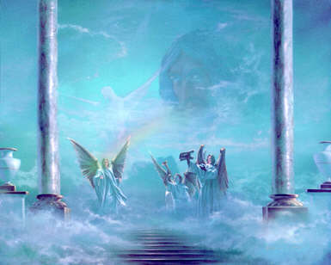

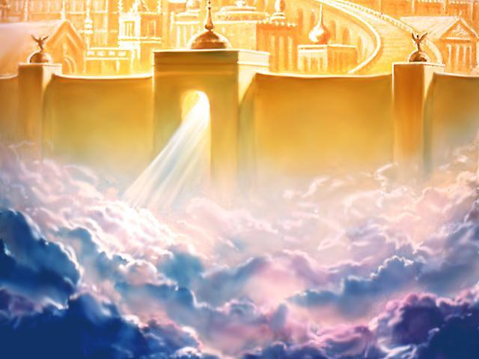

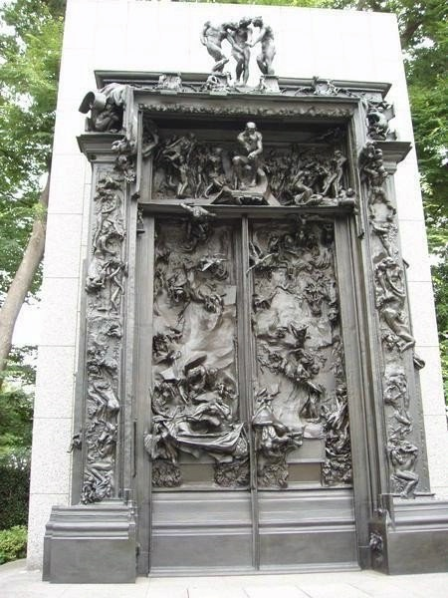

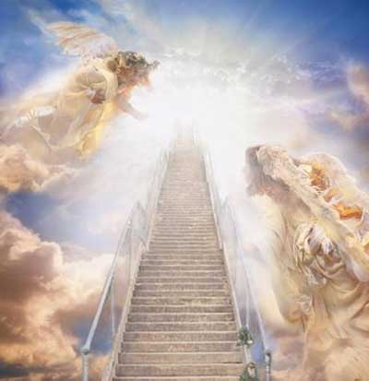

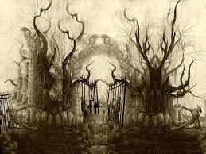

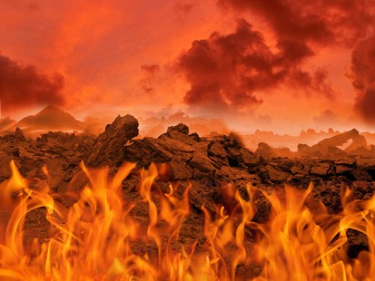

**Be Ye Thankful**  **Who gives thanks?**

Psalm 140:13 "Surely _______________ shall give thanks to your name; the upright shall live in your presence."

Psalm 145:10 "All your _________ shall give thanks to you, O Lord, and all your ________ shall bless you."

1 Thess. 5:16-18 "Rejoice _________, pray without ceasing, give thanks in all circumstances; for this is the _____________ in Christ Jesus for you."

Phil 4:6 "Do not worry about anything, but in everything by _________ and supplication with thanksgiving, let your requests be made known unto God. And the _________ of God, which surpasses all understanding, will _________ your hearts and minds in Christ Jesus."

2 Cor. 4:15 "Yes, everything is for your sake, so that grace, as it extends to more and more people, may increase thanksgiving, to the ________ of God."

Ephesians 5:4 "Entirely out of place is obscene, silly, vulgar talk; ________________, let there be thanksgiving."

Psalm 136:26 "O give thanks to the God of heaven, for his _____________ endures forever."

Eph. 1:16 "I do not cease to give thanks for you as I remember you in my ____________."

Psalm 147:7 "_________ to the Lord with thanksgiving; make melody to our God on the lyre."

Eph 5:20 "Giving thanks to God the Father at ____________ and for __________ in the name of our ________________________."

Colossians 1:12 "Giving thanks to the Father, who has enabled you to share in the _____________ of the saints in the light."

John 6:11 "Then Jesus took _____________, and when he had given thanks, he distributed them to those who were seated...."

John 11:41b "...And Jesus looked upward and said, "Father, I thank you for having ________ me."

1 Cor. 15:57 "But thanks be to God, who gives us the _________ through our Lord Jesus Christ.

*Marginalised*

*Poor*

*Vulnerable*

*Human Dignity*

**November Prayer Service**

**Primary 6 and 7**

**Theme: *Remembrance***

**Resources:**

* Altar-Table with purple cloth
* Candle
* Bible
* Book of Remembrance
* Leader’s readings
* Children’s readings
* Reflective music
* Poppy Template
* Music and lyrics of:

*I Will Be with You*

*Jesus, Remember Me*

*Oh Lord Hear my Prayer*

*Though the Mountains May Fall*

**Book of Remembrance**

Class book in which children and staff members have written the names of deceased friends and relatives. This will be placed on the altar during the remembrance service.

**Poppy Flowers**

Print template on cardboard. Colour and cut out the template pieces. Glue together the four large hearts to form a flower (the points should all face towards the middle of the flower). Glue the circle in the centre of the poppy. The children will place the poppies on the altar during the remembrance service.

**Leader**

Sign of the Cross

**All sing**

*I Will Be with You*

**Leader**

O God our Father, we come to you today, in the month of November, to ask you to surround our relatives and friends who have died with your love and glory.

We will also remember today those men and women who have given their lives in the service of their country.

**All**

O Lord, listen to our prayers.

**Leader**

Candle is lit on the altar.

**All sing**

*Jesus, Remember Me*

**Leader**

Let us now listen to the word of God and through that gain comfort and confidence in the hope of the resurrection.

*Child Reader processes with Bible to stand next to the altar.*

**Child**

A reading from the Holy Gospel according to John.

Jesus said:

I am the resurrection. If anyone believes in me, even though he dies he will live, and whoever lives and believes in me will never die.

This is the Gospel of the Lord

**All**

Praise to you, Lord Jesus Christ

**Leader**

Let us now pray:

The response to our prayers is –

*May they rest in peace.*

**Child**

For those in our families who have died…

*May they rest in peace.*

**Child**

For our friends and our loved ones who have died…

*May they rest in peace.*

**Child**

For former staff and pupils of St. Andrew’s who have died…

*May they rest in peace.*

**Child**

For those who have died in wars past and present…

*May they rest in peace*.

**All Sing**

*Oh Lord hear my prayer*

Child places the Class Book of Remembrance on the altar.

**Leader**

Let us now think particularly of those men and women who have died in the service of their country in wars past and present. Now we will read you an extract from a poem written by a Canadian Army Doctor, during the First World War. As you listen, please reflect on the deep meaning of his words.

**In Flanders Field**

In Flanders fields the poppies blow  
Between the crosses, row on row,   
That mark our place; and in the sky  
The larks, still bravely singing, fly  
Scarce heard amid the guns below.  
  
We are the Dead. Short days ago  
We lived, felt dawn, saw sunset glow,  
Loved and were loved, and now we lie,  
In Flanders fields.

**Child**

We thank you Lord for bringing us together to recall with tenderness and respect those who lost their lives from this community and the many thousands from further afield.

We pray for all those still caught up in conflicts across the world. May we be so inspired by their spirit of love and courage.

Let us all pray for peace, the peace that comes from your love Oh Father.

Let us pray to the Lord.

Amen

*Whilst reflective music is playing each child places a poppy on the altar.*

**Child**

**A prayer for peace**

Peace is the gentle lapping of the waves across the sandy beach.  
Snow softly falling on a winter’s night.  
The flight of a bird  
The smile on a baby’s face.

Reading quietly from a favourite book,  
Every night when we settle down to sleep.

Peace is a happy heart, when we are content.

Lord, grant us all peace.  
Amen

**Leader**

Leader starts - Eternal rest…

May the souls of the faithful departed…

**Leader**

God our Father, hear our prayers for our loved ones. Surround them with your mercy. Purify them with your love and bring them and all the dead into the joy of your kingdom. We ask this through Christ our Lord.

Amen

**All sing**

*Though the Mountains May Fall*

**Poppy Template**



**I Will be with You Wherever You Go**



*I will be with you wherever you go,   
Go now throughout the world!  
I will be with you in all that you say,   
Go now and spread my word!*

Come walk with me on stormy waters.  
Why fear?  Reach out, and I'll be there.   
  
 And you, my friend, will you now leave me,   
or do you know me as your Lord?

Your life will be transformed with power   
by living truly in my name.

And if you say, “Yes Lord, I love you,”  
then feed my lambs and feed my sheep.

**Jesus, Remember Me when You Come into your Kingdom**  
  
Jesus remember me, when you come into your kingdom  
Jesus remember me, when you come into your kingdom  
  
Jesus remember me, when you come into your kingdom  
Jesus remember me, when you come into your kingdom  
  
"I assure, this day you will be with me,   
this day you will be, with me in paradise."  
  
Jesus remember me, when you come into your kingdom  
Jesus remember me, when you come into your kingdom





**Lord, Hear my Prayer**

O Lord, hear my prayer.  
 O Lord, hear my prayer.  
When I call, answer me.  
O Lord, hear my prayer.  
O Lord, hear my prayer.  
Come and listen to me.

**Though the Mountains May Fall**

*Though the mountains may fall*

*And the hills turn to dust,*

*yet the love of the Lord will stand*

*as a shelter for all*

*who will call on his name.*

*Sing the praise and the glory of God.*

Could the Lord ever leave you?

Could the Lord forget his love?

Though the mother forsake her child,

he will not abandon you.

Should you turn and forsake him,

he will gently call your name.

Should you wander away from him,

he will always call you back.

Go to him when your weary;

he will give you eagle’s wings.

You will run, never tire,

for your God will be your strength.