Month/Season: June Class: Primary 1 Level: Early
Themes:
1. The Sign of the Cross – Emphasis on the Holy Spirit
2. Stories from the Old Testament
3. Stories from the New Testament

Strands of Faith : Experiences and Outcomes | Core Learning | Learning & Teaching  Class/School/Home/Parish | Resources | Assessment
Revealed Truth of God  RERC 0-04a  I am becoming aware of God as Father, Son and Holy Spirit. | I am becoming aware that, when I make the sign of the cross, I am praying to God the Father. God the Son and God the Holy Spirit. | * Pentecost is a movable feast so should be checked on the liturgical calendar. If the feast falls in June please continue with the following lessons.  PENTECOST LESSONS  Class – The teacher discusses pray with the class. What is prayer? When do we pray? When can we pray? How can we pray?  Teacher displays Sign of the Cross posters (attached to planner). She asks the children recognise what the person is doing. The teacher explains that the Sign of the Cross is our way beginning and ending prayers. Can you think of times when we make the sign of the cross? Sometimes we bless ourselves with holy water when we do it. The teacher will show the children the statements and as a class they must choose the correct statement to match the picture.  Children will work with a partner to complete Sign of the Cross worksheet.  Class – Recap on previous lesson on the Sign of the Cross. Perhaps play the clip used in the October Planner  http://www.youtube.com/watch?v=yq36oI-OuvQ  Explain that when we bless ourselves we mention the ‘Holy Spirit’. Who do you think the Holy Spirit is?  Read the story of Pentecost attached to the planner, to the children. Explain to the children that they are going to create a Holy Spirit Twirler.  The template for this is attached to the planner. It is best to print this onto card/cartridge paper before beginning rather than completing on paper.  Key Vocabulary: Sign of the cross, God the Father, God the Son and the Holy Spirit. | Sign of the Cross poster (attached to planner)  Sign of the Cross Worksheet  (attached to planner)  Internet Access  Photocopy of the Holy Spirit Twirler on to cartridge paper.  Colour Pens | Children will be able to make the sign of the cross and understand that it is how we begin and end prayers  The children will be familiar with the word ‘Pentecost’ and have a basic understanding of the story.

Strands of Faith : Experiences and Outcomes | Core Learning | Learning & Teaching  Class/School/Home/Parish | Resources | Assessment
Word of God  RERC 0-11a  I am aware of some Bible stories | I can hear, recall and respond to one of the following passages from the Old Testament.  - The first account of Creation (Genesis 1)  - The Flood (Genesis 6)  - The Birth of Moses (Exodus 2)  - The Crossing of the Red Sea (Exodus 14)  I can hear and respond to different types of stories from the New Testament.  - An event:, the widows Mite (Mark 12:41-44)  - A parable e.g. The Good Samaritan (Luke 10:29-37)  - A Miracle: e.g.  *The cure of a sick man at the pool of Bethzatha (John 5:1-9)  *The ten lepers (Luke 17:11-19)  *The Wedding at Cana (John 2:1-10)  *Walking on the water (Matthew 14:22-31) | JUNE LESSONS  Class – Explain to the children that today we are going to be going on a journey. Used the ‘Egypt’ Power Point from the EDC RERC GLOW group for Primary 1 June.  Children should complete the ‘Moses in a Basket’ craft attached to the planners.  Class - Tell the children that they are going to hear a story about Jesus. Show the children the Bible. Explain that the story is going to come from this special book and today’s story come from the part of the book called the New Testament. In today’s lesson we are going to learn about saying thank-you.  Watch one of the following clips from You Tube. You may wish to watch them first as select the one you feel is best for the children in your class.  http://www.youtube.com/watch?v=roz7IwHuupQ  http://www.youtube.com/watch?v=OpadeiWOxps  http://www.youtube.com/watch?v=Z8W3Z26-7qU  Discuss the story with the children.  *Why were the 10 men living outside the village?  *How did they get food?  *What did they have to shout if someone came near to them?  *How do you think they must have felt?  *How many said thank you?  Sit the children in a circle. Explain that they are all going to say thank you to God for something that is important and special to them. The teacher will start to show the children. E.g. I am thankful for ………  *My Family  *That I am healthy  *That I have kind and generous friends  Class – The children should write or/and draw what they are thankful for on the ‘Postcard to Jesus’. These can be decorated and pasted onto a large sheet of card and given to the Church or hung in the class. | ‘Egypt’ PowerPoint  Photocopy of Moses in a Basket craft activity attached to the planner.  Green coloured paper  Scissors  Internet Access  Photocopy on to cartridge paper the ‘Thank you Jesus’ postcard attached to the planner.  Colouring pens. | The children will become familiar with the story of Moses. They will successfully complete the craft activity.  The children will be able to recall the story of the 10 lepers.

Strands of Faith : Experiences and Outcomes | Core Learning | Learning & Teaching  Class/School/Home/Parish | Resources | Assessment
Revealed Truth of God  RERC 0-04a  I am becoming aware of God as Father, Son and Holy Spirit. | I know that, when I pray the Glory Be, I am honouring and praising God as Father, Son and Holy Spirit. | Class – Using the ‘Let’s Celebrate’ PowerPoint presentation (available on the EDC RERC Denominational GLOW group) discuss the celebration of marriage with the children. Watch the You Tube clip of the Wedding Feast at Cana. (Link on PowerPoint).  The children should complete the Wedding at Cana sequencing activity attached to the planner.  Homework – Ask the children to bring in wedding photographs from home. These could be pictures of them at a wedding or of their parents/guardians or grandparents wedding day. Ask the children to find out more about their parents/grandparents wedding day by asking them questions. Use the homework sheet attached to the planner.  Key Vocabulary: God, Holy Book, Bible, Old Testament, New Testament, parables and Miracles.  Class – Explain to the children that today they are going to learn a new prayer. This prayer is very like the Sign of the Cross and is called ‘The Glory Be’.  Ask the children if anyone knows what the word ‘glory’ means.  It means praise, rejoice etc. Watch the following clip:  http://www.youtube.com/watch?v=SF-Qh3ddDww  Teach the children the prayer with the following actions.  - Have the children form a circle.  - At the beginning make the sign of the cross ‘Glory be to the…’  - When you pray, "As it was in the Beginning," stretch your arms out parallel to the ground. When you pray, "Is now and ever shall be," stretch your arm straight above your head. When you pray, "World without End," curve your arms around as if you were carrying the world in your arms until the edge of your finger tips touch one another. When you say, "Amen," fold your hands together in prayer.  - Repeat the prayer asking the children to watch you put all the actions together.  - Have the children join you in the prayer the next time. | ‘Let’s Celebrate’ PowerPoint.  Internet Access.  Photocopy or colour print out of the Wedding at Cana sequencing activity.  Internet Access | The children will be able to recall the Wedding at Cana story through correctly sequencing the main events in the story.  The children will be able to pray ‘The Glory Be’.

Strands of Faith : Experiences and Outcomes | Core Learning | Learning & Teaching  Class/School/Home/Parish | Resources | Assessment
Primary 1 - End of year ‘Thanks Giving Assembly’

- The children should make invites for those staff who don’t usually attend i.e. parent helpers, cleaners, canteen staff, site co-ordinator, lollypop person etc.
- The hall/stage area can be decorated with examples of the children’s work and photographs throughout the year.
- A PowerPoint presentation of the photographs could run on a loop on the white board.
- It is a good idea to have some peaceful music playing quietly in the background throughout the service.

See the assembly notes attached to the planner.

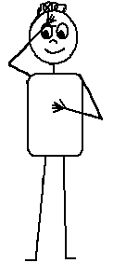





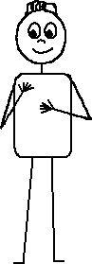

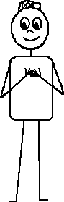

In the name of
the Father

and of the Son

and of the Holy

Spirit

Amen
Name ____________________________ Date _______

Cut out the words and paste under the correct picture.
The Sign of the Cross Worksheet - Words
In the name of the Father,
And of the Son,
And of the Holy
Spirit
Amen.
In the name of the Father,
And of the Son,
And of the Holy
Spirit
Amen.
In the name of the Father,
And of the Son,
And of the Holy
Spirit
Amen.
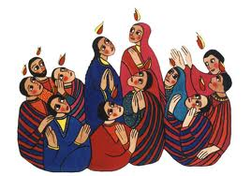
Pentecost
What is Pentecost? This is a very special time in the Bible when Jesus’ friends received the Holy Spirit. Before I explain why and how this happened there are a few things you need to know first.
Pentecost happened after Easter Sunday when Jesus rose from the dead. Jesus had already gone back to Heaven so his friends were waiting to be visited by the Holy Spirit because that's what Jesus told them would happen.
Just before Jesus was taken up to heaven he told his friends that the Holy Spirit would visit them to give them new gifts and talents.
Jesus’ friends had got together and suddenly a sound like the blowing of a strong wind came from heaven and filled the whole house where they were sitting.
Next they saw flames that separated and came to rest above the heads of everyone in the room. The fire which had come into the room was the Holy Spirit. He gave them the gift of being able to speak in different languages. It was pretty exciting and things got a bit noisy.
It says that there were people of many different countries staying in Jerusalem from all over and many of them spoke different languages. These people ran over to see what all the noise was about and were surprised to hear their own languages spoken throughout this group. Things must have sounded crazy! Imagine all these people speaking many different languages at the same time and shouting out praises to God excited that something amazing from God had just happened to them.

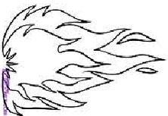
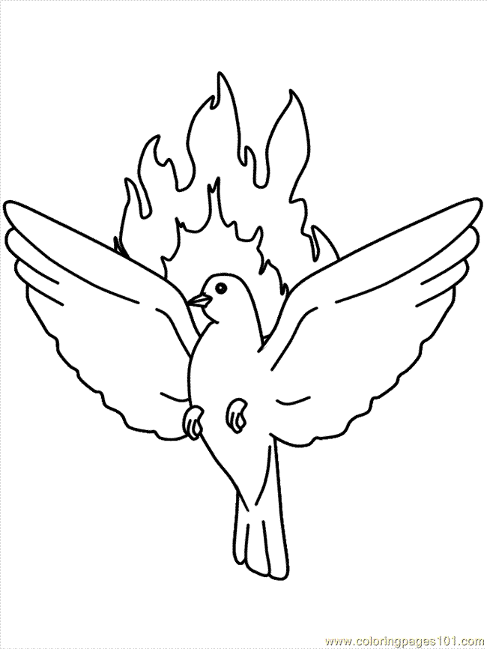
Pentecost Wind Twirler

To make your wind twirler colour brightly and cut carefully from the edge as marked to the centre.

Place a whole in the middle and thread a piece of string through and tie a knot.

Hang your wind twirler next to a window and watch the wind blow it around just as the Holy Spirit blew through the room where Jesus’ friends were sitting together at the feast of Pentecost.

The Story of Baby Moses
Most of the Israelites lived in Egypt where there were also a lot of people called Egyptians. Too bad they couldn't all just see each other as the same. But as you'll soon find out the Israelites and the Egyptians were treated very differently.
Anyway, a new king who was called Pharaoh came into power in Egypt. He didn't like it that there were so many Israelites and he thought they would one day take over the land. So he decided to make all the Israelites into slaves.
He made them work from early in the morning till late at night doing very hard work. Even if they were tired the Egyptians wouldn't give them a break, they would just make them work harder. It was very bad.
Pharaoh did all this and he still wasn't happy. The Israelites were still growing in number so he decided to make a law. If any boys were born to the Israelites he would have them killed.
At this time there was an Israelite couple who were expecting to have a baby. When they had a baby boy (whose name would later be Moses) they decided to hide him because they wouldn't let anyone kill this beautiful, precious baby of theirs.
They hid Moses for three months, but as he got older he didn't sleep as much and he cried louder than before. So his parents did the only thing they could do, they made a strong basket (sort of like a mini baby boat) and put blankets around the baby and placed the basket in some tall grass in the Nile river.
Baby Moses had a sister named Miriam, and she watched from a distance to see what would happen to her baby brother. While she was watching she saw somebody coming, she realized it was Pharaoh's daughter and her servants. They were dressed like they were famous, and she had seen her before and remembered what she looked like.
Pharaoh's daughter had come for a swim. While she was swimming she noticed a basket floating a little ways away in the tall grass. So she asked one of her servants to go see what it was.
The girl brought the basket over to her, and when Pharaoh's daughter opened it, the light startled Moses so he woke up and started to cry. "What a sweet, beautiful little baby. It must be one of the Israelite's," Pharaoh's daughter said to her servants.
Miriam had seen what had happened, and she hurried over and asked, "Would you like me to go find an Israelite woman to feed the baby for you?"
"Yes, go and find someone who can nurse the baby." she answered. Miriam ran as fast as she could and told her mother that Pharaoh's daughter had found him and wanted someone to come nurse him.
They went and found Moses with Pharaoh's daughter, and she asked them, "Please help me and nurse this baby, and I will pay you for helping me." (She didn't realize that this was actually Moses' mother).
Later he became the son to Pharaoh's daughter, and that's when she named him Moses, which means she got him out of the water.

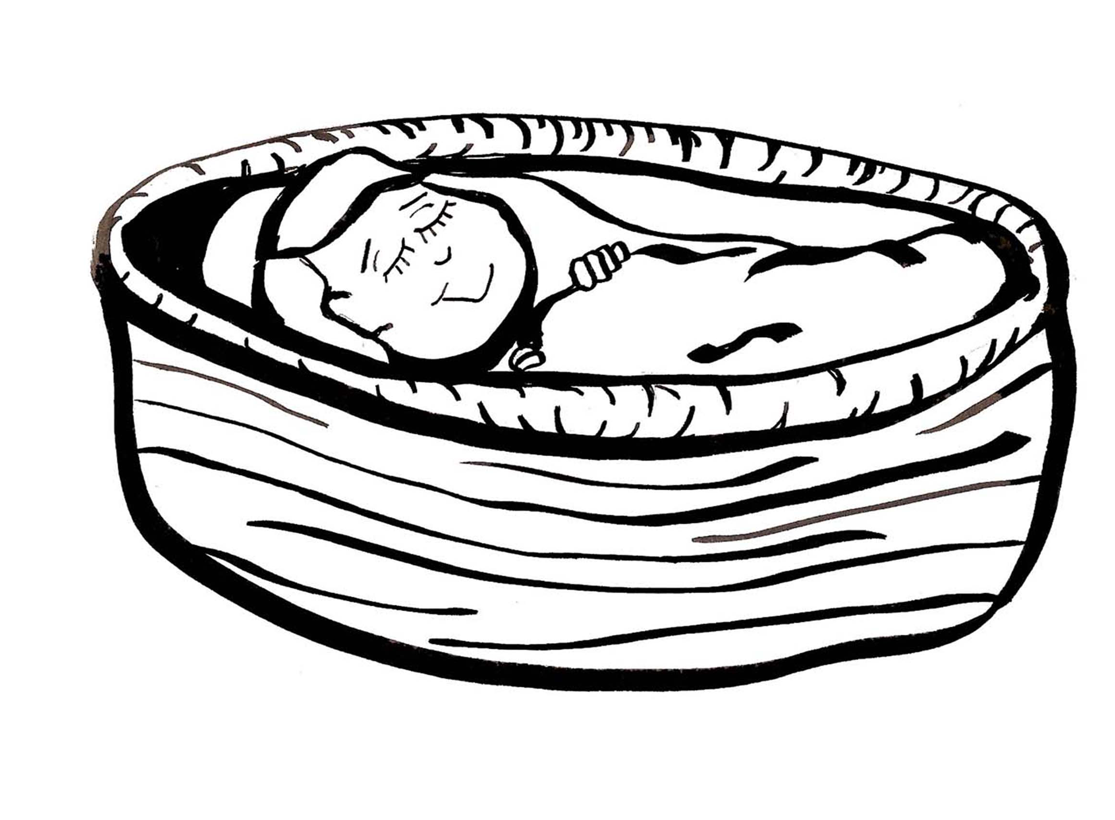
Moses in a Basket Craft

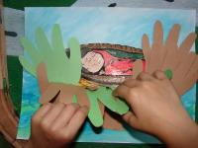
This is a fun craft you can do with
children learning about how God
protected little Moses. Trace children's
hands on colored paper and cut out to
use as reeds. Then glue them near the
wrist to the bottom of the paper.
Children can pull back the reeds to
reveal the baby Moses.

Thank You Jesus
I would like to thank you for…..
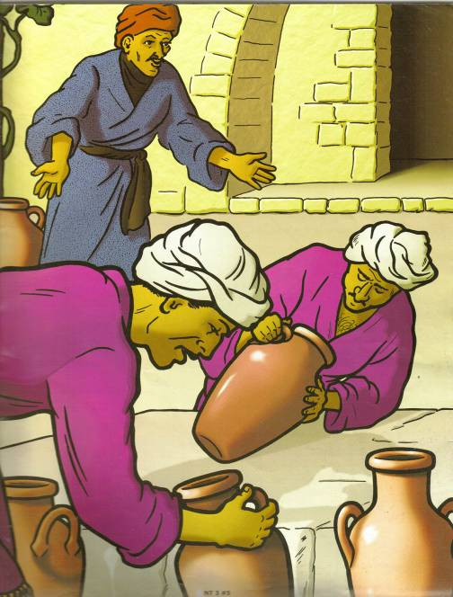
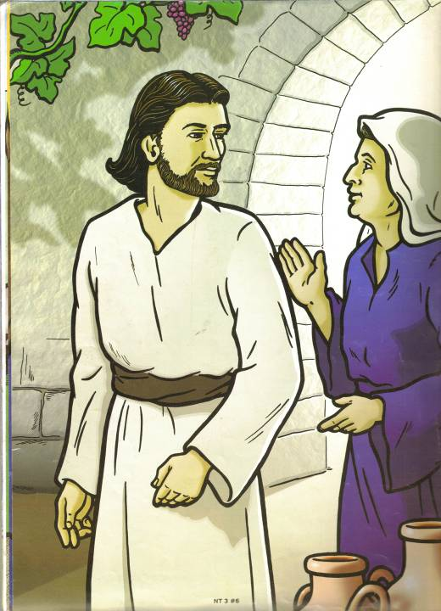
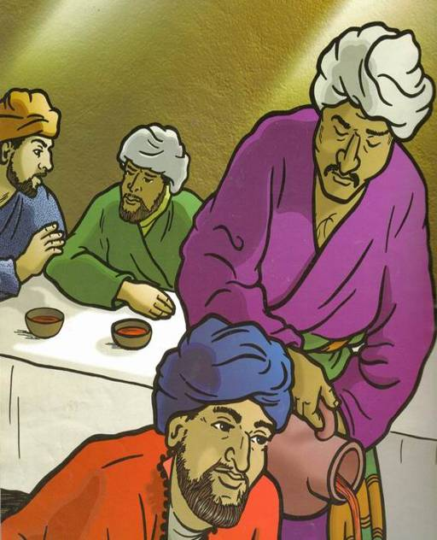
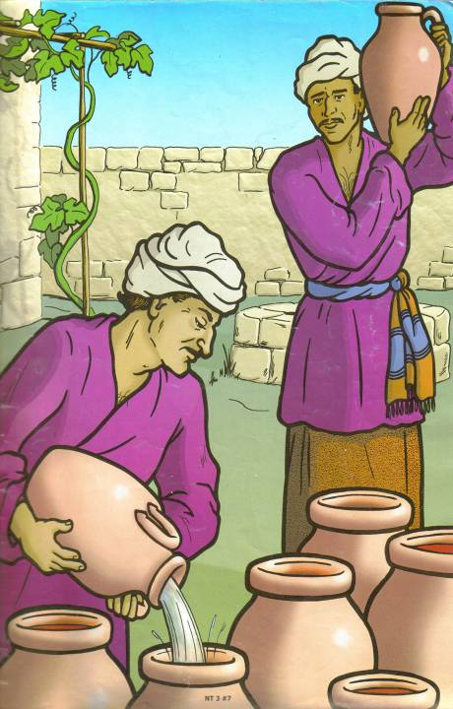
It was a miracle!
Jesus had turned the water into wine.
Jesus told the men to fill the jars with water and he blessed them.
There was no wine left at the wedding.
Jesus’ mum asked him to help.

- Cut around the four cards carefully with scissors.
- Look at the pictures and the words carefully.
- Try to put the cards into the correct order.
- Show your teacher.
- Glue them into your jotter.

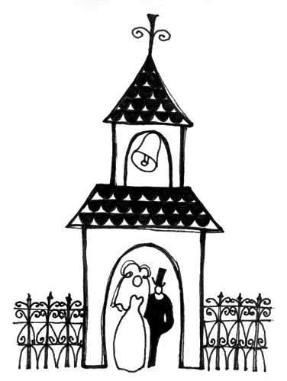
RERC Homework

Your child has been learning about the story of the Wedding at Cana (John 2:1-10). They have been discussing in class the importance of a wedding day and some of the important traditions which help to make the day special.

We are hoping that parents/guardians/grandparents will make time to speak with the children about their wedding day, show the pictures and share their special memories.

If possible please allow your child to bring a photograph into school of a wedding in their family that they can show and speak about to their classmates.

----------------------------------------------------------------------------------------------------------------------------
RERC Homework

Your child has been learning about the story of the Wedding at Cana (John 2:1-10). They have been discussing in class the importance of a wedding day and some of the important traditions which help to make the day special.

We are hoping that parents/guardians/grandparents will make time to speak with the children about their wedding day, show the pictures and share their special memories.

If possible please allow your child to bring a photograph into school of a wedding in their family that they can show and speak about to their classmates.
End of Primary 1 Assembly

Music – Gentle music playing as people enter the hall. The volume is lowered (but not turned off) to hear the children speak.

First Child: Today we come together to celebrate our first year at (School Name). We thank God for the friends that we have made and the teachers who have taught us.

Second Child: We light a candle to begin our assembly and to help us remember that God is with us.

Third Child: (Lights the candle)

Fourth Child: Dear God, we thank you for helping us to work hard and learn this year. It is not always easy to start something new but with your help we felt safe and happy.

Hymn: If I were a Butterfly
http://www.youtube.com/watch?v=o6WeVBHtL9o
http://www.youtube.com/watch?v=oa0JlTerzGI
*Split the class to make masks/ears/wings etc to look like the different animals mentioned in the song. Ask the groups to do a movement when their animal in mentioned. E.g. “If I were a Butterfly I’d thank-you Lord for giving me wings!” – Children make butterfly wings and attach them to their backs they could turn around and wiggle their wings at the audience.

Fifth Child: One of the Bible stories we have listened to is about remembering to say Thank you to God and one another.

Sixth Child: The story is about Jesus and the 10 Lepers. Lepers were people who were sick and were not allowed to live with their families anymore.

---------------------------------------------------------------------------------------------------
(The children will act out the parts while selected narrators retell the story)

Reader 1: Long ago there were 10 lepers. They had to live on a hill outside the village because people were afraid that they would also get sick if they went near them.

10 children dressed can be sitting on one side of the stage looking sad.

Reader 2: One day they heard that Jesus was coming to the village.

Child dressed as Jesus walks on to the stage. The 10 lepers point and whisper to one another “Look there’s Jesus!”

They decided to ask Jesus to make them better.

The 10 lepers approach Jesus saying different phrases “Help me please!”, “Can you make me better!”, “I believe in you Jesus!”

Reader 3: Jesus put his hands onto their heads and they were well again. The 10 men ran off to see their families.

The 9 lepers look happy and shout “we’re well again!”, “Jesus made us well!” They run off the stage. One stays on the stage and walks towards Jesus.

Reader 4: One leper walked up to Jesus and said thank you.

The one leper shakes Jesus by the hand and they smile.

Jesus asked him where the others were. He was sad that the others had not remembered to say thank you but was pleased with the man who had. Jesus told him that he was well and should live a happy life, praising God.

---------------------------------------------------------------------------------------------------

Reader 5: We thank you for coming to our assembly. We would like you to join us in saying the Our Father.

Hymn: One more step along the road I go.
http://www.youtube.com/watch?v=iQRyKMsp3pY
During the hymn show a slideshow of photographs of the children from throughout the year.

