**Month/Season:** August /September  **Class:** Primary 7  **Level:** Second

**Themes**

**1. God versus Science**

**2. Covenants**

**3. Monastic communities**

**4. Ancient Universities**

|  |  |  |  |  |
| --- | --- | --- | --- | --- |
| **Strands of Faith Experiences and Outcomes** | **Core Learning** | **Learning & Teaching**  Class/School/Home/Parish | **Resources** | **Assessment** |
| **Mystery of God**  **RERC 2-01a**  I examine God's precious gift of life and can reflect and act upon my God-given role.  **GLP**  ***HWB 2-15a***  *I am developing my understanding of the*  *human body and can use this knowledge to*  *maintain and improve my wellbeing and*  *health.*  **Mystery of God**  **RERC 2-01b**  I explore the Biblical stories of Creation and I can reflect on how we understand these truths in our modern world.  **GLP**  ***HWB 2-05a***  *I know that friendship, caring, sharing,*  *fairness, equality and love are important in*  *building positive relationships. As I develop*  *and value relationships, I care and show*  *respect for myself and others.*  ***HWB 2-45b***  *I am aware of the need to respect personal*  *space and boundaries and can recognise*  *and respond appropriately to verbal and nonverbal*  *communication*. | I can wonder at the beauty and complexity of God’s creation through the study of Science.  I recognise that Science and Sacred Scripture are complementary in helping me to deepen my understanding of the wonder of creation.  I know that God created everything out of nothing e.g.,  Genesis 1: 11 - the first account of Creation “In the beginning” Second Book of Maccabees 7: 28) - God made the heavens  Romans 4: 17 - God calls into being what does not exist, because of love.  **GLP**  *I know that men and women are created equal and that, in Gen. 2:*  *• the rib is symbolic of a person’s life;*  *• God shares life equally between man and woman (Gen. 2:21)*  *• so that they are “bone of my bone and flesh of my flesh” (Genesis 2:23)*  *I recognise that relationships between men and women are a mysterious and beautiful gift which*  *always require patience and maturity to be fully appreciated.*  *I know that men and women whether friends, family, peers, husbands or wives, help each other to*  *develop their own identity and personality in relationship with one another.* | ***Consider possible links with science as follows:***  I can identify and classify examples of living things, past and present, to help me appreciate their diversity. I can relate physical and behavioural characteristics to their survival or extinction.  **SCN 2-01a**  I can use my knowledge of the interactions and energy flow between plants and animals in ecosystems, food chains and webs. I have contributed to the design or conservation of a wildlife area.  **SCN 2-02a**  Through carrying out practical activities and investigations, I can show how plants have benefited society.  **SCN 2-02b**  I have collaborated in the design of an investigation into the effects of fertilisers on the growth of plants. I can express an informed view of the risks and benefits of their use.  **SCN 2-03a**  **Class –** Watch the following clip from You Tube  <http://www.youtube.com/watch?v=uo2zdEocNKE&feature=fvwberel>  Ask the children of their thoughts and questions about creation.  Some might ask how God managed it in just six days. Some may introduce the idea of evolution. Listen but don’t give too much away at this point.  It is important that you explain that the creation story is not supposed to be taken literally e.g. 1 day could represent 1000 years. It is explained in such a way that we can understand something so beyond our rationale.  Children should complete the creation worksheet attached to the planner.  They should check their finished work by reading the passage in Genesis. | **GLP**  *The Voice of Creation video*  *kids4truth.com/Dyna/CreationsVoice/English.aspx*  *Diocese of Motherwell exemplar*  *www.rcdomeducation.org.uk/p7-creation-and-science.html*  *God’s Loving Plan PowerPoint Primary 7 Part 1*  Internet Access Creation Worksheet  Attached to Planner  **GLP**  *God’s Loving Plan PowerPoint Primary 7 Part 2*  *Preparing for the Sacrament of Confirmation (in particular*  *dioceses)* | The children will have deepened their knowledge of the creation story. |

|  |  |  |  |  |
| --- | --- | --- | --- | --- |
| **Strands of Faith Experiences and Outcomes** | **Core Learning** | **Learning & Teaching**  Class/School/Home/Parish | **Resources** | **Assessment** |
| **Mystery of God**  **RERC 2-01a**  I examine God's precious gift of life and can reflect and act upon my God-given role.  **Mystery of God**  **RERC 2-01b**  I explore the Biblical stories of Creation and I can reflect on how we understand these truths in our modern world. | I know that creation is ongoing and that we can cooperate in God’s creative work by protecting nature and promoting life (Genesis 1: 26-28).  I can recall my earlier learning about the meaning of Original Sin. (In the Image of God, P5 2-02a, P5 2-01b)  I understand that the Creation accounts found in Sacred Scripture are not literal history but, rather, use figurative language to communicate essential truths about God and his creation and about the certainty of faith that the whole of human history is marked by Original Sin. | **Class-** Consider the question ‘Can God and science co-exist?’  Show children an image of Charles Darwin on the whiteboard.  Does anyone know who this is?  **Useful site for teacher**  <http://www.christs.cam.ac.uk/darwin200/pages/index.php?page_id=j>  He wrote a very important publication called ‘The Origin of Species’ in which he talked about evolution.  What is evolution? What is the root word?  Use the Powerpoint ‘Evolution and Creation for P7’ found on the EDC Denominational GLOW group. Ask the children to create a Venn diagram in their jotter to show the differences and similarities between evolution and creation. Highlight that there are more similarities than differences.  Go over The Creed with the children and ask where reference is made to creation. Explain to the children that as Catholics this is what we believe.  The children should complete worksheet ‘Creation and the Creed’, attached to planner. There is also a teacher help sheet attached.  **Class:** Read Genesis 1: 26-28 and discuss what they think is meant by, ‘They will have power over the fish, the birds, and all the animals, domestic and wild’. Consider the implications of that message for us today and discuss topical issues such as extinction, pollution, etc. Many of these issues would be suitable topics for debate, e.g. risks and benefits of fertilisers.  **Homework** - Children carry out research about an endangered animal of their choice so that they have special knowledge to share.  **Class –** The children should engage in the following co-operative learning activity:  Circle the Sage – The teacher identifies sages. The remaining children are divided evenly into teams. Teams send members to the sages. The sages explain what they know about their endangered animal while their class mate listens, asks questions and takes notes. All children return to their teams and explain what they have learned from their sage.  **ICT -** Children will create fact file leaflets promoting the preservation and care for endangered animals. | Internet Access RERC Jotters Creation and The Creed Worksheet Attached to planner  Bibles Internet Access  Computer Suite Printer Research Notes | The children will understand that science and scripture are complementary.   They will correctly complete the worksheet associated with this task.  The children will be able to explain ways in which we can protect and care for our world.  They will be aware of ways in which man has and still does neglect the world. |

|  |  |  |  |  |
| --- | --- | --- | --- | --- |
| **Strands of Faith Experiences and Outcomes** | **Core Learning** | **Learning & Teaching**  **Class/School/Home/Parish** | **Resources** | **Assessment** |
| **Mystery of God**  **RERC 2-01a**  I examine God's precious gift of life and can reflect and act upon my God-given role. | I have explored the concept of stewardship and understand that Christians are called by God to counteract influences that damage or destroy the natural world.  I have deepened my understanding of Original Sin by reflecting on collective situations and structures which emerge from our own sin (CCC 408) e.g.,   * communal greed which undermines our stewardship of the earth’s resources * selfishness which leads to the neglect of the weak, poor and the vulnerable. | Watch the following you tube clip which shows images of our natural world. Ask the children to comment on what they see.  <http://www.youtube.com/watch?v=tHLr_5ZgY1w&feature=related>  **Class –** The teacher will write the word ‘Stewardship’ on the board and ask the children what they think it means. Encourage them to think of other words with ‘steward’ such as ‘air steward’. What is their job?  Use PowerPoint ‘Stewardship P7’ from the EDC Denominational GLOW group. Complete the activities outlined in the presentation.  ICT research worksheet on this topic attached.  *If you are unable to access this read Genesis 1:26-31 and discuss the responsibility God has given us. Discuss in what ways we have neglected our responsibilities and the repercussions. Create a mind map showing ways in which we can all take more care and responsibility to protect our natural world.  **Class –** The children will create A3 size posters using bright and vibrant colours, encouraging others to do more to protect our natural world.  **School –** These posters could be displayed at assembly and children can report on their learning.  **Class** – Discuss the meaning of the word ‘greed’. Some children may only associate this word with food. Explain how it can relate to land, people, money etc.  Discuss how greed can undermine our stewardship of the Earth’s resources. What might these resources be oil, food, water, minerals etc  How might this kind greed cause us to neglect the weak, poor and vulnerable in our world?  Give the children a selection of newspapers and magazines (choose a wide range i.e. national geographic, tabloids and broadsheets) ask the children to cut out articles which show ways in which we are not being good ‘stewards’ of the Earth and ways in which we are.  *You may want to include stocks and shares information. Stick these on large pieces of paper to create a collage.  When complete ask the children which side has more on it. Discuss how people become so wrapped up in themselves it is easy to forget about others and our world.  **Homework – ‘**Christianity and Stewardship’ W/sheet attached to planner. | Internet Access  PowerPoint Presentation ‘Stewardship P7’  Computer Suite Access  Bibles A3 Cartridge Paper  Colouring pens/pastels  Internet Access Wide selection of newspapers/magazines  glue  mounting paper  scissors  H/work sheet attached to planner | The children will understand the word ‘Stewardship’ and examine their role as a steward of the world.  The children will understand some of the negative personality traits which undermine our stewardship of the world.  i.e. selfishness, greed. |

|  |  |  |  |  |
| --- | --- | --- | --- | --- |
| **Strands of Faith Experiences and Outcomes** | **Core Learning** | **Learning & Teaching**  **Class/School/Home/Parish** | **Resources** | **Assessment** |
| **RERC 2-01b**  I explore the Biblical stories of Creation and I can reflect on how we understand these truths in our modern world. | I am deepening my understanding of the responsibilities of stewardship of the earth’s resources, through study and reflection on the following scripture passages:   * care for the Earth (Genesis 1: 26-31) * The Rich Landowner (Luke 12: 16-21).     I know that men and women are created equal and that, in Genesis 2: the rib is symbolic of a person’s life. God shares life equally between man and woman (Genesis 2: 21) so that they are “bone of my bones and flesh of my flesh” (Genesis 2: 23). | **Class/School –** Arrange a charity event to raise awareness of one of the world problems discussed.  **Class –** Read from the Bible ‘Luke 12:16-21’ The story of the Rich Landowner.  **Discuss - Having** created the earth, what do you think God’s expectations were for us humans? How does this compare with the story of the Rich Landowner? Ask children to provide examples from the passage of what they mean. What message should we take from this story? Can you think of examples of good practice in the world today? *Lead children to think about the concept of Fair Trade, water aid, recycling projects, etc.*  **Home:** Children encourage their parents to buy at least one Fair Trade item in their big weekly shop.  **Class** – Children will complete a storyboard on the story of The Rich Landowner.  **KEY VOCABULARY:** beauty of God’s creation, complexity of God’s creation, science, complementary, wonder of creation, protecting nature, promotinglife, stewardship, earth’s resources,  **Class –** Discuss: What is equality? Does it exist in our society? Is there any place where is doesn’t exist? Don’t focus only on men and women include race (discuss history i.e. Rosa Park), disability and mentally ill (discuss asylums, WWII Hitler) etc.  Use PowerPoint presentation ‘Religion and Equality P7’ from the EDC Denominational GLOW group. Complete the tasks outlined in this presentation.  **KEY VOCABULARY:** essential truths, maturity, equal, identity, personality, identity, relationship, original sin. | Arrange meeting with SMT or pupil council to discuss charity event.  Bibles  Copies of the storyboard template attached to the planner.  Internet Access  PowerPoint Presentation ‘Religion and Equality P7’ | The children will be able to give examples of when Jesus taught us that men and women are equal.  They will be aware of gender inequality in our world. |

|  |  |  |  |  |
| --- | --- | --- | --- | --- |
| **Strands of Faith Experiences and Outcomes** | **Core Learning** | **Learning & Teaching**  **Class/School/Home/Parish** | **Resources** | **Assessment** |
| **Revealed truth of God**  **RERC 2-03a**  I can examine God's relationship with myself and others. I have reflected on how the gift of faith can permeate my whole being.  **Son of God**  **RERC 2-05a**  I know that Jesus is truly divine and truly human and I can acknowledge Him as our Saviour who brings the New Covenant. | I know that God revealed himself through the Covenants and promises God made with his Chosen People:   * Noah (Genesis 9: 8-17) * Abraham (Genesis 12: 1-13) * Moses (Exodus 19: 3-8) * The House of Israel (Jeremiah 31: 31-35).   I know that “Covenant” means a special relationship with God.  I know that, through his death and Resurrection (the Paschal Mystery), Jesus promised us peace, reconciliation with God, and the promise of eternal life and that this is called the New Covenant.    I recognise that we can learn about Jesus through the Gospels and that each Gospel gives a particular portrait of the same Jesus.  In P7 we focus on the Gospel of Luke which presents Jesus as our Saviour. Through his compassion, Jesus “brings good news to the poor” (Luke 4: 18) and shows God’s love for all, men and women, especially the downtrodden and the outsider. He is filled with the Holy Spirit throughout his ministry, and prays often to his Father in heaven. | **Class –** Discuss/revise the meaning of the word ‘covenant’. Ask the children if they can recall times in the Old Testament when Jesus has made agreements with His people.  The children should work in pairs to complete the attached worksheet, ‘The Covenant Agreements’. This can be put onto the class whiteboard and completed in the children’s RERC jotters.  *Attached are images of the three characters from the Old Testament. Children can write the correct name underneath and paste beside their work.  **Class:** Recap the meaning of the word ‘covenant’.  Recall the words during the ‘Liturgy of the Eucharist’ at Mass and discuss what ‘new covenant’ means.  **KEY VOCABULARY:** Covenant, God’s promises  **Class:** Ask the children to name the Gospels and establish that they know where the Gospels can be found. Explain to the children that each Gospel gives a particular portrait of the same Jesus.  Use ‘The Four Evangelist P7’ PowerPoint presentation from the EDC Denominational GLOW group. Discuss content with the children and complete tasks.  The children should then complete the attached worksheet ‘The Evangelists’ to assess their listening and understanding. | Bibles  ‘The Covenant Agreements’ worksheet attached to planner.  OT Images sheet attached to planner  Liturgy of the Mass Leaflet (New Translation)  PowerPoint Presentation ‘The Four Evangelists P7’  ‘The Evangelists’ worksheet | The children deepen their knowledge and understanding of the covenants God made in the OT.  The children will have a good understanding of ‘The New’ Covenant’.  The children will be able to identify the four evangelists. They will understand symbols associated with these saints and recall some details about their lives.   They will have some understanding of the different ways in which they write the Gospels and who they wrote for. |

|  |  |  |  |  |
| --- | --- | --- | --- | --- |
| **Strands of Faith Experiences and Outcomes** | **Core Learning** | **Learning & Teaching**  **Class/School/Home/Parish** | **Resources** | **Assessment** |
|  | I know that Jesus prayed often, especially before important decisions and moments in his life and that this prayer was a communion with the Father and the Holy Spirit which helps us understand the mystery of the Trinity.  I know that the Jewish people were waiting for a saviour who would save them from poverty, blindness, captivity and being downtrodden (Isaiah 61: 1-2).  I know that Jesus fulfilled these expectations in his ministry (Luke 4: 16-22- Isaiah’s prophecy fulfilled), by reaching out especially to those considered outsiders e.g.,   * sinners - the woman who was a sinner (Luke 7: 36-50); the calling of Levi (Luke 5: 27-32) * foreigners - the healing of the centurion’s servant (Luke 7: 1-10) * those who are lost – the ‘lost’ parables (Luke 15: 1-32): the lost sheep, the lost coin, the lost son * criminals - the good thief (Luke 23: 39-43). | **Class** – Discuss. Did Jesus pray? When did Jesus pray? Why did Jesus pray? It is important to explain to the children that Jesus was, although divine, human. He had worries and fear just as we do.  Complete the worksheet ‘Did Jesus Pray?’ attached to planner. This can be displayed on the class whiteboard and completed in the children’s RERC jotters.  **Class** – Read and discuss from the Bible Isaiah 61:1-2.  Teach the children the hymn ‘Go Tell Everyone’.  Read the lyrics to the song .  The following website can be registered free of charge for a midi file.  <http://www.smallchurchmusic3.com/Lyrics/D01/S01619.php>  **Class-** Teacher splits children into four groups and allocates each group a different Scripture text. The group then work on one of the following co-operative activities:  Provide a large sheet of paper. Children write all character names from the passage in the middle of the sheet and generate as many adjectives as possible to describe each one.  Each group summarises their story to the other groups, using their sheets as prompts. | ‘Did Jesus Pray’ worksheet attached to planner.  RERC Jotters  Bibles  Hymn Books Internet Access Lyrics attached to planner  Bibles Flipchart Paper  Coloured Markers | The children will understand that although Jesus was divine he was also human. They will recall times in the Bible which show Jesus Praying and how, why and what he prayed.   They will make connections to the messianic prophecies outlined in Isaiah and understand ways in which Jesus fulfilled these prophesies. |

|  |  |  |  |  |
| --- | --- | --- | --- | --- |
| **Strands of Faith Experiences and Outcomes** | **Core Learning** | **Learning & Teaching**  **Class/School/Home/Parish** | **Resources** | **Assessment** |
| **Signs of God**  **RERC 2-08a**  I have explored Christian heritage and my role in the Catholic community and I have reflected on how this role can affect my life. | I have researched one or more of the ancient Scottish abbeys and the life of the monks who lived there.  I have researched some of the contributions of monastic communities around the world to scientific inventions e.g., development of spectacles.  I can recognise the role of the Church in the foundation and development of Scotland’s ancient universities: Aberdeen, Glasgow and St Andrews.  I can name some international Christian pilgrimage sites and locate them on a map. I can describe how and why these came to be places of pilgrimage. | **Home:** Children carry out personal research at home on one of the ancient Scottish abbeys – information can be recorded as notes, mind map, etc. in homework jotters or using the report template provided.  **Class:** Children use information to create a PowerPoint presentation to be shared with their class.  **Class:** Look at the life of a monk in a monastery. The following website is useful. Take a tour of the monastery at this website.  <http://www.berkshirehistory.com/kids/monasteries_index.html>  Complete the attached worksheet ‘Jobs in a Monastery’ attached to the planner. Would you consider being a monastic? Why/ why not? Did anything surprise you about their lives? What surprised you the most?  **Class** – Children will look at artwork by monks in the middle ages. They should understand that this type of artwork was called ‘Illumination Art’.  The children should complete their own piece of artwork in this style using their initial of their first name.  Guidelines for this activity and an information PowerPoint are available from the EDC Denominational GLOW group.  **Home/Parish:** If the children or staff knows of someone in their family/parish who has been on a pilgrimage recently, they could be invited to visit the class and share their experience. Children should prepare interview questions in advance of their visit. | Homework jotters.  Report template.  Computers  Internet Access Atlases  Art Materials Teacher’s Choice  ‘Illumination Art P7’ PowerPoint Presenation | Children are aware of some aspects of their Christian heritage. |

**Creation Worksheet**

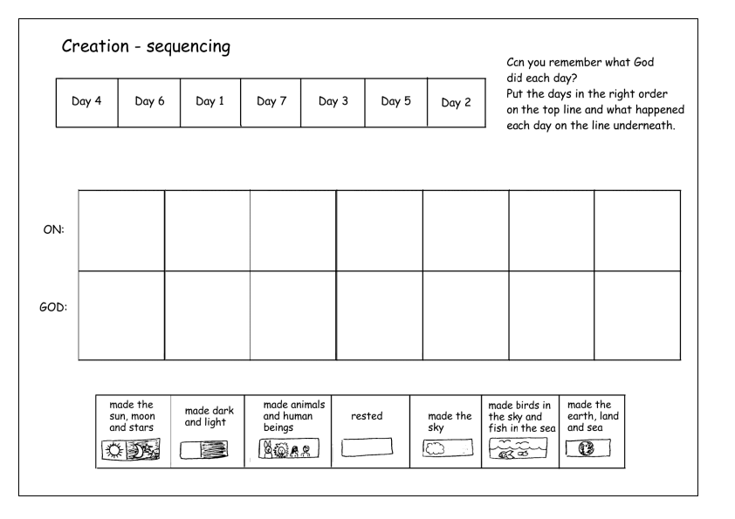

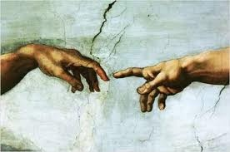**Creation  
&  
The Creed**

**Copy and complete the following lines of The Creed in your RERC jotter**

I believe in _________________________

The Father __________________

Maker of _______________________________

Of all things ____________________________.  
  
I believe in one ______________________________

The only ________________________________________.

Born of the Father ______________________________________.

God from _____________________, Light from _______________,

True ________________, From _________________________________,

Begotten, _____________________________, ___________________________

With the Father;

Through Him ___________________________________________.



**Discuss the following with your shoulder partner.**

* What do you think is meant by the phrase ‘visible and invisible’?
* What does ‘begotten’ mean?
* What does ‘consubstantial’ mean?
* What do you think is the one question that science cannot answer? Discuss this with your partner.
* Read The Creed again. Do you have a better understanding of it?
* The word ‘Creed’ comes from the Latin ‘credo’ which means ‘I believe’. What are we doing when we prayer The Creed?
* Can you think when at Mass we say this prayer? How do we say it?

**TEACHER’S NOTES**

**Creation  
&  
The Creed**

**Copy and complete the following lines of The Creed in your RERC jotter**

I believe in on **one God**

The Father **almighty**

Maker of **Heaven and Earth**

Of all things **visible and invisible.**  
  
I believe in one **Lord Jesus Christ**

*It is a good idea to give the children copies of the new ‘Order of Service’ to complete this task.*

*However, let them read through the leaflet to locate The Creed rather than point it out to them.*

*Perhaps discuss at what point during Mass we say it.*

The only **Begotten Son of God.**

Born of the Father **before all ages.**

God from **God,** Light from **Light**,

True **God**, From **True God**,

Begotten, **not made, consubstantial**

With the Father;

Through Him **all things were made**.

**Discuss the following with your shoulder partner.**

* What do you think is meant by the phrase ‘visible and invisible’?

**All things which we can and cannot see, around us and beyond.**

* What does ‘begotten’ mean?

**This means that Jesus was produced or created by God and was not created we are.**

* What does ‘consubstantial’ mean?  
  **This means the same in substance or in essence. This refers to the trinity and how God, Jesus and the Holy Spirit are one.**
* What do you think is the one question that science cannot answer? Discuss this with your partner.

**Who created the Big Bang?**

* Read The Creed again. Do you have a better understanding of it?
* The word ‘Creed’ comes from the Latin ‘credo’ which means ‘I believe’. What are we doing when we prayer The Creed?  
  **We are professing our Faith (refer to the 4 Pillars – Faith Professed). We stand and we say it together at Mass.**

**Stewards of the Earth**

**Below are some of the ways in which we are not fulfilling our responsibility to protect, nurture and care for our world. Carry out some personal research finding out more about what each is and what we can do.**

|  |  |  |
| --- | --- | --- |
| **Problem** | **What is it?** | **What can we do?** |
| **Deforestation** |  |  |
| **Global Warming** |  |  |
| **Famine** |  |  |
| **Pollution** |  |  |
| **Climate Change** |  |  |
| **Animal Extinction** |  |  |

Christianity and Stewardship

G1111977

Christians believe that we have had this responsibility since the day God made us. We should therefore do our best to ensure **every** part of our day to day life is environmentally friendly, from recycling to energy efficiency.

Christians may also choose to vote for a political candidate who shows concern for environmental issues; pray about the problems of the environment or take part in conservation projects locally or overseas.

# Genesis 1:26-31

Then God said, ‘let us make man in our image…and let them rule over the fish of the sea and the birds of the air…over all the earth, and over all the creatures that move along the ground.’

# Genesis 1:1

In the beginning God created the heavens and the earth.

# Psalm 19:1-4

The heavens declare the glory of God; the skies proclaim the work of his hands

# Psalm 95:3-6

For the Lord is the great God… In his hand are the depths of the earth, and the mountain peaks belong to him. The sea is his, for he made it, and his hands formed the dry land.

These passages from the **Bible** reflect a Christian understanding of God’s role as creator and our role as guardians or stewards of that creation.

When are people going to start reading the signs?

**What are we waiting for?**

Many of us act like the disintegration of the natural world is going to resolve itself. Or rather, won’t somebody else take care of it for us? A Christian response to this would be ‘NO!’, this is *our* responsibility, all of humankind’s. God left us the earth in good faith that we would take care of his creation for him.

This concept is called **stewardship**. We are stewards for the earth, our priority should be to ensure its safety, protect its beauty and always remember that it is JUST ON LOAN to us.

## Environmental Organisations

G1111928

Every voice counts!

There are many different organisations working to help the natural world. Some of the most famous are Greenpeace, Friends of the Earth and The World Wildlife Fund for Nature. These organisations work tirelessly to raise the environmental awareness of individuals, businesses and governments all around the world.

These particular organisations would not attach themselves to one particular religion such as Christianity. Many people work for them from many different backgrounds. However, they share a common theme with Christians: total respect for the world that we live in and determination to bring about a change for the better in the way we treat the world.

Some specifically Christian organisations are **The Christian Ecology Link** and **Christian Aid**. Whilst Christian Aid campaigns on global issues, The Christian Ecology Link works hard to raise awareness about what we can do as individuals to sort out our corner of the world.



G0140297

A Christian’s commitment to stewardship extends to all facets of the world we live in, including human and animal rights. To ***be aware***, ***take action*** and do as much as possible to ensure that ***others also accept these responsibilities***, is of huge importance to Christians.

I would say that’s a pretty good place to start…

**Answer the following:**

1. Why is the concept of stewardship so important to Christians?
2. List as many ways as possible in which a Christian can fulfil their responsibility as a steward of the earth
3. What kind of work do environmental organisations undertake? Refer to at least one specific organisation in your answer.
4. Copy out two of the Biblical passages overleaf (including their Biblical references) and explain their relevance to Christian ideas about stewardship.

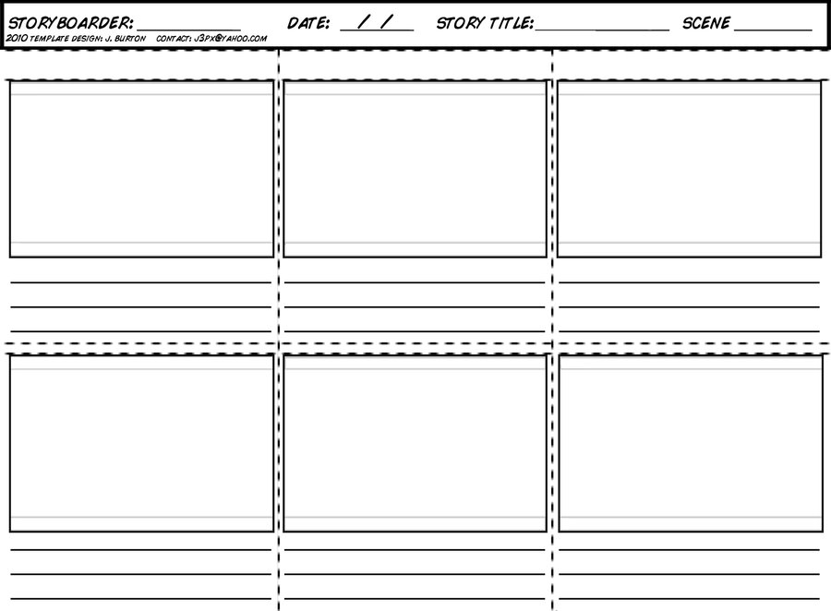**The Parable of the Rich Landowner**

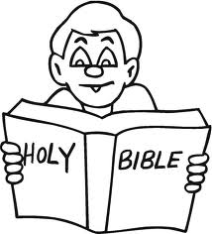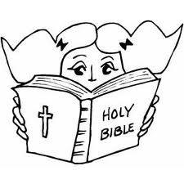 **The Covenant Agreements**

|  |
| --- |
| **Which 3 people did God make an agreement with?** |
| **What did God promise Noah?** |
| **What did Noah promise to do?** |
| **What symbol did God show in the sky to remind people of his promise? Write the quotation which describes this.** |
| **What did God promise Abraham?** |
| **What did Abraham promise to do?** |
| **What did God ask to be a symbol of his agreement with Abraham?** |
| **What did God Promise Moses?** |
| **What did Moses promise to do?** |
| **What was the symbol of this agreement between God and Moses?** |

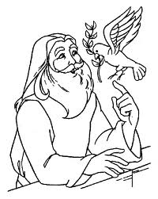

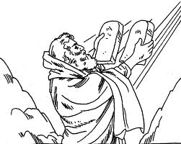

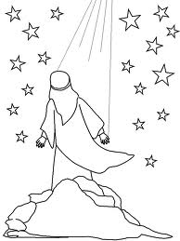



















**The Four Evangelists**

1. Write the names of the four Evangelists in the correct order.

______________________________________________________________________

1. Who was known as the ‘The Doctor’? _______________________
2. Who did Saint Mark have in mind when he wrote his Gospel? _________________________
3. Who did not report on the Last Supper and the Nativity? ____________________________
4. What does the word Evangelist mean? _________________________________________
5. What was Saint Matthew’s job before he joined Jesus? _____________________________
6. Mark was not known as one of the 12 Apostles what was he to Jesus? __________________

He was there at the start of Jesus’ ministry. Why do you think he was not one of the twelve?

______________________________________

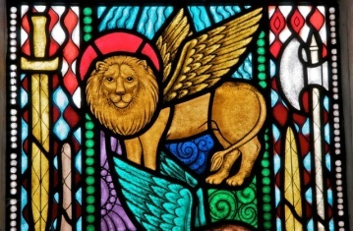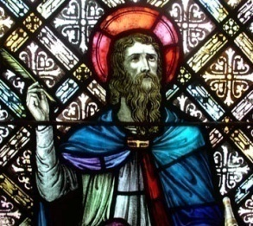**Match the correct Evangelist to their symbol and explain why it is associated to that Saint.**

**St Matthew**

[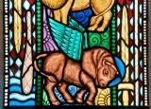](http://stainedglass.llgc.org.uk/image/5742)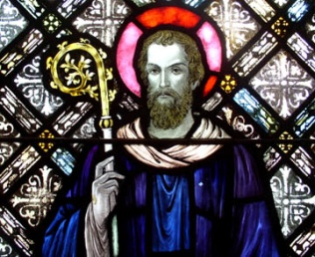

[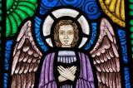](http://stainedglass.llgc.org.uk/image/5743)[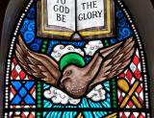](http://stainedglass.llgc.org.uk/image/5740)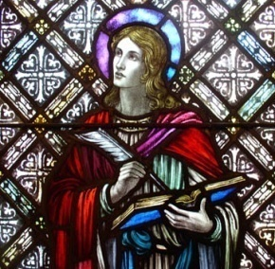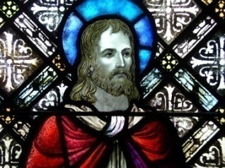

**St John**

**St Luke**

**St Mark**

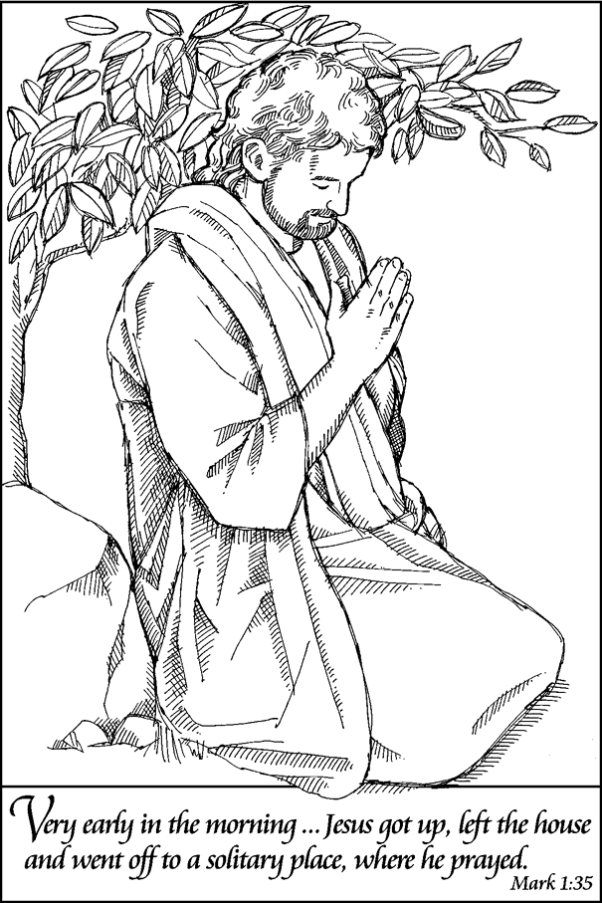**Did Jesus Pray?**

Jesus was filled with the Holy Spirit throughout his ministry, and prayed often to his Father in heaven. But how did he pray? When did he pray?

**Read the following passages from the Bible and answer the associated question.**

1. **Mark 1:35 & Luke 5:16**

Copy the quotations from scripture into your jotter. Explain how Jesus prayed here?

1. **John 17:11 & John 20-21**

Copy the quotations and reference from Scripture into your jotter. Explain who Jesus

is praying for.

1. **Luke 10:21**

Copy the quotation from scripture into your jotter. What is Jesus doing in this prayer?

1. **Matthew 26:39**

Copy the quotation from scripture into your jotter. How do you think Jesus is feeling

while he is praying?

1. **Matthew 6:5-15**

Write the title of this prayer into your jotter with the scripture reference. What was Jesus’ purpose in saying this prayer to his disciples?

**Jesus loved His Father and communicated with Him often. He prayed for wisdom and guidance in His earthly ministry. He knew the Father heard His prayers and would respond.   
This should be our goal as believers: Pray as Jesus prayed.**

**Hymn Lyrics – God’s Spirit is in my Heart**

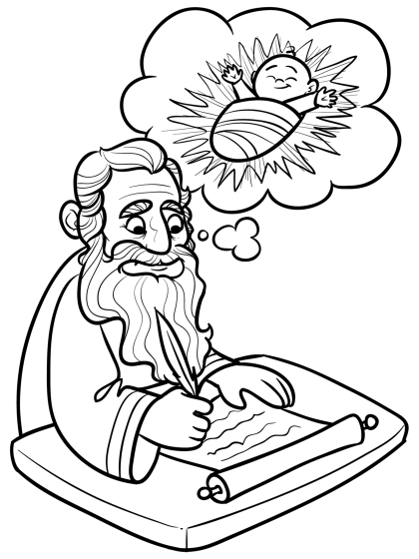God’s Spirit is in my heart,   
He has called me and set me apart.   
This is what I have to do,   
what I have to do.   
  
He sent me to give the Good News to the poor,   
Tell prisoners that they are prisoners no more,   
Tell blind people that they can see,   
And set the downtrodden free   
And go tell everyone the news that the Kingdom of God has come,   
And go tell everyone the news that the Kingdom of God has come.   
  
Just as the Father sent me,   
So I’m sending you out to be   
My witnesses throughout the world,   
The whole of the world.   
  
Don’t worry what you have to say,   
Don’t worry because on that day   
God’s Spirit will speak in your heart,   
Will speak in your heart.

Jobs in a Monastery

* 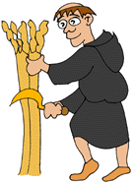The monks in a monastery did lots of different jobs like bee keeping, wine making, brewing, milling, looking after animals, growing fruit & vegetables, harvesting, fishing, building, carpentry, stonemasonry & copying manuscripts. They still spent a lot of the day praying though. Some monks had specific duties and they were given special names:
* Abbot - The monk in charge
* Prior -  The Abbot's helper
* Sub-Prior - The Prior's helper
* Cellarer - The monk in charge of stores and supplies
* Cook - The monk in charge of cooking meals
* Sacrist - The monk in charge of the abbey's treasures
* Chamberlain - The monk in charge of clothes and bedding
* Guest Master - The monk who looked after abbey guests
* Almoner - The monk who gave food and clothes to the poor
* Infirmarer - The doctor monk
* Herbalist - The monk who made medicines
* Cantor or Precentor - The monk in charge of singing
* Illuminators - Monks who paint pretty pictures in manuscripts
* Choir or Cloister Monks - Ordinary monks
* Novices - Boy monks
* Master of the Novices - The teacher monk
* Lay Brothers - Non-monks who worked at the abbey
* Lay Servants - Hired help

**TASK - Choose three of the above jobs and research more into that particular role. Note your findings in your jotter. You can print, cut and paste any images that you find to support your work.**