Jesus is condemned to death
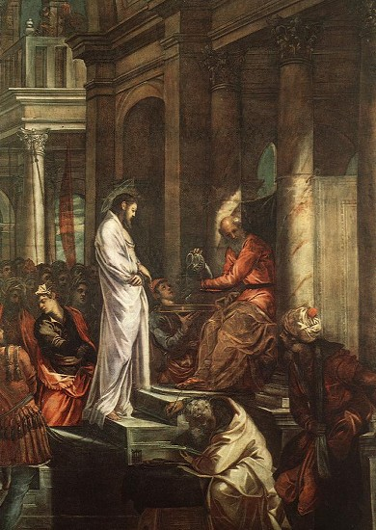
Christ before Pilate – Tintoretto

Jesus carries His cross
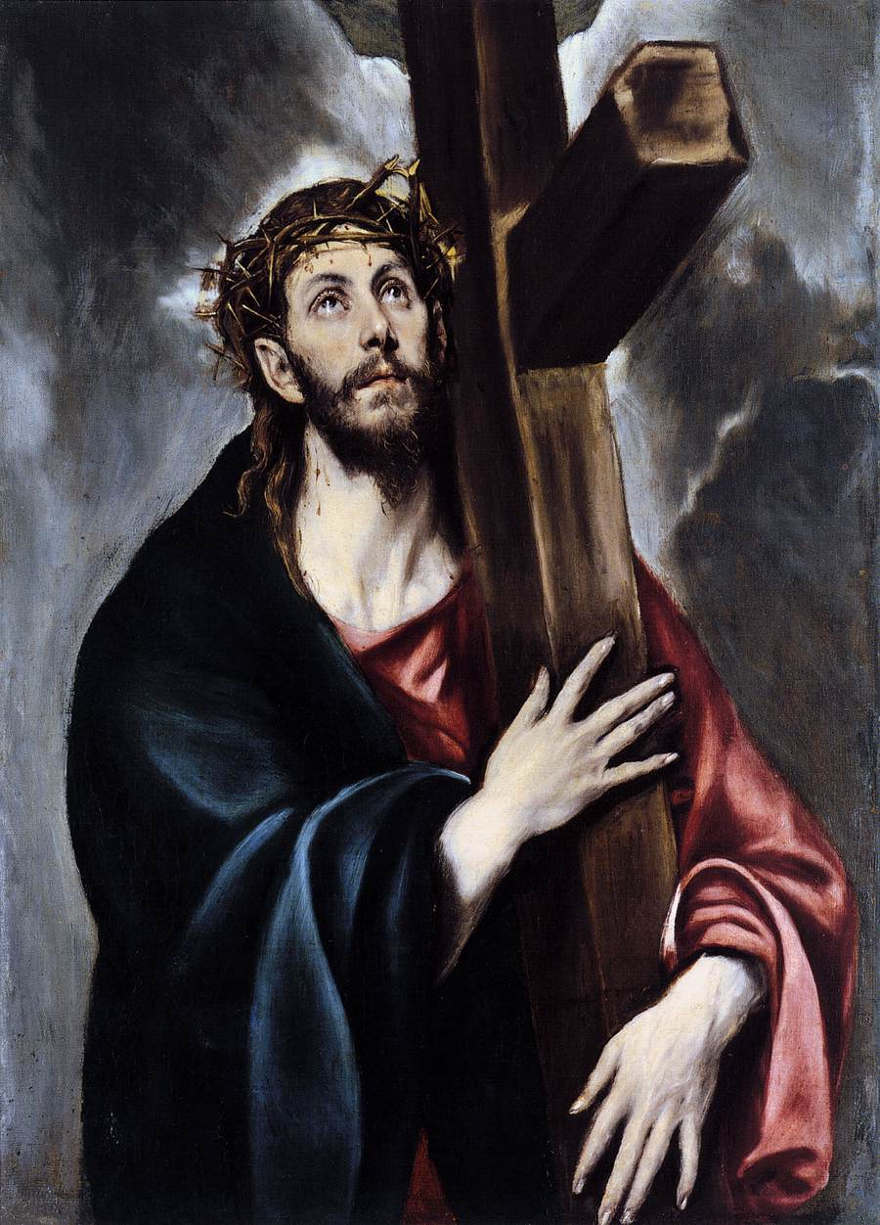
Christ carrying the cross – El Greco

Jesus falls the first time
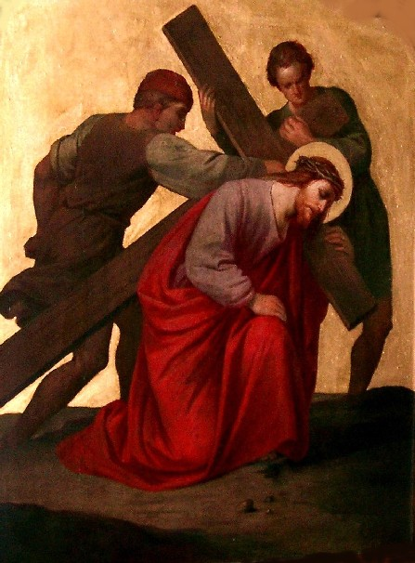
St Raphael’s Catholic Church
http://www.straphael.org.uk/stations_photos_the_cross.htm

Jesus meets his mother
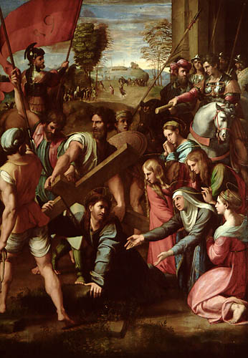

Simon of Cyrene helps Jesus to carry his cross
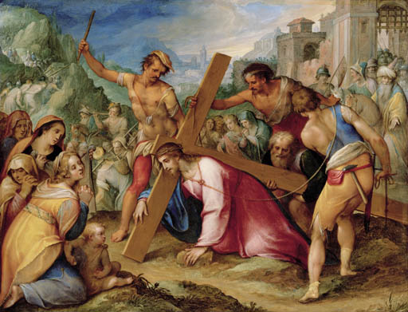

Christ on the Road to Calvary

Johann Rottenhammer (Munich 1564/5-1625 Augsburg)

Veronica wipes the face of Jesus

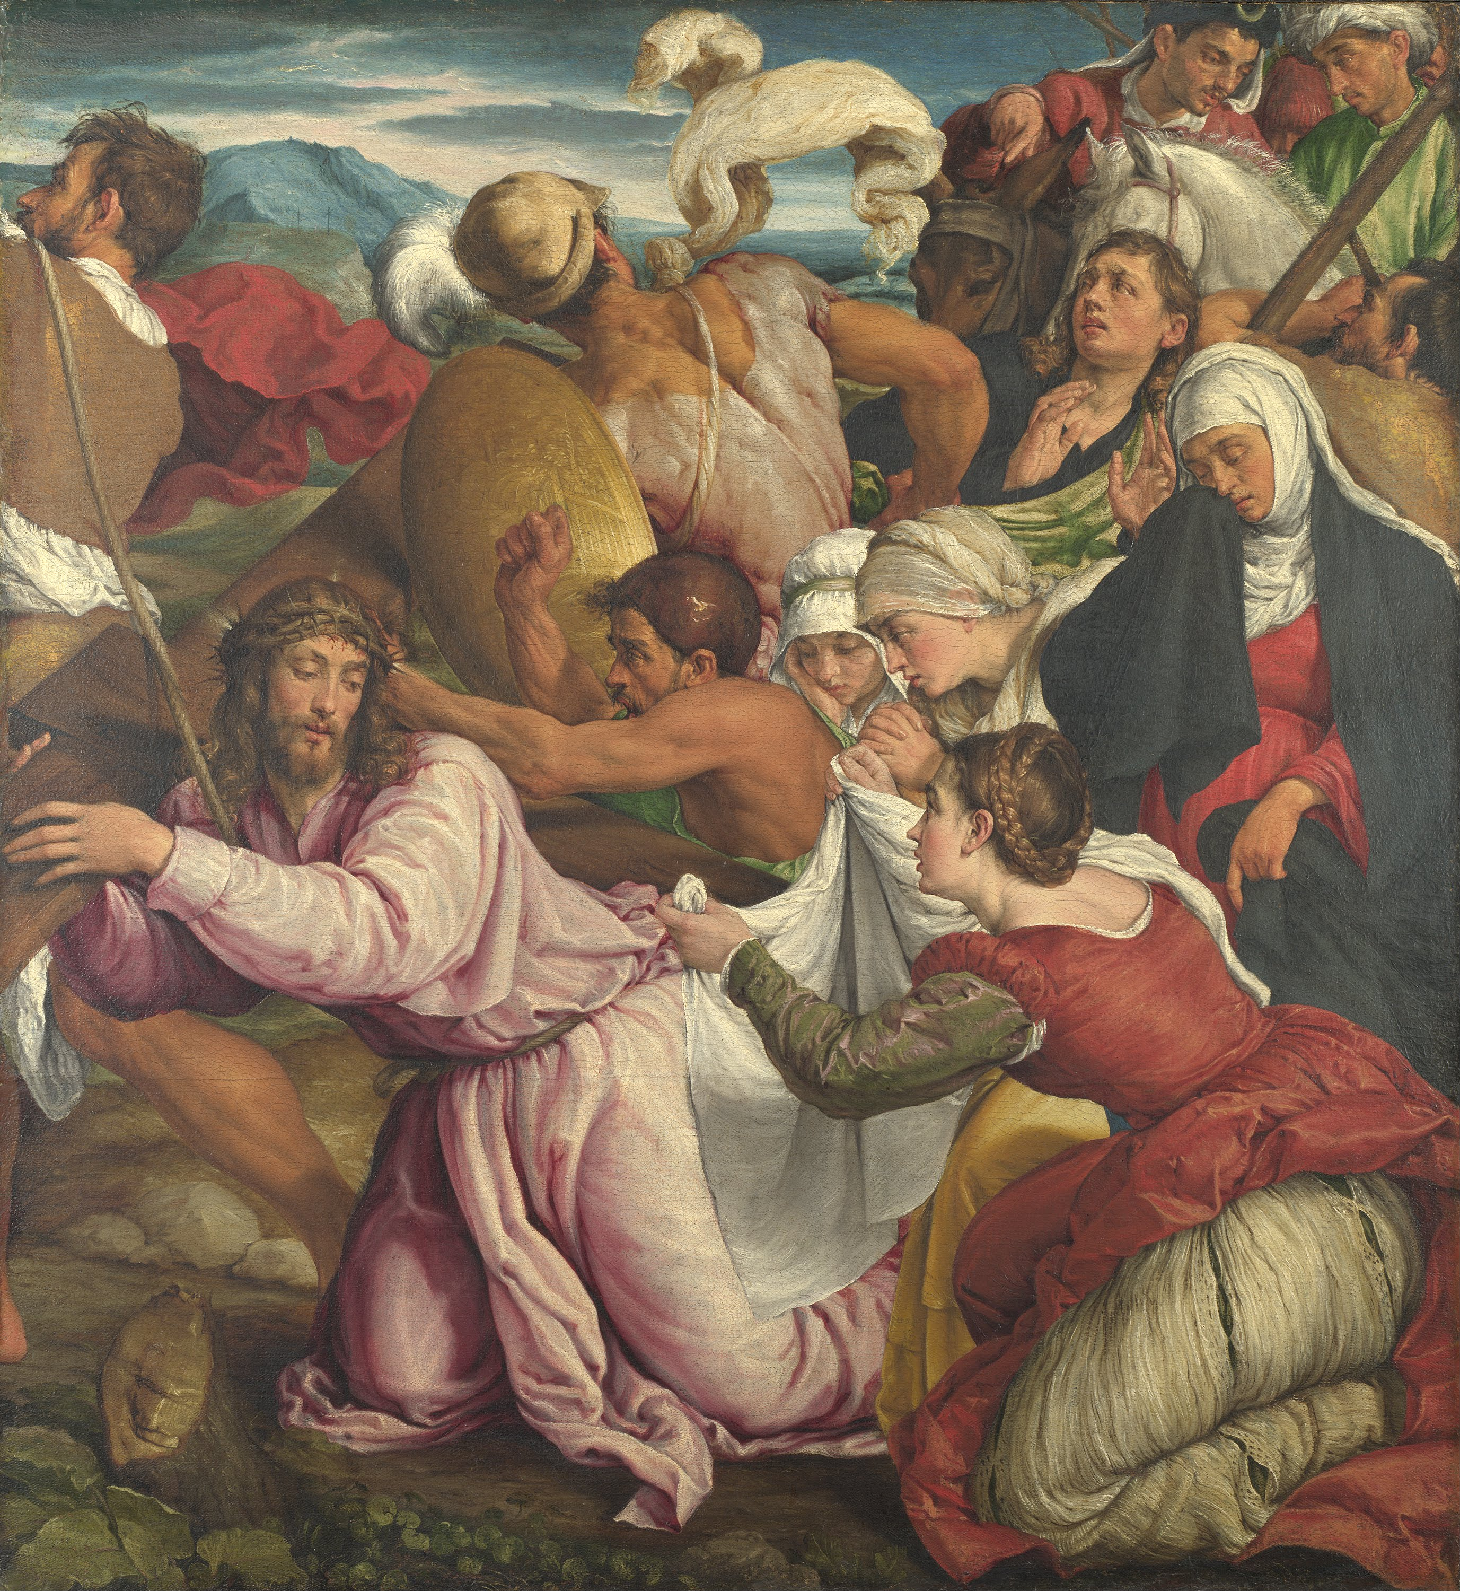

The way to Calvary

Jacopo Bassano 1545

Jesus falls the second time

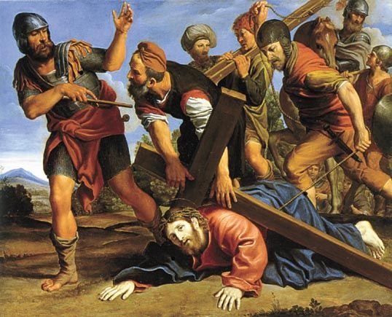

Domenichino The Way to Calvary 1610

Jesus meets the women of Jerusalem
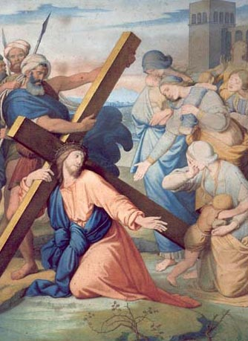
FRIEDRICH OVERBECK (1789-1869)
WATER-COLOUR ON BOARD - Vatican Museum

Jesus falls a third time

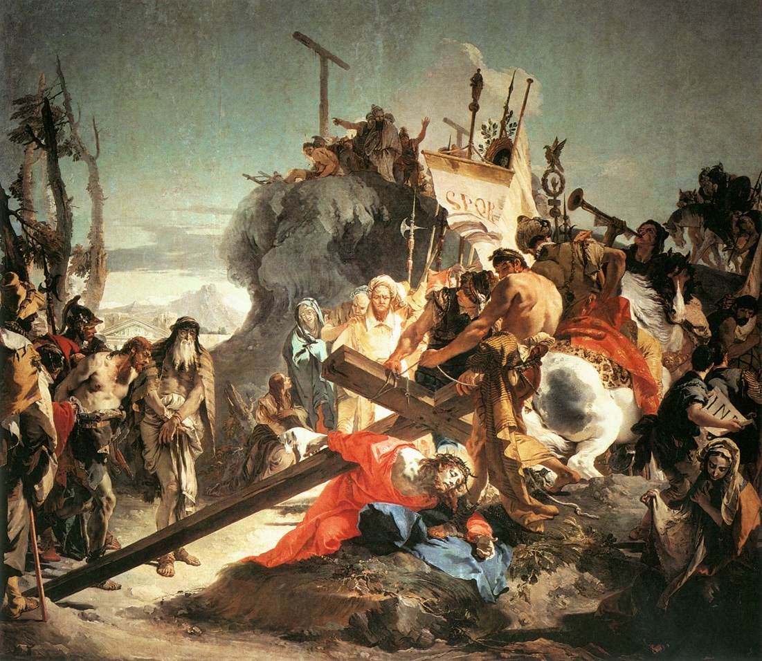

Christ Carrying the Cross by Giovanni Battista Tiepolo, 1737-1738

Jesus is stripped of his garments
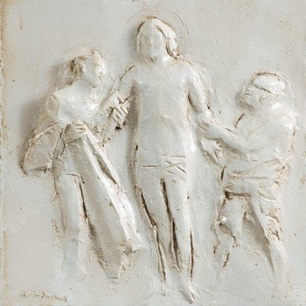
Way of the Cross 2012 – Vatican.va

Jesus is stripped of his garments (alternative)
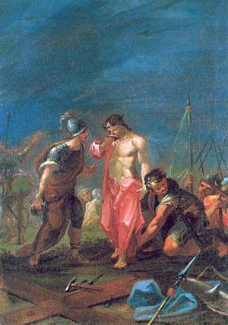
Via Crucis, Scuola Veneta - Sec. XVIII
Cattedrale – Padova
Jesus is nailed to the cross
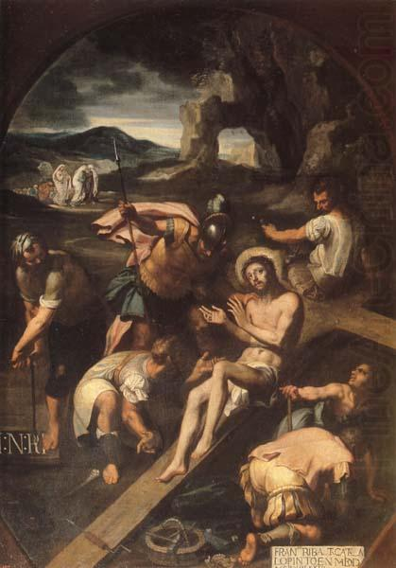
Christ nailed to the cross Francisco Ribalta 1582

Jesus dies on the cross

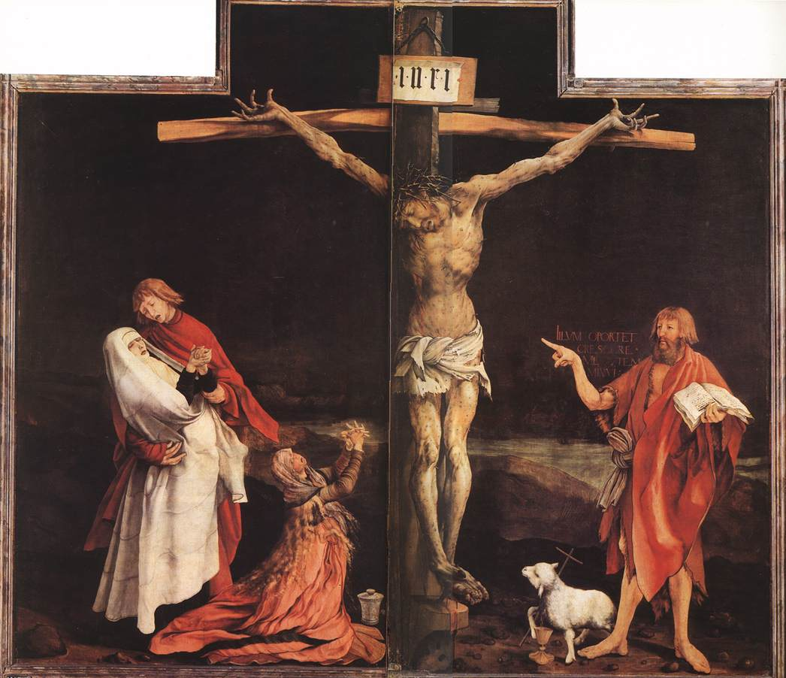

The Crucifixion Matthias Grunewald Detail from the Isenheim altar 1515

Jesus taken down from the cross
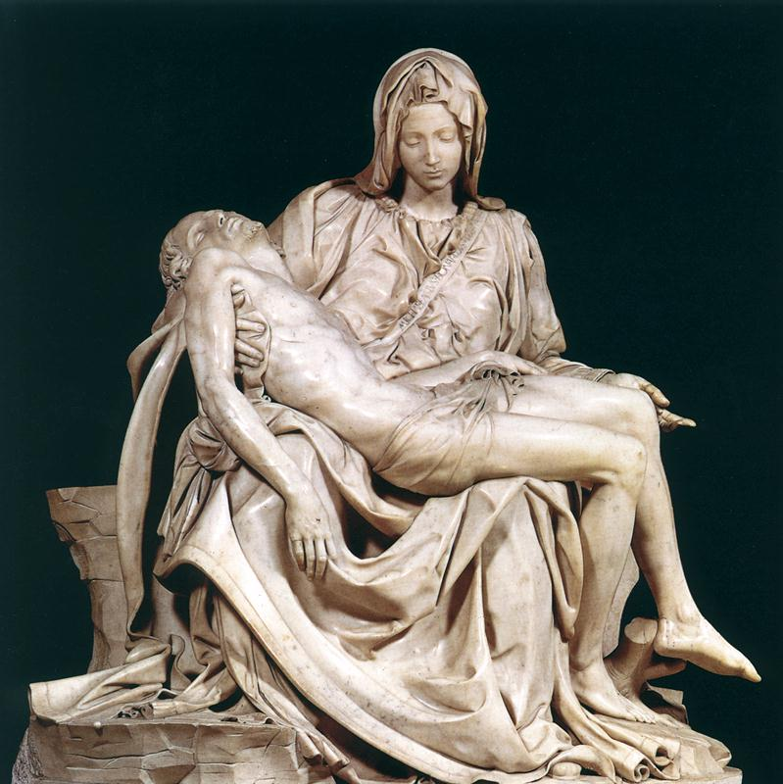

Michelangelo Pieta

Jesus is placed in the tomb
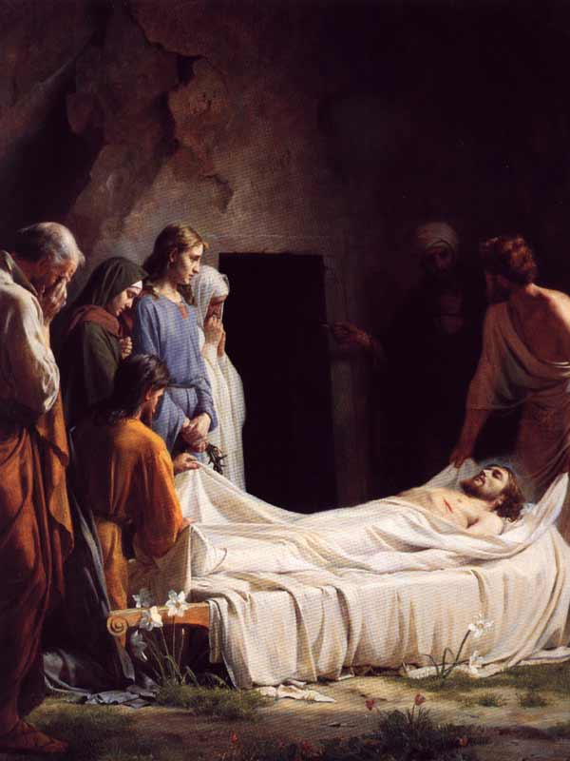

http://www.beholdthelambministry.com/14stationsofthecross.htm

Jesus placed in the tomb (alternative)
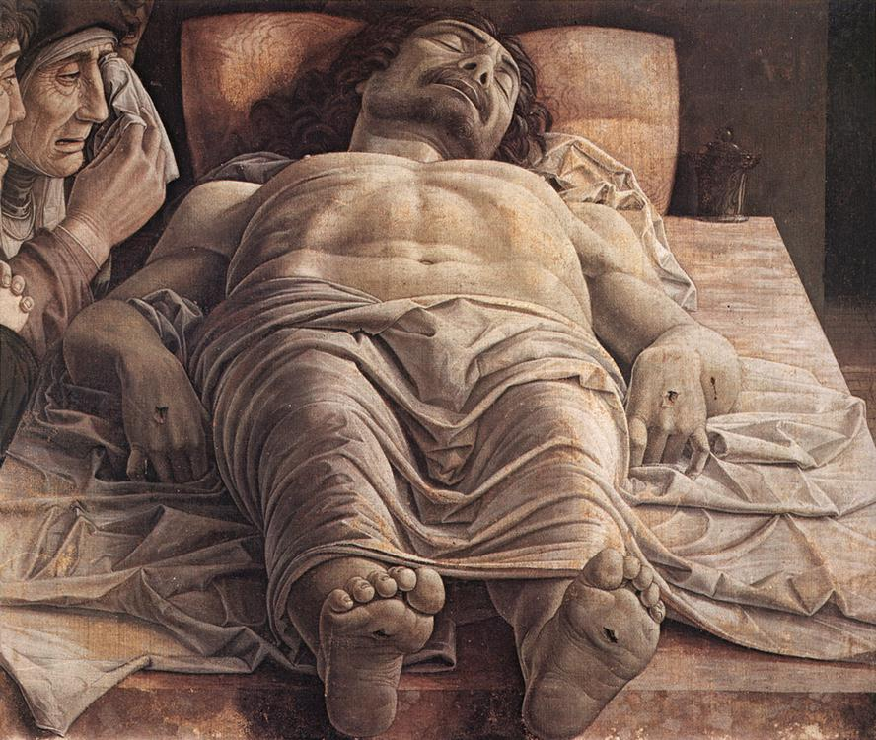

http://history.hanover.edu/courses/art/mandc.html

