Month/Season: Advent Class: Primary 3 Level: First
Themes:
1. Advent
2. The story of Christmas
3. The Story of King Herod

Strands of Faith : Experiences and Outcomes | Core Learning | Learning & Teaching  Class/School/Home/Parish | Resources | Assessment
Hours of God  RERC 1‐18a  I know some of the signs and symbols related to Lent, Easter, Pentecost, Advent and Christmastide and I can use this understanding to help me explore the  themes of these celebrations | I know that the liturgical colour used by the Church during Advent and Lent is purple and Christmastide and Eastertide is white.  I have participated with my class in dressing the class altar with these colours.  I can participate in the preparation for Christmas through prayer and joyful expectation in Advent.  I have been offered opportunities to deepen my understanding of preparation and waiting as Advent themes through the prayerful creation of an Advent Wreath.  I have been given opportunities to pray at the crib and to reflect on the birth of Jesus as a joyful event. | Class: - Teacher shows class the liturgical wheel and explains the significance of the colours. Teacher explains that Advent is a time when we are waiting for Christmas and the birth of Baby Jesus and emphasises that the liturgical colour during Advent is purple and the liturgical colour for Christmastide is white. Children colour in blank liturgical wheel.  Advent is the Season that includes four Sundays preceding Christmas. The Advent Season marks the beginning of the Liturgical Calendar. It always begins in late November or early December. On November 30th or on the Sunday that is the closest to this date, the Catholic Church begins the Liturgical Season of Advent. Advent ends on December 24th before the evening prayer of Christmas.  Christmastide lasts 12 days, beginning on Christmas Eve (December 24th) and continues to the Feast of Epiphany (January 6th).  A useful website is http://www.catholicdoors.com/courses/liturgy.htm  Class: - Children dress class altar in colours appropriate to Advent followed by Christmastide. Children pray round the class altar.  Class: - Teacher discusses the various ways we prepare for Christmas during Advent e.g. sending Christmas cards, dressing the Christmas tree, singing carols, taking part in a nativity play. Teacher explains that the children are going to make a class Advent calendar to help them count the days to Christmas. Each child will help to colour in a picture of the nativity scene. Each day in December, a picture will be stuck on a background and by Christmas day the nativity scene will be complete.  Further instructions and templates are attached to the planner.  Class: - Teacher explains that as part of the preparations for Christmas, it is traditional to make or buy an Advent wreath. If possible the teacher could assist the children in the making of a simple Advent Wreath.  To make an Advent wreath, begin with a Styrofoam circle, available at craft shops, and cut four evenly spaced holes into which you will place the four candles. Traditionally there are three purple candles and one rose candle (for the third Sunday. Place fresh evergreen branches over the Styrofoam. Replace them when they dry out in order to preserve the symbolism of the vitality of God's love. Encourage children to participate as they are able, by gathering branches, placing the candles and so on. Teacher explains the significance of the candles (advent wreath notes are attached to planner).  Class: - Class are given the opportunity to make their own cardboard advent wreath.  School: - Children participate in school Advent assemblies where the Advent wreath is lit.  Parish: - Children visit local Catholic church to view how the priest and parishioners prepare the church during Advent or the local priest could visit the class and the children could ask him questions about this.  Class: - Teacher shows children figures or pictures of Mary, Joseph and baby Jesus and sets up a crib on or near the class altar. The children are giving opportunities to pray at the crib and reflect on the birth of Jesus as a joyful event that all Christians celebrate at Christmas time.  KEY VOCABULARY: Liturgical colours, prayer, Advent wreath, praying at the crib | Liturgical Wheels  (attached to planner)  Internet  Purple Altar Cloth  White Altar Cloth  Instructions and templates for Advent calendar (attached to planner)  Styrofoam Circle  3 purple candles  1 rose candle  Evergreen branches  Advent wreath notes (attached to planner)  Advent Wreath  Template (attached  to planner)  Scissors  Art Materials  Glue  Figure or Pictures of baby Jesus, Mary and Joseph | Children show an understanding that the Church uses purple for Advent and white for Christmastide  Children demonstrate a deeper understanding of the significance of the Advent Wreath.  Children will show awareness that the birth of Jesus is a joyful event.

Strands of Faith : Experiences and Outcomes | Core Learning | Learning & Teaching  Class/School/Home/Parish | Resources | Assessment
Hours of God  RERC 1‐15a  I can honour Mary as Mother of Jesus and Our Mother. I can share why we honour her. | I can participate in the creation of a prayer space in honour of Mary in my classroom – especially in Advent and during the months of May and October.  I can recognise images and icons of Mary in the Church and in school.  I can participate in a simple liturgical procession honouring Mary.  I can thank Mary for saying ‘yes’ to God’ and agreeing to be the Mother of His Son. | Class: - Teacher discusses with the children different ways of honouring Mary as Mother of Jesus and Our Mother e.g. saying special prayers to Mary, singing hymns to Mary. Teacher tells the children that during Advent the class prayer space will be set up in honour of Mary. Teacher places a statue of Mary and/or pictures of Mary on the class prayer space. The children are told that at noon each day everyone in the school will stop to pray a special prayer to Mary called the Angelus. Teacher explains to the children that the Angelus means Angels and that Mary is in Heaven with all the angels and has a special title - Queen of the Angels. Teacher shows children a picture portraying Mary as Queen of the Angel. Every day at noon the class will stop what they are doing and pray The Angelus.  The teacher leads the prayer and the children respond with praying the Hail Mary. A copy of The Angelus is attached to the planner.  School: - The children will participate in a simple liturgical procession at assembly honouring Mary. They will respectfully process round the school assembly area scattering rose petals and congregate around a statue of Mary whilst singing Immaculate Mary.  Class: - Teacher explains to the children that the Angel Gabriel gave Mary the good news that she was going to be the mother of Jesus. The Angel Gabriel spoke these words to Mary, “Hail Mary, full of grace, the Lord is with thee,” Discuss with the children how Mary must have felt to be told this news by an angel. Ask the children where they have heard these words before? Teacher explains that Mary said ‘yes ‘ to God and  agreed to be the Mother of His Son. Teacher explains that Mary is also Our Mother too and they are all going to make a special card for Mary thanking and honouring her as Mother of Jesus and Our Mother too. These thank you cards for could be placed around the crib or on the class altar.  KEY VOCABULARY: honour Mary, Mother of Jesus‐ the Son of God, Saying ‘Yes’ to God. | Statue of Mary and/or pictures of Mary  Picture of Mary as Queen of the Angels  (attached to planner)  Words of the Angelus (attached to planner)  Lyrics of Immaculate Mary (attached to planner)  Statue of Our Lady  Baskets with artificial petals  Cardboard  Art Materials | Children show an awareness of why we honour Mary as Mother of Jesus and Our Mother too

Strands of Faith : Experiences and Outcomes | Core Learning | Learning & Teaching  Class/School/Home/Parish | Resources | Assessment
Son of God  RERC 1‐05a  I am familiar with the Christmas story and I know that at Christmas we celebrate the birth of Jesus the Son of God and Son of Mary.  In P3 we will focus particularly on the place of Joseph and Herod in the Christmas narrative. | I can hear, read and recall the narrative of Simeon and Anna (Luke 2: 22‐38), and I can recognise that they were waiting for the birth of the saviour.  I can reflect on the ways that my class, family and parish prepare in Advent to celebrate the birth of Jesus, our saviour.  I have listened to two Gospel passages (Matthew 1: 18‐25 & Matthew 2: 13‐15) and I know that Joseph listened to the Angel, God’s messenger, and chose to do what God asked.  I can hear, read and recall the story of Herod (Matthew 2: 1‐9, 13‐21).  I can recall and understand that Jesus is a king and that this was seen by Herod as a threat.  I can contrast Joseph’s way of following what God wanted and Herod’s way of acting against God.  I can examine how we can choose to follow Joseph’s way or Herod’s way. | Class: - Teacher reads from the bible Luke 2: 22‐38 and discusses the concept of waiting with the children. Where did Mary and Joseph travel to with Jesus? What was the name of the holy building that they brought Jesus too? Who had been waiting to meet the child Jesus? Why did Simeon give thanks? What Did Simeon say to Mary Who else was glad to meet Jesus? Why did Anna give thanks? Teacher discusses with the children that both Simeon and Anna were waiting for the birth of Jesus. During Advent we are waiting for Christmas and the celebration of the birth of Jesus. Teacher introduces The Christmas Story Workbook and children complete the first page - The Annunciation.  Class: - Teacher explains to the class that at Christmas time we celebrate the birth of Jesus. Mary and Joseph had to prepare for the birth of Jesus. Where did they have to go? What did Mary travel on? Do you think they were excited about the birth of Jesus? Why did they have to rest in a stable? Where did Jesus sleep? Did they have clothes for Jesus? Teacher explains to the children that during Advent just like Mary and Joseph we are preparing for Christmas. What are we doing in school? What type of concert are we taking part in? Are you excited? What do we give each other at Christmas time? What do you send through the post to your family and friends? What decorations do you put up at home? How is the Church decorated for Christmas? Children complete the next two pages of their The Christmas Story Workbook – The Visitation and The Nativity.  Class: - Teacher reads from the Bible Matthew 1: 18‐25 & Matthew 2: 13‐15). Teacher discusses the passages with the children? Who spoke to Joseph in a dream? What did the angel ask Joseph to do? Why did Joseph decide to do what God asked? What was Joseph’s relationship to Jesus? Did Joseph obey the message of God by an angel and escape to Egypt with Mary and Jesus? Why did Joseph always choose to do what  God asked? Children complete The Christmas Story Workbook - An Angel Appears to the Shepherds in the Fields. Children place shepherds in the nativity scene.  Class: - Teacher reads from the Bible Matthew 2: 1‐9, 13‐21 and discusses the passages with the children. What is the name of the king in the story? What did the wise men from the east study? What special star did they see? What baby were they looking for? Why was Herod upset? Who told him where to find Jesus? What did he ask the men from the east to do? What did Herod say he was going to do for the baby? Can you remember what Joseph did when the angel gave him a message from God? Why was Herod furious? What dreadful order did he give? What happened after Herod died? Where did the angel ask Joseph to take Mary and Jesus? Why did Joseph do as God asked? Children complete The Christmas Story Workbook – The Shepherds worship Jesus and The Wise Men from the East. Children place The Wise Men from the East in the nativity scene.  Class: - Teacher discusses with the class why Herod saw Jesus as a threat. Can you remember what the wise men from the east called Jesus? Why do you think he did not like that Jesus was called King of the Jews?  Do you think he should have been worried about a baby who was a king?  Do you think he knew how important Jesus was? Do you think he had heard about everyone going to worship Jesus? Explain to the children that Herod was a king and did not want another king to take any power or attention from him. Children complete The Christmas Story Workbook – King Herod was Very Worried and Joseph, Mary and Jesus Escape to Egypt  Class: -Teacher discusses with the children the contrast between Joseph who always followed God’s way and Herod who acted against God. Children complete the worksheet – Joseph or Herod? Children read the eight statements and write the statements in the correct column of the table.  Class; - Teacher discusses with the children how we often have to decide whether to choose to follow Joseph’s way or Herod’s way. Discuss scenarios at home or in the playground e.g. taking a toy that does not belong to you, playing with someone who is lonely. Children complete the worksheet- I have chosen to live like Joseph.  KEY VOCABULARY: Joseph, Mary, Herod, Jesus is a king | Bible  The Christmas Story Workbook (attached to planner)  The Christmas Story Workbook (attached to planner)  Bible  The Christmas Story Workbook (attached to planner)  Figures/pictures of shepherds  Bible  The Christmas Story Workbook (attached to planner)  Figures/pictures of The Wise Men from the East  The Christmas Story Workbook (attached to planner)  Joseph or Herod?  Worksheet  I have chosen to live like Joseph Worksheet | Children develop an understanding that Joseph chose to do what God asked.  Children develop an understanding that Jesus is a king and that this was seen by Herod as a threat.  Children are aware that we can choose to  follow Joseph’s way or Herod’s way.

Strands of Faith : Experiences and Outcomes | Core Learning | Learning & Teaching  Class/School/Home/Parish | Resources | Assessment
Reign of God  RERC 1-24a  I have considered ways in which the Catholic Christian community works together to show care for the world and for the needs of all people. I have reflected on the implications of this for my life and that of others. | I know that my school is a Catholic school which, with God’s help, works together with my family, my Parish and the whole Church to show care for the world and for the needs of all people.  I have responded to opportunities to participate in practical action that demonstrates care in my school environment and all those within it.  I can identify practical ways to show how I can also care for the wider community, particularly Advent. | Class: - Teacher discusses with the class that Christians are followers of Jesus Christ and that their school is a Catholic school. Catholics believe that Jesus Christ taught us to love our neighbours as ourselves. Catholics try to put this into practice by their actions and by becoming involved in a wide variety of charitable works. Discuss with the children the names of any charitable organisations that either their school or their parish has been involved in raising money for e. g .SCIAF, Lepra, Missionaries and how their donations can make a difference to these communities. Teacher shows websites on the interactive white board which allow the children to view the work done by these charities. The children could also write to these organisations asking for information about how they care for the needs of vulnerable people. Teacher explains that you can also show care for others by volunteering your time and explains the role of soup kitchens, visiting the elderly, the work of Saint Vincent de Paul, etc.  Parish: - The parish priest could be invited to visit the class to explain the role of some of the organisations within the parish who show care for others. He might be able to arrange for somebody from one of these organisations to visit the children and the children could ask questions about their role.  Class: - Teacher discusses with the class that during Advent they are going to participate in activities that will help and show care for their school environment and all those within it. What do they think they could Do? Will everyone do the same thing? Do you think it will be fun? Do you think you will make people happy? Children could be become involved in picking up litter, tidying toys and books, watering plants, helping younger children etc. These activities could be photographed and placed on the school website.  Class: - Teacher explains to the children that during Advent lots of charities help individuals or families who might not be able to afford food or presents at Christmas time. Teacher selects a local charity that is appropriate for the class to help in a practical way. This could involve bringing in presents for homeless families, making up food parcels for the needy in their area or collecting baby clothes and toiletries for mothers and babies living in poverty. The local newspaper could be contacted to come along and photograph the children presenting the goods to the charity.  KEY VOCABULARY: Catholic school, Church, care for the wider community, needs of all people | Interactive Whiteboard  Posters , Leaflets of Charities  Writing Materials  Camera  Internet | Children should demonstrate an awareness that the Catholic Christian community works together to show care for the world and for the needs of all people.  Children should demonstrate by their actions an understanding of how they can personally care for members of the school community and the wider community.

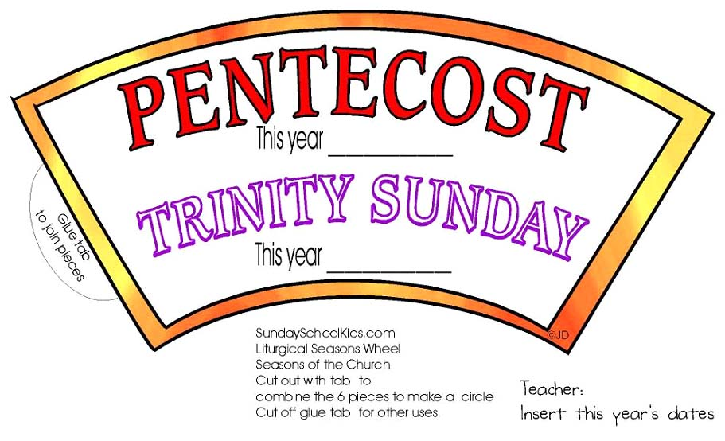

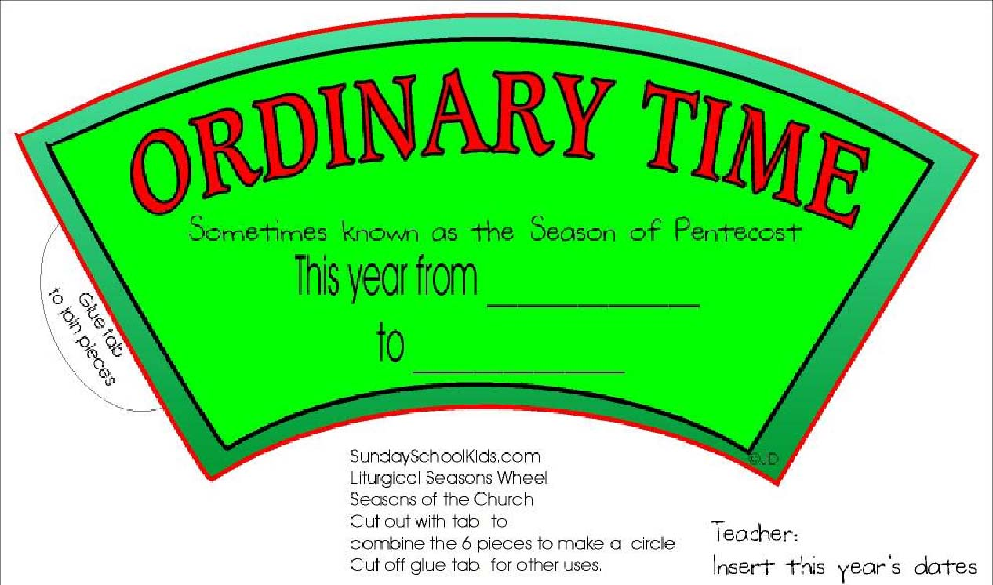
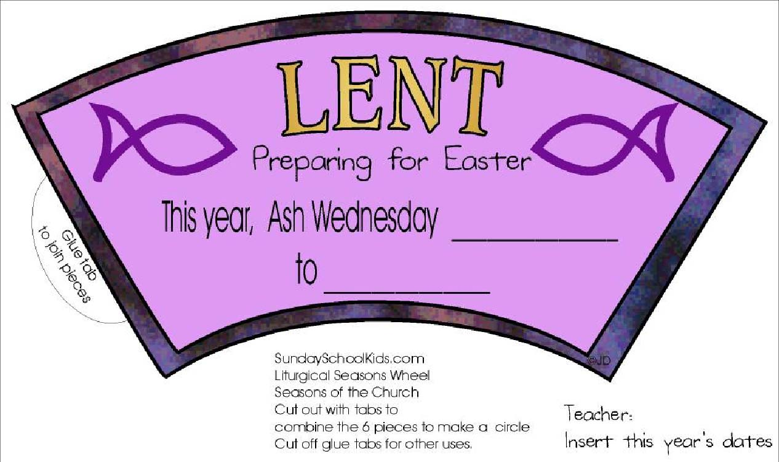
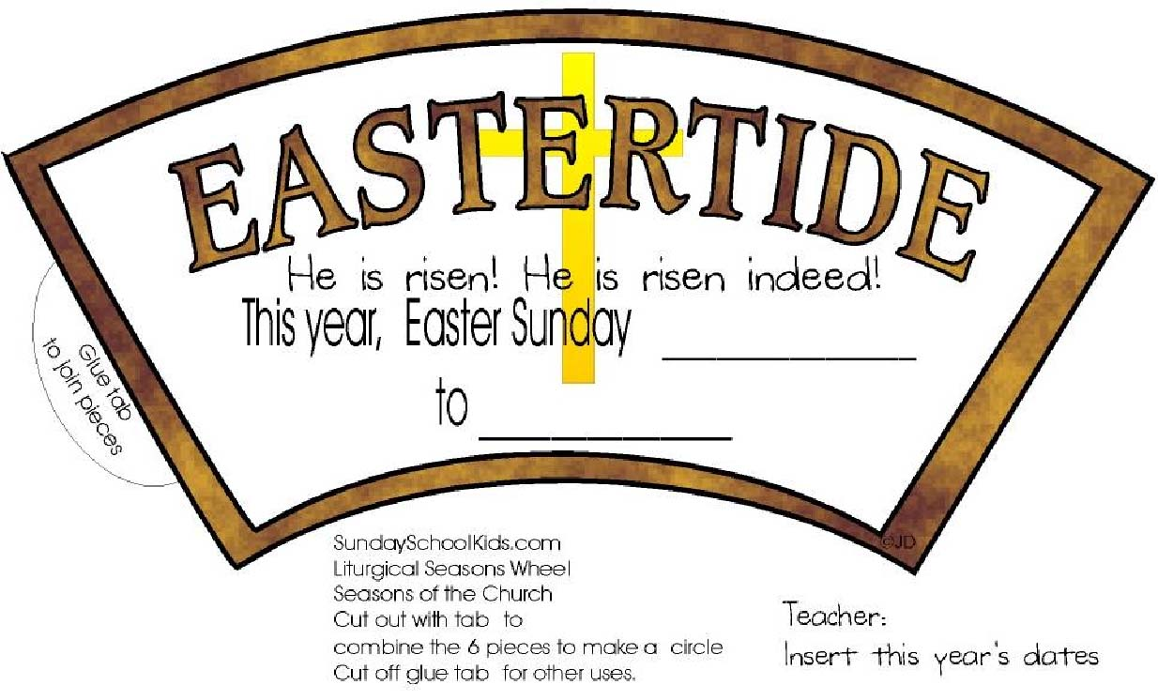
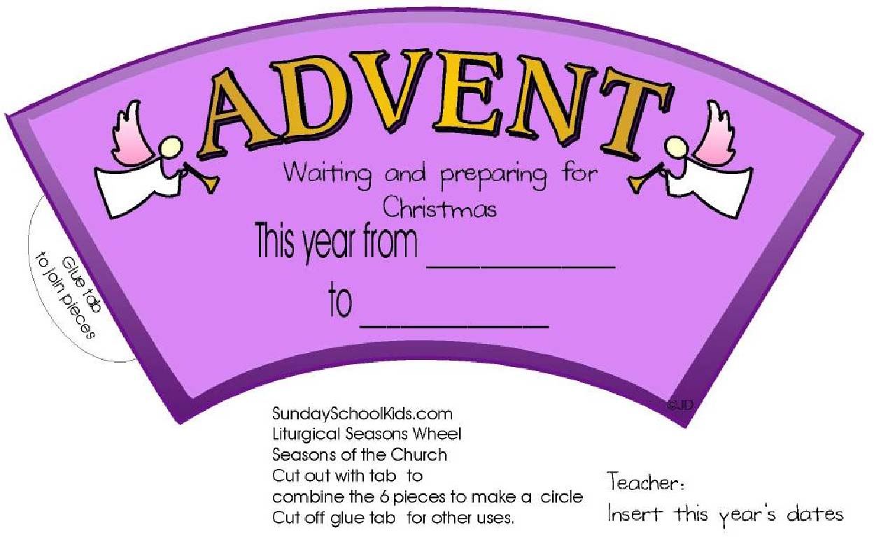
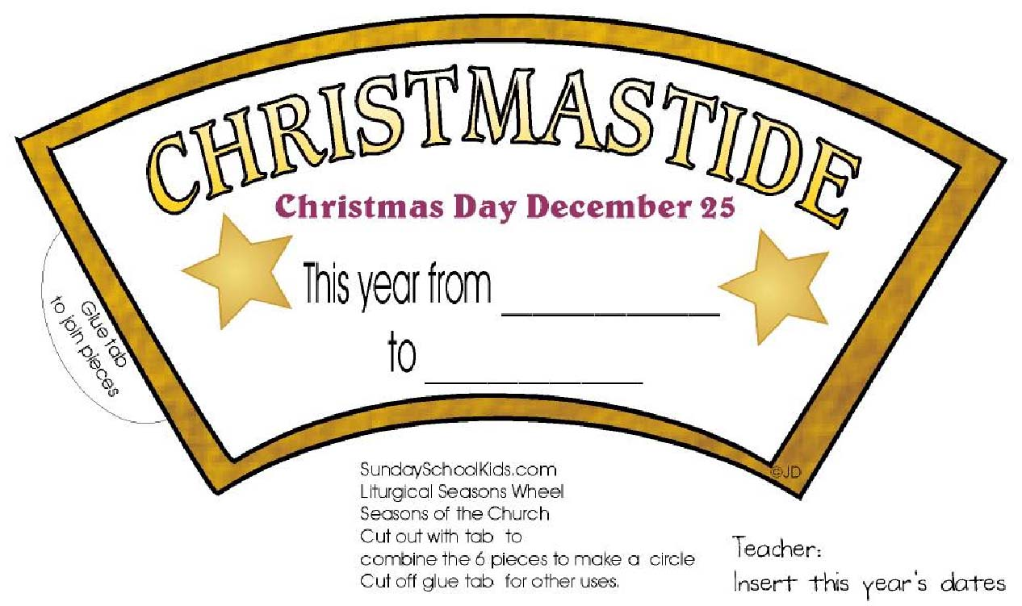

Advent Calendar

This Advent Calendar is of the Nativity. Colour and cut out the pictures. Each day, starting with December 1st, put up one piece.

The pieces can be placed in the following order:
- Stable (three pieces: 2 sides, 1 support beam)
- Stable Roof (two roof pieces)
- Palm Tree
- Palm Tree
- Bird
- Bird
- Nest
- Sheep
- Lamb
- Lamb
- Donkey
- Joseph
- Mary
- Manger
- Angel
- Angel
- Star
- Big Shepherd
- Shepherd Girl
- Shepherd Boy
- Camel
- Wise Man
- Wise Man
- Wise Man
- Baby Jesus
Baby Jesus is set to come on Christmas Day, but if you'd like him to come on Christmas Eve, you can put the entire stable up on the first day.
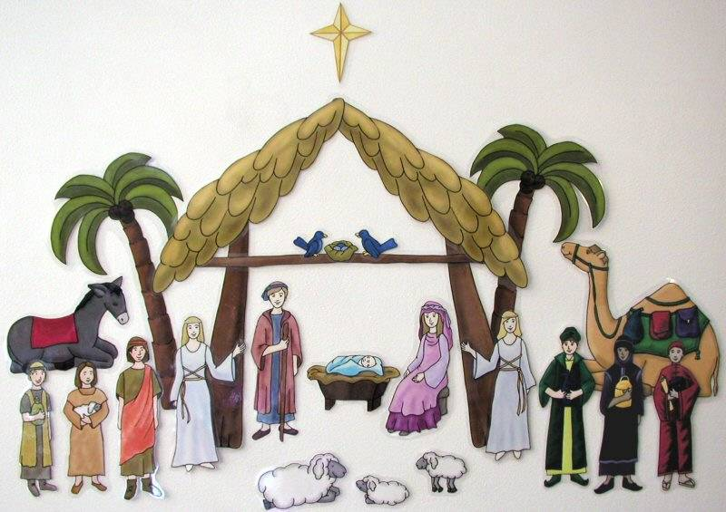
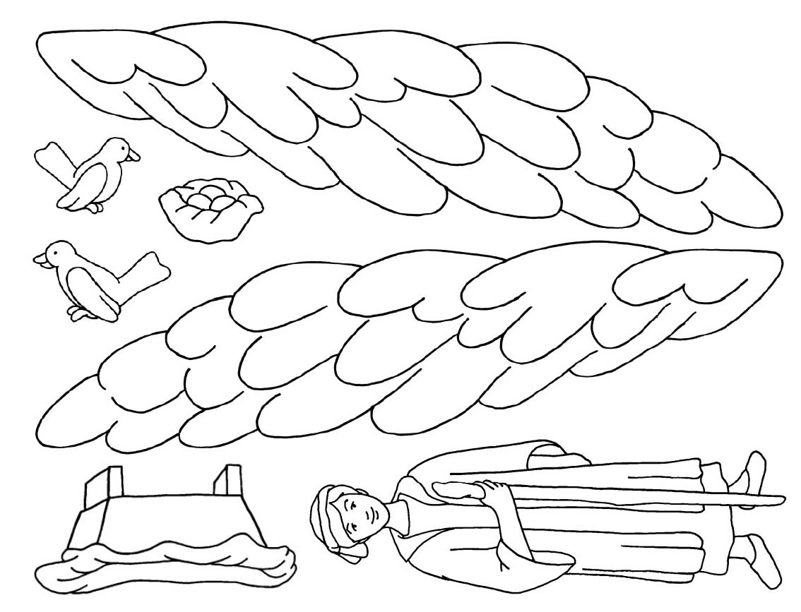
Advent Calendar Page Cut-Out 1
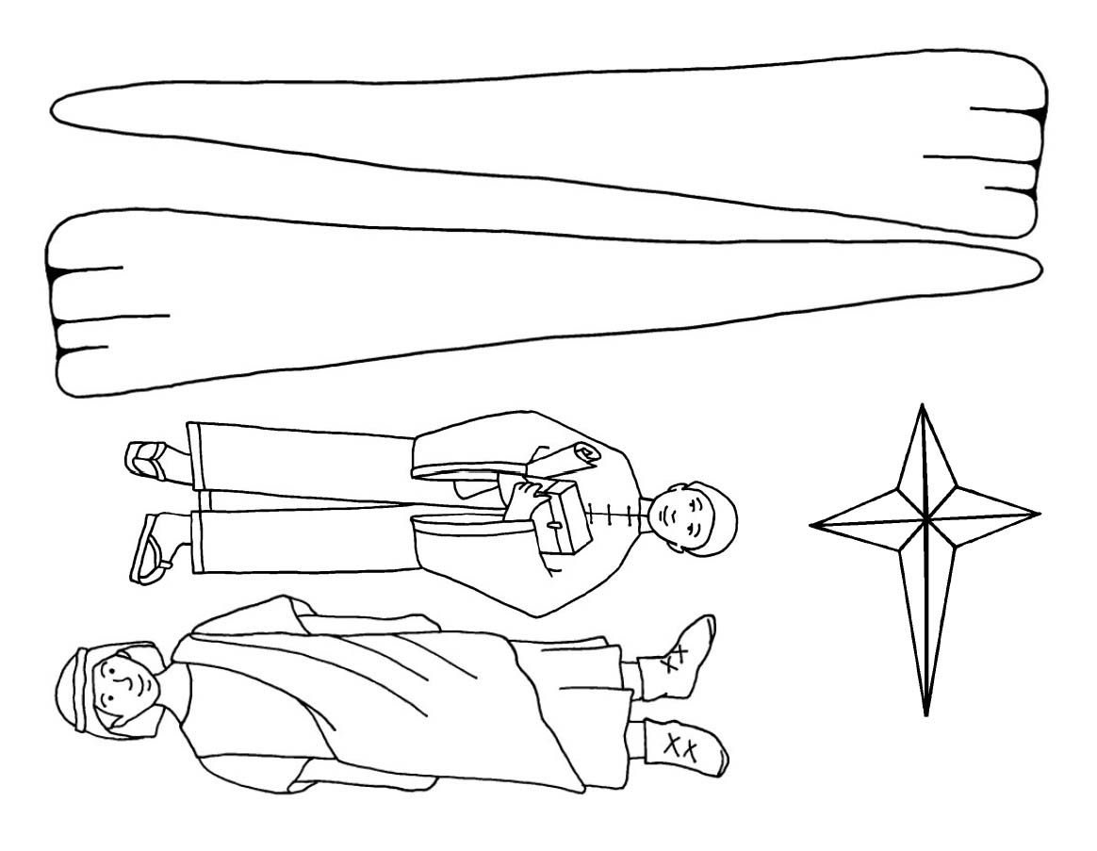
Advent Calendar Cut-Out 2
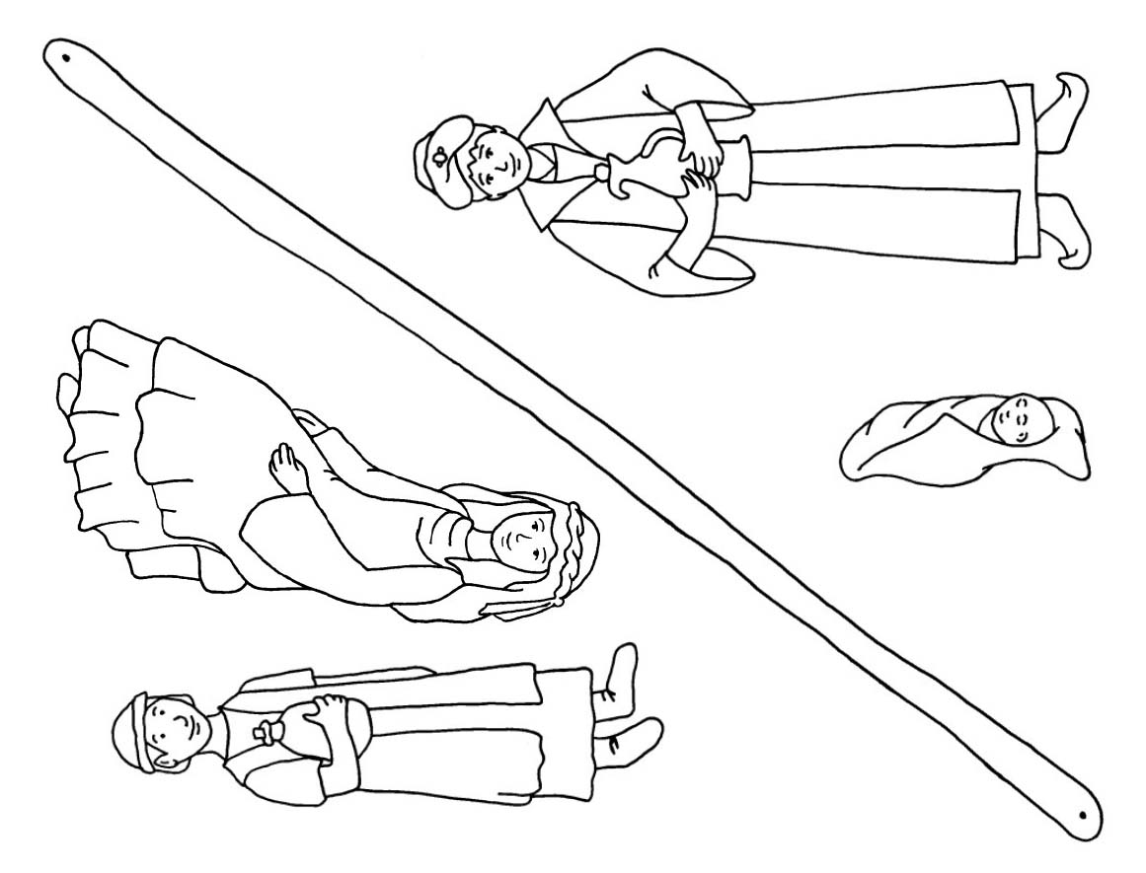
Advent Calendar Cut-Out 3
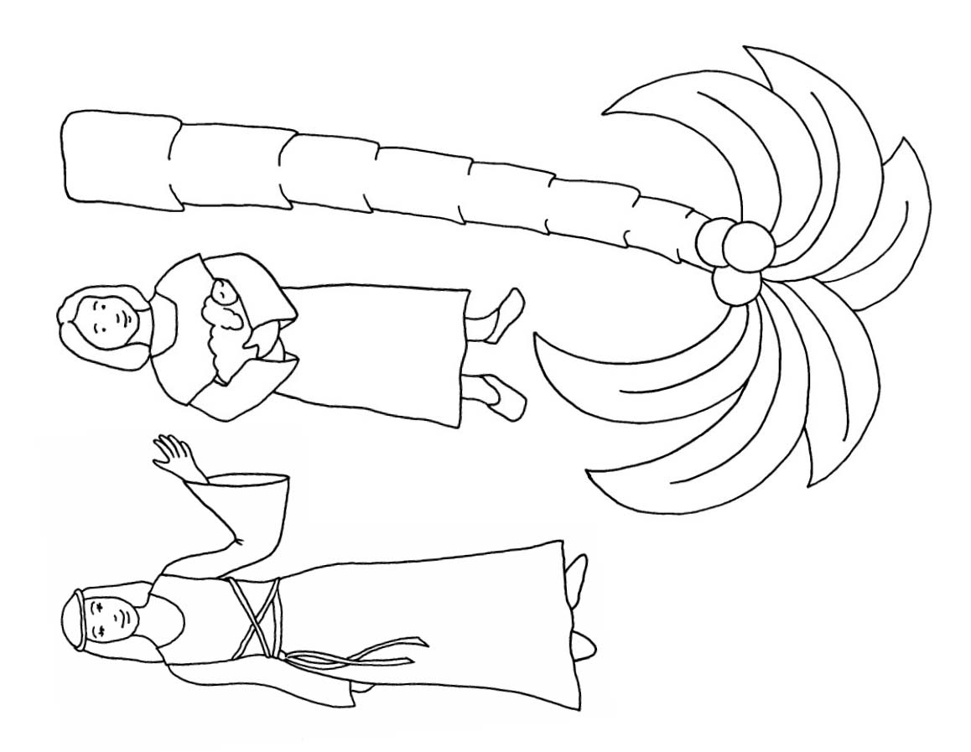
Advent Calendar Cut-Out 4
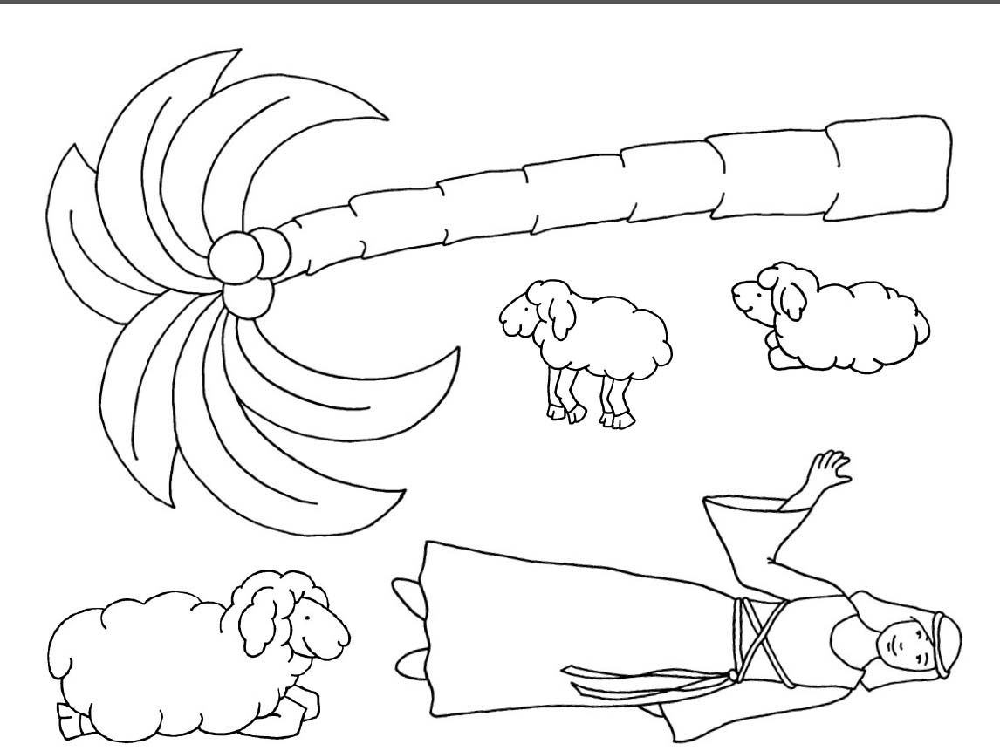
Advent Calendar Cut-Out 5
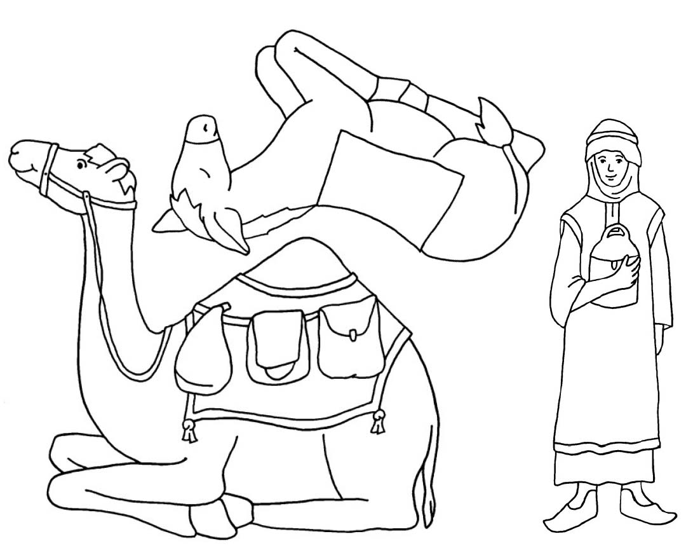
Advent Calendar Cut-Out 6
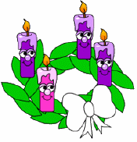
- How to make an Advent Wreath

You will need:
- Templates printed on cardboard
- Art materials
- Scissors
- Glue
Instructions
- 1. Print out the templates.
- 2. Colour or paint the template pieces.
- 3. Cut out the templates.
- 4. Glue the candles onto the base (You can glue one on each Sunday of Advent -- the pink one goes on the third Sunday).
- 5. Finish it off with the white bow.
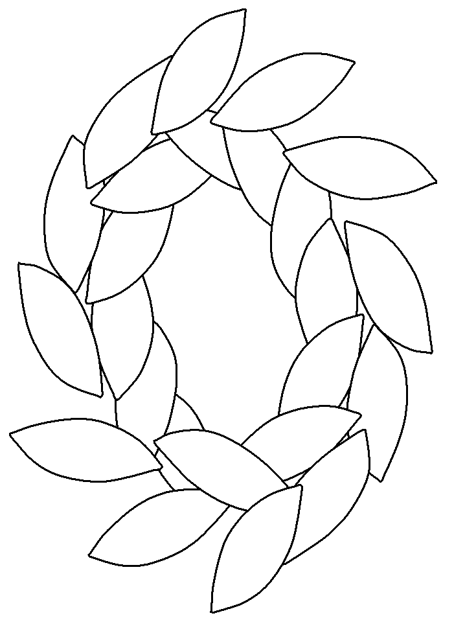
Advent Wreath
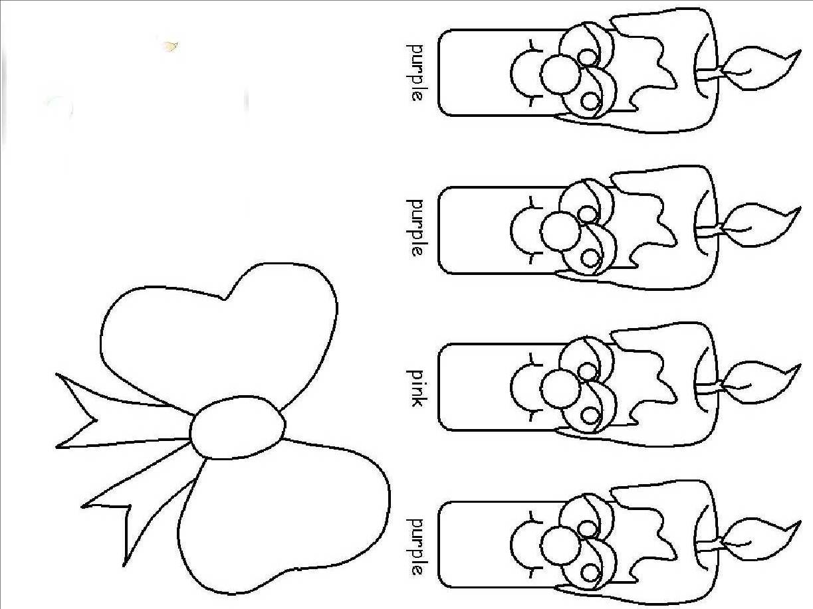
Advent Wreath Candles

Teacher Notes on the Advent Wreath

The symbolism of the Advent wreath is beautiful. The wreath is made of various evergreens, signifying continuous life. Even these evergreens have a traditional meaning which can be adapted to our faith: The laurel signifies victory over persecution and suffering; pine, holly, and yew, immortality; and cedar, strength and healing. Holly also has a special Christian symbolism: The prickly leaves remind us of the crown of thorns, and one English legend tells of how the cross was made of holly. The circle of the wreath, which has no beginning or end, symbolizes the eternity of God, the immortality of the soul, and the everlasting life found in Christ. Any pine cones, nuts, or seedpods used to decorate the wreath also symbolize life and resurrection. All together, the wreath of evergreens depicts the immortality of our soul and the new, everlasting life promised to us through Christ, the eternal Word of the Father, who entered our world becoming true man and who was victorious over sin and death through His own passion, death, and resurrection.
The four candles represent the four weeks of Advent. A tradition is that each week represents one thousand years, to sum to the 4,000 years from Adam and Eve until the Birth of the Saviour. Three candles are purple and one is rose. The purple candles in particular symbolize the prayer, penance, and preparatory sacrifices and goods works undertaken at this time. The rose candle is lit on the third Sunday, Gaudete Sunday, when the priest also wears rose vestments at Mass; Gaudete Sunday is the Sunday of rejoicing, because the faithful have arrived at the midpoint of Advent, when their preparation is now half over and they are close to Christmas. The progressive lighting of the candles symbolizes the expectation and hope surrounding our Lord’s first coming into the world and the anticipation of His second coming to judge the living and the dead.
The light again signifies Christ, the Light of the world. Some modern day adaptations include a white candle placed in the middle of the wreath, which represents Christ and is lit on Christmas Eve. Another tradition is to replace the three purple and one rose candles with four white candles, which will be lit throughout Christmas season.

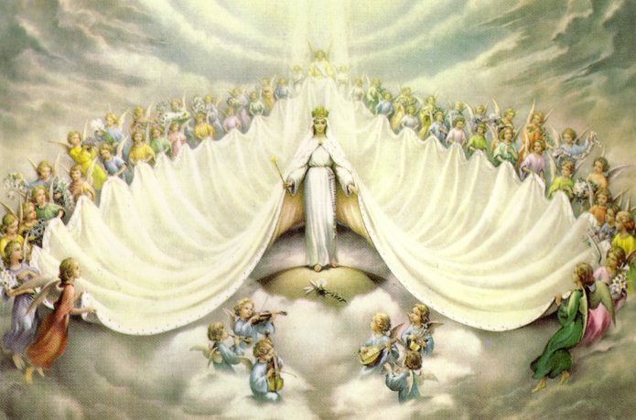
Mary Queen of the Angels
The Angelus
The Angel of the Lord declared to Mary:
And she conceived of the Holy Spirit.

Hail Mary, full of grace, the Lord is with thee; blessed art thou among women and blessed is the fruit of thy womb, Jesus. Holy Mary, Mother of God, pray for us sinners, now and at the hour of our death. Amen.

Behold the handmaid of the Lord: Be it done unto me according to Thy word.

Hail Mary . . .

And the Word was made Flesh: And dwelt among us.

Hail Mary . . .
Pray for us, O Holy Mother of God, that we may be made worthy of the promises of Christ.
Let us pray:
Pour forth, we beseech Thee, O Lord, Thy grace into our hearts; that we, to whom the incarnation of Christ, Thy Son, was made known by the message of an angel, may by His Passion and Cross be brought to the glory of His Resurrection, through the same Christ Our Lord.
Amen.

Immaculate Mary

Immaculate Mary!
Our hearts are on fire,
that title so wondrous
fills all our desire.
Refrain.
Ave, ave, ave Maria!
Ave, ave, ave Maria!
2. We pray for God’s glory,
the Lord’s kingdom come!
We pray for his vicar,
our father, and Rome.
Refrain.
Ave, ave, ave Maria!
Ave, ave, ave Maria!
3. We pray for our mother
the church upon earth,
and bless, sweetest lady,
the land of our birth.
Refrain.
Ave, ave, ave Maria!
Ave, ave, ave Maria!

The Christmas Story
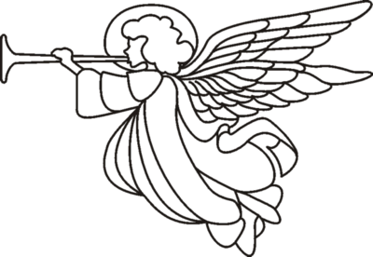

Name ______________________________
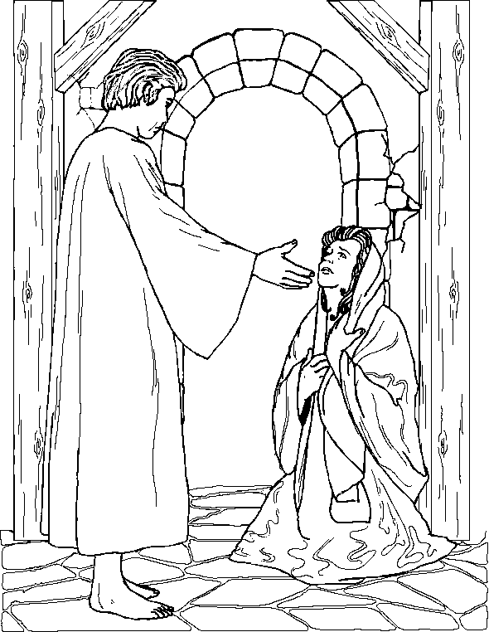
The Annunciation

The Angel Gabriel appeared to Mary and brought her a message from God. She was to be the mother of His son and she was to call him Jesus.

The Visitation

Mary went to visit her cousin Elizabeth who was also going to have a baby. When Elizabeth saw her she said, “You are the most blessed of all women and blessed is the child you will bear!"
Draw your picture of the Visitation here.
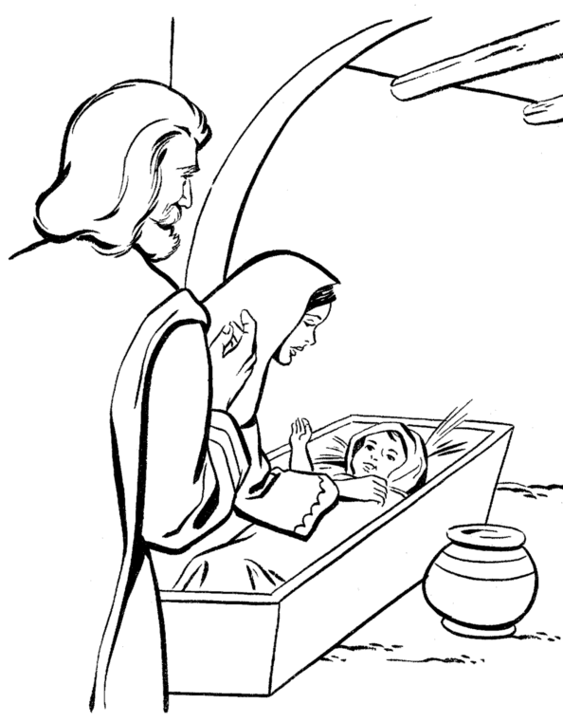
The Nativity

Joseph and Mary could find no room at any inn, but a kindly innkeeper let them use his stable. There, in the bare stable Mary gave birth to the infant Jesus, wrapped him in swaddling clothes and laid him in a manger.

With her husband Joseph and the infant Jesus, Mary became the mother of the Holy Family.
On that dark, cold night there were shepherds out in the fields, looking after their flocks of sheep.

Suddenly the night sky was filled with a great light and the shepherds were full of fear. An angel appeared and told them not to be afraid, because a ‘Saviour’ had been born and he was ‘Christ the Lord’.

Draw your picture of the shepherds and angel here.
An Angel Appears to the Shepherds in the Fields.

The Shepherds Worship Jesus

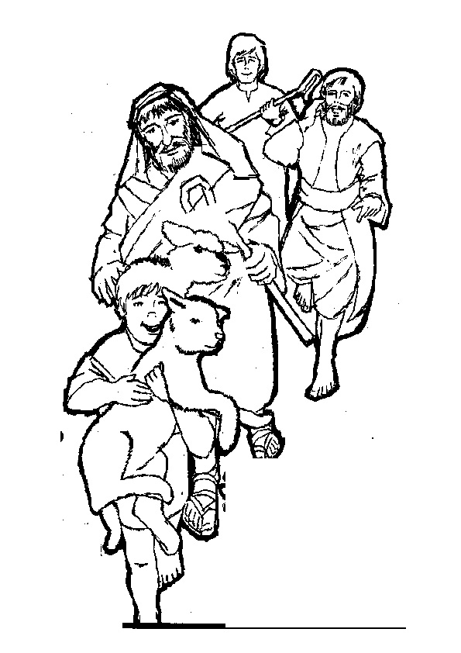
The angel told the shepherds where they
should go to find Baby Jesus.

The shepherds hurried joyfully to the stable
to worship Him.

The Wise Men from the East

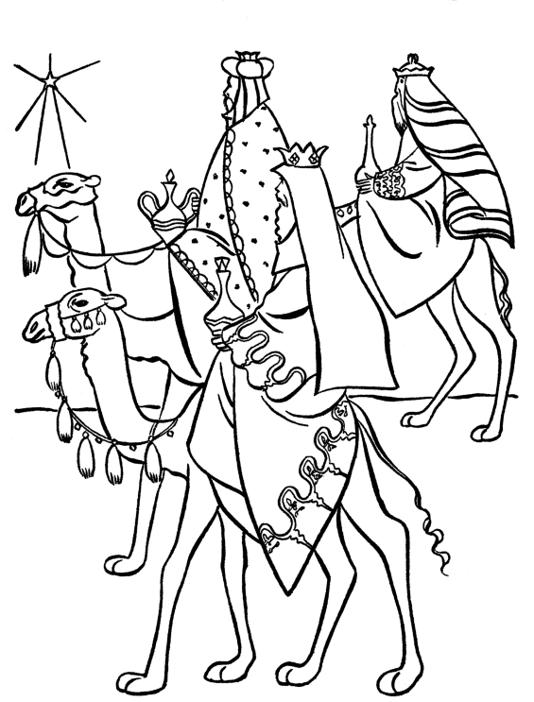

Write the story of The Wise Men from the East here. here.

King Herod was Very Worried

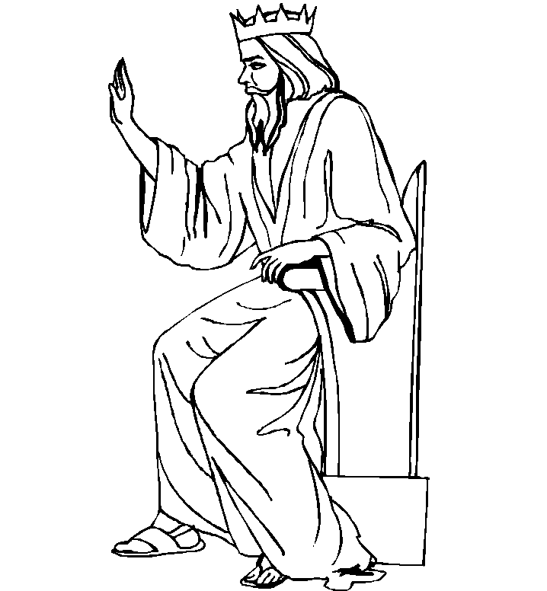
When Herod the king heard from the wise men that the baby born was called King of the Jews, he became very worried. He wanted to know where he could find the baby and so he asked the wise men to come back and tell him. Secretly he wanted to harm the baby Jesus.
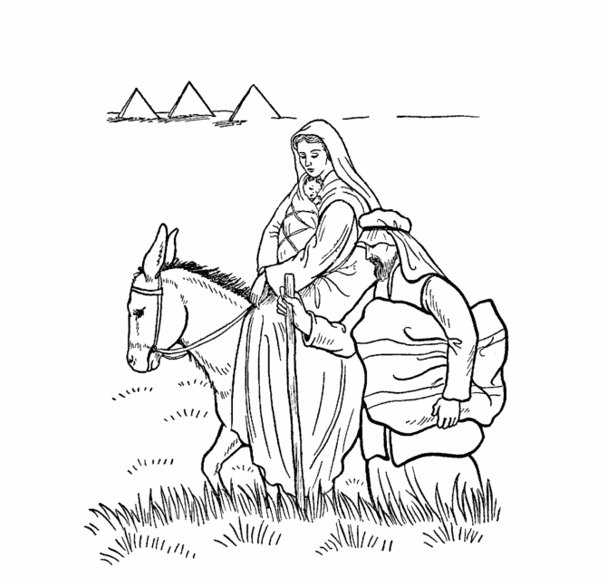
Joseph, Mary and Jesus Escape to Egypt

An angel warned the Wise Men to avoid Herod and go home another way. Then God sent an angel to tell Joseph to flee to Egypt with Mary and Jesus. There they were able to live peacefully until it was safe to go home.

Name ___________________________

Joseph or Herod?

Read the statements carefully and decide if they belong in Joseph’s box or Herod’s box.
Now write them in the correct box.

He wanted to kill all the baby boys He was the foster father of Jesus.

He always did what was right. He took Mary and Jesus to Egypt.

God sent an angel to give him a message. He cared for Mary and Jesus.

He asked the wise men from the east to help him find Jesus. He was very jealous of Jesus.

Joseph | Herod

Name…………………………………………………………..

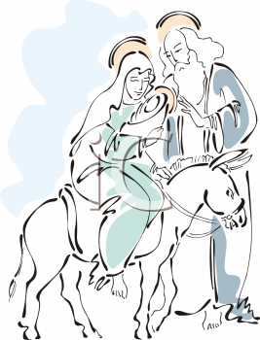
Draw a picture of yourself living like Joseph. Underneath your picture, write about what you are doing. Why did you choose to live like Joseph?

