Month/Season: Advent Class: Primary 5 Level: Second
Themes
1. Advent (Mary – The First of All Believers)
2. Prophets Who Foretold Jesus’ Birth
3. Catholic Christian Community

Strands of Faith: Experiences and Outcomes | Core Learning | Learning & Teaching  Class/School/Home/Parish | Resources | Assessment
Hours of God  RERC 2‐18a  I know some of the signs and symbols related to Lent, Easter, Pentecost, Advent and Christmastide and I can use this understanding to help me explore the  themes of these celebrations. | I can identify the meaning of some signs and symbols of Christmas (e.g. crib, star, Advent wreath). | Class: - Teacher explains that Advent is a time when we are waiting for Christmas and the birth of Baby Jesus and emphasises that the liturgical colour during Advent is purple and the liturgical colour for Christmastide is white.  Advent is the Season that includes four Sundays preceding Christmas. The Advent Season marks the beginning of the Liturgical Calendar. It always begins in late November or early December. On November 30th or on the Sunday that is the closest to this date, the Catholic Church begins the Liturgical Season of Advent. Advent ends on December 24th before the evening prayer of Christmas.  Christmastide lasts 12 days, beginning on Christmas Eve (December 24th) and continues to the Feast of Epiphany (January 6th).  A useful website is http://www.catholicdoors.com/courses/liturgy.htm  Class: - Children dress class altar in colours appropriate to Advent followed by Christmastide. Children pray round the class altar.  Class: - Teacher discusses the various ways we prepare for Christmas during Advent e.g. sending Christmas cards, dressing the Christmas tree, singing carols, taking part in a nativity play. Teacher explains that the children are going to make an Advent calendar to help them count the days to Christmas. Children colour the two pictures of the house, adult supervision will be needed to cut out the windows and door and finally the children glue the front of the house onto the inside of the house. | Purple Altar Cloth  White Altar Cloth  Template for Advent Calendar (attached to planner) | Children demonstrate an understanding that the Church uses purple for Advent and white for Christmastide.

Strands of Faith: Experiences and Outcomes | Core Learning | Learning & Teaching  Class/School/Home/Parish | Resources | Assessment
 |  | Class: - Teacher explains that as part of the preparations for Christmas, it is traditional to make or buy an Advent wreath. If possible the teacher could assist the children in the making of a simple Advent Wreath.  To make an Advent wreath, begin with a Styrofoam circle, available at craft shops, and cut four evenly spaced holes into which you will place the four candles. Traditionally there are three purple candles and one rose candle for the third Sunday. Place fresh evergreen branches over the Styrofoam. Replace them when they dry out in order to preserve the symbolism of the vitality of God's love. Encourage children to participate as they are able, by gathering branches, placing the candles and so on. Teacher explains the significance of the candles (advent wreath notes are attached to planner).  Class: - Children are given the task to complete an Advent wreath worksheet which gives them the opportunity to colour in and attach the candles in the appropriate colours.  School: - Children participate in school Advent assemblies where the Advent wreath is lit.  Class: - Teacher shows children figures or pictures of Mary, Joseph and baby Jesus and sets up a crib on or near the class altar. Teacher explains that the crib is a symbol of Christmas and many shopping centres, family homes, etc. set up a crib to represent the meaning of Christmas. The children are giving opportunities to pray at the crib and reflect on the birth of Jesus as a joyful event that all Christians celebrate at Christmas time.  Class: - Teacher explains the significance of the star at Christmas. Many decorations, Christmas cards, etc. feature a star which represents the Star of Bethlehem which guided the wise men to the stable in Bethlehem. Children will be given the opportunity to make a Star of Bethlehem. Instructions and template are attached to planner.  KEY VOCABULARY: Liturgical colours, Advent wreath, crib, star | Styrofoam Circle  3 purple candles  1 rose candle  Evergreen branches  Advent wreath notes (attached to planner)  Advent Wreath  Template (attached  to planner)  Figure/ Pictures of baby Jesus, Mary and Joseph  Star of Bethlehem Instructions and Templates (attached  to planner) | Children demonstrate an understanding of the significance of the Advent Wreath.  Children show awareness that the crib is a symbol of Christmas and the birth of Jesus.  Children show awareness that the star is a symbol of Christmas and the Star of Bethlehem.

Strands of Faith: Experiences and Outcomes | Core Learning | Learning & Teaching  Class/School/Home/Parish | Resources | Assessment
Hours of God  RERC 2‐15a  I can recognise Mary's significance within the Catholic tradition and I know that celebrating her feast days and praying to God through Mary can enrich my life. | I am learning to pray the Angelus at noon, regularly in my classroom, particularly in the season of Advent and during the months of May and October.  I can recognise that Mary is honoured as the first of all believers.  I know that Mary is given the titles ‘Mother of God’ and ‘Mother of the Church’ and I can explain what these terms mean. | Class: - Teacher discusses with the children different ways of honouring Mary as Mother of Jesus and Our Mother e.g. saying special prayers to Mary, singing hymns to Mary. Teacher tells the children that during Advent the class altar will be set up in honour of Mary. Teacher places a statue of Mary and/or pictures of Mary on the class altar. The children are told that at noon each day everyone in the school will stop to pray a special prayer to Mary called the Angelus. Teacher shows children a picture of “The Angelus “- a painting by Jean Francois Millet which depicts a man and his wife stopping to pray the Angelus. Teacher explains to the children that the Angelus means Angels and that Mary is in Heaven with all the angels and has a special title - Queen of the Angels. Teacher shows children a picture portraying Mary as Queen of the Angels. Every day at noon the class will stop what they are doing and pray The Angelus.  The teacher leads the prayer and the children respond with praying the Hail Marys. A copy of The Angelus is attached to the planner.  Class: -Teacher recalls the story of The Annunciation and discusses with the children the faith and trust Mary had in the Angel’s words. Teacher explains to the children that Mary is honoured as the first of all believers because she said “yes” to God and became the Mother of his Son. Children make figures of The Angel Gabriel and Mary from The Annunciation Worksheet.  Class: - Teacher discusses with the class the different titles giving to Mary and explains that these titles can be made into a prayer called a litany. Teacher explains that ‘Mother of God’ represents Mary as the mother of Jesus who was both fully God and fully man. The title ‘Mother of the Church’ was emphasised by Pope Paul VI when he said "For the glory of the Blessed Virgin and our own consolation, we proclaim the Most Blessed Virgin Mary Mother of the Church, of the whole people of God, faithful and pastors, and we call her most loving Mother." The Holy Father expressed the hope that this title of Mary, Mother of the church would "lead Christians to honour Mary even more and to call upon her with still greater confidence." He decreed that "from now onward the whole Christian people should give even greater honour to the Mother of God under this most loving title." Teacher asks the children to suggest other titles that Mary has been given and their significance.  KEY VOCABULARY: Angelus, Mother of God, Mother of the Church. | Statue of Mary and/or pictures of Mary  Picture of “The Angelus “ by Jean Francois Millet (attached to planner)  Picture of Mary as Queen of the Angels  (attached to planner)  Words of the Angelus (attached to planner)  The Annunciation Worksheet (attached to planner) | Children can pray the Angelus.  Children demonstrate a greater understanding of Mary’s significance within the Catholic Church.

Strands of Faith: Experiences and Outcomes | Core Learning | Learning & Teaching  Class/School/Home/Parish | Resources | Assessment
Son of God  RERC 2-05a  I know that Jesus is truly divine and truly human and I can acknowledge Him as our Saviour who brings the New Covenant.  Hours of God  RERC 2-11a  I have studied the structure of the Bible. I can identify the different parts of the Bible and I have explored God’s message in these. | I know that, in the Incarnation, the eternal Son of God became man as Jesus of Nazareth, Son of Mary.  I know that God chose and called specific people for a particular mission and purpose and I recognise that some became great prophets.  I can name some of the key prophets (Isaiah, Jeremiah…)  I know what the term ‘covenant’ means and I have explored the narrative of God’s covenant with Abraham (Gen 15). | Class: - Teacher discusses the birth of Jesus in Bethlehem with the children and how the Son of God became man as Son of Mary. Jesus was born fully human and as a baby the shepherds and the wise men came to worship him. As he grew older he was known as Jesus of Nazareth and his incarnation has been written about in the Gospels. Explain that incarnation means God taking a human form as Jesus. Teacher reads from the bible John 1:14 to the children and discusses its significance. What does John mean by the Word? How does he describe Jesus as a human being? What glory did Jesus receive? The children add the shepherds and the wise men to the crib. Children complete the Nativity Storyboard Worksheet.  KEY VOCABULARY: Gospels, Son of God, Saviour, Incarnation, Jesus of Nazareth, Jesus, Son of Mary, fully human  Class – The children will read from the Bible Isaiah 7:14. Explain to the children that this was written around 400 years before the birth of Jesus. How do you think Isaiah knew about this before it happened? Do you know what a ‘prophet’ is? A prophet is a person who is chosen by God for a particular mission or purpose. What do you think Isaiah’s mission was? Why do you think God gave this message to Isaiah even though it was 400 years before the event?  Explain to the children that Isaiah was not the only prophet who foretold the birth of Jesus.  Children should colour and cut the worksheet ‘Prophet who foretold the birth of Jesus’ and paste it into their jotter. Under the image children should write the definition of the word ‘prophet’.  Class – Recap on who Abraham is. Explain to the children that he is a descendant of Noah. What is a ‘descendant’? Explain that God spoke to Abraham. We are going to read about God’s covenant with Abraham. What is a ‘covenant’? It is a promise. Abraham was faithful and trusted God and so God promised him something special.  Read from the Bible Genesis 15:4. Explain to the children after reading that one of Abraham’s descendents is Jesus.  Complete the art activity attached to the planner.  KEY VOCABULARY: God’s call, Abraham, Isaac, covenant, mission. | Bible  Figures/Pictures of the shepherds and Wise Men (attached  to planner)  Nativity Storyboard Worksheet  Bibles  ‘Prophets Who Foretold the Birth of Jesus’ Worksheet (attached to planner)  Internet Access  Art activity instructions (attached to planner) | Children demonstrate an understanding that Jesus was fully human and became Jesus of Nazareth and Son of Mary.  Children will understand the meaning of the term ‘Prophet’.  They will be familiar with some of the prophets who foretold the birth of Jesus.  Children will understand that Jesus is a descendant of Abraham from the Old Testament.  They will understand the meaning of the word ‘covenant’.

Strands of Faith : Experiences and Outcomes | Core Learning | Learning & Teaching  Class / School / Home / Parish | Resources | Assessment
Hours of God  RERC 2-12a  I know that the Bible is the inspired Word of God and that I should treat it with reverence.  Reign of God  RERC 2‐24a  I have considered ways in which the Catholic Christian community works together to show care for the world and for the needs of all people. I have reflected on the implications of this for my life and that of others. | When I listen to a passage from the Bible I know that this is the Word of God  I can prepare myself to listen intently to each reading by being still and quiet, so that I am ready to hear God’s message, especially in the Liturgy of the Word at Mass.  I know that when I read the Bible and Sacred Scriptures, it can help me to pray and to deepen my relationship with God.  I have had opportunities to develop my ability to read aloud from Sacred Scripture in such a way that I am proclaiming the Word of God.  I know that my parish is part of the wider Catholic Church and exists within a diocesan and universal communion.  I am developing my understanding of my involvement in the community of the Catholic Church by exploring the role of the lay organisations in my diocese that work to show care for the world and the needs of all people e.g. SPRED (Special Religious Development), Justice and Peace Groups. | Class – Brainstorm with the children what facts they already know about the Bible. These facts can be written onto the board.  Discuss the terms ‘reverence’ and ‘respect’ in association with the Bible.  When listening to / reading from the Bible you must be open, quiet, and receptive.  Children will be given the opportunity to take part in Advent / Christmas services / Mass / Carol Service /Prayer service /nativity / Assembly etc. where they will read from scripture to others.  In preparation for this the teacher will make clear to the child that in sharing sacred scripture with others we are proclaiming the word of God.  Class – Children should complete the Christmas scripture worksheet attached to planner.  KEY VOCABULARY: Scriptural references, chapter and verse, God’s call, New Testament, Old Testament, sacred scripture, proclaim,  Class – Teacher should explain to the children that they are members of a parish, a deanery, which is in a diocese, universal Church. We are all part of the universal communion of Christians. What do you think by the word ‘communion’? (family/collection of people)  Parish – Teacher to be advised by parish priest the role of the different lay organisation which exist in the diocese that work to show care for all the world and the needs of the people.  Thereafter the teacher will invite a relevant representative to speak to the children about the work they do and give them the opportunity to ask appropriate questions. | Preparation materials for services / mass etc.  Christmas Scripture worksheet (attached to planner)  Teacher to arrange visit from Parish Priest and members of lay community. | Children will actively participate in the preparation and participation of Advent /Christmas activities.  The children will understand that they are not only members of their parish but a Christian Community which spreads throughout the world.

Strands of Faith: Experiences and Outcomes | Core Learning | Learning & Teaching  Class/School/Home Parish | Resources | Assessment
 | I know that in the Catholic Church people are asked to respond to God’s call to love and serve in various ways and that one such way is the religious life.  I can identify the ways in which religious orders and congregations that exist in my Diocese show care for the world and the needs of all people and I know that some do this primarily by prayer (contemplative) while others do so primarily through active ministry (active).  I have researched the founder of one of these religious orders/congregations, and I can identify their charism.  I have used this information to inspire and challenge me to respond to God’s call to care for the poor.  I know that I am called to respond to the needs of others when I can. | Class – The following website should be used as the teacher wishes. It contains information on the life of Blessed Mother Teresa of Calcutta.  http://www.request.org.uk/main/history/teresa/teresa02.htm  The work on this should be spread over the next few days and the website contains a wide variety of activities from which the teacher can pick and choose. Information can be printed from the web or projected on to the white board and read together as a class.  Teacher should show these children the following website:  http://www.carmelnuns.org.uk/  Compare the two orders : The Little Sisters of the Poor (active)  The Carmelite Order (contemplative)  Class – On completion of the work related to Blessed Mother Teresa, the children should complete the attached worksheet.  Class – Reflect on the past lessons regarding the church and the life of Blessed Mother Teresa. Ask the children how they could respond to God’s call to care for the poor. Brainstorm ideas and decided on a class charitable activity for Advent.  KEY VOCABULARY: diocesan, universal communion lay organisations, religious life, contemplative and active, charism, religious orders, and congregations. | Internet Access  Blessed Mother Teresa Worksheet (attached to planner) | Children will have a good understanding of the life of Blessed Mother Teresa of Calcutta.  They will understand the difference between active and contemplative prayer.  The children will reflect on previous learning and discover ways in which they can help the poor.  The children will actively participate in a charity event.

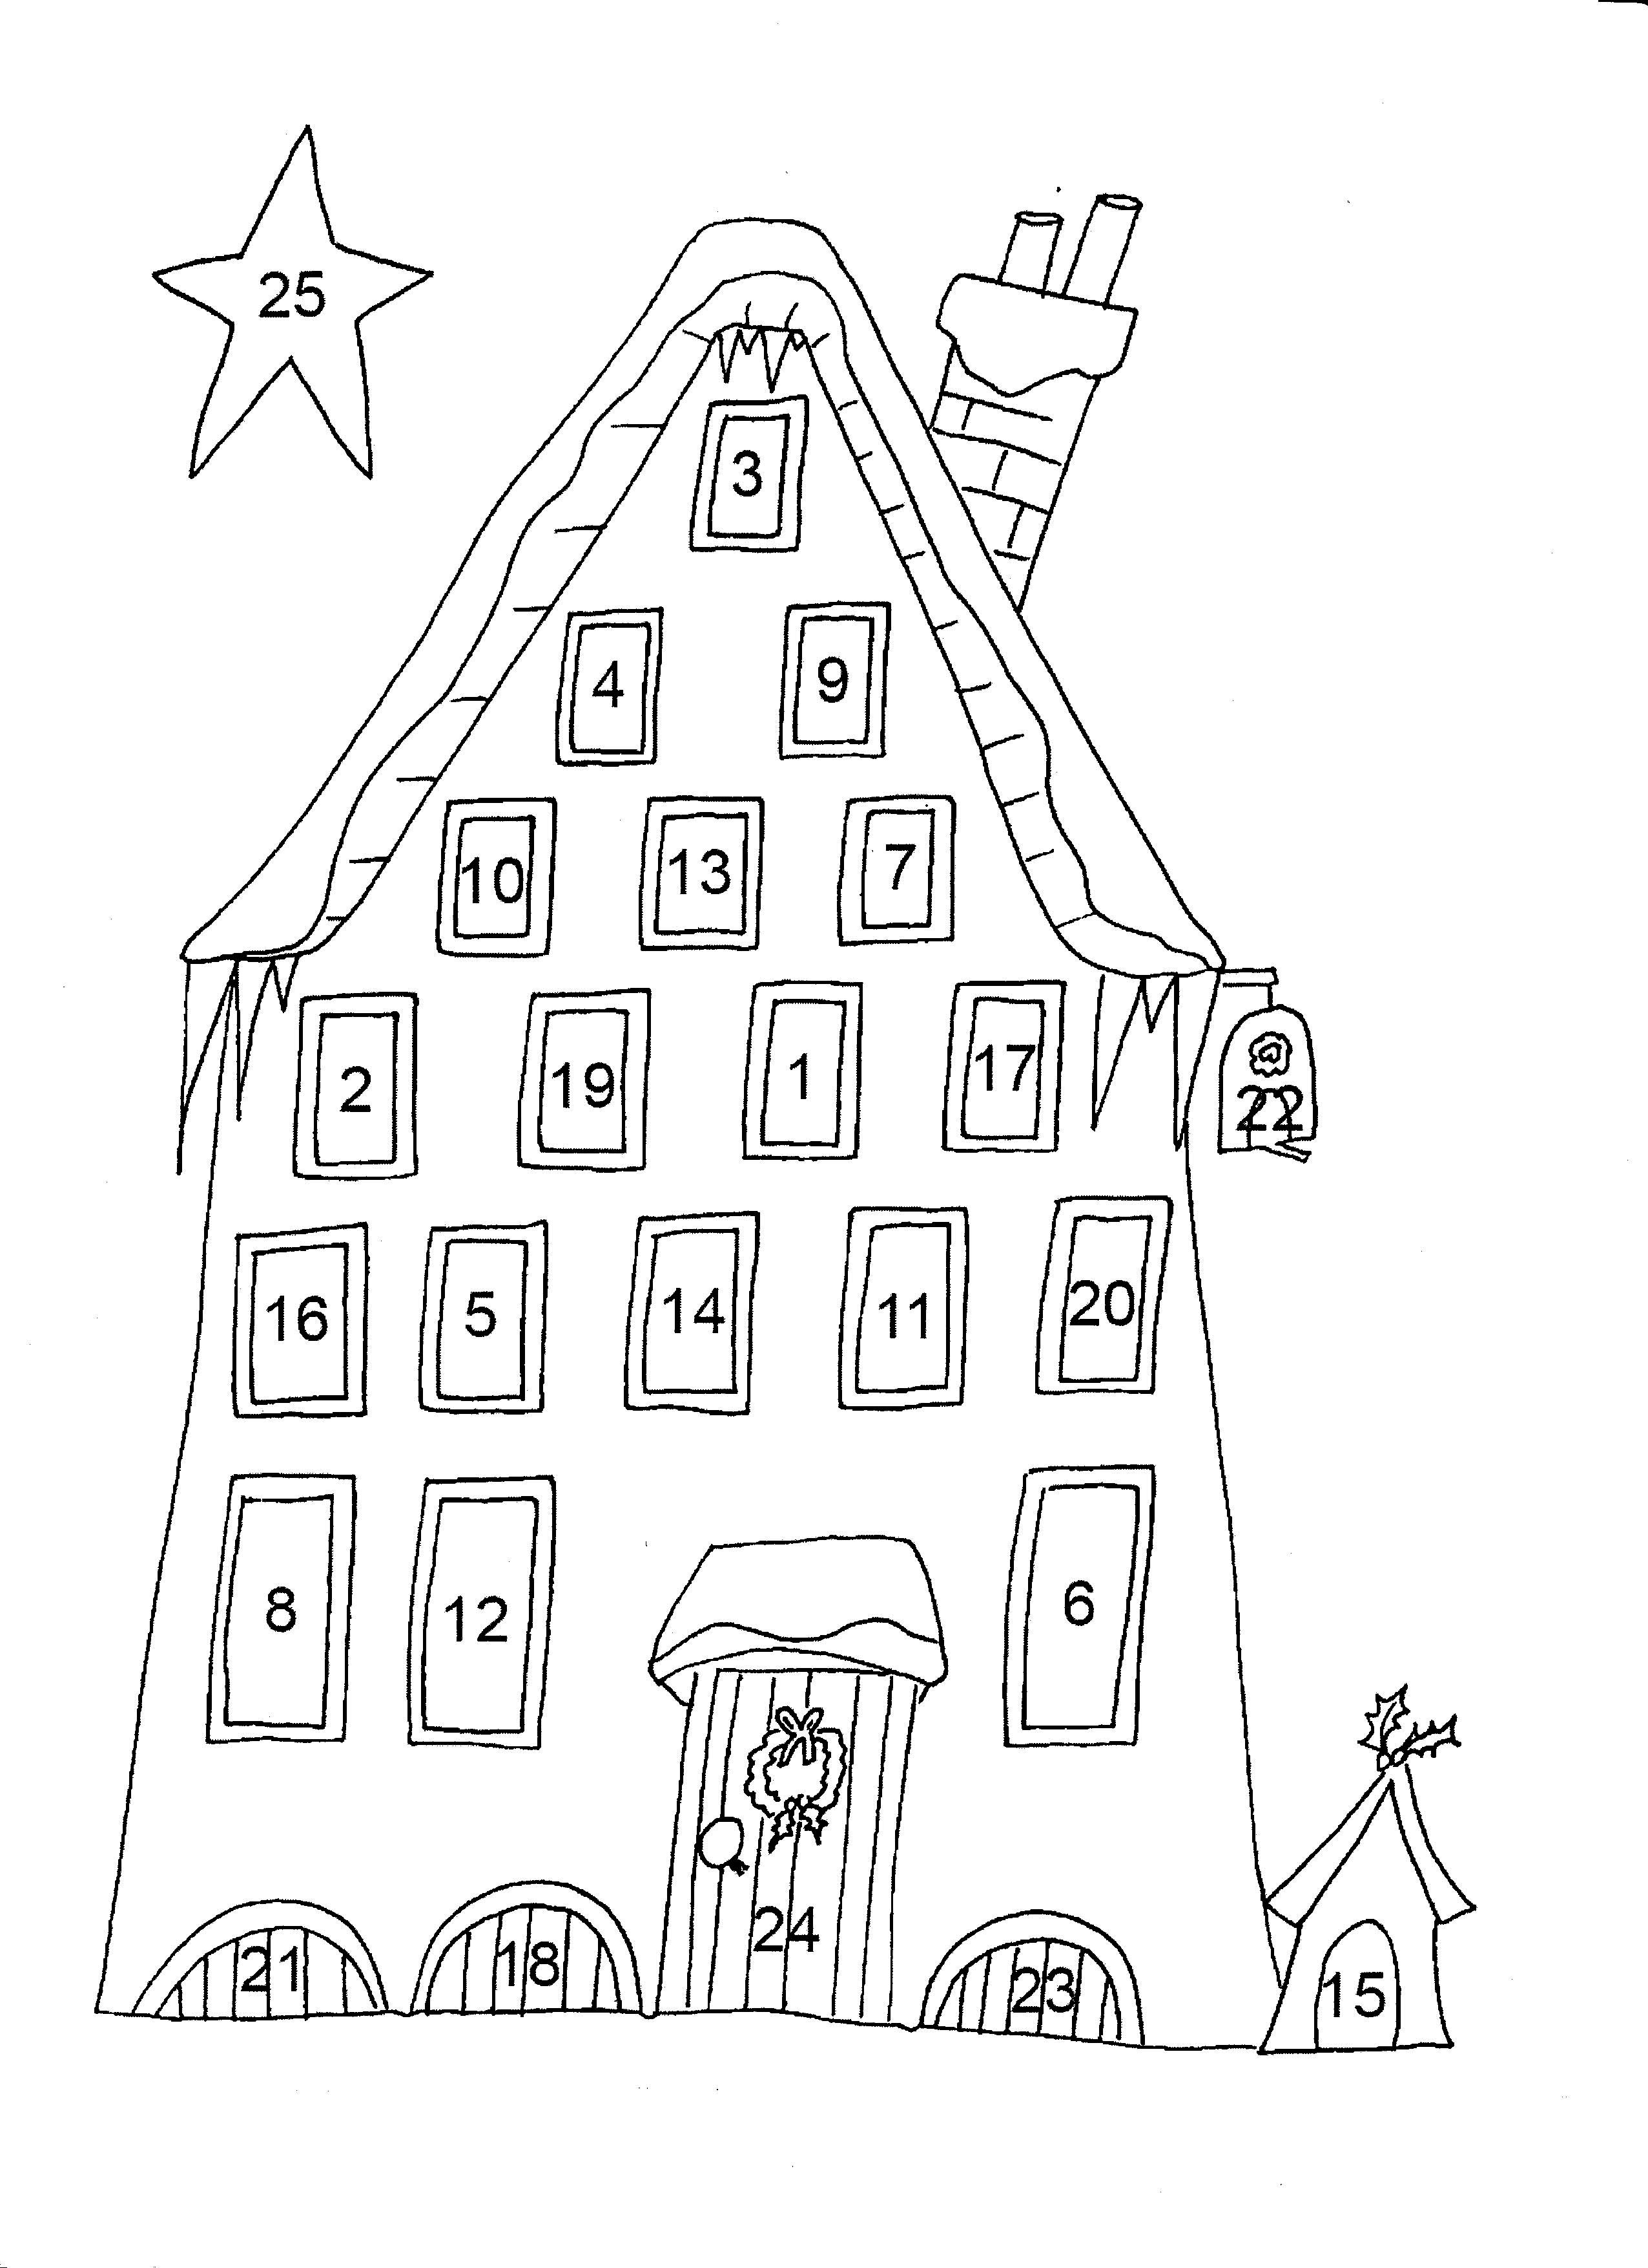
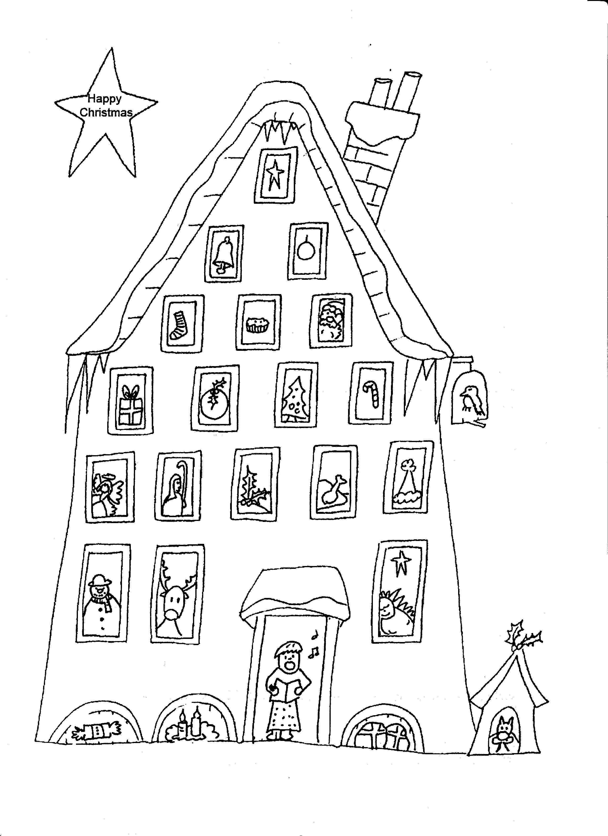
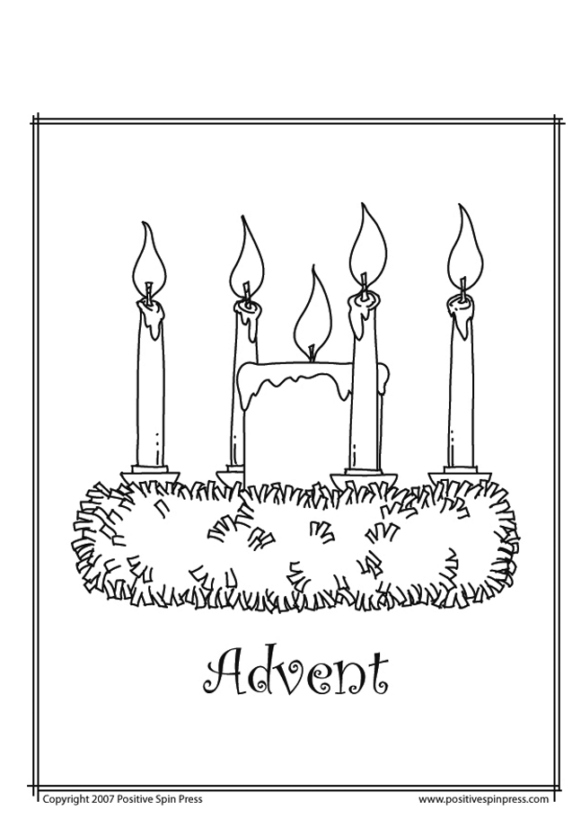
Name..............................................
Teacher Notes on the Advent Wreath

The symbolism of the Advent wreath is beautiful. The wreath is made of various evergreens, signifying continuous life. Even these evergreens have a traditional meaning which can be adapted to our faith: The laurel signifies victory over persecution and suffering; pine, holly, and yew, immortality; and cedar, strength and healing. Holly also has a special Christian symbolism: The prickly leaves remind us of the crown of thorns, and one English legend tells of how the cross was made of holly. The circle of the wreath, which has no beginning or end, symbolizes the eternity of God, the immortality of the soul, and the everlasting life found in Christ. Any pine cones, nuts, or seedpods used to decorate the wreath also symbolize life and resurrection. All together, the wreath of evergreens depicts the immortality of our soul and the new, everlasting life promised to us through Christ, the eternal Word of the Father, who entered our world becoming true man and who was victorious over sin and death through His own passion, death, and resurrection.
The four candles represent the four weeks of Advent. A tradition is that each week represents one thousand years, to sum to the 4,000 years from Adam and Eve until the Birth of the Saviour. Three candles are purple and one is rose. The purple candles in particular symbolize the prayer, penance, and preparatory sacrifices and goods works undertaken at this time. The rose candle is lit on the third Sunday, Gaudete Sunday, when the priest also wears rose vestments at Mass; Gaudete Sunday is the Sunday of rejoicing, because the faithful have arrived at the midpoint of Advent, when their preparation is now half over and they are close to Christmas. The progressive lighting of the candles symbolizes the expectation and hope surrounding our Lord’s first coming into the world and the anticipation of His second coming to judge the living and the dead.
The light again signifies Christ, the Light of the world. Some modern day adaptations include a white candle placed in the middle of the wreath, which represents Christ and is lit on Christmas Eve. Another tradition is to replace the three purple and one rose candles with four white candles, which will be lit throughout Christmas season.


Instructions – 3D Star of Bethlehem

You will need:

- 2 star shapes printed on cardboard

- Scissors

- Art materials

- Cord

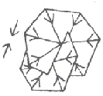
What to do:

1. Cut out the two stars and colour them.

2. Cut on one star’s dotted line right up to the centre.

3. Slide the stars together, top to bottom.

4. Punch a hole at the top of the star and push the cord through to form a loop.


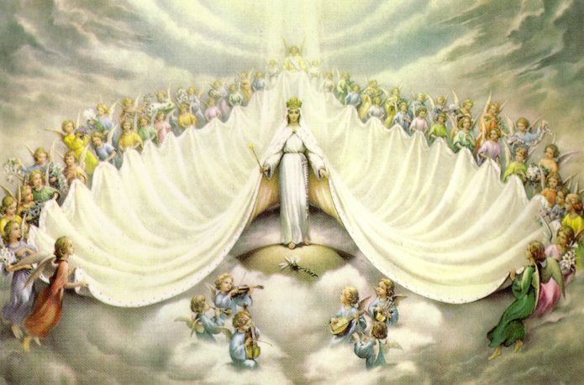
Mary Queen of the Angels
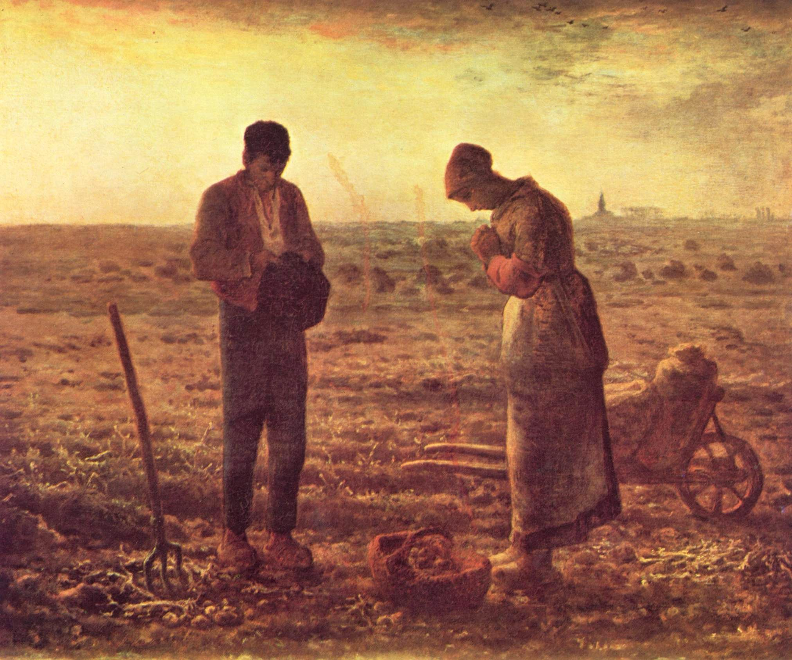
“The Angelus" by Jean-Francois Millet, 1857 Louvre, Paris.
The Angelus
The Angel of the Lord declared to Mary:
And she conceived of the Holy Spirit.

Hail Mary, full of grace, the Lord is with thee; blessed art thou among women and blessed is the fruit of thy womb, Jesus. Holy Mary, Mother of God, pray for us sinners, now and at the hour of our death. Amen.

Behold the handmaid of the Lord: Be it done unto me according to Thy word.

Hail Mary . . .

And the Word was made Flesh: And dwelt among us.

Hail Mary . . .
Pray for us, O Holy Mother of God, that we may be made worthy of the promises of Christ.
Let us pray:
Pour forth, we beseech Thee, O Lord, Thy grace into our hearts; that we, to whom the incarnation of Christ, Thy Son, was made known by the message of an angel, may by His Passion and Cross be brought to the glory of His Resurrection, through the same Christ Our Lord.
Amen.

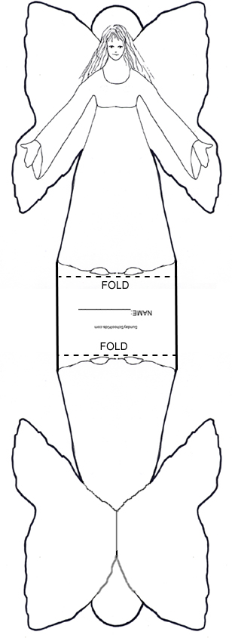
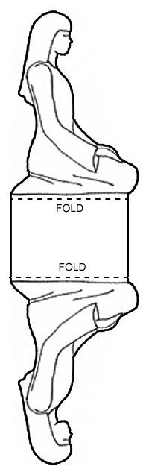
The Annunciation
1 |  | About two thousand years ago, a young woman called Mary lived in the town of Nazareth. Nazareth was part of a country ruled by a Jewish king named Herod. She was going to marry Joseph, a carpenter. One day, Mary was visited by an angel called Gabriel who told her that she would soon have a very special baby. The baby would be the Son of God and was to be called Jesus, meaning “Saviour”. The angel told Mary that the baby would, one day, be a very great king. Not long afterwards, Mary and Joseph were married.
2 | 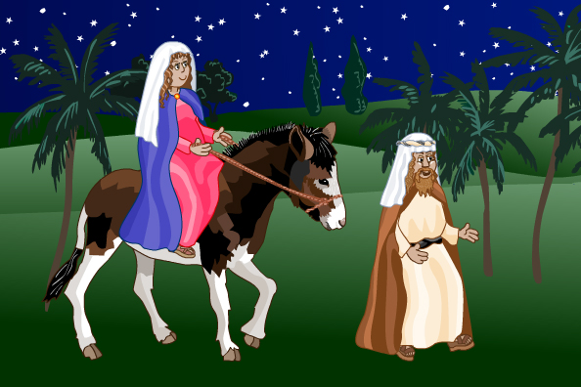  Mary and Joseph made the long journey to Bethlehem.
3 |  | At last, Mary and Joseph arrived in Bethlehem. The town was very busy with all the people who had travelled there to register to pay their taxes. Mary was very tired and needed a place to stay, but they were late arriving in the town and all the houses and inns were full. There was no room for them anywhere. Eventually, one caring innkeeper took pity on Mary and sent them to a stable at the back of the inn, where he kept his animals. They were welcome to stay there.
4 | 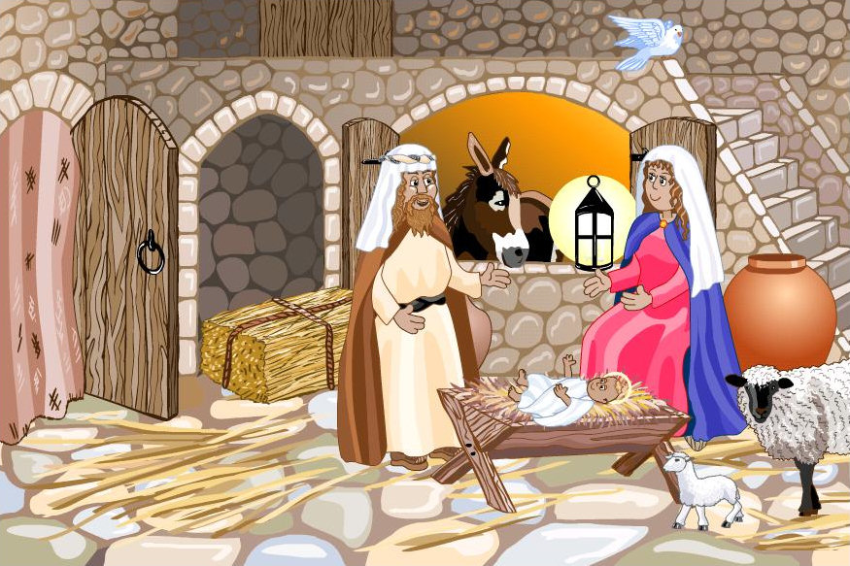  That night, Mary’s baby was born in the stable.
5 |  | Meanwhile, some shepherds were caring for their flocks of sheep in the nearby hills. Suddenly, a dazzling light lit the sky. An angel appeared and told the shepherds the astonishing news that the Son of God had been born in a stable in Bethlehem and that he would be the greatest king of all. The shepherds hurried to Bethlehem, following a bright, new, silvers tar that had appeared in the sky.
6 | 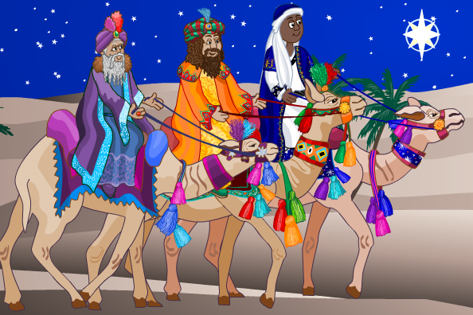  Three wise men followed the star hoping to find the new king.
7 |  | The three wise men approached King Herod and asked him where they could find the new, baby king. King Herod was alarmed because he did not want anyone to take his place as ruler. He did not know who the new king was, so he told the wise men to return to his court to tell him where they had found the baby. What he didn’t tell them was that he then meant to kill this new king.
8 | 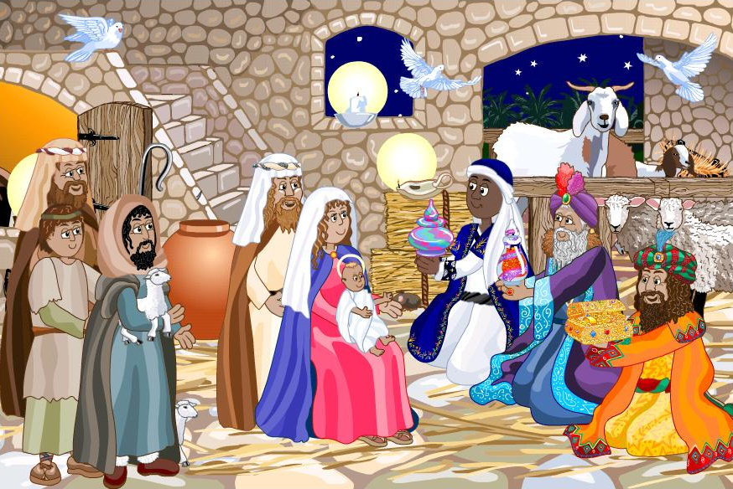  The wise men gave gifts to the baby Jesus.
9 | Mary and Joseph fled to Egypt, away from King Herod. | Joseph and Mary soon left the stable. Joseph had a dream telling him to take Jesus and Mary immediately to Egypt, where they would be safe from King Herod. The wise men also left Bethlehem without telling King Herod about Jesus. They did not trust King Herod, so they ignored his orders and returned straight to their own country.  Jesus spent the first few years of his life growing up quietly with his parents in Egypt.

Use the Bible to look up the references of Isaiah and Micah and choose one for each prophet and write it into the speech bubbles below.

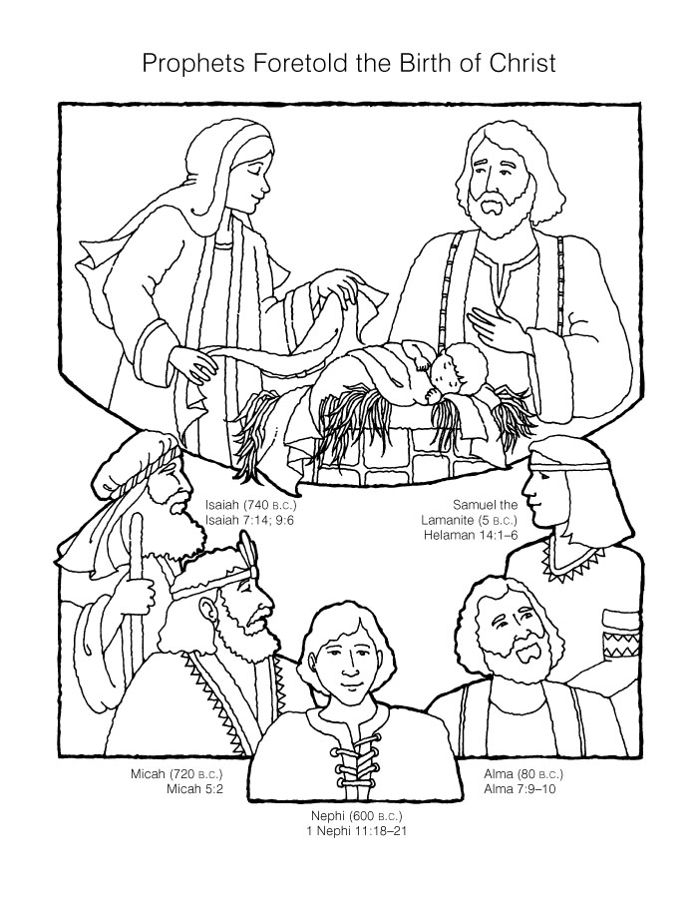
Colour the picture and paste into your jotter.

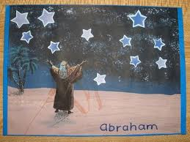

You will need:
- Black paper / White paper
- Star template
- Chalk or pastels
- Coloured image of Abraham (Can be copied and cropped from http://www.fbctopeka.com/before-abraham-was-i-am and cut out)

Create a collage of the scene from the Bible. Use the stars below to as templates. In the largest star write the name Jesus.

Teacher should create a banner with the Bible Quote.

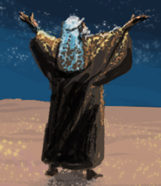

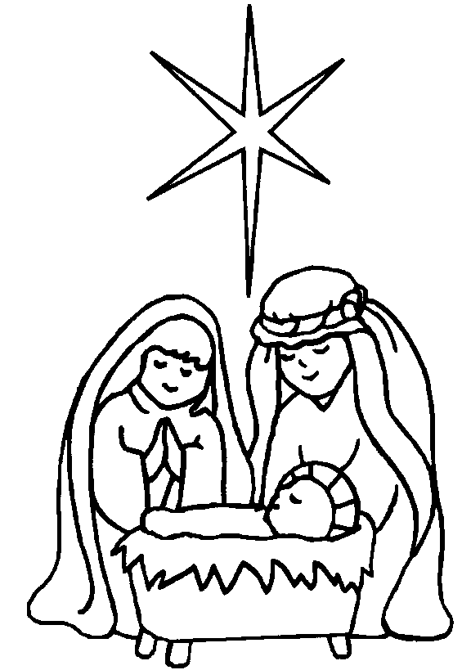
Name……………………………………………..

Bible Verses and Scriptures about Christmas
Find these verses in your bible and complete the table below writing about what it tells us about the birth of Jesus Christ.

Scripture | What it tells us about the Christmas Story
- Isaiah 7:14

Luke 1:35

Luke 2:1-20

Matthew 2:1-12

The Life of Blessed Mother Teresa

Name: | Born | Nationality
Family: | Places of Residence:
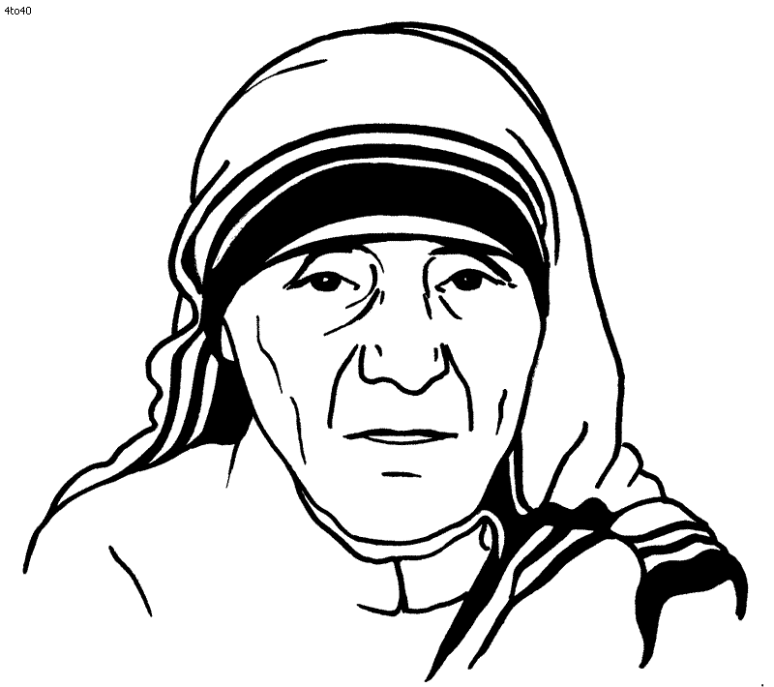
Major Life Events:
(bullet points)

Holy Order: | Character Traits / Charisms
God’s Plan for her:

